Secrets and Bombs: The Piazza Fontana bombing and the Strategy of Tension - Luciano Lanza

Secrets and Bombs 21: TIMETABLE – A Basic Chronology (with video links)
January 29, 2012 //
1

2 Votes

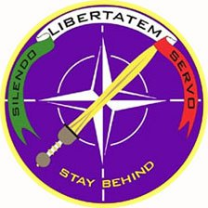
Gladio (Italian section of the Clandestine Planning Committee (CPC), founded in 1951 and overseen by SHAPE (Supreme Headquarters Allied Powers, Europe)
1969
25 April — Two bombs explode in Milan: one at the FIAT stand at the Trade Fair and another at the bureau de change in the Banca Nazionale delle Communicazione at Central Station. Dozens are injured but none seriously. AnarchistsEliane Vincileone, Giovanni Corradini, Paolo Braschi,Paolo Faccioli, Angelo Piero Della Savia and Tito Pulsinelliare arrested soon after.
2 July — Unified Socialist Party (PSU), created out of an amalgamation of the PSI and the PSDI on 30 October 1966, splits into the PSI and the PSU.
5 July — Crisis in the three-party coalition government (DC, PSU and PRI) led by Mariano Rumor.
5 August — Rumor takes the helm of a single party (DC — Christian Democrat) government.
9 August — Ten bombs planted on as many trains. Eight explode and 12 people are injured.
7 December — Corradini and Vincileone are released from jail for lack of evidence.
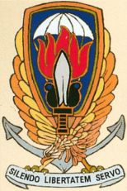
Gladio
12 December — Four bombs explode. One planted in the Banca Nazionale dell’Agricoltura in the Piazza Fontana in Milan claims 16 lives and wounds a further hundred people. In Rome a bomb explodes in the Banca Nazionale del Lavoro, wounding 14, and two devices go off at the cenotaph in the Piazza Venezia, wounding 4. Another bomb — unexploded — is discovered at the Banca Commerciale in the Piazza della Scala in Milan. Four hours later, ordinance officers blow it up. Numerous arrests are made, chiefly of anarchists. Among those arrested is the anarchist Giuseppe Pinelli.
15 December — Anarchist Pietro Valpreda is arrested at the Milan courthouse and taken to Rome that evening. Around midnight, Pinelli ‘falls’ from the fourth floor at police headquarters in Milan.
In Vittorio Veneto, Guido Lorenzon visits lawyer Alberto Steccanella to report that a friend, Giovanni Ventura, may have been implicated in the 12 December bomb outrages.
16 December — Taxi-driver Cornelio Rolandi identifies Valpreda as the passenger he ferried close to the Banca Nazionale dell’Agricolturain the Piazza Fontana on the afternoon of 12 December.
17 December — Press conference by Milan anarchists at the Circolo Ponte della Ghisolfa. The Piazza Fontana massacre is described as a “State massacre”.
20 December —Nearly 3,000 people attend Pinelli’s funeral.
26 December — Steccanella takes an affidavit written by Lorenzon to the prosecutor in Treviso.
31 December — Treviso prosecutor Pietro Calogero questionsLorenzon.
1970
27 March — Rumor forms a four party government (DC, PSI, PSDI and PRI).
15 April — Inspector Luigi Calabresi begins proceedings against Pio Baldelli, the director of the weekly Lotta Continua who had accused him of responsibility for Pinelli’s death.
21 May — Milan examining magistrate Giovanni Caizzi asks that the file on Pinelli’s death be closed and that it be recorded as an accidental death.
3 July — Antonio Amati, head of Milan CID, agrees to Caizzi’s request to close the file on Pinelli’s death.
22 July — Bomb on ‘Southern Arrow’ train kills 6 and injures 139.
6 August — Emilio Colombo takes the helm of a four party coalition government (DC, PSI, PSDI and PRI).
9 October — Calabresi-Lotta Continua case opens. Aldo Biotti, withMichele Lener representing Calabresi, chairs the court. Baldelli’s lawyers are Marcello Gentili and Bianca Guidetti Serra. The prosecution counsel is Emilio Guicciardi.
7 December — Prince Junio Valerio, leader of the Fronte Nazionale, leads an attempted coup d’état. Licio Gelli, head of the P2 masonic lodge, is in charge of kidnapping the president of the republic,Giuseppe Saragat.
12 December — Demonstrations in Milan on the first anniversary of the Piazza Fontana massacre. Fierce clashes between police and demonstrators. Student Enzo Santarelli dies when struck in the chest by a tear-gas canister fired by the police.
1971
13 April — Treviso examining magistrate Giancarlo Stiz issues warrants for the arrest of three Venetian Nazi-fascists: Giovanni Ventura, Franco Freda and Aldo Trinco. The offences alleged against them are: conspiracy to subvert, procurement of weapons of war and attacks in Turin in April 1969 and on trains that August.
28 May — The anarchists tried in connection with the bombs in Milan on25 April 1969 are acquitted. However, some are convicted of minor offences: Della Savia is sentenced to eight years, Braschi to six years and ten months, Faccioli to three years and six months. Tito Pulsinelliis cleared on all counts. All are freed from jail.
7 June — The Appeal Court in Milan accedes to a request by the lawyerLener that Judge Biotti be discharged from the Piazza Fontana investigation.
16 July — Death of taxi-driver Rolandi, the sole witness againstValpreda.
4 October — A fresh inquest into Pinelli’s death is held as a result of a complaint brought by his widow Licia Rognini. Milan-based examining magistrate Gerardo D’Ambrosio brings voluntary homicide chargers against Inspector Calabresi, police officers Vito Panessa, Giuseppe Caracuta, Carlo Mainardi, Piero Mucilli, and carabinieri LieutenantSavino Lograno.
21 October — Judge D’Ambrosio orders Pinelli’s corpse to be exhumed.
24 December — Giovanni Leone is elected president of Italy.
1972
17 February — Giulio Andreotti forms his first government: it is made up exclusively of Christian Democrats.
23 February — Piazza Fontana massacre trial opens in the Court of Assizes in Rome. Judge Orlando Falco presides. The prosecution counsel is Vittorio Occorsio. The accused are Pietro Valpreda, Emilio Bagnoli, Roberto Gargamelli, Enrico Di Cola, Ivo Della Savia, Mario Merlino, Ele Lovati Valpreda, Maddalena Valpreda, Rachele Torri, Olimpia Torri Lovati and Stefano Delle Chiaie. After a few hearings the court declares that it is not competent to hear to hear the case.
4 March — Treviso magistrates Stiz and Calogero have Pino Rauti, the founder of Ordine Nuovo and journalist with the Rome daily Il Tempo, arrested on charges of involvement in the subversive activities of Freda and Ventura.
6 March — Piazza Fontana trial is relocated to Milan.
15 March — Death of publisher Giangiacomo Feltrinelli. His bomb-mangled body is discovered at the foot of an electricity pylon in Segrate, Milan.
22 March — Venetian magistrates Stiz and Calogero indict Freda andVentura for the Piazza Fontana massacre in Milan.
26 March — The investigation by Stiz and Calogero is passed to the Milan district authorities. It is handled by examining magistrateD’Ambrosio to whom public prosecutor Emilio Alessandrini is seconded.
24 April — Judge D’Ambrosio frees Pino Rauti for lack of evidence.
7 May — Early elections. Rauti is returned as deputy on the MSI ticket. Il Manifesto puts up Valpreda as a candidate but he is not elected.
17 May — Inspector Calabresi is shot dead in Milan.
31 May — A bomb concealed in a car goes off in Peteano (Gradisca d’Isonzo) three carabinieri are killed and one wounded.
26 June — Andreotti remains PM by forming a government with the DC, PSDI and PLI.
13 October — The Court of Cassation transfers the Piazza Fontana case to the Catanzaro jurisdiction.
10 November — A weapons arsenal is discovered in an isolated house near Camerino.
15 December — Parliament passes Law No 733, known also as the “Valpreda Law”.
30 December — Valpreda and the other anarchists from Rome’sCircolo 22 Marzo still in custody (including Gargamelli) are released.Merlino is also freed.
1973
15 January — Freda loyalist Marco Pozzan is smuggled out of the country by the SID.
9 April — Guido Giannettini, Agent Zeta, is smuggled out of the country by the SID.
17 May — Gianfranco Bertoli throws a bomb at Milan police headquarters: 4 people lose their lives and nearly 40 are injured.
7 July — Rumor returns to the government, supported by the DC, PSI, PSDI and PRI.
28 September — Enrico Berlinguer, head of the Italian Communist Party, publishes his first article in the communist weekly Rinascitabroaching the “historic compromise”.
1974
14 March — Rumor forms his fifth government with DC, PSI and PSDI support.
28 May — a bomb explodes in Brescia’s Piazza della Loggia during a demonstration organised by the United Antifascist Committee and the trade unions: 8 people are killed and almost 100 injured.
30 May — Federico Umberto D’Amato is replaced as head of theBureau of Confidential Affairs at the Interior Ministry.
20 June — Giulio Andreotti, Minister of Defence, reveals in an interview with Il Mondo that Giannettini is a SID agent, while Corriere della Sera reporter Giorgio Zicari is an informant.
4 August — A bomb explodes on board the Italicus train on the Rome-Munich line as it passes through the San Benedetto Val di Sambro (Bologna) tunnel, killing 12 people and wounding 48.
8 August — Giannettini surrenders himself to the Italian Embassy in Buenos Aires.
22 November — Aldo Moro forms a DC-PRI coalition government.
1975
27 January — Piazza Fontana case opens before the Court of Assizes in Catanzaro. The accused are: Franco Freda, Giovanni Ventura, Marco Pozzan, Antonio Massari, Angelo Ventura, Luigi Ventura, Franco Comacchio, Giancarlo Marchesin, Ida Zanon, Ruggero Pan, Claudio Orsi, Claudio Mutti, Pietro Loredan, Gianadelio Maletti, Antonio Labruna, Guido Giannettini, Gaetano Tanzilli, Stefano Serpieri, Stefano Delle Chiaie, Udo Lemke, Pietro Valpreda, Mario Merlino, Emilio Bagnoli, Roberto Gargamelli, Ivo Della Savia, Enrico Di Cola, Maddalena Valpreda, Ele Lovati Valpreda, Rachele Torriand Olimpia Torri Lovati.
1 March — Bertoli is sentenced to life imprisonment for the 17 March 1973 bomb attack outside police headquarters in Milan. This sentence is upheld on appeal on 9 March 1976.
27 October — Milan magistrate D’Ambrosio closes the file on the Pinelli death. According to the finding, the anarchist died as the result of “active misfortune”. The ‘misfortune’ resulted in his having fallen out of the window. All those indicted for his death are absolved.
1977
1 October — Freda flees to Costa Rica. He will be arrested and extradited in August 1980.
23 November — General Saverio Malizia, legal adviser to Defence Minister Mario Tanassi is convicted by the Court of Assizes in Catanzaro of perjury and is freed shortly afterwards.
1979
16 January — Ventura flees to Argentina.
23 February — The Catanzaro Court of Assizes returns its first verdict.Freda, Ventura and Giannettini are sentenced to life imprisonment for mass murder, outrages and justifying crime. Valpreda, cleared on the basis of insufficient evidence, is sentenced to four years and six months for criminal conspiracy. Merlino receives the same sentence.Gargamelli is sentenced to 18 months for criminal conspiracy. Bagnoligets a two year suspended sentence. The perjury charges againstValpreda’s relations and Stefano Delle Chiaie are thrown out; Malettiis sentenced to four years for aiding and abetting and perjury; Labrunagets two years and Tanzilli gets one year for perjury.
1980
4 April — Francesco Cossiga forms a DC-PSI-PRI government.
30 July — The Potenza Court of Assizes acquits General Malizia after the Court of Cassation’s repeal of the 23 November 1977 verdict of the Catanzaro Court.
2 August — Bomb explodes in Bologna railway station killing 85 people and injuring dozens more.
18 October — Arnaldo Forlani forms a four-party (DC-PSI-PSDI-PRI) coalition government.
1981
20 March — The Catanzaro Court of Appeal acquits Freda, Ventura,Giannettini, Valpreda and Merlino on grounds of insufficient evidence.Freda and Ventura are sentenced to 15 years each for conspiracy to subvert the course of justice, for the bombings of 25 April 1969 in Milan and for the train bombs of 9 August 1969. Charges against Maletti andLabruna are dismissed.
28 June — Five-party coalition government (DC-PSI-PSDI-PRI-PLI) forms under Giovanni Spadolini.
24 August — A commission of inquiry drops the charges against Giulio Andreotti, Mariano Rumor, Mario Tanassi and Mario Zagari accused of laying false trails by the SID.
1982
10 June — The Court of Cassation assigns a second appeal case to a court in Bari, leaving Giannettini out of the reckoning.
1985
1 August — The Appeal Court in Bari clears Freda, Ventura, Valpredaand Merlino of the charge of massacre on the grounds of insufficient evidence, but upholds the 15-year sentences on Freda and Ventura, and further reduces the sentences on Maletti (one year) and Labruna(ten months).
1986
1 August — Craxi re-elected as premier of a five-party government.
1987
27 January — The first section of the Court of Cassation, with Corrado Carnevale presiding, rejects all appeals and upholds the verdict passed by the court in Bari on 1 August 1985. Freda, Ventura, Valpreda andMerlino are at last left out of the judicial reckoning.
1988
13 April — Ciriaco De Mita heads a five-party (DC-PSI-PRI-PSDI-PLI) government.
2 July — Leonardo Marino, formerly with Lotta Continua, surrenders to the carabinieri in La Spezia. After 24 days he confesses his guilt to the carabinieri in Milan, naming himself as the getaway driver in the murder of Inspector Calabresi. He also accuses Ovidio Bompressi (another ex-member of Lotta Continua) as the actual killer, and at Adriano Sofri and Giorgio Pietrostefani, the two leaders of that extra-parliamentary organisation, as having ordered the killing.
1989
January — Examining magistrate Guido Salvini launches a new investigation into rightwing subversion and the Piazza Fontana massacre.
20 February — The Catanzaro Court of Assizes clears Delle Chiaie andMassimiliano Fachini of charges in connection with the Piazza Fontana massacre.
1991
12 April — Seventh Andreotti government, a four-party coalition (DC-PSI-PSDI-PLI).
5 July — The Catanzaro Appeal Court upholds the verdict clearingDelle Chiaie and Fachini of involvement in the Piazza Fontana massacre.
1994
11 May — Silvio Berlusconi forms a centre-right government including the FI, AN, LN and CCD. For the first time in post-war Italy the AN orAlianza Nazionale (formerly the MSI) is in government.
1995
13 March — Judge Salvini orders proceedings to be instituted againstNico Azzi, Giancarlo Rognoni, Mauro Marzorati, Francesco De Min, Pietro Battiston, Paolo Signorelli, Sergio Calore, Martino Siciliano, Giambattista Cannata, Cristiano De Eccher, Mario Ricci, Massimiliano Fachini, Guido Giannettini, Stefano Delle Chiaie, Gianadelio Maletti, Sandro Romagnoli, Giancarlo D’Ovidio, Guelfo Osmani, Michele Santoro, Licio Gelli, Roberto Palotto, Angelo Izzo, Carlo Digilio, Franco Donati, Cinzia De Lorenzo and Ettore Malcangifor involvement in Piazza Fontana massacre.
April — Following the order for proceedings tabled by Judge Salvini,Grazia Pradella and Massimo Meroni are appointed prosecution counsel. D’Ambrosio is to supervise them.
1996
17 May — Romano Prodi forms a centre-left government including the PDS, PPI, RI, and UD, the Greens and supported from without by the RDS. For the first time in post-war Italy (since the governments in the immediate post-war years) the Democratic Left Party [PDS], formerly the PCI, is in government.
1 August — Death of Federico Umberto D’Amato, former chief of theBureau of Confidential Affairs at the Interior Ministry.
4 October — Acting on behalf of Judge Salvini, the expert Aldo Giannuli finds 150,000 uncatalogued Interior Ministry files in a cache on the Via Appia on the outskirts of Rome.
1997
22 January — Sofri, Pietrostefani and Bompressi are finally convicted of killing Calabresi (this is their sixth trial) by the Court of Cassation and sentenced to 22 years in prison. Charges against Marino are thrown out.
2000
5 October — The Court of Cassation throws out the application for a review of the trial that led to Sofri, Pietrostefani and Bompressi being sentenced to 22 years in prison. It closes the ‘Sofri Case’ and marks the launch of a campaign for clemency.
11 March — Milan’s fifth court of assizes sentences Carlo Maria Maggi,Francesco Neami, Giorgio Boffelli and Amos Spiazzi to life imprisonment for their part in the bomb attack at Police HQ in Milan on17 May 1973. Gianadelio Maletti is sentenced to 15 years for destroying and concealing evidence.
28 November — death of Gianfranco Bertoli.
2002
30 June — Milan’s second court of assizes sentences Delfo Zorzi,Carlo Maria Maggi and Giancarlo Rognoni to life imprisonment for thePiazza Fontana massacre of 12 December 1969. Stefano Tringali is sentenced to three years for aiding and abetting. Pentito Carlo Digilioreceives a mandatory sentence.
7 July — death of Pietro Valpreda.
27 September — Appeal court Carlo Maria Maggi, Francesco Neami,Giorgio Boffelli and Amos Spiazzi of the 17 May 1973 bomb attackon Milan police HQ. Gianadelio Maletti’s conviction is overturned.
2003
11 July — The Court of Cassation reverses the acquittals of Carlo Maria Maggi, Francesco Neami and Giorgio Boffelli, and orders a fresh appeal hearing in relation to the attack on Milan police headquarters on 17 May 1973. Amos Spiazzi and Gianadelio Malettiare finally absolved and acquitted.
2004
12 March — Milan court of appeal overturns the verdicts of 30 June 2001 which sentenced Delfo Zorzi, Carlo Maria Maggi and Giancarlo Rognoni to life imprisonment for the Piazza Fontana massacre. Now nobody is to blame for that massacre. Not even these three neo-nazi relics. Nobody planted the bomb in the Banca Nazionale dell’Agricoltura. We need scarcely be surprised. The first verdict, back in 2001, came as a surprise, as did the first verdict in Catanzaro. The verdict of 23 February 1979 that — for that first crime — passed life sentences on Franco Freda, Giovanni Ventura and Guido Giannettini. Those two verdicts were, in fact, an anomaly. If, as I believe I have shown, Piazza Fontana was a state massacre, why on earth would the state want to sit in judgment on itself? Let alone the actual perpetrators? The Ordine Nuovo and Avanguardia Nazionalemilitants were the witting-unwitting pawns in a game bigger the one that they were playing. The neo-Nazis wanted to change the social and political order in order to introduce an authoritarian, hierarchical regime that would make a clean sweep of “bourgeois democracy”, whereas those in power wanted to cling to that power, not hand it over to the Left. It will be a topic of conversation again in a few years, once nearly forty years have gone by since the massacre. By then it will be nothing but history. Revised and amended, in accordance with the dictates of the revisionism that now rules the roost. However, the verdict from the Milan appeal court contains some spectacular contradictions. First, there is the crude contradiction. At the first trial, Stefano Tringali was sentenced to three years for aiding and abetting; now his sentence has been reduced to one year. How can he still be guilty of aiding and abetting when the main accused have been acquitted? What aiding and abetting could he possibly have done if no crime was committed?
A mystery, one of the many mysteries created by the Italian judiciary. In essence, Milan’s magistrates have declared that the pentito Carlo Digilio is an unreliable witness because he has repeatedly contradicted himself and made mistakes. True he has made some — after suffering a stroke that has left him somewhat impaired — whereas the other pentito, Martino Siciliano, is to be heeded, even though he has supplied “hearsay” evidence which cannot be used for the purposes of trial. A pity no notice was taken of the fact that the magistrate who laid the groundwork for this trial, Guido Salvini, did not draw the line at the evidence laid by the pentiti but looked for — and found — specific confirmation of what Digilio and Siciliano had been saying. It wasn’t enough that Zorzi (initially defended by Gaetano Pecorella, chairman of the Chamber of Deputies’ Justice Commission, a man who also defended Silvio Berlusconi), had repeatedly threatened and pliedSiciliano with bundles of cash to retract. Siciliano was, in fact, a “wavering” pentito, but in the end, in the courtroom, he confirmed each of the charges. That was not enough. The acquittal of the trio underlines the old formula of insufficient evidence — which formally no longer obtains. The Milan judges then tacked on this real “gem” in explaining the reasoning behind their acquittal verdict. Retracing the sequence of the 1969 outrages, they concede that Giovanni Ventura and Franco Freda may well have been behind the Piazza Fontana bombing and not just the bomb attacks of 25 April in Milan and the train bombings on 9 August, for which they had already been sentenced to 15 years. The last laugh came in Milan. The two culprits identified by the Treviso investigating magistrate – Giancarlo Stiz (See Chapter 15 – On the Trail of the Fascists) could be the real culprits even though there is insufficient proof of their connections with the Ordine Nuovo group in Venezia-Mestre and Milan. However, there is this small detail: Freda andVentura were finally acquitted on 1 August 1985 and thus could not be charged with that offence.
Then (years ago) the upper echelons of the Italian state — the Christian Democrats and Social Democrats, who for years have effectively been working in cahoots with the Italian and American secret services (using rightwing extremists as their cohorts) in order to preserve the status quo in Italy, even at the price of bombs and outrages — were dropped from the case. Pietro Valpreda died on 7 July 2002. So many other protagonists are now dead too, and many of their confederates have also left the stage. Developments in the case have been followed vaguely by leading newspapers, and it was only the acquittal verdict that was given any real prominence. No one is to be guilty of the “mother of all outrages”. That is how “reason of state” wants it to be. Luckily, there are some who refuse to play ball. Every 12 December many thousands of 15-18 year old students demonstrate in so many squares around Italy and in Milan, and the Milan procession ends in the Piazza Fontana. That outrage remains an indictment of the criminality of the powers that be. What may be covered up in the courtrooms is “fact” for many. Very many — that has to count for something.
VIDEO LINKS:
LA STORIA SIAMO NOI
1: Piazza Fontana
2: La Pista Anarchica
3: Ordine Nuovo
4: Servizio Secreto
5: The Trial
6: Report on Terrorism
7: The Strategy of Tension
8: Nucleo di Difesa di stato
9: The role of the United States
10: The Borghese Coup
11: The Death of Pinelli
12: The Death of Calabresi
13: Calabresi’s crimes
14: Calabresi – First Victim
15: Gladio
THE BLACK ORCHESTRA (1-9)
L’Orchestre Noir 1
L’Orchestre Noir 2-9
L’Orchestre Noir 3-9
L’Orchestre Noir 4-9
L’Orchestre Noir 5-9
L’Orchestre Noir 6-9
L’Orchestre Noir 7-9
L’Orchestre Noir 8-9
L’Orchestre Noir 9-9
GLADIO
Episode 1: The Ring Masters 1992
Episode 2: The Puppeteers 1992
Episode 3: Foot Soldiers 1992
DIARIO DI UN CRONISTA — TERRORISMO NERO
Diario di un cronista – Terrorismo nero – parte 1
Diario di un cronista – Terrorismo nero – parte 2
Diario di un cronista Terrorismo nero parte 3
PIAZZA FONTANA: Una strage lunga quarant’anni.
Parla Roberto Gargamelli 1/2.
Parla Francesco Piccioni. 2/2
Piazza Fontana – Strategia della tensione (magistrato Pietro Calogero sulla strage di Piazza Fontana 12 dicembre 1969)
ANNI SPIETATI
Anni spietati – Milano – prima parte (69)
Anni spietati – Milano – seconda parte (72)
Anni spietati – Milano – terza parte (75)
Tags25 April 1969, active misfortune, Adriano Sofri, Agent Zeta, Alberto Steccanella, Aldo Biotti, Aldo Giannuli, Aldo Moro, Alianza Nazionale, Amos Spiazzi, Angelo Izzo,Angelo Piero Della Savia, Angelo Ventura, Antonio Amati, Antonio Labruna, Antonio Massari, Banca Commerciale, Banca Nazionale del Lavoro, Banca Nazionale dell’Agricoltura, Bianca Guidetti Serra, Bureau of Confidential Affairs, Carlo Digilio,Carlo Mainardi, Carlo Maria Maggi, Cinzia De Lorenzo, Circolo 22 Marzo, Circolo Ponte della Ghisolfa, Claudio Mutti, Claudio Orsi, Cornelio Rolandi, Corrado Carnevale, Corriere della Sera, Cristiano De Eccher, Ele Lovati Valpreda, Eliane Vincileone, Emilio Alessandrini, Emilio Bagnoli, Emilio Colombo, Emilio Guicciardi,Enrico Berlinguer, Enrico Di Cola, Enzo Santarelli, Ettore Malcangi, Federico Umberto D’Amato, Francesco Cossiga, Francesco De Min, Francesco Neami, Franco Comacchio, Franco Donati, Franco Freda, Fronte Nazionale, Gaetano Tanzilli,General Saverio Malizia, Gerardo D’Ambrosio, Giambattista Cannata, Gianadelio Maletti, Giancarlo D’Ovidio, Giancarlo Marchesin, Giancarlo Rognoni, Giancarlo Stiz,Gianfranco Bertoli, Giangiacomo Feltrinelli, Giorgio Boffelli, Giorgio Pietrostefani,Giorgio Zicari, Giovanni Caizzi, Giovanni Corradini, Giovanni Leone, Giovanni Spadolini, Giovanni Ventura, Giulio Andreotti, Giuseppe Caracuta, Giuseppe Pinelli,Giuseppe Saragat, Grazia Pradella, Guelfo Osmani, Guido Giannettini, Guido Lorenzon, Guido Salvini, historic compromise, Ida Zanon, Il Manifesto, Il Mondo, Il Tempo, Inspector Luigi Calabresi, Italian Communist Party, Italicus train bombing, Ivo Della Savia, Judge Biotti, Judge Orlando Falco, Licia Rognini, Licio Gelli, Lotta Continua, Luigi Ventura, Maddalena Valpreda, Marcello Gentili, Marco Pozzan,Mariano Rumor, Mario Merlino, Mario Ricci, Mario Tanassi, Mario Zagari, Martino Siciliano, Massimiliano Fachini, Massimo Meroni, Mauro Marzorati, Michele Lener,Michele Santoro, Nico Azzi, Olimpia Torri Lovati, Ordine Nuovo, Ovidio Bompressi,P2 masonic lodge, Paolo Braschi, Paolo Faccioli, Paolo Signorelli, Piazza della Loggia, Piazza Fontana, Piero Mucilli, Pietro Battiston, Pietro Calogero, Pietro Loredan, Pietro Valpreda, Pino Rauti, Pio Baldelli, Prince Junio Valerio, Rachele Torri, Rinascita, Roberto Gargamelli, Roberto Palotto, Ruggero Pan, Sandro Romagnoli, Savino Lograno, Sergio Calore, SID, Silvio Berlusconi, Southern Arrow bombing, state massacre, Stefano delle Chiaie, Stefano Serpieri, Stefano Tringali,Tito Pulsinelli, Udo Lemke, Unified Socialist Party (PSU), United Antifascist Committee, Valpreda law
CategoriesGladio, Italy, Piazza Fontana, State Massacre, Strategy of Tension

Secrets and Bombs 20 : YEAR ZERO
January 29, 2012 //
1

Rate This

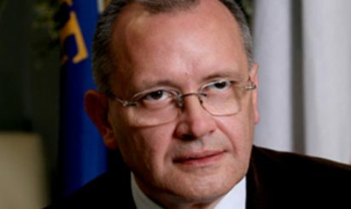
Judge Francesco Morelli
Rome, 3 May 2005. In a monotonous drone, in the courthouse in the Piazzale Clodio, the chairman of the second criminal section of theCourt of Cassation (Supreme Court), Francesco Morelli, reads out a historic verdict: and turns down the appeals against the verdicts brought in by the Appeal Court in relation to the Piazza Fontana massacre.Acquittals all round, the TV and newspaper headlines read. In fact, the Court of Cassation endorsed the verdicts acquitting Carlo Maria Maggi,Giancarlo Rognoni and Delfo Zorzi, all three of them characters (and, at the time, members of the neo-Nazi Ordine Nuovo organisation) in the never-ending story that began on the afternoon of 12 December 1969. A historic verdict in two senses: because that massacre was carried out thirty six years earlier and because it rings down the curtain on an affair that has (by altering it) written Italy’s history in the blood of its sixteen dead (to which number must be added one more who passed away years later as a result of injuries received) and the almost one hundred injured (the eighty-six officially recorded, plus another ten or so who opted to leave the Banca Nazionale dell’Agricoltura and seek treatment elsewhere).
The “State massacre” has reached the end of the line. From now on no magistrate is going to dare delve any further into that undergrowth. Back in 1989, Milan’s investigating magistrate Guido Salvini took us to task for lifting the lid off that “state mystery”. That year he inherited a very superficial investigation into rightwing subversion from within (eversione). He probed. Questioned. Listened. Ordered inspections of the records of the police, study centres and state administrations. Singling out individuals who up until that point had never been mentioned in investigations into the 12 December 1969 outrage. An unprecedented and yet at the same time tired old vista took shape.
A gang from the Venezia-Mestre Ordine Nuovo, headed by Zorzi, and with Carlo Digilio serving serving as its “quartermaster” (under the supervision of Maggi), can be linked to the activities of another, Padua-based neo-Nazi group, the gang of Franco Freda and Giovanni Ventura. A body blow! Yes, because Freda and Ventura were acquitted back in 1985 and again in 1987 of all charges relating to the Piazza Fontana but given fifteen year terms for two attacks (on 25 April in Milan and the train bombings of 9 August) that amounted to “dummy runs” for the 12 December bombing.
Acquitted in those two verdicts, Freda and Ventura, together with SIDinformant Guido Giannettini, were nevertheless sentenced on 23 February 19790 by the Court of Assizes in Catanzaro to life imprisonment for the Piazza Fontana outrage. A body blow, then. Pigeons coming home to roost. Investigations by a Treviso magistrate,Giancarlo Stiz, had, way back in the early 70s, identified those truly responsible for the massacre. Making nonsense of the charges framed by two Rome magistrates – Vittorio Occorsio and Ernesto Cudillo – who were “resolutely convinced” that the outrage had been carried out by Pietro Valpreda, an anarchist, and a dancer to boot. The perfect culprit.
At which point, on foot of the Salvini inquiry, they had merely to proceed to trial and, the trail of evidence gathered from confessions obtained could not have helped but lead to conviction of the neo-Nazis and the placing of a legal seal in the halls of justice upon what many people – so very many people – already knew.
In fact, on 30 June 2001, the Milan Court of Assizes, chaired by Luigi Martino, passed life sentences on Maggi, Rognoni and Zorzi, plus a three year term for Stefano Tringali for aiding and abetting Zorzi.
But there is a but. The judges of lower court convicted them in spite of prosecuting attorneys Grazia Pradella and Massimo Meroni. Put simply, the pair of them were ill-prepared for trials of such intricacy: nothing more was to e heard from them and they returned to the limbo from which they had been sourced. It looks as it Pradella and Meroni were chosen in order to hobble the Salvini investigation. In which they were successful.
On 12 March 2004 the Milan Court of Appeal in fact acquitted Maggi, Rognoni and Zorzi. With this curious footnote: it slashed Tringali’s sentence from three years to one year, he having been found guilty of aiding and abetting Zorzi. A detail that only some “hair-splitting” jurist could explain, logic dictating that where there was no offence committed there could not have been any aiding and abetting.
In essence, the judges in Milan held that the pentito Carlo Digilio(whose role as pentito earned him immunity from prosecution for his activities as quartermaster to the Venezia-Meste Ordine Nuovo group) is an unreliable witness in that he repeatedly contradicted himself and made mistakes. True, he made them after having suffered a stroke that left him somewhat impaired (albeit that his medical reports, which were not taken under consideration, insisted that he was fully in control of his mental faculties). The other pentito, Martino Siciliano, on the other hand, is a credible witness but offers “hearsay” evidence unusable in a trial context. It was not enough that Zorzi (a very wealthy clothing industrialist-turned-Japanese citizen whose initial defence counsel wasGaetano Pecorella, a deputy for Forza Italia and subsequently for the PDL, a man who was also defence counsel to Silvio Berlusconi), had repeatedly threatened Siciliano and offered him loads of money to get him to retract. And, to be sure, Siciliano has been a “wobbly” pentito but, in he end, inside the courtroom, he has stood by all of his accusations. Not enough. The acquittal of the trio hammered home the old formula about insufficiency of the evidence, a formula that has now been formally done away with.
The Milan judges then tossed in a real “gem” by way of a grounding for their acquittal decision. Reconstructing the sequence of attacks in 1969, they acknowledged that Giovanni Ventura and Franco Freda were responsible for the Piazza Fontana and not just for the bombings in Milan on 25 April and the 9 August 1969 train bombings: “The acquittal of Freda and Ventura is a mistake, the result of a state of familiarity with the facts superseded by the matters adduced in this trial.”
In short, the ultimate hoax was mounted in Milan. The two culprits singled out by Stiz (see Chapter XVI: On the Trail of the Fascists) are supposedly the people responsible for the massacre, but, as to their relations with the Ordine Nuovo members from Venezia-Mestre and Milan, there is insufficient proof. Also closing off any involvement byStefano Delle Chiaie, the then leader of Avanguardia Nazionale in Rome, which is to say, of the group that provided the logistical back-up (and not just logistical back-up) for the bombings on 12 December 1969, of the Cenotaph (four dead) and the Banca Nazionale el Lavoro in the Via Veneto (fourteen dead). After years as a fugitive from justice, Delle Chiaie returned to Italy and was finally acquitted in 1991.
Then again (many a long year ago) the upper reaches of the Italian state … those Christian Democrats and Social Democrats who effectively acted in cahoots with the Italian and US secret services (and with rightwing extremist henchmen) .., in order to uphold the status quo in Italy, bombs and massacres or no bombs and massacres, have finally been cleared.
What both the right and (albeit for different reasons) the left want is for us all to forget or to be left bewildered. Through a strategy mounted on the basis of reports from the Massacres Commission released towards the end of 2000. First came the report from the DS (Democratic Left)parliamentary group. A reading (or re-reading) of the years of the bombings, outrages and coup attempts. The DS has come up with what seems at first glance to be a reconstruction sufficiently under-pinned by facts and verdicts and scrutiny. The upshot is that the spotlight focuses on the role of neo-Nazi and neo-fascist organisations, on the protection they enjoyed from the machinery of state, the courts, the secret services and on the prominent role played by the CIA and NATO secret services. The novelty in all this was the spotless image that the Italian Communist Party (PCI) donned in the 60s and 70s: the party of Luigi Longo andEnrico Berlinguer is depicted as the great stalwart, standing by democracy in Italy. In short, the highest self-praise.
Then came the retort from the parliamentarians Alfredo Mantica andVincenzo Fragalà back in the days of Alleanza Nazionale. In two brief but fantastic reports they turned the spotlight back on to the anarchists. “In the investigation into the Piazza Fontana there was more and worse to come: any clue that might have pointed to the anarchist line of inquiry was simply ignored.” According to Mantica and Fragalà, in fact, the real culprit behind the 12 December 1969 massacre in Milan was Pietro Valpreda. And Giuseppe Pinelli, entangled in the matter (and maybe even a police informer) supposedly took his own life after the screws were put on him. Furthermore, in relation to bombs, the Milan anarchists allegedly had a history which, they argue, reaches right back into the early 1960s. It is therefore only reasonable that those responsible for the strategy of tension should be sought in those quarters. All under the aegis of the Soviet secret service: the KGB.
A cack-handed gambit, not even seriously documented and replete with contradictory inferences, but which has a specific political purpose: to show that the history of those years is open to diametrically opposite interpretations. And if none of them is wrong, then none of them is right. Better therefore to let it go and resort to the all too Italian practice of starting with a clean slate.
The aim was clear: to wind up the Massacres Commission following the 2001 elections (in which the centre-right were the victors). Thereby conceding that the 1960s and 1970s had been dire. But now we need to leave them behind and send everybody home again, all blameless.
That past is a hot potato for both political camps. The right is involved in it up to its neck, so much so that it wiped its hands of an electoral pact with Pino Rauti and his MSI-Fiamma tricolore. He would have proved an unduly uneasy ally on account of his having been heavily involved in the era of outrages: Ordine Nuovo, of which Rauti was the leader back then, was in many instances the sword arm of that strategy. To say nothing of Giorgio Almirante’s Movimento Sociale and their dalliances with black terrorism. And the Gianfranco Fini who was Almirante’s ultra-loyal young admirer back then, would have us forget his past. In 2005, in fact, the Alleanza Nazionale rebranded itself as the “democratic right”. So extremist posturing has to be left behind. Hence the centre right’s need to lay to rest an uncomfortable and decidedly unpalatable past.
In a way it is a similar story with the centre-left, especially its main component part, the DS (Democratic Left, these days known as the PD, Democratic Party). Its fore-runner, the PCI, used (to adopt a more schematic viewpoint) the facts about the state massacre (which it knew) to boost its own own access to power. In practice, it put a price on its silence. How? By putting the squeeze on the Christian Democrats, a huge political melting-pot wherein pro-coup elements lived cheek by jowl with “democratically more presentable” personnel. The famous tactic of “I am in the know but I’ll say nothing if we can come to some arrangement”. A tactic that also prospered in part because – in the PSDI {Italian Social Democratic Party) – the Christian Democrats had an ally committed to drawing a veil over the role of the US secret services. The “American party” operating in the Italy of the 1960s and 1970s (it being no accident that it came into being in 1947 with substantial funding from the CIA via the AFL-CIO union conduit).
Again in 2000, there were other magistrates on the same wave-length.Libero Mancuso, a public prosecutor in Bologna, was something of a prophet: in fact he argued that dwelling on the Piazza Fontana amounted to indulgence in “judicial archaeology” in that nothing would ever come of it.
It was no coincidence that Judge Salvini was forced to defend himself against charges levelled by fellow magistrates, especially by his Venetian colleague Felice Casson, with help from the reporter Giorgio Cecchetti from La Nuova Venezia and La Repubblica, the source of a number of scoops relating to news that was still top secret. In the end, Salvini was cleared both by the Higher Bench Council and by the Court of Cassation. He had been charged with “contextual compatibility” (i.e. the charge was that he ought never to have worked for the court in Milan and with violating the obligations of the bench (having used SISMIagents to unearth information about Martino Siciliano). The entire affair throwing up a far from irrelevant issue: anybody who looks into the Piazza Fontana and raises questions about the “official version” is an irritant.
In 2000, in September to be exact, senator-for-life Paolo Emilio Tavianimade significant statements following those he made in 1997 to the Massacres Commission. In May 1974, he had been Interior minister and it was Taviani, no less, who dismantled Federico Umberto D’Amato’s Confidential Affairs Bureau (Ufficio Affari Riservati). This was a significant move, for D’Amato had been one of the leading elements directing inquiries away from rightwing subversives and the 12 December massacre (not only that, but he was indeed the puppet-master of certain schemes). The senator-for-life told members of the carabinieri ROS that he had learned in 1974 that the bomb planted in Milan had not been meant to claim any lives and that a SID agent, Rome lawyer Mateo Fusco di Ravello, had been on the brink of leaving Fiumicino airport for Milan with the mission of preventing the attacks. He was about to board his plane when he heard that the bomb had already gone off. Fusco’s daughter Anna (Fusco died in 1985) confirms that her father had long been working for the SIFAR and then for the SID and that he had, on several occasions, spoken to his daughter about the abortive attempt to prevent the Piazza Fontana massacre. Which is yet another morsel showing how the most mportant state agencies were au fait with the planning of the attacks and had tried only at the eleventh hour to soften their impact. In that regard Fusco, whose daughter has stated that he was very close to Rauti, was one high level contact between the military and the secret services and Ordine Nuovo. But Taviani did not stop there. He said that among the institutional officials actively shifting the blame towards the left was an officer in Padua,Manlio Del Gaudio. And who might this gentleman be? Why, Lieutenant-Colonel Del Gaudio, the then commander of the Padua carabinieri, allegedly the serviceman to whom the SID’s GeneralGianadelio Maletti entrusted the task in 1975 of “shutting off the Turkish tap”, i.e. source Gianni Casalini, an Ordine Nuovo member and SID informant who intended to “unburden his conscience” and lift the lid on everything he knew about the group’s responsibilities in relation to the train bombings of 8 and 9 August 1969. But the Milian Assize Court refused to listen to Taviani in April 2001 (Taviani then died on 17 June) or Fusco di Ravello. How come? Their evidence had surfaced at a point when the proceedings were close to a conclusion: and anyway, it was not regarded as “absolutely necessary”. Just one of many things that highlight the state provenance of the many outrages that punctuated the 60s and 70s. And many another could be mentioned. All pointing in the same direction.
http://espresso.repubblica.it/multimedia/24226612/1/2
Nowadays the climate is better suited to letting an issue as bothersome as the Piazza Fontana fade into oblivion. Pietro Valpreda died on 7 July 2002. So many of the other protagonists are also dead, just as so many of their confederates have also left the stage. And the verdict handed down by the Court of Cassation has set the seal on a de facto situation: no one is to be held to blame for that slaughter.
So how did this tangled tale, starting with anarchists only to arrive at Nazifascists, Italian and American secret services, and now closed up with “acquittals all round” all begin? Plainly, we need to turn back to that notorious 12 December 1969.
NOTE: List of fascists who travelled to Greece as guests of the Greek Junta’s secret services
TagsAlfredo Mantica, Alleanza Nazionale, Carlo Digilio, Carlo Maria Maggi, Delfo Zorzi,Ernesto Cudillo, Federico Umberto D’Amato, Felice Casson, Forza Italia, Franco Freda, Gaetano Pecorella, Gianadelio Maletti, Giancarlo Rognoni, Giancarlo Stiz,Gianfranco Fini, Gianni Casalini, Giorgio Almirante, Giovanni Ventura, Grazia Pradella, Guido Giannettini, Guido Salvini, Libero Mancuso, Manlio Del Gaudio,Martino Siciliano, Massimo Meroni, Ordine Nuovo, Paolo Emilio Taviani, Piazza Fontana massacre, Pietro Valpreda, SID, SIFAR, SISMI, Stefano Delle Chiaie. Avanguardia Nazionale, Vincenzo Fragalà, Vittorio Occorsio
CategoriesGladio, Italy, Piazza Fontana, State Massacre, Strategy of Tension

Secrets and Bombs 19: State Massacre
January 16, 2012 //
0

Rate This

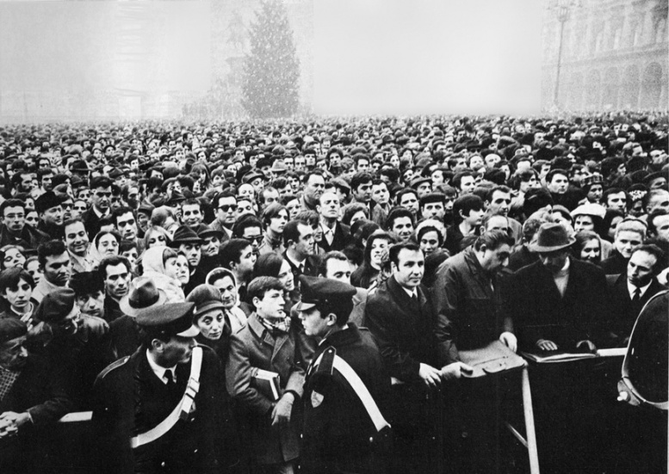
On 5 December 1969 the Piazza del Duomo was packed with left-wingers, rather than the expected fascists
Mariano Rumor wasted no time. The day after the bombings of 12 December 1969, the prime minister called a meeting of the secretaries of the Christian Democrats, the Socialist Party, the Unified Socialist Party (the name used by the social democrats after the socialist split on 2 July 1969) and Republican Party. His aim was to rebuild a four-party coalition cabinet.
It was to take them over three months to come up with a new government line-up. The overall impression was that although the socio-political situation might be dramatic, in the palaces of Rome they were still using the same old alchemy in the allocation of ministerial portfolios likely to assuage the various political camps.
Mauro Ferri and Mario Tanassi, the two leaders of the new social democratic party, were behind a strong government that — riding the wave of emotion triggered by the bombs — sought to impose an authoritarian stamp on the country. They spoke for that “American party” (as it was known) which vehemently opposed Italy’s progressive drift leftwards.
Rumor’s real intention was to establish a centre government ofChristian Democrats and the Unified Socialist Party that would crown, at policy level, the strategy that had led to the Piazza Fontana carnage. But the enormous turnout of trade unionists and left-wingers at the funerals in Milan forced him to think again.
The situation that had developed since 1968 was worrying to broad sections of the middle and entrepreneurial classes. First the student unrest and then the labour unrest had fuelled their paranoia about the “red menace”. The traditional unions had for many months been unsuccessful at keeping their members’ struggles within the parameters of the usual demands. So much so that on 3 July 1969 a general strike called to press for a rent freeze witnessed the FIAT workers in Turin’sMirafiori plant chanting an ironic slogan that had a threatening ring as far as the ruling class was concerned: “What do we want? Everything!”
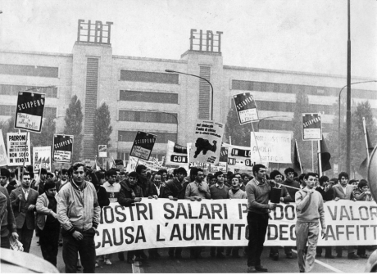
Striking workers at the FIAT Mirafiori plant (1969)
That slogan had immediately taken off. Soon it was being chanted with growing insistence on marches. And in fact 1969 recorded 300,000 hours lost to strikes as compared with the 116,000 average for the 1960s. Labour costs were on the rise, from 15.8 per cent (or 19.8 per cent in industry), increasing the wages component of the gross national product from 56.7 up to 59 per cent. A discernible shift in earnings was under way. A threat to the privileged classes of society and to those who only a few short years before had been the beneficiaries of the “economic miracle”.
A seemingly pre-revolutionary situation existed in the country. Even though the revolution for which most students and a segment of the workers yearned for was not merely a distant prospect, but a practical impossibility, but what did that matter? Many honestly believed it was just around the corner, and many more were afraid that that was the case.
Even though the advocates of the radical transformation of society were a tiny minority compared with the total population, the nation’s political axis was shifting to the left. Although harshly criticised by the extremist fringe, the Communist Party was preparing to expand into new areas. Caught on the hop by the student demonstrations at the start of 1968, the Communist Party leaders from the Via Botteghe Oscure quickly deployed to make up the lost ground, especially in the field of institutional politics — parliament. So much so that on 28 April 1969 the debate began on disarming the Italian police in an attempt to turn them into British “bobbies”. It only took the bombs in Milan on 25 April to consign that scheme to utopia.
The strategy of tension was under way. This phase involved a revamping and synthesis of what had already been devised in theory and put into practice since the mid-1960s by leaders of the far-right and important elements in the armed forces. Italian Nazis and fascists were eager to eradicate the “communist contagion” and in this they were aided, abetted, monitored and, ultimately, directed by the Italian andAmerican secret services.
The CIA had been operating in Italy since the end of World War Two. In 1947 it had funded — through the AFL-CIO — the breakaway socialist party led by Giuseppe Saragat and helped by anti-Stalinist revolutionaries, the Iniziativa Socialista, led by Mario Zagari. Apart from the ideological motives that drove Saragat and Zagari, the CIA’s dollars successfully undermined the Popular Front and facilitated the victory of the Christian Democrats on 18 April 1948 when they took 48.5 per cent of the votes and won an absolute majority in the Chamber of Deputies.
That victory had almost been written off. On 20 March 1948, George Marshall, the US Secretary of State, had warned Italians that in the event of a communist victory all US aid to Italy would dry up. In 1969 the CIA found its activities facilitated — the Italian president, Saragat, was a man who owed them a favour.
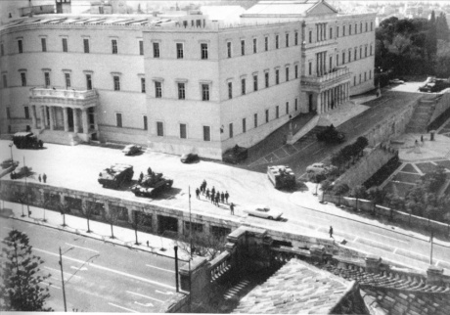
April 21, 1967: The Greek Colonels launch their US-led coup d'état
The CIA had one great foe — communism, just as the KGB used every method available to it to combat the West. But whereas in the Third World the two agencies fought on almost equal terms — with the KGB having the edge — in the west the CIA brooked no interference. So much so that in 1967 it came up with a brilliant resolution to the Greek crisis by installing its own man, George Papadopoulos in power by means of a coup d’état. From this point on the “coup-makers” held the upper hand in the Agency in Europe — and would continue to do so right up until the mid-1970s.
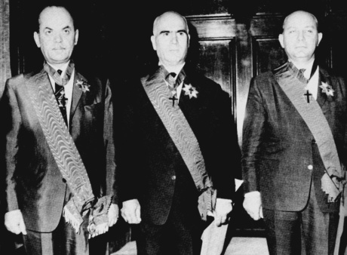
After Greece it was Italy’s turn and within the US-dependent SID the coup-maker faction was in the ascendant. From 1966 — the year he took office — Admiral Eugenio Henke led the SID and D Bureau was headed by Federico Gasca Queirazza, one of those who had been briefed in 1966 by agent Guido Giannettini on what the Venetian NazisFranco Freda, Giovanni Ventura and Delfo Zorzi were planning.
Gasca Queirazza passed this information on to his superior, Henke, who in turn forwarded the information to Interior Minister Franco Restivo. Did Restivo pass on this information to his party colleague and prime minister, Mariano Rumor? No? That takes some swallowing, if only because the repeated unbelievable attacks of amnesia suffered by Rumor during the first trial in Catanzaro provoked such hilarity, in spite of the dramatic setting.
When Vito Miceli took over from Henke in 1970, the coup-maker faction was no longer simply diligently coordinating the attacks mounted by the far-right, it had taken the initiative as a direct organiser and Junio Valerio ’s coup attempt was part and parcel of this new dynamic. Miceli was also to stand trial for this later, but, as ever, nothing came of it.
When they struck on the night of 7 December 1970’s men were not nostalgic old codgers. They had substantial cover and assistance. Miceli briefed Defence Minister Tanassi on what was happening, as did the chief of staff, Enzo Marchesi. In fact, Restivo knew everything even before the plotters held part of his ministry for a few hours. But when questioned in parliament on 18 March 1971, after the news had broken, Restivo denied everything. Naturally.
The history of the coup in Italy remains unfinished business, as is the case of Piazza Fontana. History repeated itself in April 1973 with theRosa dei Venti conspiracy, which involved even greater heavyweights who were much better prepared than Borghese had been — officers such as Colonel Amos Spiazzi (who had been around the block earlier, on 7 December 1970).
The man who oversaw this proliferation of attacks and coup preparations was a leading engineer by the name of Hung Fendwichwhose office was based in Rome’s Via Tiburtina. But it was not located in the sort of secret lair that one might imagine; it was in the offices of theSelenia Company, part of the STET-IRI group, for which he worked.
Fendwich was the typical eminence grise who studied and refined plans, drew up analyses of the socioeconomic and political situation, but left the operational work — the “dirty work” — to men of more modest rank, men such as Captain David Carrett attached to the FTASE base(NATO command in Verona from 1969 to 1974), or his successor (up until 1978), Captain Theodore Richard based in Vicenza.
Sergio Minetto, one of the CIA’s top Italian informants, led these men. Minetto was the man to whom Carlo Digilio, their plant inside theOrdine Nuovo group in Venice, would have been reporting. As an operator it was he who prepared the explosives and trained Delfo Zorziand Giovanni Ventura in the group’s powder magazine — an isolated house in the Paese district near Treviso.
The bomb attacks that erupted in Italy between 1969 and the mid-1970s (although they continued after that date) were regarded as overtures to a coup d’état. Indeed, although the coup never happened, it was always in the air and indeed had a precise function. It sent out a clear and menacing message to the opposition — i.e. the Communist Party.
But it was no coincidence that following the coup in Chile in September 1973 — which brought the number of military regimes around the globe to 47 — PCI secretary Enrico Berlinguer floated the idea (from the columns of the review Rinascita) of an “historic compromise” — i.e. for a government agreement between the Christian Democrats, the Italian Communist Party and the Italian Socialist Party. But it was to take another 23 years before the Democratic Left Party, the PCI’s heir, entered the government as part of a centre-left coalition.
The bombings crystallised the institutional political situation and in response the left presented the prospect of armed struggle. The ongoing outrages and the threat of a coup, among other things, drove many extra-parliamentary militants underground, including people such as the publisher Giangiacomo Feltrinelli.
All this gave rise to a vicious circle, which, to some extent, served as an a posteriori excuse for the theory of “opposing extremisms’. The only hope was to trust whoever was in power at the time — that is, the men who were rubber-stamping and providing the cover for what the Interior Ministry’s Bureau of Confidential Affairs and the SID were doing under instruction from the CIA.
From the ministers came the directives and the secret services carried them out — and added more than a little initiative in the process. It was no coincidence in 1974, when SID officers brought Defence Minister Giulio Andreotti (in the fifth Rumor government) the recordings made by Captain Antonio Labruna with industrialist Remo Orlandini, a man who had been caught up in the coup attempt. Andreotti’s advice was that they “do a bit of pruning”. Translation? Purge the tapes of the most important names, which is to say the names of high-ranking military personnel implicated in the failed coup attempt.
This behaviour was similar to that of his predecessor, Mario Tanassi(defence minister with the fourth Rumor government). In the summer of 1974 Judge Giovanni Tamburino asked the SID for information about the pro-coup activities of General Ugo Ricci whom he considered one of the men behind the Rosa dei Venti. The SID, who knew all about Ricci’s activities, reported that the general was a man of unshakable democratic beliefs. But before forwarding that report the SID chief forwarded the judge’s request to Tanassi who returned it with the annotation: “Always say as little as possible.”
The practice of saying nothing or telling lies continued through the years. On 13 October 1985 the weekly Panorama published extracts from a document by Bettino Craxi, the prime minister, inviting the men of the secret services “to abide by a policy of noncooperation” with the magistrates questioning him.
Craxi never denied the veracity of that report. How could he? But he did bring pressures to bear on the judges to ignore it. So the politicians knew all about the secret service plots — and were often the prime movers behind it. They knew that the fascists were being used to further the strategy of tension and they were either jointly responsible for this or direct promoters of it, like Restivo.
So there was raison d’état behind the 12 December 1969 bombs — a matter of opting for terrorism as a means of holding on to power.
“12 December 1969 signalled a watershed in the history of the republic, in the history of the left, in the history of movements […] because in effect on that date, along with 16 ordinary individuals there perished a significant portion of the first republic — a substantial portion of the machinery of state consciously plumped for illegality. It set itself up as a criminal power while continuing to man essential institutions and was permitted to do so (the ‘State servants’, policemen, judges, secret agents, politicians, secretaries, ministers, pen-pushers and henchmen who cooperated in the implementation of this crime and its cover-up by the laying of false trails, obstruction and ensuring the crime remained unpunished are numbered in the thousands). Since then, Italy has ceased to represent a constitutional democracy in the fullest sense”, wrote the political scientist Marco Revelli in his book Le due destre.
That political analysis is borne out and documented in the investigation carried out by Judge Guido Salvini: ”The protection afforded members of the Venice cell […] was absolutely vital, insofar as the caving-in of even one of the accused would have led the investigators, level after level, right to the highest powers who had made the operation on 12 December feasible, and the repercussions from that might well have proved incompatible with the maintenance of the country’s political status quo.”
Such widespread collusion also raises doubts. How much did the main opposition party — the Italian Communist Party, now the Democratic Left Party — know about the Piazza Fontana massacre? A lot, to be sure. But how much? And to what extent did the fear of bombs and coup d’états taint the PCI’s positions? To what extent was it induced by such fear to propose its historic compromise and then embrace coexistence? The answer to that can be found only in the archives in the Via Botteghe Oscure, which are as impenetrable as the Vatican’s.
But we can offer one answer, an answer which — given the guilt that lies at the highest levels — can only be that the massacre of Piazza Fontana was a State massacre. And the State was, moreover, the mother of all the massacres.
Tags7 December 1970, Admiral Eugenio Henke, AFL-CIO, Bettino Craxi, Bureau of Confidential Affairs, Captain Antonio Labruna, Captain David Carrett, Captain Theodore Richard, Carlo Digilio, Christian Democrats, CIA, Colonel Amos Spiazzi, D Bureau, Delfo Zorzi, Enrico Berlinguer, Enzo Marchesi, Federico Gasca Queirazza,Franco Freda, Franco Restivo, FTASE base, General Ugo Ricci, General Vito Miceli,George Marshall, George Papadopoulos, Giangiacomo Feltrinelli, Giovanni Ventura,Giulio Andreotti, Giuseppe Saragat, Guido Giannettin, Hung Fendwich, Iniziativa Socialista, Italian Communist Party, Judge Giovanni Tamburino, Judge Guido Salvini,Junio Valerio Borghese, KGB, Marco Revelli, Mariano Rumor, Mario Tanassi, Mario Zagari, Mauro Ferri, Mirafiori plant, Piazza Fontana massacre, Remo Orlandini,Rinascita, Rosa dei Venti conspiracy, Selenia Company, Sergio Minetto, SID, STET-IRI group, Strategy of Tension, Unified Socialist Party
CategoriesGladio, Italy, Piazza Fontana, State Massacre, Strategy of Tension

Secrets and Bombs 18: The Carnevale Verdict
January 15, 2012 //
1

Rate This

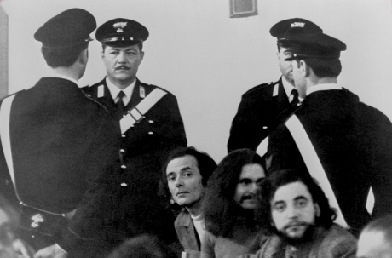
Rome, Feb 1972: Pietro Valpreda, Roberto Gargamelli and Emilio Bagnoli — and nine others (Piazza Fontana trial presided over by judge Orlando Falco)
The proceedings had been under way for only a few days before everything ground to a halt. The scene was the Court of Assizes in Rome and the trial, which opened on 23 February 1972, was that of the anarchists from the Circolo 22 Marzo, of Pietro Valpreda’s relations and, in his absence, the Nazi-fascist Stefano Delle Chiaie for giving perjured evidence on Mario Merlino’s behalf.
But the judges, however, soon realised that the matter was not within their competence. Prompted by some of the anarchists’ defence lawyers — Francesco Piscopo, Giuliano Spazzali, Placido La Torre andRocco Ventre — court president Orlando Falco chose to rid himself of what had become a hot potato of a trial. Even the public prosecutorVittorio Occorsio tried to pin the shortcomings and partiality of the investigation on his colleague, examining magistrate Ernesto Cudillo.
It was as though he wanted it forgotten that he had launched the investigations. It was he who had arranged the identification by taxi-driver Cornelio Rolandi. Again, it was he who — in the indictment presented to the courts, as if to salvage the only piece of evidence on which he had built his indictment — had denied the glaringly obvious.
Occorsio wrote:
“What Rolandi claimed in the preliminary section of the identification document — ‘I was shown by the carabinieri in Milan a photograph that I was told must the person whom I should recognise’ — should be taken to mean that when Rolandi was shown Valpreda’s photograph at police headquarters, the taxi driver was asked to identify him — yes or no, of course — as the person he had carried in his taxi. Any inference in this connection regarding supposed and implicit solicitation of positive recognition is quite gratuitous.” And in order to hammer home this convoluted reasoning, he concluded: “Indeed if the word ‘should’ was used, the obligation implicit in that very term refers to the judicial burden of the act of identification rather to the results thereof.”
Faced with such untenable positions the Court in Rome switched everything to Milan on 6 March. The trial had returned, as judicial logic would have it, to the city where the massacre had occurred. But Milan prosecutor-general, Enrico De Peppo, was not having that. According to him, Milan could not offer the necessary neutrality in which to debate a matter of such delicacy. Furthermore — according to De Peppo — the city was virtually under the control of extra-parliamentary leftists eager to mount actions “designed to demonstrate — regardless of due process — the alleged innocence of Valpreda and the other co-accused.” Actions that might provoke a response from the far right. He applied to the Court of Cassation to have the case relocated again, and on 13 October the case was placed under the jurisdiction of the Catanzaro Court of Assizes.
But it did not begin immediately. It was not until 27 January 1975 that proceedings opened, proceedings that would find the anarchists —Pietro Valpreda, Emilio Bagnoli, Emilio, Roberto Gargamelli, Ivo Della Savia and Enrici Di Cola; Valpreda’s relations — Maddalena Valpreda, Ele Lovati, Rachele Torri and Olimpia Torri — in the dock beside the indescribable Mario Merlino, the Nazi-fascists: Franco Freda, Giovanni Ventura, Stefano Delle Chiaie, Marco Pozzan andPiero Loredan di Volpato del Montello; fascists working for the secret services: Guido Giannettini and Stefano Serpieri, and SID officers:Gianadelio Maletti, Antonio Labruna and Gaetano Tanzilli.
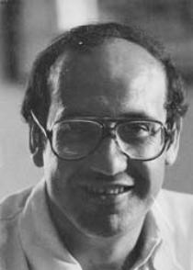
Emilio Alessandrini (Milan magistrate)
Why this motley crew? The Catanzaro court combined two trials that led to irreconcilable results — the investigation byOccorsio and Cudillo and the later investigation by Milanese magistrates Gerard D’Ambrosioand Emilio Alessandrini. The latter case also relied on inquiries conducted by magistrates in Treviso and Padua and elsewhere — inquiries that had brought to light the part played by the fascists and secret services in the bombing strategy.
The first verdict was returned on23 February 1979, nearly ten years after the attacks. Three life sentences — for Freda, Ventura and Giannettini, for the massacre and outrages. But Giannettini was the only one in court: Freda was on the run in Costa Rica and Ventura in Argentina. Maletti was sentenced to four years for procuring perjured testimony and Labruna and Tanzillieach got two years. Valpreda and Gargamelli were cleared of massacre, on grounds of insufficient evidence and convicted on the count of criminal conspiracy. Valpreda was sentenced to four years and six months and Gargamelli one year and six months. Bagnoli was given a two year suspended sentence for criminal conspiracy; Merlino was cleared on grounds of insufficient evidence, but got four years and six months for criminal conspiracy.
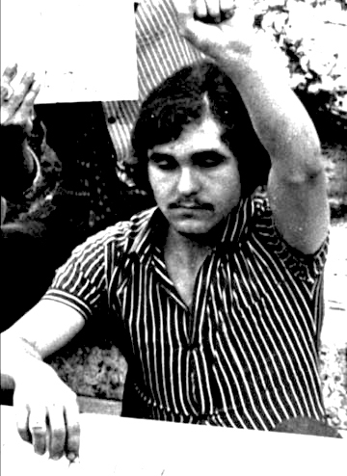
Rome, 29 December 1972: Roberto Gargamelli
The treatment doled out to Valpreda’s relations— who had supported the anarchist’s alibi — was somewhat ambiguous and the perjury charge was thrown out. The same line was taken with Delle Chiaie. And what ofElena Segre, Valpreda’s friend, who had also confirmed the anarchist’s alibi? She had vanished from the records. Another mystery.
The findings handed down in Catanzaro amounted to a contradictory sentence: it recognised the guilt of Freda, Ventura and Giannettini, but was still partly rooted in the case prepared by Judges Occorsio andCudillo — hence the decision to dismiss the case against the anarchists and conspiracy convictions on the basis of insufficient evidence.
But something else cast an ambiguous light on the verdict. Faced with reticence on the part of some of the VIP witnesses, the judges in Catanzaro opted not to take action themselves, and referred the trial records relating to ex-premiers Giulio Andreotti and Mariano Rumor, and former ministers Mario Tanassi (Defence) and Mario Zagari(Justice) back to Milan. The judges did, however, have grounds for pride in the contradictions into which General Saverio Malizia, Tanassi’s legal adviser, blundered and had him arrested in the courtroom. He was tried immediately and sentenced to one year, but was soon released. This was followed by the usual outcome — the Court of Cassation annulled the trial and referred the case to the Court of Assizes in Potenza who cleared Malizia on all counts on 30 July 1980.
To the aid of the politicians came the judge from Milan, Luigi Fenizio (to whom the investigation had passed when Alessandrini was killed by members of the underground Prima Linea organisation on 29 January 1979) who forwarded an order declaring their innocence to the parliamentary commission of inquiry. On 24 August 1981 the commission closed the file on the accusations against Andreotti,Rumor, Tanassi and Zagari and all four politicians were dropped from the investigation.
But the real sensation came at the appeal hearing when, on 20 March 1981, the Catanzaro court cleared the fascists and the anarchists on the count of massacre. So now no one was to blame for the Piazza Fontana.Freda and Ventura were sentenced to 15 years for conspiracy to subvert and for the bomb attacks of 25 April 1969 and 9 August 1969. In effect, the judges unpicked the logical continuity — underpinned by the evidence — which linked the three main 1969 attacks. They absolved Giannettini on grounds of insufficient evidence and reduced the sentences passed on Maletti and Labruna.
The court of Cassation had this in mind when, on 10 June 1982, it entrusted a second appeal to Bari, to put paid once and for all to the proceedings against Giannettini, who was able to announce: “The implication of myself was prompted by political motives. The intention was to strike at the SID through me.”
The same ritual was played out in the appeal court in Bari (Puglia) — with one outstanding difference: the prosecutor, Umberto Toscani, asked that Valpreda be found not guilty. But the judges chose to stick with tradition: doubt should serve the fascists as well as the anarchists. Meanwhile, they reduced Maletti’s sentence — who was on the run in South Africa — to one year, and that of Labruna to ten months.
With that verdict on 1 August 1985 the curtain was to be brought down on the Piazza Fontana massacre. The final act came in the Court of Cassation in Rome, which rejected every application for a new trial (the Cassation was in fact the central prop of this courtroom farce). It was the highest levels of the judiciary that had taken the initial investigation away from Milan and entrusted them to Rome. They were the ones who had argued that Milan was ungovernable and that the trial should be heard in Catanzaro. They had also conjoined the cases against the anarchists and the fascists.
On 27 January 1987, the first section of the Court of Cassation put paid to a trial that had spread out to occupy time and space. It was Judge Corrado Carnevale (who was later to earn fame as the “verdict-quashing judge”) who was in charge of the most important section of the Court of Cassation and who distinguished himself as the “king of the nit-pickers”, who put Mafiosi, terrorists and bankrupts back on the streets.
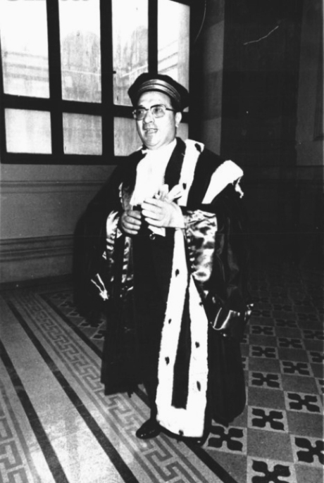
Judge Corrado Carnevale
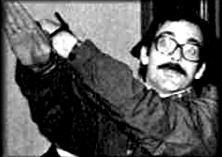
Mario Tutti
Here are a few examples of this: on 16 December 1987,Carnevale annulled theItalicus massacre case, the main accused in which were the neo-fascists Mario Tutiand Luciano Franci. Earlier he had repealed the life sentence passed on the Greco brothers who had been found guilty of ordering the murder ofJudge Rocco Chinnici. On 25 June 1990 Carnevale repealed the life sentence passed on Raffaele Cutolo, head of the mafioso Nuova Camorra Organizzata. He also cleared Licio Gelli, on 15 October 1990, on charges of subversion and membership of an armed gang. On 5 March 1991 he ordered a retrial in the case of the 24 December 1984 bombing of the Naples-Milan express in which 16 people were killed and hundreds injured. The upshot of this was the repeal of the life sentence passed on mafia boss Pippo Calò. Such frantic activity could scarcely pass unremarked and in 1995 Judge Carnevale’s performance was the subject of a book, La giustizia è cosa nostra (Justice is Our Thing).
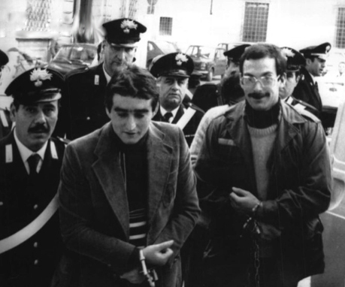
Mario Tuti and Luciano Franci
Carnevale has repealed 134 life sentences — 19 of which were passed on the mafioso Mommo Piromalli — plus 700 years’ imprisonment for 96 people charged with mafia membership, drug-dealing and murders.
In short, now the massacre was the subject of new court proceedings following the arrest of Delle Chiaie, Carnevale was the very man for the Piazza Fontana case. And so, on 26 October 1987, the seventh trial relating to the Piazza Fontana massacre — not counting the two aborted by the Court of Cassation — opened with Delle Chiaie and Massimiliano Fachini together in the dock. After 90 sittings, both men were cleared of involvement on 20 February 1989, a verdict confirmed by the Court of Appeal on 5 July 1991
Tags24 December 1984 bombing, 29 January 1979, addalena Valpreda, Antonio Labruna, Catanzaro Court of Assizes, Circolo 22 Marzo, Cornelio Roland, Ele Lovati,Elena Segre, Emilio, Emilio Alessandrini, Emilio Bagnoli, Enrici Di Cola, Enrico De Peppo, Ernesto Cudillo, Francesco Piscopo, Franco Freda, Gaetano Tanzilli, General Gianadelio Maletti, General Saverio Malizia, Gerard D’Ambrosio, Gianadelio Maletti,Giovanni Ventura, Giuliano Spazzali, Giulio Andreotti, Greco brothers, Guido Giannettini, Italicus massacre case, Ivo Della Savia, Judge Corrado Carnevale,Judge Rocco Chinnici, La giustizia è cosa nostra, Licio Gelli, Luciano Franci, Luigi Fenizio, Marco Pozzan, Mariano Rumor, Mario Merlino, Mario Tanassi, Mario Tuti,Mario Zagari, Nuova Camorra Organizzata, Olimpia Torri, Orlando Falco, Piero Loredan di Volpato del Montello, Pietro Valpreda, Pippo Calò, Placido La Torre,Prima Linea organisation, Rachele Torri, Raffaele Cutolo, Roberto Gargamelli,Rocco Ventre, Stefano delle Chiaie, Stefano Serpieri, Umberto Toscani, Vittorio Occorsio
CategoriesGladio, Italy, Piazza Fontana, State Massacre, Strategy of Tension

Secrets and Bombs 17: The Wild Goose Chase is the Important Thing
January 14, 2012 //
0

Rate This

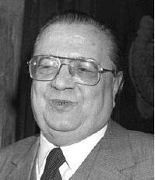
Puppetmaster: Federico Umberto D'Amato
When the Milan anarchists from thePonte Della Ghisolfa circleaccused the Interior Ministry of covering up for those guilty of the Piazza Fontana massacre at their press conference on 17 December 1969, the reporters present were incredulous and scoffed. They wrote about “youngsters reeling from the shock of recent days”. But the facts have shown that that accusation was not without foundation.
In fact, we need to take a much closer look at what was being done in the 1960s and 1970s by the Interior Ministry’s Bureau of Confidential Affairs, a powerful security-cum-espionage centre run byFederico Umberto D’Amato. Born in Marseilles in 1919 of a Piedmontese father and Neapolitan mother, D’Amato had risen to prominence in his youth when, in 1945, he had handled contacts with the intelligence services of the Salò Republic to recover the archives of the OVRA (Organization for Vigilance and Repression of Anti-Fascism), Benito Mussolini’s secret service. He joined the Viminalein 1957 as an ordinary official and rose through its ranks to head the Bureau of Confidential Affairs.
D’Amato was replaced on 30 May 1974, following the slaughter in Brescia, but he stayed on at the Viminale and in fact still controlled the bureau — just as he did when his formal superiors, Elvio Catenacci andAriberto Vigevano were the directors.
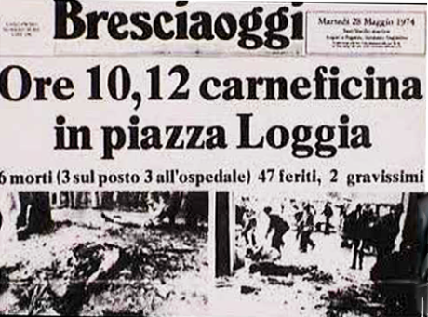
D'Amato was replaced following the May 1974 Brescia outrage
He was obliged to retire in the mid-1980s, moving a lot of important secret files built up over decades abroad. These were tangible evidence of the power he had wielded over many Italian politicians, entrepreneurs, senior managers and intellectuals. But D’Amato was not just a super-spy — he was a man who appreciated the delights of the table and it was in that capacity he edited the weekly food column ‘La tavola’ inL’Espresso and the Guide to the Inns and Restaurants of Italy, published by the same paper. His passion for wine and good food caused his cirrhosis of the liver, and he died in August 1996.
When the student revolts erupted in 1968, D’Amato — who described himself as a sbirro (a plod) but was in fact a skilled double- and even triple-dealer and never let an opportunity go a-begging — was not worried about “students playing at revolution”. His target was, as ever, the Communist Party.
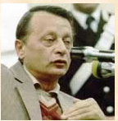
Stefano Delle Chiaie (D'Amato's facilitator in Avanguardia Nazionale)
It was his idea to commission the publishing of thousands upon thousands of pro-Chinese leaflets, which he entrusted to Stefano Delle Chiaie for distribution through Avanguardia Nazionale and Ordine Nuovo members. The latter stuck them up on walls in nearly every town in Italy. By providing a helping hand to the PCI’s main competition on the left, D’Amato’s aim was to stir up problems for the largest Communist party in the western world.
But D’Amato’s activities did not stop there. Through his connections with Delle Chiaie and many other Nazi-fascist leaders, he was well placed to manipulate the far-right groups. In practice, D’Amato remotely controlled Delle Chiaie, the Avanguardia Nazionale leader.
The man from the Viminale was also Italy’s representative in theAtlantic Alliance Security Office — NATO’s espionage wing, and was therefore able to control the activities of men such as Carlo Digilio, the quartermaster of Ordine Nuovo’s Venice group and an agent of the CIA and NATO’s security service. It was Digilio who fed Delfo Zorzi with the explosives that were used in the bombs on 12 December 1969. Digilio, a conscientious fellow, reported back regularly to his superiors, as was his duty. D’Amato was, therefore, constantly informed as to the activities of Zorzi, Franco Freda and Giovanni Ventura — as well as being a sleeping partner in them.
So who was ultimately responsible for the Piazza Fontana massacre? And if D’Amato controlled Delle Chiaie, is it conceivable that he was unaware of the latter’s part in the bombings in Rome on 12 December 1969? The idea that D’Amato was implicated is anything but a fantasy, given that the Bureau of Confidential Affairs stepped in to protect the activities of the Freda-Ventura group.
An answer in the affirmative seems convincing. It was Catenacci, who posted flying squad boss Pasquale Juliano far from Padua just as he was about to arrest Freda, before Pasquale could complete his task. It was also Catenacci who immediately after Giuseppe Pinelli’s death — having been promoted to deputy chief of police — conducted a secret inquiry in Milan police headquarters and took evidence from the police officers present at Pinelli’s “flight”.
Then, having given them absolution, he prepared the groundwork forJudge Giovanni Caizzi’s dismissal of the charges against the police. Finally, it was D’Amato, the protector, who allowed Delle Chiaie to go on the run for 17 years.
D’Amato was one of the most powerful men in Italy and it may not have been a coincidence that the famous 150,000 files uncovered towards the end of 1996 came to light after his death.
In its strategy of chasing political wild geese and conjuring up false evidence or mounting provocations, the Bureau of Confidential Affairshad a sound ally, but one with whom it had serious differences, as happens in the world of espionage. That partner occupied the Palazzo Barachini, the headquarters of the SID.
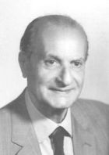
General Vito Miceli (SID chief 1970)
General Vito Miceli held the top job at the SID on 18 October 1970, having taken over from Admiral Eugenio Henke who went on to become army chief of staff. In June 1971General Gianadelio Maletti arrived to take over D Bureau at the SID — its most sensitive department — from Colonel Federico Gasca Queirazza. For top secret operations he established a base under the cover of theTurris Film Company at 235 Via Cecilia, a street off the famous Via Veneto, and it was from these offices that one of his men,Antonio Labruna, head of the NOD, the SID’s operational wing, operated.
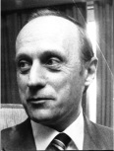
General Gianadelio Maletti (head of SID's 'D' Bureau)
When a discernable fascist lead surfaced in connection with the Piazza Fontana massacreand it become increasingly less concealable, the new bosses of the Italian secret services played their role well as misleaders and provocateurs. First they came up with false documents, which they fed to the judges in dribs and drabs. They then cobbled together a larger-scale operation. The carabinieri in Camerino, under Maletti’s supervision, discovered a huge arms dump near that town on 10 November 1972.
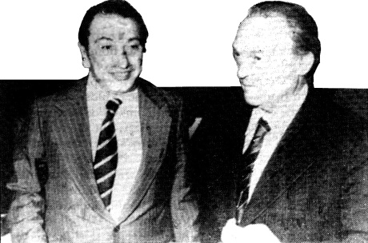
SID Captain Antonio Labruna (left) with lawyer.
The dump contained three categories of weapon: World War Two matériel; a second category intended to give a left-wing signature to the dump — catapults, glass marbles, spray cans, bottles, cork stoppers, paraffin and sulphuric acid — the ingredients for making Molotov cocktails. The last category comprised 25 MK2 pineapple-style hand grenades (US-made), TNT, high-powered explosives (pentrite), an anti-tank mine and detonators, fuses and German-made timers. All accompanied by upwards of 600 blank identity cards and a coded card index.
The day after the discovery an article appeared in the daily Il Resto del Carlino — a newspaper belonging to the Attilio Monti group — over the by-line of Guido Paglia, an Avanguardia Nazionale member who had recently become a journalist. The article claimed that the coded card index discovered in the cache was “incontrovertible proof of the subversive and paramilitary activities of certain leftwing extremist groups”.
But Paglia did not stop there. Even although the coded documents had yet to be examined and deciphered, the reporter seemed to know already that the arsenal belonged to leftwing extremists from Rome, Perugia, Trento, Bolzano and Macerata. On 3 January 1973 four left-wingers from these places were charged. The only one missing was the terrorist from Rome.
What was it that led the Carabinieri to these four individuals? The answer was simple, if bewildering. The coded pages (every page was topped by an explanatory key) contained a list of 31 activists from the extra-parliamentary left. But Paglia, however, in a frantic hurry to get his scoop as well as complete his provocation, had jumped the gun somewhat. And knew about things that even the carabinieri were not yet in a position to disclose to him. Furthermore, the owner of the isolated house where the cache had been found had been there only a few days prior to the discovery — and there had been no weapons there at the time.
Briefly, this was the sort of set-up that would collapse even while the charges were being prepared. However, it took until 28 April 1976, three years later, for the matter to be brought to closure, with a postscript in the Macerata Court of Assizes when the Ancona prosecutor-general challenged the dropping of the charges. The accused’s dealings with the courts finally ended on 7 December 1977 when they were cleared on all counts.
Meanwhile, light was being shed on the roles of Labruna and especially of Captain Giancarlo D’Ovidio, commander of the Camerino carabinieri who was to move on to the SID’s D Bureau. They were put in the frame by secret service Colonel Antonio Viezzer, a P2 member, on trial for passing secret material to Licio Gelli.
The Labruna-D’Ovidio trail came to nothing, the examining magistrates having dropped the charges on the basis of legal arguments that many other jurists regarded as irrational.
But, in 1993 further significant evidence came to light regardingD’Ovidio’s role as the organiser of this provocation and the part played by Guelfo Osmani, an SID “asset”. The Camerino affair, while it failed to have the effect the secret services had been looking for, it at least generated serious differences and divisions within far left groups with, for example, Italian Maoists being accused of “adventurism”. General Maletti jotted down, in his own hand, in the margins of the report on Camerino the comment: “Good result”.
Soon afterwards, Maletti’s men faced even more taxing missions because their involvement in the 12 December 1969 bombings; lots of other terrorist activities were about to emerge into the harsh light of day.
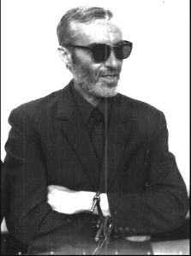
Marco Pozzan (Freda loyalist)
In January 1973, Freda loyalistMarco Pozzan fled to avoid an arrest warrant issued by the Treviso magistrates.Massimiliano Fachini, who had overseen so many operations on behalf of his comrade Freda, contacted D Bureau. Fachini was well known and Pozzan vouched for him and accompanied the fugitive to the offices of the Turris Film Company in Rome where he was met by Labruna and Guido Giannettini.
Labruna took Pozzan under his wing and had a false passport made out for him in the name of Mario Zanella (a name that turns up in the list of members of the P2 masonic lodge). On 15 January, Labruna escorted Pozzan to Fiumicino airport where he handed him over tomaresciallo Mario Esposito and the pair travelled to Madrid. On arrival in the Spanish capital, Esposito took back the false passport and flew back to Italy.
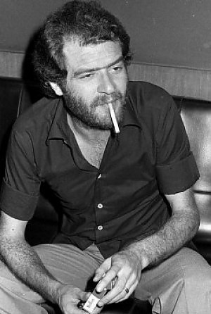
Giovanni Ventura
In March 1973,Giovanni Venturawas in Monza prison being questioned by the Milan judgesGerardo D’Ambrosio andEmilio Alessandrini. Ventura was looking for a way out and was beginning to confess. The easiest solution was an escape, somethingMaletti left toGiannettini to organise. Delfo Zorzi told Carlo Digilio to help Giannettini arrange Ventura’s escape: “Arrange for him to escape. Otherwise Ventura is going to talk.”
Agent Zeta, Giannettini’s code name, contacted Ventura’s sister,Mariangela and his fiancée, Pierangela Baretto and persuaded them his escape plan would work. He gave them two keys that — as was later established in court — opened the prison doors. He also gave them two cans of spray, which the D Bureau had obtained from a firm in Berne to dope the guards.
Once out of prison, Ventura was to be smuggled out to Spain, but he did not trust Giannetini, fearing perhaps that his real destination was not Madrid but that he was to be eliminated once and for all during the breakout. But that was not the end of it; he would escape later, on 16 January 1979, during a stay in Catanzaro, when things were better organised.
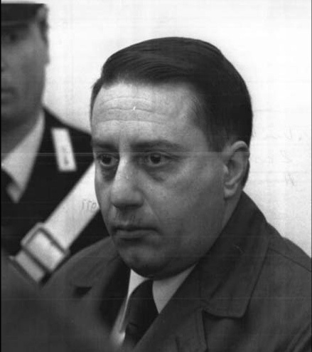
Guido Giannettini (journalist and SID agent)
Giannettini’s turn came in April 1973. Agent Zeta, a SID officer since 1966 who operated under the cover of journalist, was now firmly in the sights of Judge D’Ambrosio who had been pressing the SID, unsuccessfully, for information about Giannettini. The latter, a key contact between the secret services and the Freda-Ventura groupcould not afford the luxury of answering questions that would hold his role up to scrutiny, so he chose to go on the run.
Using the SID’s “travel bureau” he slept overnight in the Turris film company’s apartment and was escorted out of the country the following day by the ubiquitous maresciallo Esposito. But with one difference, on 9 April the pair stopped off in Paris where Giannettini was due to fly on to Madrid, and from there to Buenos Aires.
He escaped just in time. The Milan magistrates had Giannettini’s Rome apartment searched in May and a warrant was issued for the arrest of Agent Zeta in January 1974.
Before leaving France, Giannettini gave an interview to journalist Mario Scialoja from L’Espresso in the spring of 1974 to let his bosses know how loyal he was (in case they abandoned him to his fate). He stated: “The sole aim behind naming me as a SID agent is to implicate military circles, especially the SID, in the Freda case. I will have no truck with this gambit.”
But events were moving quickly. In an interview published in the 20 June edition of Il Mondo, Giulio Andreotti told journalist Massimo Caprarathat Giannettini was an SID agent and that Corriere della Sera reporterGiorgio Zicari was an established informant. That was a direct signal to Giannettini that he should no longer feel safe — not even in Buenos Aires.
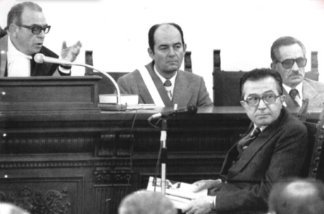
Giulio Andreotti giving evidence in the Piazza Fontana case
On 8 August Giuseppe Derege Thesauro was made Italy’s ambassador to Argentina. At the Catanzaro trial the diplomat declared: “Giannettini did not hide it from anybody at the embassy that he was running scared and required protection.” Brought back to Italy,Giannettini stuck to his tactics to the end and refused to talk. He made vague allusions by way of signals to his superiors that he would keep mum as long as they stood by him. Hence the statements and depositions from SID chiefs and ministers hell bent on playing downAgent Zeta’s record — the man who had kept them informed about the terrorist activities in which he participated along with Freda and Ventura.
The gamble paid off and the puppet-masters behind the outrages threw Giannettini a few crumbs to stop him talking. He was rewarded for his silence when the Court of Cassation finally dropped proceedings against him in 1982. But he was not left unemployed for long, being taken on by the rightwing financier and publisher Giuseppe Ciarrapico.
Tags17 December 1969, Admiral Eugenio Henke, Agent Zeta, Antonio Labruna, Atlantic Alliance Security Office, Attilio Monti group, Avanguardia Nazionale, Bureau of Confidential Affairs, Camerino affair, Captain Giancarlo D’Ovidio, Carlo Digilio,Colonel Antonio Viezzer, Colonel Federico Gasca Queirazza, D Bureau, D Bureau at the SID, Delfo Zorzi, Emilio Alessandrini, Federico Umberto D’Amato, Franco Freda,General Gianadelio Maletti, General Vito Miceli, Gerardo D’Ambrosio, Giovanni Ventura, Giuseppe Pinelli, Guelfo Osmani, Guide to the Inns and Restaurants of Italy,Guido Giannettini, Guido Paglia, Il deposito di Camerino, Il Resto del Carlino, Italian Communist Party, Judge Giovanni Caizzi, Licio Gelli, Marco Pozzan, Mario Zanella,Massimiliano Fachini, Nato Intelligence Service, Ordine Nuovo, P2, Pasquale Juliano, PCI, Pierangela Baretto, Ponte della Ghisolfa circle, Salò Republic, Servizio Informazioni Difesa, SID, Stefano delle Chiaie, Turris Film Company
CategoriesGladio, Italy, Piazza Fontana, State Massacre, Strategy of Tension

Secrets and Bombs 16: ‘Inspector Window’
January 13, 2012 //
1

Rate This

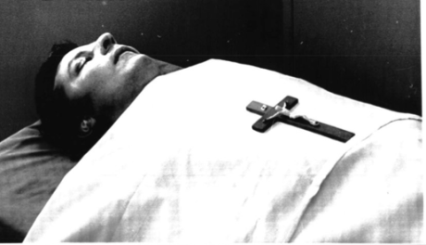
Inspector Luigi Calabresi (17 May 1972)
A shot from a pistol, then another, echoed through the Via Luigi Cherubini, near the corner of the Via Mario Pagano in Milan, then a man walked briskly from the scene, got into a car, and disappeared leavingInspector Luigi Calabresi dead on the pavement. It was 17 May 1972.
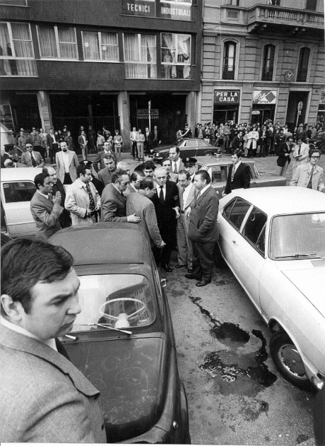
Milan, Via Luigi Cherubini, 17 May 1972: Calabresi murder secene
So ended the life of the policeman that much of the left held responsible for Giuseppe Pinelli’s death. While many of the newspapers of the extra-parliamentary left, especially the weekly Lotta Continua, openly accused the inspector, the most often repeated slogans during protest marches were: “Calabresi — assassin” and “Pinelli, I will be avenged.” The walls of many cities were covered with posters depicting Calabresi with blood on his hands.
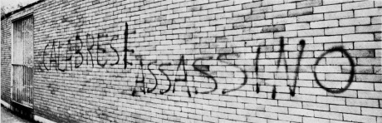
The writing on the wall
As far as a substantial sector of public opinion was concerned, the inspector, born in Rome in 1937, was no longer a glittering and decorated public servant, always dapper with his designer jumpers and claiming to be a “liberal” who voted social democrat. He had become a protagonist in the strategy of tension.
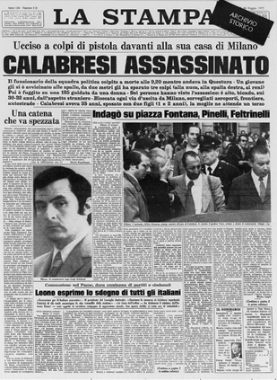
Lotta Continua’s press campaign became even more outspoken when reporters monitoring developments at the Palace of Justice learned that the investigation into Pinelli’s death was about to be wound up, with the police found blameless.
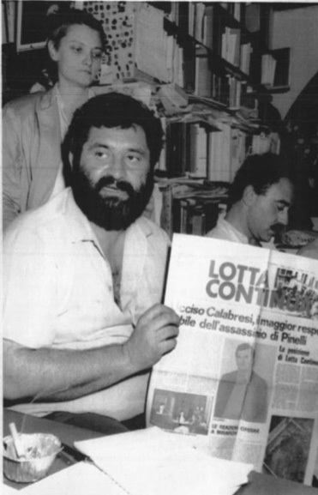
Lotta Continua's anti-Calabresi campaign
In fact, acting prosecutor Giovanni Caizzi closed the file on 21 May 1970. The intention of the editors of Lotta Continua was to provoke Calabresi — who had been rechristened as “Inspector Window” — to get him to sue the paper in order to reopen the “Pinelli case” before the courts. On 15 April, Calabresi brought charges against Pio Baldelli,Lotta Continua’s editor-in-chief, for “ongoing and aggravated defamation through attribution of a specific act”, to wit, responsibility for Pinelli’s death.
But Milan’s prosecutor-general, Enrico De Peppo, delayed for over a month before assigning the case to a magistrate for investigation, and pressed Caizzi to finish his examination in the meantime. The trial was to begin once Caizzi had declared Pinelli’s death an accident.
The courtroom confrontation between Calabresi and Baldelli opened on 9 October 1970. It was a trial heavy with expectations and was prefaced in September by an appeal published in the weekly L’Espresso and signed by Italian intellectuals, university lecturers and politicians (including Elvio Fachinelli, Lucio Gambi, Giulio Maccacaro, Cesare Musatti, Enzo Paci, Carlo Salinari and Mario Spinelli). Their public letter opened with a challenge: “Railway man Pino Pinelli died on the night of 15-16 December 1969 as a result of a fall from a window at Milan police headquarters. How, we do not know. All we know is that he was innocent.”
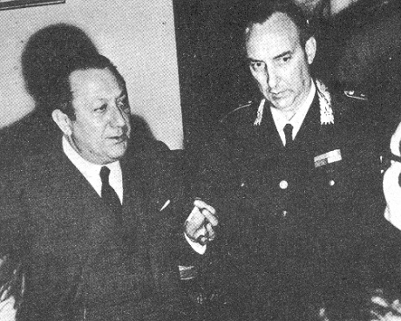
Marcello Guida
After criticising the closure of the file on his death and the application to have the suit brought by Pinelli’s loved ones against police chiefMarcello Guida (who had libelled the anarchist) set aside, the signatories concluded: “We owe the magistrate our respect, but we cannot help but hold him jointly responsible for the death of Giuseppe Pinelli, a second time, by ascribing to him crimes not of his doing — and bearing the grave responsibility of murdering our faith in a justice that is no longer justice when it fails to reflect the conscience of its citizenry.”
But there was also a film that was enjoying great success —Investigation of a Citizen Above Suspicion — directed by Elio Petriand featuring Gian Maria Volonté, with a soundtrack by Ennio Morricone. Audiences immediately identified the inspector played by Volonté as Inspector Calabresi.
In court, Michele Lener defended Calabresi, and Marcello Gentili andBianca Guidetti Serra acted for Baldelli. The judge was Carlo Biottiand the prosecuting attorney was Emilio Guicciardi. The court was surrounded by an impressive deployment of police and carabinieri.
The opening session was packed to overflowing, with people shouting out “murderer” when Calabresi entered to give evidence.
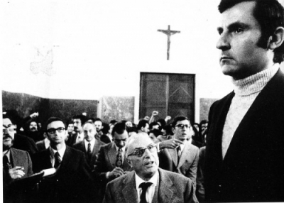
Calabresi giving his evidence in court
The inspector spoke of Pinelli as a decent fellow with whom he had swapped views. He had even made the anarchist the gift of a book(Enrico Emanueli’s Un milione di uomini) and Pinelli had reciprocated with a gift of Edgar Lee Masters’s Spoon River Anthology. He had handled Pinelli’s interrogation because he was under orders and inquiries were being made in every direction. In short, Pinelli’s questioning on 15 December had been relaxed, and only once did he utter the phrase: “Valpreda has talked.” But that was as far as it went. And when Pinelli jumped, Calabresi was in the office of his senior officer,Antonino Allegra.
Calabresi failed to mention the threats he had been making for months against Pinelli when he realised he could not count on him to collaborate.
“During a picket mounted in San Vittore in September to demand the release of the anarchists arrested for the bombings on 25 April, Calabresi had approached Pinelli and — after an exchange of words — told him angrily: ‘I’m going to make you pay’ ” recalled Cesare Vurchiofrom the Ponte della Ghisolfa circle, an eye-witness to that exchange.
The other police officers trooped through the court during the succeeding sittings. The script never varied, down to use of the same phrases and terminology: ‘calm and relaxed”; “launched himself into the void”; “I received the news”. They gave the clear impression that they were all going through a lesson committed to memory.
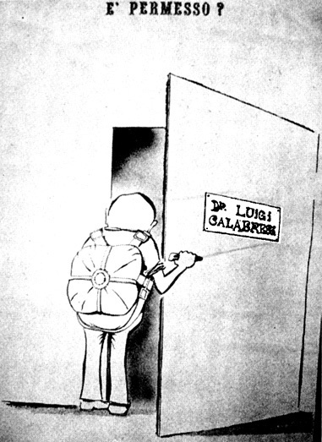
Popular newspaper cartoon depicting requirement of visitors to Calabresi’s office to wear a parachute
But there were noticeable departures from what they had told Judge Caizzi previously. The times had altered. The interrogation had not ended at midnight but at 11.30 p.m. The window had not been wide open, but closed on one side. Savino Lo Grano, newly promoted carabinieri captain, originally said he had watched Pinelli throughout and saw him throw himself from the window. Now, in court, he claimed he had seen no such thing: he had been looking at the open window while two police officers, trapped behind the shutters, had been unable to stop the anarchist.
The greatest absurdity, however, came in the statement of brigadiere Vito Panessa. He contradicted himself and allowed his mouth run away with him, first admitting things, then denying them. Finally he issued a denial that had the ring of an unwitting confession: “I have said that I am not in a position to provide details but, broadly speaking, bear in mind that there was no agreed story and it was, therefore, a matter for investigation … Each of us went before Judge Caizzi and gave out the story that.”
Judge Biotti suddenly interjected: “Signor Panessa, you are rambling!” before asking Panessa: “What is this business about an agreed story?” Panessa answered: “It is not the case that there was an exchange of views between those of us who had been present: the following day we each went before the judge and told him what we could remember.”
The case dragged on along similar lines for five more months, but in the end Baldelli’s defence lawyers scored their first victory. Pinelli’s bodywas to be exhumed and undergo fresh forensic examination.
What were Gentili and Guidetti getting at? They wanted to check if Pinelli’s body still carried any sign of a karate chop delivered while under interrogation, the sort of blow that might have left Pinelli irretrievably disoriented and leading to the fall from the window. And that was precisely what Lener did not want to hear.
Change of scene.
Lener moved that Judge Biotti be removed from the case and, on 7 June 1971, the Appeal Court dismissed him. On what grounds? The judge had spoken with Calabresi’s defence counsel on 21 November 1970 when he allegedly said something about pressure from upstairs to ensure the case ended with Baldelli’s acquittal, and he had supposedly told him that “both he and the other two judges were convinced that the famous karate chop had broken Pinelli’s spinal column.”
The removal of Biotti was the ace card played by Calabresi’s defence at a point when it was perhaps still possible to establish — in spite of a year and a half’s having passed — how Pinelli died. The trial quickly became bogged down.
A further investigation was launched into Licia Pinelli’s — Guiseppe’s widow — complaint to examining magistrate Gerardo D’Ambrosiowhich led to manslaughter charges being brought on 4 October 1971 against the police team which had interrogated Pinelli: Calabresi, Lo Grano, Panessa, Giuseppe Caracuta, Carlo Mainardi and Pietro Mucilli. D’Ambrosio had the anarchist’s body exhumed on 21 October. But, as lots of scientists and physicians had argued, given the advanced state of decomposition, it was by then hard to discover anything.
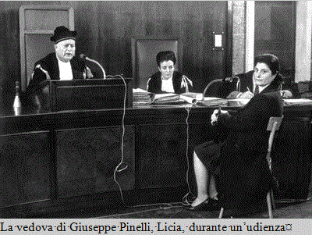
Licia Pinelli during a legal hearing
Things moved on to the verdict passed on 27 October 1975. Calabresi— no longer a deputy inspector but now a full inspector — was by then three years dead. The verdict focused on “active misfortune” as the cause of Pinelli’s death. D’Ambrosio cleared all the accused on the grounds that “the total lack of evidence that something happened is, under our procedural system, as well as under the system of other more progressive states, tantamount to evidence that a thing has not happened.”
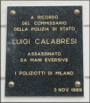But the “Calabresi case” refused to go away. On17 May 1973 a monument to the inspector was unveiled in the courtyard of Milan police headquarters to mark the first anniversary of his death. The ceremony was attended by Interior minister Mariano Rumor.
Gianfranco Bertoli, having recently returned to Italy from Israel, threw a bomb at the entrance to the headquarters. His intention — as he declared after his arrest — was to get the authorities paying tribute to Calabresi, but a police officer had kicked the device away and it had ended up among the crowd. Carnage ensued: four lives were lost and nearly 40 people were injured.
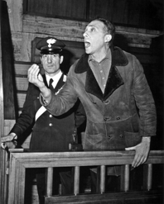
Gianfranco Bertoli
Bertoli claimed he was an individualist anarchist. But nearly all the press described him as a fascist and cited a series of previous actions (attacks on leftwing party premises and others) that were to fall through during the trial.
Born in Venice in 1933, Bertoli — a member of the PCI’s Youth Federation up until 1952 — had a record as a petty criminal and had been in and out of jail for years. He was sentenced to life imprisonment on 9 March 1976.
From 1993 Bertoli enjoyed an open prison regime. But his case still held a few surprises in store. It would seem (the conditional tense is de rigueur in this tale) that fresh information has since surfaced regarding those who had somehow incited him to carry out his deed — protagonists of the strategy of tension, perhaps.
So who killed Calabresi? There was silence on that front up until 2 July 1988 when Leonardo Marino, a former FIAT worker and ex-member ofLotta Continua, gave himself up to the carabinieri in La Spezia (he sold crepes from a kiosk in nearby Bocca di Magra). He wanted to come clean about his and his colleagues’ part in the Calabresi murder.
But 17 days were to elapse before he signed a statement. Why? That remains a mystery. He was taken to Milan, and it was a further seven days before he made a full confession. Another mystery. On 28 July, in addition to Marino, Adriano Sofri, Ovidio Bompressi and Giorgio Pietrostefani were arrested. Sofri had been the unchallenged national leader of Lotta Continua and Pietrostefani was the movement’s leader in Milan.
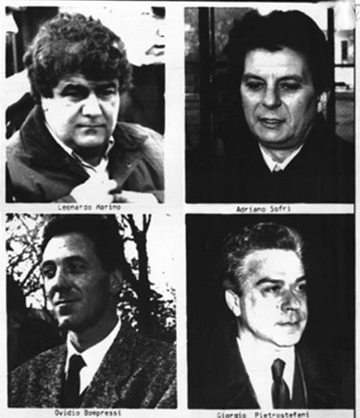
Calabresi's assassins: (top l/r) Leonardo Marino, Adriano Sofri, Ovidio Bompressi and Giorgio Pietrostefani
A lengthy procession through the courts began. The charges were based exclusively on Marino’s confession that he had driven the getaway car, Bompressi actually committed the murder. Sofri andPietrostefani had given the go-ahead. The initial verdict was handed down in July 1991. They were all found guilty as charged. The conspirators and perpetrator received 22 year sentences, Marino 11 years. On 23 October 1992, the Court of Cassation dismissed the verdict on the basis of insufficient motive. So, on 21 December 1993 the Appeal Court of Assizes cleared them all. The verdict was thrown out again on 27 October 1994, and a third Appeal Court confirmed the 22-year sentences passed on Sofri, Bompressi and Pietrostefani, whileMarino, thanks to extenuating considerations, saw his case dismissed. On 22 January the Court of Cassation had the final word and confirmed the convictions.
Tags17 May 1972, Adriano Sofri, Antonino Allegra, Bianca Guidetti Serra, brigadiere Vito Panessa, Carlo Biotti, Carlo Mainardi, Carlo Salinari, Cesare Musatti, Cesare Vurchio, Edgar Lee Masters, Elio Petri, Elvio Fachinelli, Emilio Guicciardi, Ennio Morricone, Enrico De Peppo, Enrico Emanueli, Enzo Paci, Gerardo D’Ambrosio,Gian Maria Volonté, Gianfranco Bertoli, Giorgio Pietrostefani, Giovanni Caizzi, Giulio Maccacaro, Giuseppe Caracuta, Giuseppe Pinell, Inspector Luigi Calabresi,Inspector Window, Investigation of a Citizen Above Suspicion, Judge Caizzi,L’Espresso, Leonardo Marino, Lo Grano, Lotta Continua, Lucio Gambi, Marcello Gentili, Marcello Guida, Mariano Rumor, Mario Spinelli, Michele Lener, Ovidio Bompressi, Panessa, PCI’s Youth Federation, Pietro Mucilli, Pio Baldelli, Ponte della Ghisolfa circle, Savino Lo Grano, Spoon River Anthology, Un milione di uomini
CategoriesGladio, Italy, Piazza Fontana, State Massacre, Strategy of Tension

Secrets and Bombs 15: On The Trail of the Fascists
January 12, 2012 //
1

Rate This

Pasquale Juliano tried but it blew up in his face.
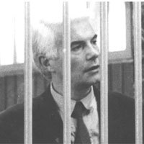
Franco Freda (one of the authors — with Ventura — of the Piazza Fontana bombing of 12 December 1969)
In the spring of 1969, the head of the Padua flying squad, Pasquale Juliano, developed an interest in the activities of a neo-Nazi group operating in the city. Some of his informants — Niccolò Pezzato andFrancesco Tomasoni — had told him that the people responsible for the attacks on the homes of police chief Francesco Allitto Bonannoon 20 April 1968 and the office of university rector Enrico Opocher on 15 April 1969 were part of a group headed by Franco Freda.
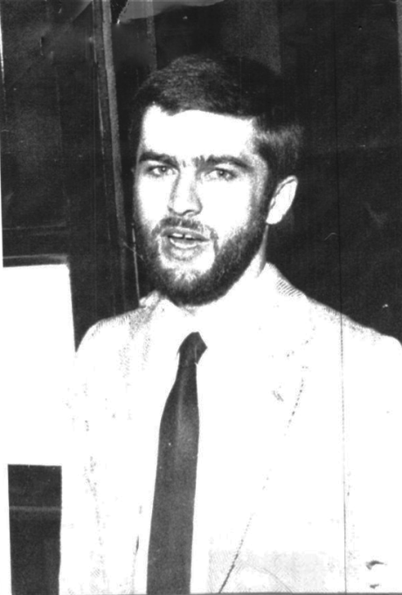
Massimiliano Faccini (Quartermaster)
Juliano organised a stakeout on the home of Massimiliano Fachini, convinced he was the quartermaster in charge of the group’s weapons and explosives. One June evening, thanks to his usual sources, Juliano surprised Giancarlo Patrese (another member of Freda’s group) at the house in possession of a bomb and a revolver. He ordered the arrest of Patrese, Fachini and Gustavo Bocchini, grandson of Arturo Bocchini, the one-time chief of police under the fascists. Juliano believed he had made a start on breaking up the bomb team, but instead he found himself caught up in an “affair” bigger than he was. Patrese confessed he had received the arms and explosives from none other than Juliano’s own informant, Pezzato, who had entered Fachini’s house with him.
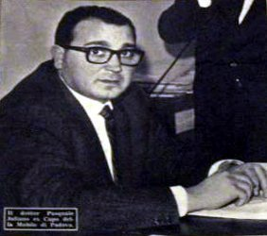
Pasquale Juliano (former head of Padua's Flying Squad)
This account of events was denied by the building’s concierge,Alberto Muraro, a one-time carabinieri. Patrese had entered on his own and left on his own, but his evidence was insufficient and Juliano was accused of having entrapped the three fascists.
The director of theconfidential affairs bureau of the Interior Ministry, Elvio Catenacci then suddenly and unexpectedly intervened. Catenacci — the same official who conducted the investigation at police headquarters in Milan following Pinelli’s death — ordered Juliano’s immediate suspension from duty without pay and it was to be two years before he was reinstated and reassigned to Ruvo di Puglia, and it was not until 1979 that Juliano was finally cleared.
A campaign of dissuasion followed. Pezzato and Tomasoni, the informants, were jailed and placed in the same cell as Patrese, who persuaded them to retract. Meanwhile, on 13 September, the conciergeMuraro was found dead at the foot of some stairs. Accidental death, investigators concluded, without so much as an autopsy, as would be normal in such cases. ‘One of these days you’ll drop by looking for me and I’ll be found with my head caved in in the cellar or in the lift shaft”, Muraro had confided to his friend Italo Zaninello shortly before his death.
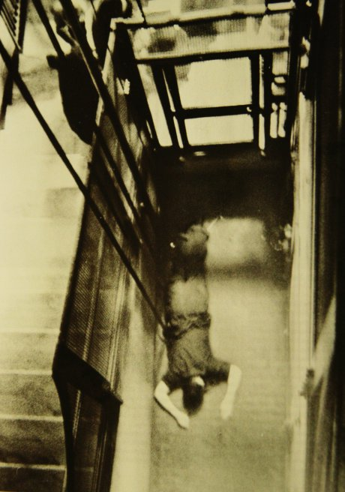
Alberto Muraro
Muraro had been due to present himself before the magistrate looking into the Juliano case two days later, on 15 September. The confidential affairs bureau had yet again intervened efficiently: Freda was not to be obstructed.
Notwithstanding the protection he enjoyed, Freda found someone else making inquiries about him — carabinieri maresciallo Alvise Munari.
The examining magistrate in Treviso, Giancarlo Stiz, had commissioned Munari —whose family had worked the land around Bassano del Grappa for generations — to investigate a lead resulting from a statement made by a teacher of French in Marrada, Guido Lorenzon, a member of the Christian Democratic Party.
Vittorio Veneto, 15 December 1969. Lorenzon visited Albert Steccanella, a local lawyer who told him a long and convoluted story about a friend of his, Giovanni Ventura, a publisher and bookseller from Castelfranco Veneto. Ventura, Lorenzon said, had mentioned the12 December bombings to him on the afternoon of 13 December, after returning from Milan or Rome and showed sufficient familiarity with the events and places involved as make an impression on Lorenzon.
Lawyer Steccanella sensed Lorenzon’s story might lead on to significant revelations, so he asked him to set it all down in a memorandum, which he did and delivered to him three days later. On 26 December, having realised the gravity of the facts provided by Lorenzon, the lawyer visited the Treviso prosecutor and related everything that his client had told him: that there was in the Veneto a subversive organisation which might just have been implicated in the massacre.Count Pietro Loredan backed this organisation from Volpato del Montello.
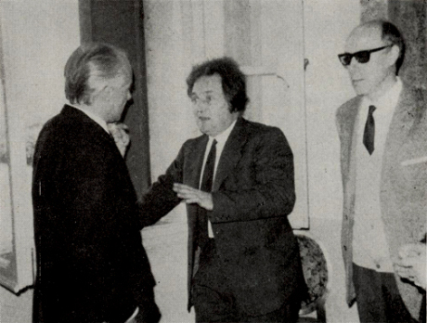
Conte Pietro Loredan (centre)
On 31 December Lorenzon called on the public prosecutor in Treviso,Pietro Calogero and told him about Ventura’s confidences. The publisher had planted a bomb which had failed to go off, in a public office in Milan, in May; he had funded the August train bombings; he knew the underpass at the Banca Nazionale del Lavoro where the bomb went off on 12 December like the back of his hand and could not understand how on earth the bomb in the Banca Commerciale in Milan had failed to explode. Also, in September, Ventura showed him a battery-operated timer. Furthermore, he was constructing a device for use against US president Richard Nixon during his forthcoming visit to Italy.
These were important revelations. On 12 February 1970, the examining magistrate in Rome, Ernesto Cudillo, was due to hear this witness from Venice, but he did not impress him. Even so, he could not completely ignore this encounter: on the afternoon of the following day, at the conclusion of the questioning of Pietro Valpreda, he asked the anarchist if he knew anyone by the name of Giovanni Ventura or Guido Lorenzon. “I don’t know anybody of that name. The only two Venturas I have ever met and known are both dancers”, was Valpreda’s response.
Lorenzon was so overcome with guilt at his betrayal of his friend Ventura that on 4 January 1970 he told him that he had approached the magistrates. Ventura and Freda then put the French teacher under pressure to change or retract his statement. A seesaw of statements and retractions followed, but anomalous retractions at that, as Lorenzon himself later confessed to the judges: “It occurred to me to retract something which I had never stated. I had mentioned things that I had heard, things which I had never actually seen, but I had never stated, say, that Ventura had gone to the Piazza Fontana and that Ventura had planted the bombs on the trains, but he still told me everything that I later recounted. In my retraction, however, I therefore retracted something that I had never said, secretly hoping that that statement might then be taken for what it was, to wit, false. It was only a way of buying time because at the time the magistrate was away and I had to face Ventura on a daily basis.”
Investigators finally kitted Lorenzon out with a tape-recorder to be used secretly in conversations with Ventura. The tapes were then forwarded to Rome, to Cudillo and his colleague Vittorio Occorsio, the prosecuting counsel who found nothing of interest in them. Occorsio, however, ventured the following statement: “Lorenzon’s charges are without foundation. In the lengthy taped conversations the only point of note is that Ventura offered no confidences of the sort and therefore spoke in terms that plainly show that he had nothing to do with the events. There is nothing to suggest that Ventura was, even marginally, an accomplice in the outrages of 12 December 1969.” Cudillo andOccorsio found Ventura “a decent guy” and Freda “a gentleman”. In short, they were two upstanding citizens who had been unfairly slandered by Lorenzon.
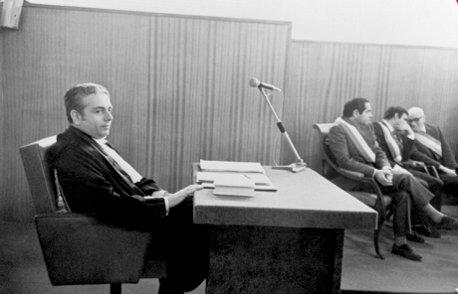
Vittorio Occorsio (prosecuting counsel)
The Treviso magistrates did not share these opinions. When the tapes were returned to Stiz at the end of 1970, there was a change of tune. After listening carefully to the taped conversations, Stiz immediately sent for Lorenzon who confirmed everything to him. Stiz continued with his inquiries, carefully scrutinising the book Justice is Like A Tiller: It Goes Where It is Steered, written by Freda as an attack on Juliano’s investigation. He listened to other witnesses and on 13 April 1971 he indicted Freda, Ventura and Aldo Trinco for conspiracy to subvert the course of justice and, above all, for the bombings in Milan on 25 April and for the 9 August train bombings. But the trio’s defence lawyers petitioned for the case to be heard before the judges in Padua on grounds of territorial competence. The accused were released.
A further change of scene. On 5 November, during restructuring work at the home of Giancarlo Marchesin, a leading socialist in Castelfranco Veneto (Treviso), builders discovered a crate filled with weapons behind a wall. When questioned by Stiz, Marchesin admitted that the crate had been given to him by Franco Comacchio on behalf of Giovanni Ventura. The crate (which Comacchio had received from Ruggero Pan, an assistant in Ventura’s bookshop doing his military service at the time) had initially held explosives too, but Comacchio had hidden these in the countryside near Crespano.
On 7 November Comacchio went with some carabinieri from Treviso to collect the explosives. But without warning the carabinieri unexpectedly blew up the 35 sticks. But sticks of what? Judging by the characteristic smell of bitter almonds after the explosion, it must have been the by now famous gelignite.
Later statements by Carlo Digilio indicated that from 1967 the Ordine Nuovo groups in Padua and Venice had had a dump in the Paese area (near Treviso) where they had stored a large quantity of explosives and weapons in the use of which they were instructed by Digilio himself. It was later discovered that the few weapons shipped to Marchesin’s home were a tiny, tiny part of the two groups’ arsenal, which had been divided up after the Piazza Fontana massacre.
Questioned by magistrates, Pan began talking. Weapons and explosives had been passed to him by Ventura. Why? In 1968 Pan had worked in Ventura’s bookshop and on 10 March 1969 he had been hired, throughFreda’s influence, as an attendant at the Configliaschi Institute for the Blind. The concierge there was Marco Pozzan, one of Freda’s most loyal followers. Freda had tried to draw the young Pozzan into his group and confided a number of things to him regarding the attacks being mounted in Padua and in other cities. All of these details wound up in an affidavit that Pan wrote in jail, heavily implicating Ventura and Freda, especially in the train bombings.
At this point in the investigations the name of Ordine Nuovo founder and Il Tempo reporter Pino Rauti came up — along with another journalist, Guido Giannettini (an important figure of whom more anon.) Rauti was also the author of the book Red Hands on the Armed Forces, published under the nom de plume Flavio Messalla.
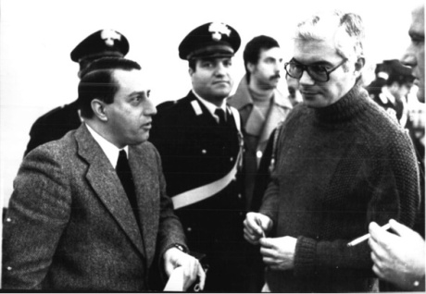
Guido Giannetini ('journalist' and secret service agent) with Franco Freda
Marco Pozzan implicated Rauti in subversive activity, along with Fredaand Ventura. Pozzan insisted Rauti had taken part in a meeting of the group in Padua on 18 April, during which the bombings in Milan on 25 April were approved). Stiz and Calogero dispatched marescialloMunari to Rome on 4 March 1972 to arrest Rauti on charges of massacre. On 22 March, Freda and Ventura were indicted in connection with the Piazza Fontana outrage.
Invocation of that crime obliged the Treviso magistrates to hand its case over to their Milan colleagues and from then on it was in the hands of examining magistrate Gerardo D’Ambrosio.
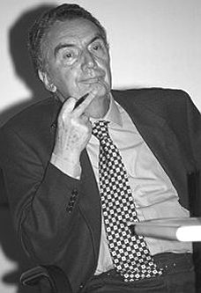
Gerardo D'Ambrosio
Rauti denied all charges and Pozzan retracted — and was promptly smuggled out of the country to Spain with the aid of the SID. Renato Angiolillo, Il Tempo’s publisher, and a number of editorial staff insisted that on the day in question, 18 April, Rauti had been at work in the editorial offices. So, one month later, on 24 April, D’Ambrosio freedRauti on the grounds of insufficient evidence. The parliamentary elections were held on 7 May and Rauti was elected on the MSI ticket. The likelihood is that Pozzan implicated Rauti on Freda’s instructions in order to have someone in the frame someone who could mobilise the MSI on Rauti’s, and thereby also on Freda’s behalf.
But D’Ambrosio was more fortunate with Ventura who admitted involvement in the May 1969 attacks in Turin and those in July in Milan. More importantly, he implicated his friend Freda in the attacks. It was from Freda, the Padua lawyer, he had taken delivery of the bombs. Again, it had been Freda who had announced the August bombings before they happened. Point by point, everything in Lorenzon’s confession in 1969 was confirmed — almost four years after the event.
But something else emerged from the interrogations by the judges in Treviso and Milan, something considerably more serious for Ventura. It was proved he had definitely been in Rome on the afternoon of 12 December 1969. Ventura finally admitted this, but clung desperately to a weak alibi that was to soon be demolished — that he had gone to the capital because he had been informed the previous day his brotherLuigi, a resident of a Catholic boarding school, had suffered a serious epileptic fit. The incident was true, but the date was false. According toDon Pietro Sartorio, the bursar of the home, Luigi Ventura had his attack at 12.30 p.m. on 14 December (on the Sunday rather than the Friday). Don Sartorio called a Red Cross ambulance and a physician who checked the boy over and said that no resuscitation was necessary — the fit having passed. The bursar informed the Ventura family of the fit and expressed his regret that he had not been advised of the boy’s state of health.
Ventura had been caught out — but there was more. He claimed that on the afternoon in question, after phoning the school and discovering Luigi was feeling better, he had visited a family friend, Diego Giannolla in his law chambers. He then went to the Lerici publishing house to meet his partner Rinaldo Tomba — alibis which both denied. In the end he claimed he had spent the evening of 12 December in the home of a friend, Antonio Massari who put him up for the night.
But that was not the only night Ventura had spent in Rome. According to the register of the Locarno hotel, he had stayed in Rome from 5 to 8 December as well as on the night of 10-11 December, only returning home on 13 December. Meeting up with Lorenzon that afternoon, he was excited about what had happened in Milan and Rome and initiated the loose talk that — after Lorenzon had reported it first to Steccanella and then to magistrates in Treviso — implicated Ventura and Freda in the bombings.
Tags12 December bombings, Albert Steccanella, Alberto Muraro, Aldo Trinco, Alvise Munari, Antonio Massari, Arturo Bocchini, Banca Commerciale, Banca Nazionale del Lavoro, Carlo Digilio, Christian Democratic Party, Confidential Affairs Bureau of the Interior Ministry, Configliaschi Institute for the Blind, Count Piero Loredan, Diego Giannolla, Don Pietro Sartorio, Elvio Catenacci, Enrico Opocher, Ernesto Cudillo,Flavio Messalla, Francesco Allitto Bonanno, Francesco Tomason, Franco Comacchio, Franco Freda, Gerardo D’Ambrosio, Giancarlo Marchesin, Giancarlo Patrese, Giancarlo Stiz, Giovanni Ventura, Guido Giannettini, Guido Lorenzon,Gustavo Bocchini, Justice is Like A Tiller: It Goes Where It is Steered, Luigi Ventura,Marco Pozzan, Massimiliano Fachini, Niccolò Pezzato, Pasquale Juliano, Pietro Calogero, Pietro Valpreda, Pino Rauti, Red Hands on the Armed Forces, Renato Angiolillo, Richard Nixon, Rinaldo Tomba, Ruggero Pan, SID, talo Zaninello, Vittorio Occorsio
CategoriesGladio, Italy, Piazza Fontana, State Massacre, Strategy of Tension

Secrets and Bombs 14: Stick it to the anarchist!
January 11, 2012 //
1

Rate This

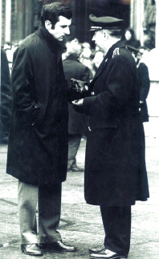
Inspector Luigi Calabresi of the Milan Special Branch
FASCISTS PLANTING BOMBS.Police arresting anarchists. That is the traditional view of this story. The orders came from above. The left had to be hit and the man in Milan to do it was Inspector Luigi Calabresi. Like his Roman political squad colleague, Umberto Improta, Calabresi carried out these orders with the utmost diligence. On the afternoon of the 12 December bombings, Calabresi was quick to zero in on “that criminal lunaticValpreda”. After all, it had worked for him after the 25 April bombingswhen he had jailed anarchists for the bombs at the Fair and at Central Station in Milan. But he was not happy when, only a few days earlier, on 7 December, Antonio Amati, the head of the Milan investigation bureau, had been obliged to free two of them — Giovanni Corradiniand Eliane Vincileone — for lack of evidence. Now, faced with carnage of the Piazza Fontana, Calabresi was not going to make do with youngsters like Paolo Braschi and his friends. He needed an adult and Valpreda, at 36, was the right age. He needed someone like Valpreda who had had dropped his characteristic irony and self-mockery and was now given to hotheaded talk.
Hanging out in bars in the Brera (once Milan’s artists’ quarter) Valpreda would launch into long, heated speeches, which were increasingly tainted with a flavour of “fire and brimstone”. The Brera was also teeming with police informers, and the value of an informant is determined by the “quality” of the intelligence he can pass to police headquarters. Valpreda’s speeches grew more exaggerated in the telling and re-telling. Was Valpreda all for confrontations during demonstrations? He was for urban guerrilla warfare. Did he ever talk about “exemplary actions” carried out by a handful of people, but capable of galvanising the masses? He wanted outrages carried out.
Valpreda laid himself wide open with his increasingly “purple” statements and when he joined forces with two young anarchists, Leonardo Claps, aka Steve, and Aniello D’Errico to launch the duplicated bulletin Terra e libertà, the organ of the I Iconoclasti group, group (that is, those three), he wrote a piece for the first (and only) issue in March 1969 entitled “Ravachol is back”.
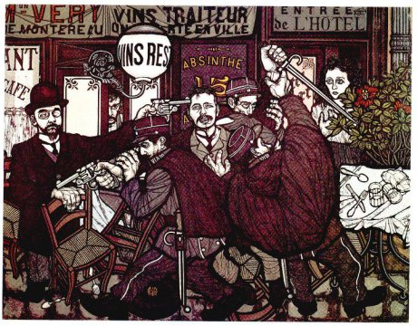
The arrest of Ravachol at the Restaurant Very, Paris (Flavio Costantini)
This was seized upon by the police to substantiate their thesis that Valpreda was bomb-crazy. Ravachol was the pseudonym used by a French anarchist, François-Claudius Koenigstein, guillotined in 1892 and renowned in late 19th century Paris for his dynamite attacks on the high bourgeoisie. In the public’s collective imagination Ravachol was the very stereotype of the anarchist. Yet, in that article, after listing a succession of small attacks (nearly all of them using something reminiscent of a letter-bomb, or big fire-crackers rather than real explosives), Valpreda had closed his article with this comment: “Hundreds of youngsters are ready to organise in order to take their places as enemies of the State and to cry out ‘No God and No Master’, with Ravachol’s dynamite, Caserio’s dagger, Bresci’s pistol, Bonnot’s machine-gun, and the bombs of Filippi and Henry. Quake, bourgeois! Ravachol is back!”
If such mind-boggling prose left the police in ecstasy, it infuriatedGiuseppe Pinelli. “I booted that twat Valpreda out of the Ponte [della Ghisolfa]”, he told his comrades from the Bandiera Nera group. After that, from the beginning of 1969 on, relations between Pinelli and Valpreda had cooled. And when Pinelli attended the Gruppi di iniziativa anarchica (GIA) — one of the three strands which made up Italy’s organised anarchist movement alongside the Italian Anarchist Federation (FAI) and the Federated Anarchist Groups (GAF) (theBandiera Nera group to which Pinelli belonged was linked to the GAF) — convention in Empoli on 2 November 1969, the friction between them worsened. After the convention the anarchists gathered in a trattoria. Valpreda said hello to Pinelli but got no response. Indeed Pinelli used this chance to tell him that he did not regard him as a friend and therefore had no reason to acknowledge his greeting. Valpreda, his dignity offended in front of everyone, flew off the handle and threw a salt-cellar at Pinelli. It was the last time they set eyes on each other.
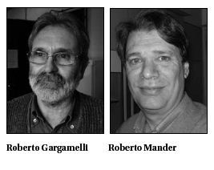In Rome, Valpreda fell out with the anarchists from the Circolo Bakuninwhom he called too staid and only good for making speeches. He argued on more than one occasion that the students and workers were shrugging off the old regime so time to strike was now. And so, with a group of youngsters in tow — Roberto Mander, Roberto Gargamelli, Enrico Di Cola, and another, Emilio — he set up the Circolo 22 Marzo. This was the group joined by Mario Merlino, officially formerly of the Avanguardia Nazionale, and by “comrade Andrea”, i.e. Salvatore Ippolito, a public security agent. These two ‘plants’ were to be complemented, on and off and from the outside, by Stefano Serpieri (one of the founders ofOrdine Nuovo with Pino Rauti and since the mid-1960s a regular SIDinformant). Serpieri’s role was marginal but he wanted to ingratiate himself with his superiors. After all he still had to justify the retainer that he was paid by the SID.
Under such surveillance, the members of the Circolo 22 Marzo set about engaging in “politics”. To them this meant taking part in demonstrations which usually ended in clashes, carrying out token actions such as — under Merlino’s leadership — 7 October, throwing a petrol bomb at the door of the MSI branch in Colle Oppio). In short, raising their profile.
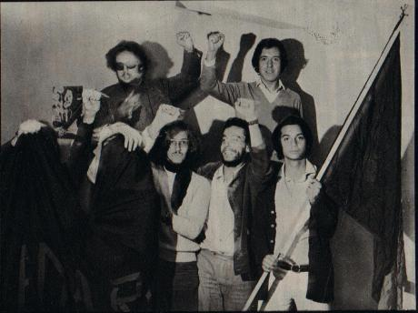
Circolo 22 Marzo
Valpreda was the oldest and could boast a sound command of anarchist thought. It was natural, therefore, that he became the most visible member of the Circolo 22 Marzo. The police of course knew this. After the 9 August bomb attacks Valpreda was picked up a dozen times. The police also tried to get him to crack by offering money (98,000 lire) and held out the prospect of his getting a contract with RAI TV. But Valpreda refused to bite and told the police to get stuffed. So surveillance on the group was stepped up, even though it was not doing any more than many other extreme leftwing groups. Why all the attention? The answer is simple: Valpreda was being targeted. He would make a good scapegoat, should the political situation require one. It was not important that he was not doing anything particularly serious: he — an anarchist and a member of a group which in practice had cut itself off from other Rome anarchists — regularly made inflammatory speeches and claimed to have thrown the odd Molotov cocktail. His image fitted the bill. That he was innocent did not matter.
Only by using that sort of reasoning can we comprehend how, in the immediate aftermath of the bombings, Calabresi came to pester every arrested anarchist for news about “that criminal lunatic Valpreda”. Calabresi knew about the falling-out between Pinelli and Valpreda, just as he knew that the Rome anarchist Aldo Rossi was not well disposed towards “that guy from Milan who makes a mess of things unaided.” Maybe he believed that levelling the massacre charges at Valpreda would not bring any response from the anarchists. The charges against him might not do their image any good, but after all the only people indicted would be Valpreda and one or two others from the Circolo 22 Marzo. But the inspector was mistaken. In part because there was also the matter of our having lost Pinelli.
An unforeseen event occurred. A tiny movement numbering only a few thousand supporters across Italy mobilised with a speed and determination that almost defied belief. A counter-information campaign was launched that — while it found the anarchists out on their own to begin with — had, within a few weeks drawn in ever-widening sectors of the left until it even engaged the un-politicised. By the end of January 1970, tens of thousands of Milanese were taking to the streets to demonstrate opposition to the repression in the wake of the Piazza Fontana massacre.
But the phrase “State massacre” had yet to enter the vocabulary of the left. Indeed, on 24 March 1970, the Milanese anarchists were on their own when they demonstrated under that catch phrase. But over the succeeding months, other demonstrations, rallies, debates, public declarations by intellectuals and cultural figures set the seal on a profound change in the attitudes of many people. Valpreda turned from being a guilty party into an innocent and “the accidental death of an anarchist” became a Dario Fo farce that toured Italy and abroad, holding the police account up to ridicule. Virtually every Italian director signed up to a documentary on the various hypotheses that could have led to Pinelli’s demise. These all read like an indictment of the police — above all of Calabresi. In short, the massacre was becoming a burden upon police, magistrates and secret services.
After three years, on 15 December 1972, parliament got around to voting on law no 773 (which came to be known as the “Valpreda law”) that freed Valpreda from prison. Article 2 of this law allowed the granting of “temporary release to the accused who finds himself in preventive custody […] even in instances where binding arrest warrants have been issued.” Which are precisely the circumstances in which anarchists from the Circolo 22 Marzo found themselves. Acquitted with Valpreda on 30 December were Borghese, Gargamelli and Merlino. Mander had been freed several months earlier and Di Cola escaped to Sweden where he was welcomed as a political refugee.
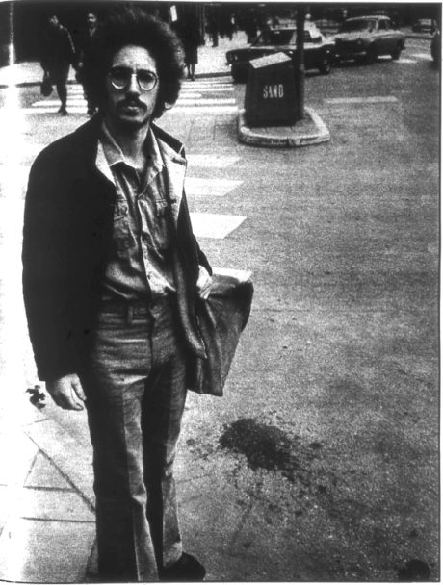
Enrico di Cola of the Circolo XX Marzo (on the run in Switzerland)
The monthly A-rivista anarchica (which in those days was selling upwards of 10,000 copies) published an editorial in January 1973 entitled “Our Victory:” “Valpreda, Gargamelli and Borghesi are Free! […] The government has budged under pressure from ‘respectable’ segments of democratic public opinion. It would be crass triumphalism for us to argue that we, the anarchists, the revolutionaries, got it to shift. Yet we are convinced, without bragging, that it represents a victory for us, not the democrats. First of all because we shook that democratic public opinion out of its customary slumber, we forced it to feel scandalised, to feel indignation. Secondly, because, in spite of everything, the repressive structures of the ‘democratic’ State have, in the eyes of the public, emerged bruised from the affair, albeit given a fresh coat of democracy. The victory is ours, we say again, and we do not accept the defeatist pessimism of those who look upon the discharge from prison as merely a shrewd move by the authorities. It is that as well, to be sure […] but the release of Valpreda, Gargamelli and Borghese remains substantially a defeat for the State and a victory for us.”
However, the progress of the trials arising out of the Piazza Fontana carnage, which would conclude in 1991, were to show that whoever it was, within the State, who had devised the strategy of tension — he had certainly not acknowledged defeat.
Tags25 April bombings, A-rivista anarchica, Aldo Rossi, Aniello D’Errico, Antonio Amati,Avanguardia Nazionale, Bandiera Nera group, Circolo 22 Marzo, Circolo Bakunin,comrade Andrea, Dario Fo, Eliane Vincileone, Empoli, Enrico Di Cola, Federated Anarchist Groups (GAF), François-Claudius Koenigstein, Giovanni Corradini,Giuseppe Pinelli, Gruppi di iniziativa anarchica (GIA), I Iconoclasti group, Inspector Dr Luigi Calabresi, Italian Anarchist Federation (FAI), law no 773, Leonardo Claps,Mario Merlino, Ordine Nuovo, Paolo Braschi, Piazza Fontana massacre, Pietro Valpreda, Pino Rauti, Ravachol, Roberto Gargamelli, Roberto Mander, Salvatore Ippolito, SID, state massacre, Stefano Serpieri, Steve, Terra e libertà, the accidental death of an anarchist, Umberto Improta, Valpreda law
CategoriesGladio, Italy, Piazza Fontana, State Massacre, Strategy of Tension

Secrets and Bombs 13: 25 April 1969 — With Murderous Intent
January 10, 2012 //
1

Rate This

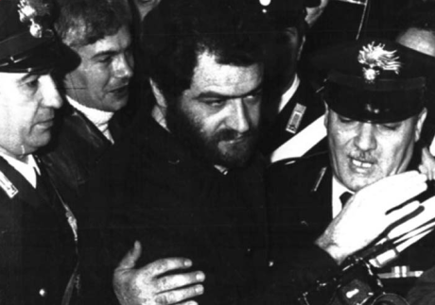
1975, Catanzaro: Franco Freda and Giovanni Ventura arrive to be tried for their role in the Piazza Fontana bombing
BACK TO THE BOMBING, that is, back to 1969. The Milan bombs on 25 April 1969 injured only a few people. The same was true of the train bombing on 9 August. These devices had all used the same sort ofRuhla brand timer. The same brand, which a strange fellow had bought in batches of, three and four from the Standa store in Treviso. But the first one put to the test had failed.
On 24 July a bomb in Milan’s Palace of Justice failed to explode so the terrorists called in an expert. Franco Freda had an electrician Tullio Fabris (who had installed some chandeliers for Freda in his studio in the Via San Biagio in Padua) explain to him how to connect up an alarm clock to a resistor that would then light storm lamps. Fabris gave Freda a technical run-down, which he tested out on the trains. The experiment worked: eight out of ten bombs exploded. The two, which failed to explode, had used Ruhla timepieces.
The next step was to switch to timers. Freda, through Fabris, ordered 50 60-minute timers from Elettrocontrolli in Bologna. On 19 September Freda travelled to the Bologna with Fabris to collect the Junghan-Diehl timers.
New gear, new trials. Lesson one: Fabris showed Freda (even prior to buying the timers) how to connect the battery, chromium-nickel wire and storm lamp to a timing device. Having seen the results for himself, Freda had Fabris buy a length of the wire. Lesson two: after collecting the timers, the electrician gave Freda and Ventura a quick run-down on timing devices and their use. Freda studiously took notes. Lesson three: Under Fabris’s supervision, Freda and Ventura twice assembled a device. The trial went perfectly. Everything was now ready for the big one. In fact the bag containing the unexploded bomb left at the Banca Commerciale Italiana in Milan’s Piazza della Scala was found to contain the dial from a Junghans-Diehl timing device. The bag was one of a batch made by the German firm of Mosbach-Gruber and imported into Italy. The bags used in the bombings were of two sorts: the brown City 2131 and the black Peraso 2131 models, and in Italy only three firms sold both sorts — Biagini in Milan, Protto in Cuneo and Al Duomo in Padua.
When the owner of the Al Duomo luggage shop, Fausto Giuriati, saw the photo of the bag in the newspapers and on television, he rang police headquarters. It took a few days before someone from the police called at his shop. Loretta Galeazzo, his shop assistant, said she had sold four bags of that sort to a well-dressed young man on the evening of 10 December. The Padua police forwarded a report to Milan police headquarters and to the confidential affairs bureau at the Interior Ministry, but it was three years before anyone called back to the Padua city centre shop. Even then it was not on any instructions from Milan or Rome. Who came to call? It was Carabinieri Alvise Munari, making inquiries on behalf of examining magistrate Giancarlo Stiz in Treviso.
Let us remain in Padua — the day before the bombings. Here is a reasonable reconstruction of events based on what we know so far. Freda, by now an expert thanks to Fabris’ training, put the explosive devices using the gelignite obtained by Delfo Zorzi, and wired them up to the Junghans-Diehl timers. He placed them in the bags bought from the Al Duomo shop in Padua and in another bag. He then passed the bags to the people whose job it was to transport them. Zorzi then left for Milan where members of Giancarlo Rognoni’s La Fenice were waiting for him. They were to provide the operational base, a flat near the Piazza Fontana. Ventura on the other hand travelled to Rome to deliver his device to comrades from the Avanguardia Nazionale, answerable to Stefano Delle Chiaie.
On the afternoon of 12 December 1969 two bags containing two gelignite bombs wired up to Junghans-Diehl timers were planted in theBanca Nazionale dell’Agricoltura in the Piazza Fontana and theBanca Commerciale Italiana in the Piazza della Scala. A further device was planted in the underpass at the Banca Nazionale del Lavoro in Rome and two more at the tomb of the Unknown Soldier in the Piazza Venezia. The Ordine Nuovo and Avanguardia Nazionale members had carried out their mission almost to the point of perfection.
The only hitch was the failure of the device left at the Banca Commerciale in Milan, but lo and behold, along came expert Teonesto Cerri, as we have seen, who destroyed the incriminating evidence. But not completely. In the confusion he forgot to blow up the dial of the timer left behind in the bag.
It was that timer that would betray the Freda group and its partners. Only five were ever used, the others were passed to Cristiano De Eccher to hide them.
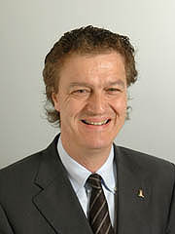
Cristiano De Eccher
De Eccher, a descendant of a noble family of the Holy Roman Empire, had a castle in Calavino near Trento. In 1969 he was 19 years old, a member ofAvanguardia Nazionale, a Padua University student and in close contact with Freda. He was one of the few people with whom the aristocratic Freda used the familiar form of address, perhaps because of De Eccher’s ancient aristocratic lineage. So De Eccher was a point of contact between the two Nazi groups. De Eccher hid the timers, but he was more loyal to Delle Chiaie than to Freda and was never to hand the timers over again. So much so that he provoked fury in the Paduan prosecution counsel who complained to a fascist colleague, Sergio Calore, “about being let down by a baron of the Holy Roman Empire”.
Since Freda could not deny having bought the timers, he claimed that he had passed them to a certain Captain Hamid from the Algerian secret services that supposedly asked for them to use in attacks on Zionist targets. Spectacularly, the judges believed this, not at all disturbed by the fact that the Israeli secret service, Mossad, stated that no Captain Hamid existed. The judges appeared to believe that it was perfectly plausible that an Algerian agent should have approached a law officer in Padua to obtain timing devices.
Meanwhile the electrician Fabris made only partial admissions to the court. Why? He had been threatened three times into keeping his mouth shut — twice by Massimiliano Fachini and again by Massimiliano Fachini in the presence of Pino Rauti.
In fact the timers had not gone to Algeria. They remained in the care ofDe Eccher who was under the protection of carabinieri Colonel Michele Santoro. Some ended up with the La Fenice group in Milan and some with Avanguardia Nazionale in Rome, which had used a few in the attacks on the Reggio Calabria express trains on the night of 21-22 October 1972.
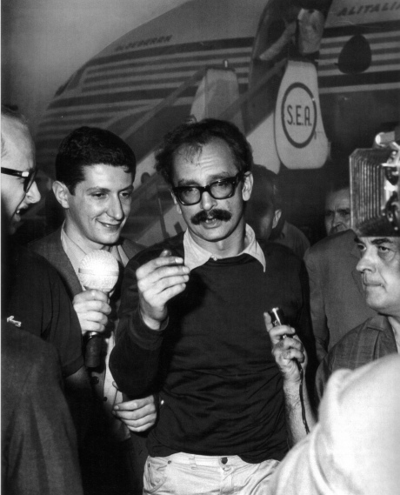
Giangiacomo Feltrinelli (1926-1972 - probably murdered!)
In 1973 La Fenice group militants prepared a plan to plant a few of these timers in a house belonging to Giangiacomo Feltrinelli (found dead in Segrate in March 1972) The house — in fact it was a chateau in Villadeati in the Monferrato— was the property of the Feltrinelli family who scarcely ever used it. A few militants from Giancarlo Rognoni’s group were to break into the chateau and hide the timers before tipping off the carabinieri. The purpose of all this was to steer the Piazza Fontana investigations back to the “red trail”, at a time whenD’Ambrosio was zeroing in on the fascists. But the scheme had to be shelved because Rognoni found it too far-fetched.
Two years earlier, Martino Siciliano and Marco Foscari from theVenice Ordine Nuovo had turned their attentions to Feltrinelli. Foscari had a family home in Paternion in Carinthia (Austria), not far from a chalet belonging to Sibilla Melega. Feltrinelli, whose was on the run at the time, often hid out in the chalet and it occurred to the two Ordine Nuovo members that they might kidnap him, ferry him back to Italy and leave him for the police to find.
So, armed with hunting rifles, behind the wheel of an off-road vehicle and accompanied by Foscari’s gamekeeper, a former Waffen SS member, off they went to grab Feltrinelli. They also had a bottle of ether to help them subdue the publisher, rope to tie him and a trunk in which to ferry him over the border.
But their plan was improvised and they were out of luck: “We had no problems locating the property where the chalet was, but Feltrinelli was nowhere to be seen and, anyway, the chalet appeared locked up. So we abandoned the plan as readily as we conceived it”, Siciliano recalled.
So much for the timers. Now to the gelignite. The bombings on 12 December 1969 did not use all the explosives; some were used later by the Venice Ordine Nuovo group.
Mestre, 27 October 1970. Siciliano was putting together a time bomb, but unsure as to whether or not he had primed it correctly, it occurred to him to connect to a shared fuse wired to the gelignite. Piero Andreattaplanted the device, which exploded, outside the Coin store in the Piazza Barche.
But the gelignite was used also in more telling and more lethal bombings. Delfo Zorzi handed Marcello Soffiati from the Verona group a bomb assembled using some of the explosive which he took to Milan where he handed it over to members of the Milanese Squadre d’azione Mussolini (SAM) (Mussolini Action Squads) who, in turn, sent it on to Brescia.
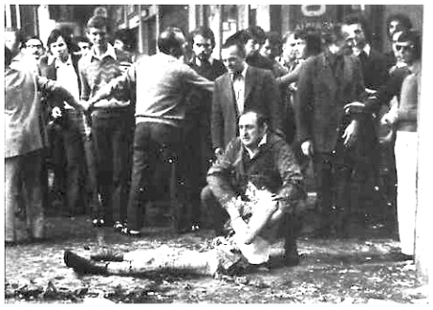
Piazza della Loggia. Brescia, 8 May 1974: bomb explodes during a demonstration sponsored by the Brescia United Antifascist Committee and local trade unions
This bomb exploded at 10.20 am on 28 May 1974, during a demonstration sponsored by the Brescia United Antifascist Committee and the trade unions in the Piazza della Loggia in Brescia. It went off during a speech by Franco Castrezzati the provincial secretary of the FIM-CISL. Eight people died and nearly a hundred people were injured. This incident triggered a falling-out in Ordine Nuovo ranks and relations between Zorzi and Soffiati deteriorated to the point where they became enemies. Soffiati could not forgive his Venetian colleague for implicating him in an operation of such significance, especially one that departed from the strategy adopted hitherto — planting bombs that could be blamed on the left.
Tags25 April 1969, 27 October 1970, 28 May 1974, Algerian secret services, Alvise Munari, Avanguardia Nazionale, Banca Commerciale Italiana, Banca Nazionale del Lavoro, Brescia United Antifascist Committee, Captain Hamid, Colonel Michele Santoro, Cristiano De Eccher, Delfo Zorzi, Elettrocontrolli, Fausto Giuriati, Franco Castrezzati, Franco Freda, Gerardo D’Ambrosio, Giancarlo Rognoni, Giancarlo Stiz,Giangiacomo Feltrinelli, Holy Roman Empire, Junghan-Diehl timers, La Fenice group, Loretta Galeazzo, Marcello Soffiati, Marco Foscari, Martino Siciliano,Massimiliano Fachini, Mosbach-Gruber, Mossad, Mussolini Action Squads, Ordine Nuovo, Piazza della Loggia bombing, Piero Andreatta, Pino Rauti, Reggio Calabria express train attacks, Ruhla brand timer, Sergio Calore, Sibilla Melega, Squadre d’azione Mussolini (SAM), Stefano delle Chiaie, Teonesto Cerri, tomb of the Unknown Soldier, Tullio Fabris, Venice Ordine Nuovo
CategoriesGladio, Italy, Piazza Fontana, State Massacre, Strategy of Tension

2: 13 December, 1969 — ‘Open up! This is the police!’
December 29, 2011 //
1

1 Vote

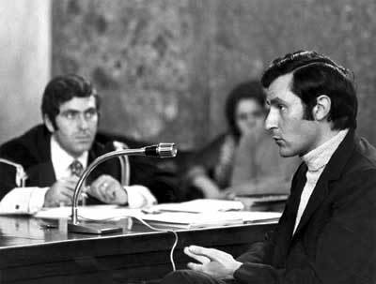, Socorrorso
Inspector Dr. Luigi Calabresi, anarchist specialist of Milan’s Special Branch
‘Horrific massacre in Milan’ ran the headline in the Corriere della Sera’s edition of 13 December. ‘Foul provocation’, screamed the front page of Il Giorno. ‘Massacre in Milan. A terrorist plan for Italy?’ asked La Stampa. ‘Horrific attack leads to awful massacre in Milan. Fits in with fascist provocations and reactionary intrigues’, suggested L’Unità.
But whereas the major newspapers confined themselves to reporting the facts — on the front page at least, and were not yet venturing any hypotheses, except for the PCI newspaper — there were already clear ideas emerging as to the identity of the perpetrators and brains behind the previous day’s massacre.
On the evening of 12 December itself, the prefect of Milan, Libero Mazza, sent Christian Democrat prime minister Mariano Rumor, a telephone message that did not beat about the bush:
“Credible hypothesis that immediate inquiries should focus on anarchoid groups as well as extremist fringe. Following consultation with the judicial authorities, strenuous steps already underway to identify and arrest those responsible.”
The suggestion was plain. And it certainly would not find the officers in charge of the investigation all at sea. Inspector Dr. Luigi Calabresi, deputy head of Special Branch at the Milan Questura (police headquarters), was already targeting leftwing extremists. Motive? Look at the targets: banks and the war monument.
As far as he was concerned they were a dead giveaway. His immediate superior, Antonino Allegra, was even quicker off the mark. The running of the investigation seemed to be following a ready-made script. Indeed, those arrested were primarily anarchists and members of the extra-parliamentary left, with only a few far right activists.
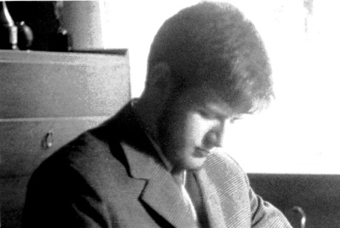
Paolo Finzi, 1970
THAT 12 DECEMBER Paolo Finzi was in bed with a temperature. A touch of ‘flu. Barely 18 years old he was a student at the Giosuè Carducci liceo (high school) in Milan where he was active in the school anarchist group. Another member was Fabio Treves who was to acquire celebrity several years later as a musician and city councillor.
Shortly before midnight there was a knock on the door of the Finzi household. It was the police. Paolo’s anxious parents, Matilde and Ulisse, were told bluntly: “We are taking your son to the Questura because because he a main suspect in the Piazza Fontana massacre.”
Matilde Bassani Finzi was not the sort of woman to shock easily. She was 51 years old and had been an active antifascist since the late 1930s, as a member of Soccorso Rosso (Red Aid) in her native town, Ferrara. From 1943 she played an active role in the resistance in Rome, working with the Bandiera Rossa (Red Flag) groups. She was a woman tempered by her past.
But that night Matilde Bassani worried for Paolo, the youngest of her three children, who had been taken to the fourth floor in the Via Fatebenefratelli, the offices of Milan’s Special Branch. The premises were crowded with leftwingers, mostly, except for four fascists who were chatting with the police.
Paolo spotted Giuseppe Pinelli. He knew him as one of the ‘old hands’ from Milan’s Ponte Della Ghisolfa anarchist group and founder of theCroce Nera Anarchica (Anarchist Black Cross). But there was another anarchist there, older even than Pinelli and whom Finzi knew as a friend of his parents: Virgilio Galassi. Galassi had been a militant in the libertarian movement since the war, but by 1969 he was no longer active. Yet he too was among the suspects rounded up. Why?
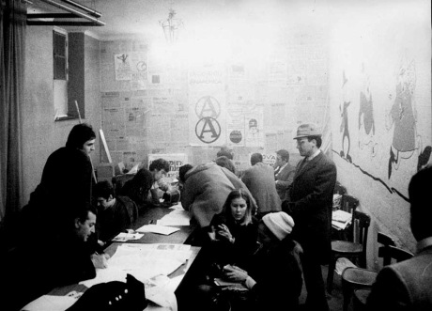
Meeting of the Ponte della Ghisolfa anarchist group
The reason is as straightforward as it is laughable: he worked for the training section at the Banca Commerciale Italiana, where the unexploded bomb had been discovered. But he didn’t remain long at the Questura and was released after the bank’s president, Raffaele Mattioli, intervened on his behalf.
The hours passed. The prisoners were summoned into another room, one at a time, where they were interviewed. It was the usual routine. Alibis were checked, opinions sought on what had happened and one final question:
“Who do you think it was?”
But the question was superfluous; the police had assumed from the start that the bombing was the work of anarchists.
The detainees were then moved downstairs to the holding cells. By the afternoon of 13 December it was all over and nearly everyone released.
But the police continued with their inquiries — or, rather, arresting leftwing militants. Unlike Paolo Finzi, Fausto Lupetti was not a boy: he was 26 years old, but was in the frame. A member of the Italian Marxist-Leninist Party which a few years earlier had split into two factions, a black (libertarian) and a red (Marxist), Lupetti, a publisher, belonged to the latter. What is more, this “pro-Chinese” was unusual inasmuch as he lived in a commune in a large apartment in the Via Mosso, off the Via Padova in Milan.
At 6.00 am. on 13 December the members of the commune were wakened by the arrival of the police. Everyone was taken to the station for questioning. Lupetti also saw Pinelli who was probably the best known anarchist ‘face’ in leftist circles in Milan.
“I remember the ground in front of him was strewn with cigarette butts”, recalled Lupetti who was taken later that evening to the San Vittore prison where he remained until 29 December, along with Pasquale Valitutti known as ‘Lello’, a young anarchist, and Andrea Valcarenghi, the leading light of the Onda Verde (Green Wave) group and, from 1971 onwards, the man in charge of the monthly Re Nudo.
On 15 December the front page of the Corriere della Sera carried the splash headline: ‘Twenty seven extremists held in San Vittore. Most are members of neo-anarchist groups tied to international organisations’. The thrust of the article, written by Arnaldo Giuliani, says much about the climate being created at the time:
“At the end of the first forty hours on inquiries, the investigation into the Piazza Fontana massacre can be summed up as follows: 1) so far, upwards of one hundred and fifty suspects drawn from opposing extremes have been arrested; 2) at 8.00 pm. yesterday, 27 youngsters most of them members of anarchoid groups suspected of connections with international anarchist movements were being held in San Vittore.”
The anarchist trail was explored in greater depth in the inside pages. A headline on page five read: ‘Anarchist old hands from the Diana among those rounded up in extremists’ dens’. The author of this report, Enzo Passanisi, profiled the Milan anarchist movement, as if to familiarise readers with the ambience in which the outrage might have been hatched:
“Italian anarchists are gathered together into a federation, the FAI […] But most of Milan’s anarchists, numbering up to two thousand — with active members and sympathisers — espouse an autonomous line. They consist of circles and groups, only one of which, the Sacco e Vanzetti group whose members are mostly older anarchists, is affiliated to the FAI. The other dozen groups are broken down according to their respective fields of activity.
“For example, the Lega anarchica Milanese (Milan Anarchist League), which is active in the university sector, has members in eight institutions of higher learning. There is also the anarchist trade union. It is worth stressing that the policy line espoused by the movement […] preaches subversion of society and the seizure of power by the masses directly through popular assemblies and labour communes, eschewing both government and parliament after the example of the Ukrainian Republic set up during the struggle between the Bolsheviks and the Russian Whites.”
Having described the ‘likely’ perpetrators, Passanini went on to describe the bomb. But not the one in the Piazza Fontana, but the one at theDiana theatre on 23 March 1921.
As an ‘historical precedent’, Passanisi had raised this matter with some anarchists from the Ponte della Ghisolfa. The answer he got was:
“A mistake. The intention was to strike at the magistrates staying in the hotel adjoining the theatre: the judges who were holding Malatesta in prison without a trial. Agents provocateurs from the police managed to get the target altered at the last minute and there was a massacre. A massacre that we have always deplored.”
This left the door open for Passanini to comment:
“There is always a margin for error between the attack that is acceptable to the anarchist line and the one that it repudiates. Could there have been a mistake made last Friday too?”
But the comparison between the bank bombing and the Diana bombing had been made as early as the evening of 12 December by Alberto Grisolia in the Corriere della Sera, the daily newspaper run by Giovanni Spadolini, who was more of an historian than a journalist.
“It’s akin to the Diana”, Grisolia told Giulio Polotti, class of 1924, the then secretary of the UIL in Milan a socialist deputy. (In the 14 December edition of the Corriere della Sera Grisolia wrote: “In terms of the seriousness of the attack, the only precedent in Milan is the Diana attack theatre attack […]”.)
Polotti, chairman of the Fondazione Anna Kuliscioff, recalled that Friday afternoon:
“There was a meeting of the three unions at the CISL premises in the Via Tadino to discuss plans for the strike over renewal of contacts. The news of the explosion reached us at around 5.00 pm., and so, in my capacity as a deputy, I made my way immediately to the Piazza Fontana to see what had happened. I stepped into the bank concourse and, horror!, trod on the arm of one victim. Then I climbed to the first floor, where the mayor Aldo Aniasi, prefect Libero Mazza, questore Marcello Guida and Cardinal Giovanni Colombo also arrived. By that point it was unmistakable — there had been a bomb. I telephoned Antonio Giolitti in Rome who told me there had also been explosions in the capital. After my telephone call I bumped into Grisolia who spoke to me of the bombings having an historical precedent in the Diana outrage.”
There was a similar atmosphere in Rome. The Corriere della Informazione wrote in its 14 December afternoon edition:
“Extremists of every hue did not sleep undisturbed last night. Throughout the city, police carried out a massive round-up of extremists of every persuasion, individuals involved in movements that have never made any secret of their subversive intentions.”
Further on the author of the article, Fabrizio De Santis, adjusted his aim: “These are clearly people who will shrink from nothing. They seek not only to strike fear into the population and signal their existence as challenging revolutionary elements. They seek to kill.”
The psychological and social climate was in place. All that was required was a monster to plaster all over the front pages.
TagsCroce Nera Anarchica, Diana Theatre, Errico Malatesta, Giuseppe Pinelli, Mariano Rumor, Paolo Finzi, Ponte della Ghisolfa, Soccorso Rojo, Virgilio Galassi
CategoriesGladio, Italy, Piazza Fontana, State Massacre, Strategy of Tension

I: 12 December 1969 — An Explosive Day
December 28, 2011 //
1

2 Votes

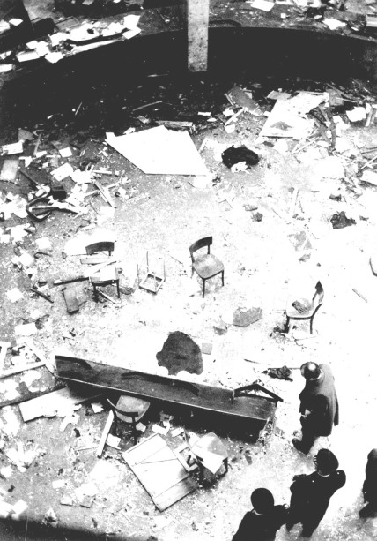
MILAN, December 12 1969: Banca Nazionale dell'Agricultura, Piazza Fontanta
The dapper, middle-aged gent who boarded Tram 23 at the Piazza Missori stop did not give the impression of some pop-eyed individual talking to himself, or haranguing the crowd in disjointed sentences. Yet, immediately after paying his 70 lire fare he stared straight ahead and exclaimed: “What was that? A burst boiler — or a bomb?”
A few of the passengers on the tram trundling towards Porta Romana continued either poring over their newspapers or chatting among themselves. Those closest to the middle-aged gent, however, gazed at him, partly stupefied and partly intrigued. The unsolicited speaker started again: “Coming from the Piazza Fontana, an inferno … there are ambulances, police, carabinieri there … there’s been an explosion at the Banca dell’Agricoltura …”
No one on board the tram, which was, moving away from the centre of Milan, knew anything as yet. The time was a little after five o’clock on the afternoon of another Friday in the run-up to Christmas. But this was no ordinary Friday. This was Friday 12 December 1969 and less than half an hour earlier, at 4.37 pm., a bomb had taken the lives of 14 people (a further two died in hospital) and injured about one hundred. It was a massacre, as the first helpers to reach the scene were to say.
The Piazza Fontana bomb was not the only one. Another device was found close to the Banca Commerciale Italiana in the Piazza della Scala. At 4.25 pm., an employee of the Banca Commerciale, Rodolfo Borroni, spotted a black bag abandoned near the entrance to a lift and picked it up in the belief that it belonged to some absent-minded customer. The bag was heavy. Borroni opened it, together with some colleagues, and discovered a metal box inside, a rectangular plastic envelope and a black disc with graduated markings from 0 to 60.
Nothing else. Someone suggested it could be a bomb. Brigadiere Vincenzo Ferrettino took the bomb into the court-yard and placed on the ground. It was a crucial piece of evidence, but four hours later, at 9.00 pm, Teonesto Cerri, engineer and ballistic expert, attached a TNT charge to the lock and blew the bag up.
Guido Bizzarri, an army NCO and bomb-disposal officer with more than forty years of experience behind him would later tell reporters: “I would have defused it, but nobody asked me to. There was more danger in blowing it up than in opening it.”
This was one of the first mysteries of that 12 December, one which was quickly followed by another. Almost two months later, on 7 February 1970, it emerged that in the bag containing the bomb there was a piece of coloured glass that the Milan police forwarded to the Criminalpol in Rome for forensic examination. Analysis showed the glass was similar to that used in Pietro Valpreda’s workshop in Rome where he manufactured liberty lamps. Valpreda was a Milanese anarchist who had recently moved to the capital.
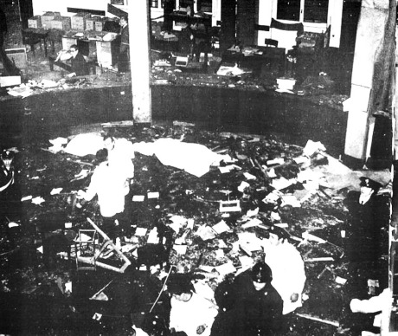
Milan, 12 December 1969: Banca dell’Agricoltura Piazza Fontana
The sequence of explosions on that incandescent day ended in Rome. Between 4.40 pm. and 4.55 pm, in an underground corridor at the Banca Nazionale del Lavoro in the Via Veneto, an explosion injured 14 of the bank’s staff. Within the space of ten minutes, after 5.20 pm., two less powerful devices exploded at the National War Monument in the Piazza Venezia. This time only four people were injured — onecarabiniere and three passers-by.
And so ended that day of massacre. Radio and television broadcast their first reports while newspaper sub editors decided on the banner headlines for the following day’s editions.
TagsGiuseppe Pinelli, Pietro Valpreda, state massacre, Strage di Stato, Strategy of Tension
CategoriesGladio, Italy, Piazza Fontana, State Massacre, Strategy of Tension

