AN OPEN LETTER
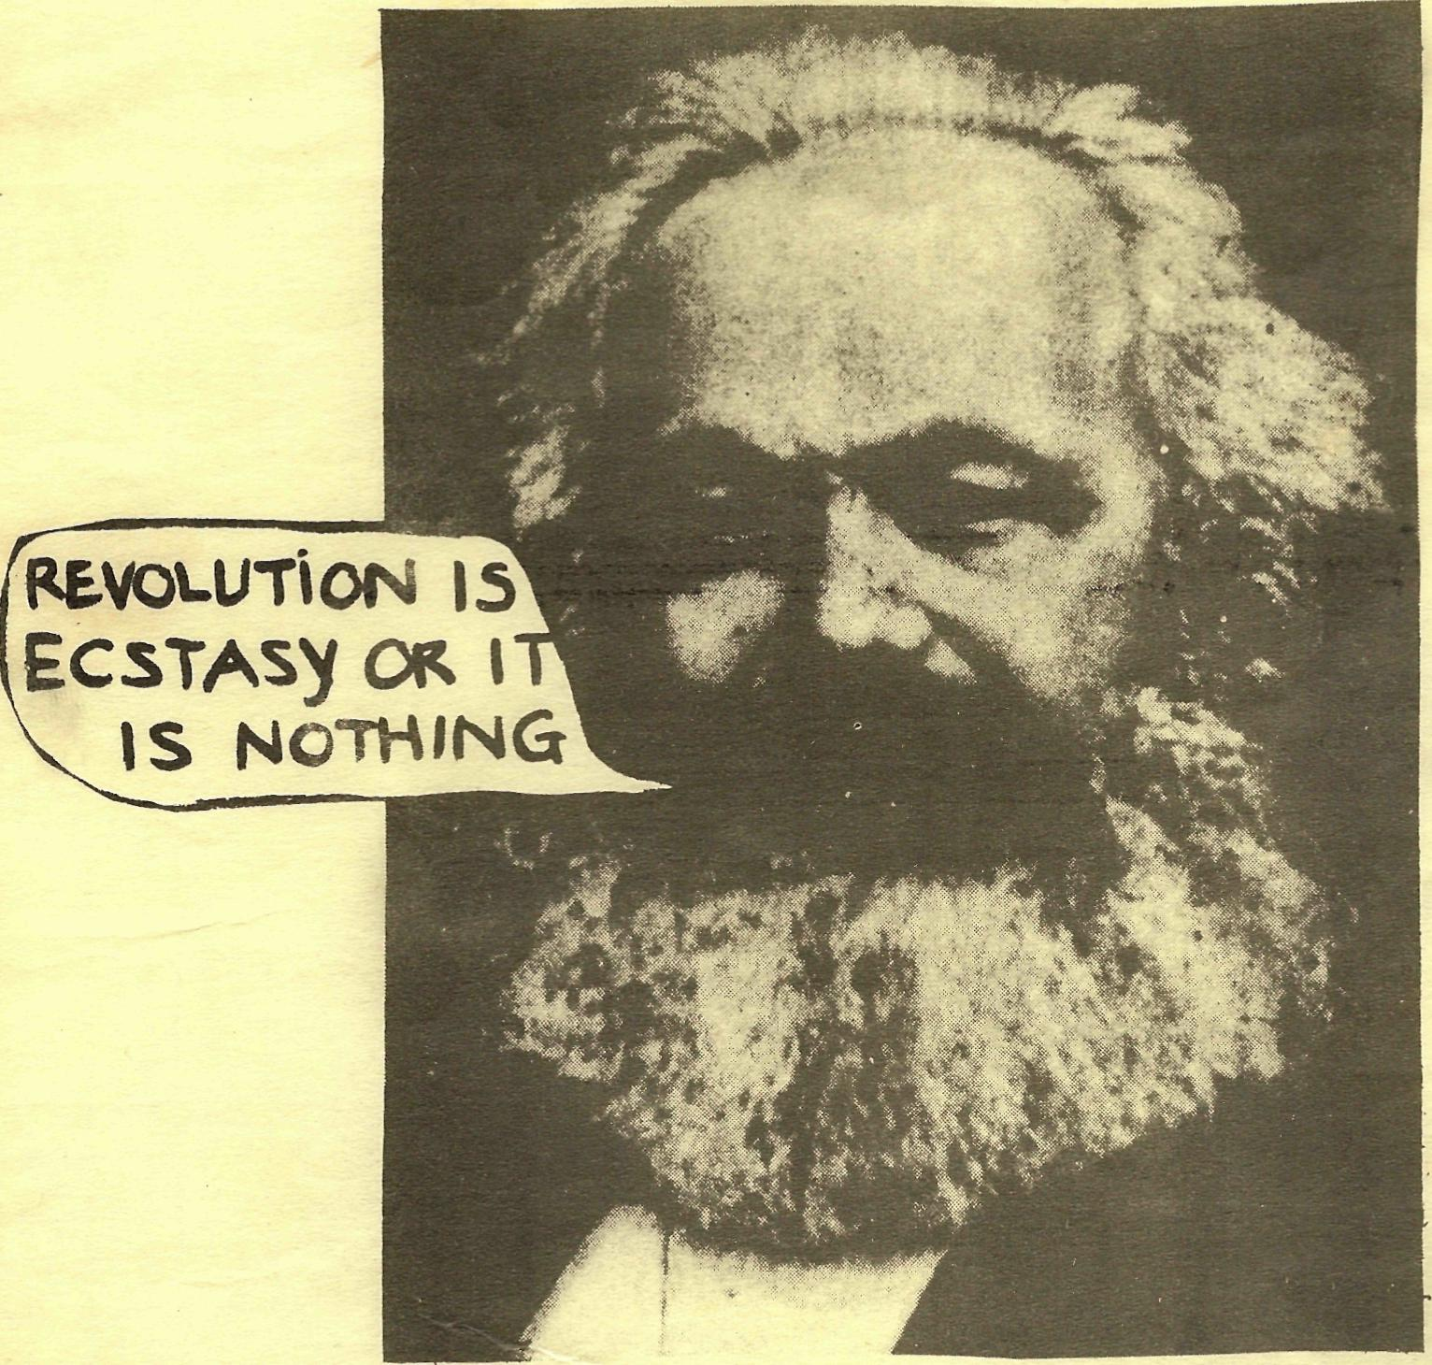
TO THE SPGB
AN OPEN LETTER TO THE SPGB FROM THE LONDON SITUATIONISTS
Table of Contents
FOR THE AUTOMATED ECONOMY OF ABUNDANCE 2
THE SPECTATORSHIP OF THE PROLETARIAT 2
THE MASK CAME OFF IN THEIR GLEEFUL HANDS 5
BUSINESSMEN THEY DRINK MY WINE 5
CHANCE WEAVES ENCOUNTERS WHILE PROBABlLITY MAKES FOR ACCOMPLICES 6
RECUPERATION 7
YOUR SPECULATIONS AND OURS 7
TO TOUCH THE TRUTH IS TO TOUCH YOUR GENITALS 8
EVERYTHING THE EYE SEES AND COVETS, LET THE HAND GRASP IT 9

FOR THE AUTOMATED ECONOMY OF ABUNDANCE
"Since the emergence of commodity-production, nothing in the world escapes the implacable development of this neo-fatality, the invisible ecohomic rationality: the logic of the commodity. Totalitarian and imperialist in essence,demands the entire planet as its turf, and the whole of mankind as its servants. Wherever the commodity is, there are only slaves."
(Internationale Situationniste, no 11, October 1967 )
Like you, we dont like being on the defensive, and we reject all solutions to our problems based on defensive strategies as futile. You call it Running Fast To Stand Still.
We likewise condemn reformist practices which change the shape of the system but not its oppressiveness, and incidentally create strata of reform parasites and defence-brokers, like lawyers, social welfarers shrinks, specialists of all persuasions, the new mind cops practising repressive tolerance.
We are desperate enough to demand revolution, immediate and now, beginning and ending in social relationships, and using our armed love to bring out desires to fruition.
Like you we see the revolution as necessarily being the project of the immense majority in the interests of the immense majority. We see through the shit of vanguardism and minority coup d' etats and the defeatist strategy of barricades.
We too wish to suppress the market economy on a global scale and institute production for use alone. We see that this will necessitate the dissolution of the State and its replacment by an administration of things, put an end to forced labour for all time and usher in an age in which the inherited technology will be freed from its market fetters and expanded to provide the economic basis for a society of play and unrivalled leisure.
Gone will be the widespread insecurity of the Rat Race of careerism and "meritocracy" (i.e. submitting to iae highepriests of productivity) People, instead of relating to each other impersonally as things will relate to each other as people capable of dialogue and subjectivity.

THE SPECTATORSHIP OF THE PROLETARIAT
The Situationist International developed the Theory of the Spectacle which is complementary to, and largely supercedes, Marx's Theory of Commodity Fetishism.
Now this is no exotic irrelevance or superfluity.
We gain strength every time we see men unafraid to use and transform all the objects which surround them, instead of accepting them as given, pre-packaged, immutable, the mocking talismans of our alienation.
We gain strength every moment we can exist other than as the pawns in someone else's game, as the subjects of our own destinies.
Since the only purpose we can see to life is the pursuit of untramelled pleasure, to feed the senses to capacity, to take that road of excess which alone leads to the palace of wisdom, to make the Reality Principle synonymous with the Pleasure Principle, we wish to organise the whole of social life to multiply and intensify good sensations.
We consequently recogniss the major obstacles presented by Great Art, Popular Entertainment, Ideeology and the vertigo of "keeping up appearances" all life is organised around the reception and projection of images.
Nowhere is reality encountered except in those free zones where experiment -alists have torn aside the veil of stereotypes, roles and simplistic dogma.
What is this reign of terror which insulates us in cocoons of delusion and how is it maintained?
Forced labour and its devitalising drain on mental and physical powers makes people unable and then unwilling to create situations for themselves: they need to be "entertained".
They are the captive audience which gives rise to whole industries organised to produce substitutes for their impotence.
The permanent anxiety of scrambling for survival inside the framework of careerist meritocracy makes men and women into synthetic hustlers. Appearance is primary, being is secondary. Experts and other monopolists ride the waves of imagery, at least to their guaranteed survival.
Art is "representative " in class society, i.e. not meant to stimulate the senses but to reverberate in the conceptual mind admist a web of ab -stractions, triggering off buzzes m>cated solely in the head.
The role of Art is to provide a separate, elevated sphere from everyday life, which compensates for the greyness and banality of the latter, and to "cream off" and isolate the most ambitious and talented members ef the population. And in compensating, of course, it legitimises.
Only when the energy dormant in everyday life, the long-unsolicited creativity of the masses, is unleashed in a revolution aimed at the suppression of work and the transcendence of mere survival will Art be realised, but only by suppressing it as a privileged sphere.
The revolutionary celebration has not yet begun; when it does we will make sure it never ends.

When the desires and perspectives of groups of people are represented politically by authoritarian experts and their authoritarian expertise, ideology has appeared in the classical Marxist sense, and the whole real movement is turned on its head, its leadership born of a fundamental lie. Political representation as always gets bureaucratised.
Art, ideology, entertainment- all one-way communications, all employing narcotic media. "The Spectacle is the guardian of sleep".
But it is not enough to analyse these spectacular phenomena as symptoms of the apathy and ignorance of the working class. We must question this very apathy and ignorance, and decide on how many fronts we can fight simultaneously. The Spectacle blunts the quest to realise desires without mediation.
In such an overwhelmingly confusing, privatizing, complexly alienating society, the Spectacle is the main enemy for us just as the clouds of religion were Marx's targets in his early years.

"Dialectics is a drunken revel at which not one member is sober" (Marx') so why does the S.P.G.B. still seek radio and TV time? Has it lost faith in its powers of dialogue? Must it now join the monologue of Power, at last uniting with "The Passing Show" instead of impotently opposing it with "Socialism as usual" (Head Office window poster in recent months.)
Dave Steele vs Bishop Montefiore (Granada's "7 Days") a threat to the media monopoly? Nah-just a new sensation for the TV voyeurs. Why get off our arses when conceptual ping-pong has already broken out in the Reality Studios? Weill be considering the possibility of anarchism in high places next.

THE MASK CAME OFF IN THEIR GLEEFUL HANDS
The failures of the Gordon Riots, the Paris Commune, the Petrograd Risings of 1905 and February 1917, Budapest 1956 and Paris 1968 were not that they were not explicitly aiming to abolish wage-labour and commodity-production, but that they forgot what they actually did,
They were intimidated and undermined by bureaucracies with vested interests contrary to such POWER WITHOUT MEDIATORS.

Money had largely ceased in these isolated explosions to mediate the relations between people. They had taken their desires for reality.
Intellectually, and at some distance from them, we can doubtless prove that they were doomed to defeat or degeneration. As, long as they were not conscious of what they had actually done in a practical sense only, and had not translated this theoreticalIy, they were the willing dupes of the eventual beneficiaries, the recuperators. But we bid you not to overlook their considerable achievements. As Marx said about the Commune: "For them, the supercession was there already".

BUSINESSMEN THEY DRINK MY WINE
In speculating how much energy lies dormant and repressed, one cannot avoid mentioning the contribution of Wilhelm Reich.
His concept of "character armour" was inseparable from his concept of "orgasmic potency" (or the lack of it ).
The development of defense mechanisms to deal with pain and revulsion, those characteristics of high-speed ruthless plastic civilisation, also reduces the capacity to recieve pleasurable stimulation by touch, smell and taste, to a greater extent than is realized. Such stimulation being ineffectual, the would-be "lover" resorts to all
kind of ruses to obtain satisfactory release the use of phantasy,
"extraordinary" stimulation (e.g. sadism, masochism), the adoption of archetypal roles.
BUT ONLY THE DISSOLUTION OF THE CHARACTER ARMOUR CAN SUFFICE, and the question of this dissolution is inseparable from the whole mindfucking, depersonalizing apparatus of modern society, from the system of forced labour down to the repetitive dreams of the sleepmachines, the Entertainments Industry and its spectacular weaponry (TV, radio, cinema etc.) and the Ideology Industry (all the saviors of the working class with their futuristic Edens).

CHANCE WEAVES ENCOUNTERS WHILE PROBABlLITY MAKES FOR ACCOMPLICES
In line with what has already been said about the great dangers of politically representing real social relationships, we must now dissect your Party.
And we judge it prematurely centralized, reflected in the stagnant and relatively impersonal branch life, where members merely carry on their charades through their "revolutionary" roles. You relate to people as potential recruits and not primarily as potential friends.
Socialism is not ready to be manifested in a centralized organization. Primary groups, episodic contacts, embryonic networks-the "occult" basis-is barely emerging even now. This is the first achievement, before we can even contemplate a formal organisation.
We believe that your founder members way back in 1904 expected a rapid take-off, a sharp escalation in the civil war after they had dismissed the SDF as counter-revolutionary and proclaimed themselves the political nucleus of the new society. They would surely shudder to see how the S.P.G.B. has faithfully reproduced the fetish of growth-for-itself within its ranks.
When a person joins the Party, he is subjected to premeditated indoctrination to "raise" him to the ideological level of official Party speakers.
The dialogue miscarries. If the new member is unwary he will be channelled into your own narrow visions of what revolution means.
People being the subject of creative spasms and consequent irregular output, we condemn the mechanical way the Socialist Standard comes out every month regardless of the quality of the content. The bureaucratic habits are infiltrating.
Even worse is the way SPGBers feel the need to be protected from the vices and eccent ricities and (dare we say?) sheer ignorance of their fellows via the Editorial Committee. Now this suggests several things. That anyone is allowed to join the Party provided he satisfies the minimum requirements (largely a memory sufficient to pass O-level Sociology). That once in, he must never be trusted.And that a handful of members monopolize the drive and creativity. All the others are mere reproducers of the ideology, and distributors of the journal. What a sepft -ration! The spectatorship revels in vicarious pleasure at the exploits of its own specialists.
Objectivity is the armoured myth of all specialists. All there is is consensus reality and heretics and madmen. Where would you say (objectively) we are at?
We Situationists are, as individuals freely associated, accountable to no group except insofar as we have made specific, not general undertakings.
Altruism, the equally ugly sister of ideology, is an open prison where everything is assumed and we have only the illusion of being together.
We organize around specific projects, not around an ideology, and certainly not around relationships.
Just as in modern capitalism the worker is encouraged to sacrifice his nervous system for the subsistence rewards at the end of the week, the SPGB unconsciously reproduces this mechanism.
They believe that socialism can only come if large numbers of proles (including themselves) see it as a mighty labour, to unearth the pot at the rainbow's end, the socialist millennium. (They have a bad dose of the Protestant Ethic)
But socialism as a movement can only be meaningful for its participants
if from the start they reject the promises of a technological Eden
as their motivation, and seek instead to make everyday life intrinsically
fulfilling.
NOW-NOT IN A GENERATION, NOT FOR OUR CHILDREN OR OUR GRANDCHILDREN.
RONEO REVOLUTIONARIES, SOCIAL ENGINEERS, SOCIAL ARCHITECTS!
KILL THE SPECIALIST WITHIN YOU, FOR THE SUPPRESSION OF POLITICS HAS BEGUN.
EVERYONE HIS OWN EDITOR.

RECUPERATION
The days are receeding when the union bureaucracies, the Labour and Social-Democratic Parties, the Bolshevik heirs and the more "enlightened" bourgeoisie can retard, with any force (using their unique brands of confusion)the growth of proletarian consciousness.
Ultimately, it will be the avant-garde politicos and other modernists who will be the saviours of the capitalist system of alienation and reification.
Just as the arty-farters like Lennon and Warhol and the so-called "Underground" pursue every new market, so the Solidarity crew with their ?self-managed sweat and the SPGBers who have not yet realized that boredom is counter revolutionary, will shepherd the black sheep back into the fold, and rip the balls out of those desperate for freedom.

YOUR SPECULATIONS AND OURS
No brothers and sisters, the economy will not fall into our laps because 400 pompous SPGB M.P.s vote on it, nor because these guys take over from the former paymasters of the State, the parliamentary gang of
bandits.
You yourselves realize this, and perhaps more prevalent among you is the "consciousness" argument, not basing itself on the State's fetishistic allegiance to the ruiing majority in Parliament, but on the armed forces' class-consciousness, and their unwillingness to be used against the working class.
But can you not stretch this stream of thought further and see through the whole parliamentary read to socialism as the fetish it is? It seems obvious to the Situationists that the working class, in the process of struggle- on the interpersonal level-will create all the organizations they need. The final confrontation between the proletariat and the bourgeoisie may be conducted though well-coordinated workers' councils.
The minor skirmishes and trial runs will be of the past, the expropriation will be imminent,the civil war will reach its climax as the jubilant proles dance through the former corridors of power. The State neutralized and then dissolved, the Society of Play will take off, into the realm of untrammelled freedom.
It seems obvious that the workers' councils will be the beginning, the means and the end of the present struggle. SOME ORGANS WILL BE NECESSARY and if the continuity of the revolution is to remain unbroken these will be the basic organs of post-takeover society, at all times being democratic, anti-hierarchical and involving voluntary participation.
The SPGB envisages 30 or 40 million happy balloteers stepping out one sunny morning to abolish capitalism. A majority of sober socialist M.P.s will attend the subsequent Parliament. (Perhaps the Queen will be there?)And the Shah will be Invited ?) And that bejewelled old buffoon the Serjeant-at-Arms will ring the Division Bell and the Speaker will, with trembling voice, announce the biggest cliff-hanger since Edward Heath was rumored drowned off Southend.
Maybe Granada and London Weekend TV will have David Dimbleby doing the commentary and Robert Mackenzie will be doing his fortune-telling (statistically of course) whilst William Hills and Ladbrokes will complete to offer the best odds......
But capitalism is not a THING to be "abolished”, it is a set of social relationships which must be transformed. Are the armed forces to be merely passive consumers of Parliamentary orders? Indeed, are we to tolerate the existence of a special detachment with the right to bear arms? No, the best guarantee of minimizing the violence of the reaction is for the proletariat to arm itself.

TO TOUCH THE TRUTH IS TO TOUCH YOUR GENITALS
Feudalism was a relatively static, stable society composed of
people with few aspirations at all except to survive and share in the
relatively rich community life of the Middle Ages.
It revolved around a set of unchallenged assumptions, with the central -reference point being "God", the fount from whom all legitimacy and power flowed. A mythology,yes, but a UNITARY mythology.
Everyone knew his station and was so socialized as to ensure that he would never have much cause for neurosis; as long as he discharged his obligations he could expect his statutory reward.
Then came the dynamically disturbing bourgeoisie with their technocratic rationality, their monster generalized commodity-production and their revolutionizing of the means of production. They developed the working class in their wake to take us into a new realm of possibilities......
The reconstruction of a new unitary society to replace the automized synthetic chaos of capitalism.

And we are the heralds of this new unitary society which will draw its power not from myth but from reality* from itself knd its own brilliant resources, and will have its own sensory delights and carnal desires as its central "reference point. ("Since God died "deviance" has died with him. Now everything is possihle and permitted"-De Sade)

EVERYTHING THE EYE SEES AND COVETS, LET THE HAND GRASP IT
We have learned that poetry must be made by all and not made by one, THAT POETRY CAN ONLY BE MADE BY ALL. Only in communist revolution, transforming the very relations between people, reaching into every private nook and cranny of the collective psyche can we avoid premature ageing, can we stop dying all the time. WE'LL BE WHOLE MEN OR DEAD ONES.
YOUR TURN TO PLAY, COMRADES!
Crucial dissatisfaction with the SPGB as a whole exists within its ranks, but the people concerned are not aware of the sources of their alienation.
As long as they refuse to accept as a minimum the previous theses, the dissatisfied will opt for surface tinkerings with the various manifestations of the SPGB which bear witness to its degeneracy.
Nothing less than a complete reconstructuring job is necessary to prevent the endless recurrences of contradictions in the SPGB.
And this reconstructuring job, profound and deep in its implications, requires nothing less than the dissolution of the organization, and its dis-integration into less impersonal face-to-face groups of friends. (I have no comrades who are not friends).
We realize that this proposal will be dismissed contemtuously; many older members have their own regularized life-styles, prestige and years of past "investment in revolution" at stake here.
But assuming that most delegates will give at least cursory attention to this document, they must realize that the very integrity of the SPGB is at stake.
A coherent reply is expected from those who remain in the SPGB, from those who still choose to see it as "the vehicle of revolution".

Failing this (and we contend that any reply from those defenders of the faith must be a failure) the SPGB must recognize the pre-eminence of the London Situationists, of the SPGB's self-proclaimed role as the party to which the working class must muster.
(Not that we at Ducasse/Mau Mau wish to assume this role
We see ourselves as catalysts and not as THE institution to wreak social transformation).
We appeal to all SPGBers who do not regard themselves as"mature" (i.e.having stopped developing),"responsible"(to whom?) and above all "sane", to resign from this shadow world of wooden postures gestures and terminology, to come round and meet us.
Better still, discuss this document (and anything else burning you, up) with the evil megalomaniacs (in the pay of foreign powers) present at Conway Hall distributing this statement to fellow April Fools.
So fuck this stilted conference with its innumerable role-playing speakers. Its not worth the gas!
A weekend spent reinforcing the ideology, sheltering from the sunshine, is a weekend spent further fucking up your nervous systems. A conference where there is no communication would be a comedy worthy of Chaplin were it not so tragic.
Why don't you talk about your wildest dreams, your desires, your "private" urges, why not (as even the Bolsheviks allowed Kollontai to do ) discuss your sex-lives?
This need not lead to the suspension of the revolution. THIS IS THE REVOLUTION, the exorcism of all imaginary and real barriers between people. THIS NEED NOT MAKE THE SPGB THE SUPER-POLITICAL ARM OF NEUROTICS ANONYMOUS. This is the only basis for the integration of the members into a real revolutionary community, instead of a more-or-less contractual association of individuals who separate their "public revolutionizing" from their "private lives".
I hope this clumsy tune I have played for you has struck some primordial chords en your minds. If it hasn't its because I am braindamaged too.
WHEN WORDS MAKE LOVE AND JOKES KILL THEN WE SHALL ALL BE FREE.
THIS OPEN LETTER IS ANTICOPYRIGHT; EVERYBODY MUST DO EVERYTHING THEY WISH TO DO WITH IT
ALL REPRISALS TO
(1) ISIDORE DUCASSE
(2) EALING MAU-MAU
(3) FRIENDS OF LAUTREAMONT
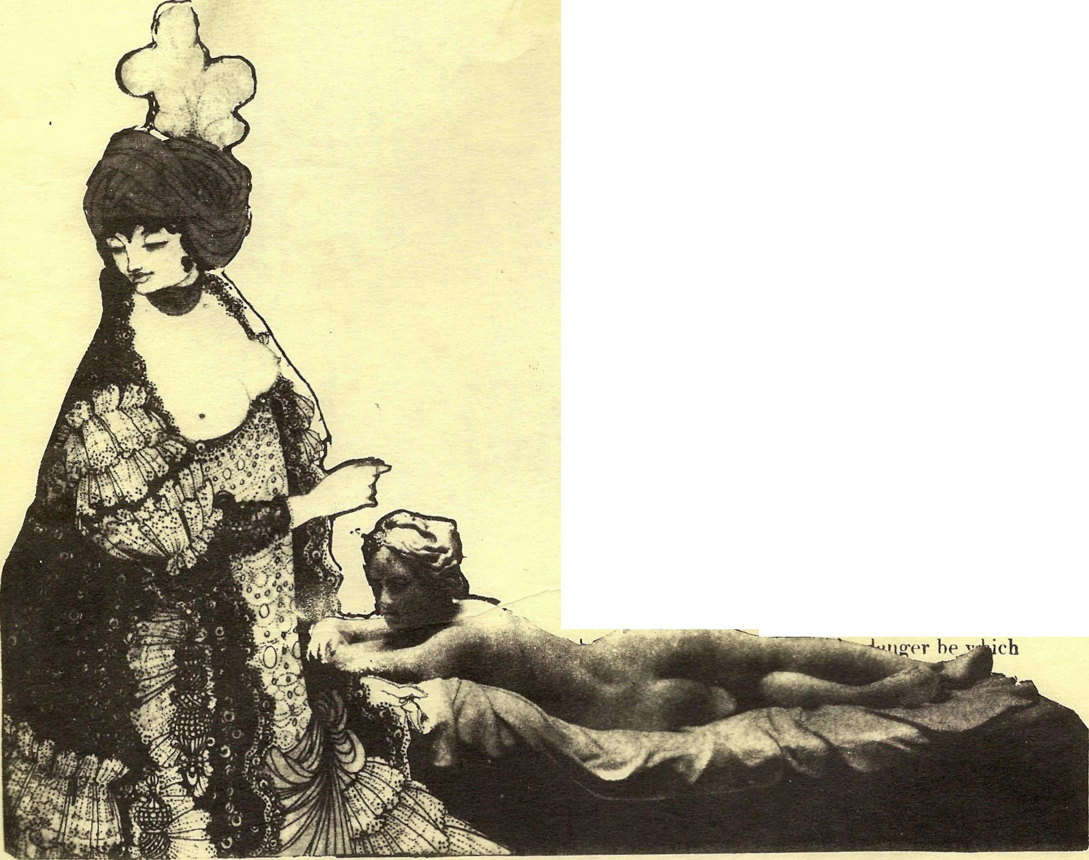
"And therefore," returned Mr. Dalben, "because children are ignorant, kind parents have been given to them, and they are early taught to trust these parents, and they may be sure, that, unless they are very odd sort of parents, they will not lead them into danger; therefore it is a mark of want of confidence, and o a blameable decree of cowardice, when a child refuses to follow a kind father who calls him to attend him,

