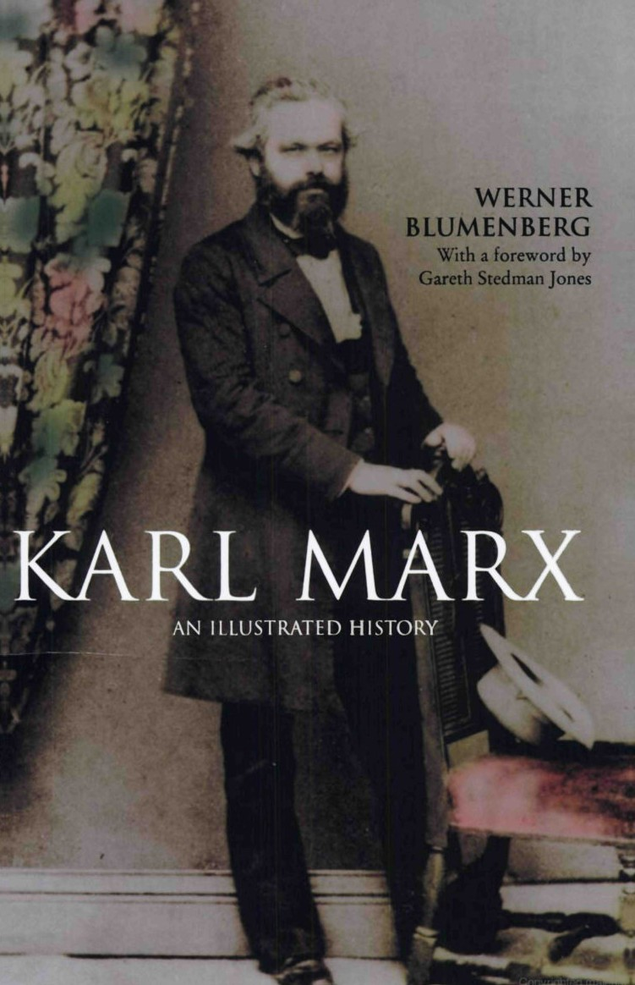

Portrait of Marx

Werner Blumenberg

Portrait of Marx

AN ILLUSTRATED BIOGRAPHY

TRANSLATED BY DOUGLAS SCOTT

HERDER AND HERDER

II  III I V | Introduction: The Problem of a aphy Ancestors, Family Life and School 5  Life at the University - Conflict with his Father 18 In the Ranks of the Young Hegelians and the Liberals | 37
v | The Power of New Ideas: Communism 51
VI  VII | 1848 - Revolution as Idea and Reality 83  First Years in London - The Sleepless Night of Exile | 97
VIII | The Wretchedness of Existence 109
IX | Journalism and Contemporary History 127
X | Lassalle: Marx's Dislike of
 | German Social Democracy 135
XI | The Intemational- A Life and Death Struggle 146
XII | The Unfinished Life-Work 158
XIII | The Finale and Posthumous Fame 168
 | Chronology 179
 | Opinions 182
 | Biblioaphy 187
 | Acknowledgements 192
 | Index 193

I
Introduction:
The Problem of a Biography

Particularly in the case of Marx, most critics (whether hostile or friendly) have concentrated on the work rather than the author, on Marxism rather than on Marx. They have not seen clearly enough that both the transitory and the permanent elements in his passionately tttbulent work can best be understood by considering the abilities, the historical background and the personal destiny of the man of flesh and blood. - Gustav Mayer

The voluminous literature of the ideological dispute between East and West is one indication that Karl Marx does not belong to the past, but rather that his influence, even today, continues to be the strongest intellectual force of the nineteenth century. This is shown even more forcibly by the fact that there are whole areas in which 'Marxism' has become a dominant and influential ideology offering a constant potential alternative to other forms of state and society.
More than ninety per cent of the confusing and overwhelming wealth of literature about Marx is concerned with his theories, and it is by no means true to say that every book helps to clarify these theories or awakens interest in the reader. There is continual argu­ ment about Marx's theories, and in the process the creator of them is deliberately overlooked. But Marx was not a scholar striving to obtain 'objective' knowledge ; he was (as Engels rightly said of him) 'more than half a revolutionary politician'. And therefore, since his theoretical work was openly intended to justify his political aims, it is hard to see why so little attention should be paid to the strong personality traits which were so important in the construction of this work.

2 Introduction : The Problem of a Biography

Hence the epigraph by Gustav Mayer, which dates from 1918, is still absolutely valid today. Nor can we take as completely absurd the view of E. H. Carr, with which he prefaced his biography of Marx written in the thirties : that the Marxist assumption that Marxism had come directly from heaven like the Tables of the Law, or had sprung fully-armed like Athene from the head of its creator, was completely unmarxist. For there is no reason to exclude Marxism from the Marxist law, which says that every idea is a product of the social conditions of the period in which it arose. Hence Marx's life must be important for an understanding of Marxism.
The classic biography of Marx is that by Franz Mehring, which also appeared in 1918; despite many other publications it has not been improved upon so far. Before and since, various biographies, large and small, have appeared which, depending on their attitude to Marx's ideas, have usually employed bright or sombre colours. Even the literature favourable to Marx is heavily interspersed with legend and prefers to adopt an apologetic tone. It is noteworthy that even Marx's supporters were always in a certain state of embarrass­ ment with regard to him : Marx was really different from how he had been represented, and they knew this.
This astonishing fact is illustrated by Mehring'S research itself. He was probably the person who was best acquainted with Marx the man. By far the most important source for a biography of Marx was his correspondence with Friedrich Engels, issued in 1913 after being seriously abridged by Bebel and Bernstein. All authorities as well as the leading socialists were agreed that drastic abbreviations were 'necessary', on both 'moral' and propagandistic grounds. It was impermissible for Marx to be as he disclosed himself. Marx, the discoverer of infallible objective laws operating with absolute cer­ tainty, must himself be entirely free from subjectivity, if he was to serve as a source of certainty. But now the correspondence with Engels showed that he was a person ofthe most extreme subjectivity, with the result that the very thing which constituted his greatness as a man was bound to impair the consistency of his views. In one of the reports he submitted, Mehring bluntly stated his opinion that, if this correspondence were to appear in full, all the efforts that he himself, Kautsky, Bernstein and others had been making for twenty years to preserve Marx's literary reputation would have been in vain. And although he recommended all future students of Marx to 'keep

Introduction : The Problem of a Biography 3

absolutely immune from all attacks of "Marxolatory" " we can see where his own better judgement led him to fob the reader off with not always very clear intimations.
To have published the Marx-Engels correspondence in full is one of the great services performed by David Riazanov, the founder and for many years the director of the Marx-Engels Institute in Moscow. This monumental work appeared from 1929 to 1931, in four solid volumes of the Collected Edition of Marx and Engels. Riazanov was justifiably convinced that Marx had the right to appear just as he really was; and that the world had the right to make the acquaintance of this great man as he actually was. But it was clear at once that Riazanov's great publication posed a number of problems to students of Marx which have still not been fully mastered even today. It was also clear that many accounts used as principal sources for portraying Marx's personality - such as those by his children or a number of his friends - had lost much of their value. These had not become com­ pletely useless; but now so much material of a different kind had to be set against them that Marx could no longer be viewed plainly and simply as a model citizen or hero, but was seen to be a very difficult and complicated personality.
Just as it was a great service to publish this correspondence, so it is a great pity that during the ensuing thirty years this rich material has not been used as the basis for a comprehensive and really accurate biography. The great work by Auguste Cornu has so far only reached the beginning of the forties, still a fairly neutral period. On the other hand the correspondence was responsible for the distorted picture that Leopold Schwarzschild drew of Marx. Werner Sombart, after his panegyric in Das Lebenswerk von Karl Marx (published in 1909), justified his change of heart about Marx by saying that the correspondence (which he only knew in the abridged edition) was 'nauseating' and showed 'what a thoroughly corroded soul had dwelt in Marx'. Marx's misere did not give him a better opinion of the man, but only shocked him; and later, of course, Sombart went much further. The same applies to Schwarzschild. It is astonishing that this eminent publicist, who produced one of the best German periodicals (with his Tagebuch during the Weimar Period, and his Neues Tagebuch during the emigration), could adopt the amazing opinion that a man was the sum of his mistakes, or that a work such as Marx's, with its immense scale and its world-wide application,

4 Introduction : The Problem of a Biography

could be explained in terms of weaknesses of character. However his view was not entirely accidental: he wished to reveal Marx as the origin of all totalitarian states, and wanted to forge a weapon for the Cold War. Even today it is possible for a French scholar, Maximilien Rubel, to speak of 'Marx cet inconnu'. And a great deal of detailed work is necessary before we can say that we possess a picture of Marx that does him justice.

II
Ancestors, Family Life and School

Karl Heinrich Marx was born on 5 May 1818 in Trier, then a small country town of twelve thousand inhabitants. His father, Heinrich Marx, was a lawyer, whose marriage with Henriette Pressburg had been blessed with four sons and five daughters. The eldest son, Moritz-David, died in 1815, soon after he was born. In Marx's life we shall later encounter the elder sister Sophie, as the wife of the advocate Schmalhausen in Maastricht, and also the two younger sisters: Louise, who married the law student Juta and emigrated to South Africa, and Emilie, wife of the engineer Conradi in Trier. During the time that Marx spent in his parents' house, up to 1836, four others - Hermann, Henriette, Karoline and Eduard­ were still alive. They all died young from tuberculosis. In this large family Karl Marx spent a happy childhood. Family life was harmo­ nious, and relations with the parents were affectionate; among their circle of acquaintances there reigned the sentimental atmosphere of the Biedermeier period. The family enjoyed a certain middle-class prosperity. The father acquired some standing in his profession, became a magistrate, and in 1819 was able to afford his own house, No.8 Simeonstrasse, close by the Porta Nigra, into which the family moved from the house at No. 10 Briickenstrasse, the 'Karl Marx House'.
The forbears of the father as well as the mother had been rabbis for many generations; it was an old custom that the children of rabbis tended to intermarry. Genealogical researches have given us some information about the family tree.* Jewish scholars have rightly

*B. Wachstein, 'Die Abstammung von Karl Marx' in FestsknJt i anledng af Professor David Simonsens 7o-aange ffJdseldag (Copenhagen, I923),
277 ff.; E. Lewin-Dorsch, 'Familie und Stammbaum von Karl Marx' in Die Glocke (Berlin, 1923), IX, I, 309 ff. and 340 ff.; H. Horowitz, 'Die Fam.ilie Lwow' in MonatsschnJt fur Geschichte ulld WissellSchaft desJudertrums (Frankfurt, 1928), T�, 487 ff.

6 Ancestors, Family Life and School

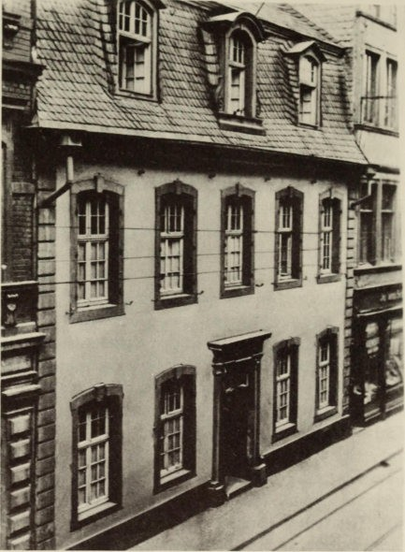

The house in Trier where Marx was born

objected that biographies of Marx have paid little attention to this family tradition. Thus Eugen Lewin-Dorsch says the following about Mehring's treatment in his big biography : 'In his book of more than 500 pages . . . this great expert and exponent of Prussian history has clearly not been able to interest himself greatly in this aspect of his biography of Marx. But we cannot help agreeing with Oncken when (in his biography of Lassalle) he says: "In a man's biography the period ofgrowth is always more fruitful and attractive

Ancestors, Family Life and School 7

than the period of achievement. . . . " Although - or perhaps precisely because - Marx almost deliberately overlooked his Jewish descent, it falls to his biographer to trace the threads that bind him to the Jewish world. And first we must pay attention to the rabbinical element. . . . Of course one must certainly not exaggerate the emphasis on such a background, but on the other hand one must not dismiss it too lightly. For instance Mehring says that Marx's father had already "completely outgrown his Jewishness", that the son "had takenover thiscomplete freedom from all Jewish prejudice as a valua­ ble gift from his parental home"; and that in the letters he received from his father "there were no traces, either good or bad, of Jewish­ ness ". Such an evasive and at the same time disparagingand ignorant verdict on the matter is of little use. It merely touches the superficies of intellectual life, the individual's consciousness of self; it does not penetrate to the depths, where the forces of personality are mysteri­ ously and invisibly formed. Marx himself has said, "The tradition of all past generations weighs like a mountain on the minds of the living. " And if we wish to understand the full humanity of this man, we must also take into account this inheritance from his rabbinical past, the importance of which he himselfcertainly never fully realized. The enlightened culture of his parental home, his father's conversion to Protestantism, even his own strong and steadily emphasized anti­ pathy towards the Jewish commercial spirit cannot really outweigh the "tradition of all past generations" which was present in him too.' Marx's father was born in Saarlautern in 1782, the third son of the Rabbi Meier Halevi Marx. The latter subsequently became the rabbi in Trier, and he was followed in this office by his eldest son Samuel, who died in 1827. There were a number of rabbis among his ancestors. In the family of the wife of Meier Halevi Marx we find many important scholars. This wife, the grandmother of Karl Marx, was Chaje, the daughter of Moses Lwow, who had also been a rabbi in Trier. And the latter's father, Josua Heschel Lwow, was Rabbi of Trier in 1723, and Rabbi of Ansbach after I733. He was a great scholar; and it was said of him that no decision was ever taken in the Jewish world without his opinion first being sought. His father in turn was Aron Lwow, who in his youth had also been the Rabbi in Trier and after about I693 was Rabbi ofWesthofen in Alsace. He was a son of the scholar Moses Lwow of Lemberg. Amongst his ancestors there were famous men such as the Craccw scholar Josef ben Gerson

8 Ancestors, Family Life and School

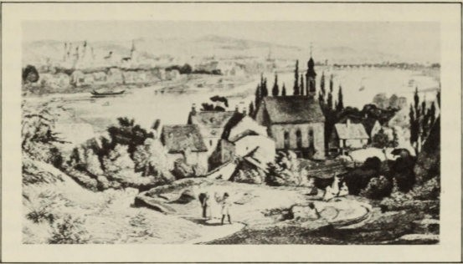
Trier in the early nineteenth century

ha-Cohen, Meir Katzenellenbogen, rabbi and head of the talmudic college in Padua (d. 1 565), and Abraham he-Levi Minz (i.e. from Mainz, died about 1 525) Rabbi of Padua. The latter's father (born about 1 408) had left Germany about the middle of the century on account of the persecutions and was 'one of the greatest authorities of the German and Italian Jewish communities'.
Marx's grandfather on his mother's side or one of his ancestors had emigrated from Hungary to Holland; this grandfather was Rabbi of Nijmegen. A sister of the mother, Sophie, married the banker Lion Philips, grandfather of the founder of the Philips business. Marx often visited this family in Zaltbommel ; he frequently had financial dealings with the uncle, who acted as trustee for his mother, and until 1870 he was certainly friendly with these Dutch relatives.
During the Middle Ages (which in the case of the Jews lasted until about 1800) the Jewish communities possessed full autonomy in their own affairs. From an economic, religious and cultural point of view, the communities carried on an independent life; as far as the state and city were concerned, they were represented principally by their rabbis. Since the communities largely had their own legis­ lation and jurisdiction for civil rights, the rabbi was also directly concerned in looking after these; it was to him, and not to the secular

AnustOTS, Family Life and School 9

court, that the Jews would appeal when they were in difficulties. The rabbi was not so much concerned with preaching and the cure of souls; he was first and foremost a teacher and a scholar. During the t-talmudic period the Jewish laws were no longer codified; judgement was ven on the basis of the Talmud, while in difficult cases this was done after written opinions had been invited from well­ known scholars. These opinions were founded on detailed exegesis according to established patterns. A glance at the literature concerned with these patterns - henneneutic induction, analogy, antinomy or syllosm - ves some idea of this method, making the fullest sible use of exegesis, extremely subtle and frequently leading to sophistries. At any event the delivering of theseopinions presupposed a comprehensive knowledge of the tradition, the Halacha of the Talmud, a knowledge that could only be acquired by unremitting study. In the family tree we are concerned with several men who were renowned in the literature of these opinions, men such as Joshua Hesche! Lwow and Josef ben Gerson Ha-Cohen. If we visua- lize the character of the early rabbihood, we may say that Karl

Marx's binh certificate

N: :'.1
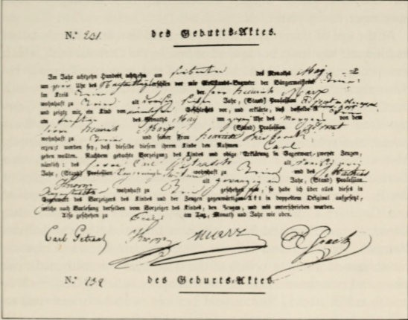

10 Ancestors, Family Life and School

Marx represented both the summit and the product of a century-old tradition of scholars.
There is many a trait in his personality that one is tempted to ascribe to particular ancestors, for example his combativeness to that same Joshua Heschel Lwow. On occasions it has happened that these influences have been summarily passed over, as for instance when Arthur Sakheim called him 'the exegetist and talmudist ofsociology' . Marx's astonishing gift for association, the acuteness of his thought, his power of exposition, the subtlety of his polemics and his mastery of dialectic have all been seen as the heritage of this long line of scholars trained in intellectual work and sharpness ofunderstanding. Georg Adler emphasizes the 'natural responsiveness of Marx's mind' to radical deduction, and his 'tendency towards abstraction, deduction and construction', which must have been even more strongly developed by his study ofthe philosophy of Hegel. However this may be, one must by no means overlook Marx's ancestors. Such is the view of all Jewish scholars, and hence of those best able to gauge possible influences (for example, Adler, Dubnow, Farb­ stein, Horowitz, Lewin-Dorsch, Mayer, Sakheim, Wachstein and de WoIfI'). Many researchers link Marx up with the old prophets. But this, like Marx's alleged antisemitism, is something we shall have more to say about later.
At the age of thirty-five, in the year r8 16 or 1817, Marx's father had himself baptized ; but instead of joining the Catholic faith, which was predominant in Trier, he adopted the evangelical creed. He chose the latter because, like Heine, he equated Protestantism with intellectual freedom. Whereas in Poland the education of Jews consisted solely of Hebraic and rabhinical studies, and anything outside this sphere counted as being hostile to religion (for example, Moses Mendelssohn's attempt to translate the Pentateuch into German met with a religious ban), in Western Germany the spirit of the Enlightenment had to some extent penetrated into evangelical and Catholic, as well as Jewish, circles. It was no accident that Borne, Heine, Hess and Marx all came from the Rhineland. Even Heinrich Marx had read Voltaire, Rousseau and Kant and emanci­ pated himself from the beliefs of the synagogue ; he cultivated deist views and recommended to his son 'the pure belief in God' such as one found in Locke, Newton and Leibniz and which was such an effective support for morality. But for him baptism was not, as it

Ancestors, Family Life and School 11

had been for Heine, merely the 'entrance-ticket to European cul­ ture'. It was not even necessitated by persecution of the Jews in the Rhineland and in Alsace at this time. A much more direct occasion for it was the situation of constraint created for the Jews by the reaction after the fall of Napoleon. In Prussia in 181 5 they were excluded from all public offices, and by a decision of the Minister of the Interior on 4 May 1816 the deftition of public office was extended to include legal practice and the carrying on of a chemist's shop. Even a recommendation by the president of the Commission for Sumary Justice, that (on account of his outstanding qualifica­ tions) Heinrich Marx should be accepted into the judicial service, was rejected by the Minister. Thus if he wanted to continue in his profession, which he had worked hard to enter despite privations and domestic conflicts, he would have to undergo baptism. This step meant a complete break with his family. His brother Samuel died in 1827 as the senior rabbi of Trier, and after that his sister-in-law and other relatives lived in the town. Naturally the families knew each other ; but nothing is known of any close bond between them. Nor is it known whether Heinrich Marx spoke to his son at the time about the reasons for his baptism.
The children were baptized on 26 August 1824, but the mother not until 20 November 1825 ; she delayed this step out of respect for her father who was still alive.
The pressure that forced Heinrich Marx to move over to Christ­ ianity tended to strengthen his liberal and oppositional inclinations. These were expressed in January 1834 at the social club, on the occasion of a banquet in honour of the Trier deputies to the Rhine Landtag. In his speech Justizrat Marx made mention of the King, 'to whose magnanimity we owe the first steps towards national repre­ sentation. In the fullness of his omnipotence he has, of his own free will, instituted assemblies of the estates, in order that truth should advance to the steps of his throne . . .'. Although the King had repeatedly broken his solemn promises to allow a constitution, there was absolutely no irony intended in this remark ; but the government viewed this banquet - one of many similar events that took place at this time under the slogan of a constitution - as being an expression of the liberal spirit. And soon afterwards there were great goings-on at the commemoration banquet of the social club. There was a singing of the 'Marseillaise', of 'Was ist des Deutschen VaterIand?',

12 Ancestors, Family Life and School

and other 'infamous songs'. Even Marx's father, denounced by certain officers, was involved in the subsequent investigation, and henceforth the government regarded him as one of those 'from whom no sort of conciliation was to be expected in the present tension between Prussia and the Rhineland'. Karl Marx was then sixteen years old.
At the same time the liberalism of the father was very moderate. He was altogether loyal and much too mild for his opposition to be really determined. His attitude towards Prussia was patriotic, in contrast to the anti-Prussian feeling that was predominant in Trier. When his student son was planning to write poetry, he recommended him to take, as the subject for 'an ode on the grand scale', some episode
from Prussian history, for example the Battle of Waterloo, which would do honour to Prussia and would allow 'the Genius of the
Monarchy . . . to play a role'. A poem of this kind would also help his son's career.
For five years Karl Marx went to the Jesuit school in Trier, which during the Prussian period was known as the Friedrich-Wilhelm Gymnasium. The school had a good reputation, chiefly owing to the fact that it was run by the Principal Wyttenbach who was very much respected by the people of the Rhineland as a Kantian and a liberal, although the authorities did not approve of him so much. He taught Marx history. In his leaving-certificate the candidate showed good marks in the classics, in German and in history, but was less industrious in mathematics and in French. His German essay was described as being 'really good', though the author fell 'into his usual mistake here of exaggeratedly struggling to find the unusual and ornate epithet'. It was stated that he could translate the Latin and Greek classics with care and proficiency, even the more difficult passages, 'especially those where the difficulty was not so much in the oddity of the language as in the matter itself and the connection of the ideas'. His knowledge of French was good, and also of religious doctrine and mathematics; he was fairly skilled in history and geography; on the other hand his knowledge of physics was only moderate.
From the candidate's religious essay, in which he was asked to show 'How the believer is joined with Christ according to John xiv, with all its necessity and consequences', attempts have been made to deduce a basic Christian attitude for Marx. But this is incorrect. The youth, who was baptized without being asked, could say nothing

Ancestors, Family Life and School 13

. • .• :Me ..- _ ". ..,_,_#.
'.I- - --:- _ t"- ;-\\ A..•fl. ..� -
''';>-{( -'- 4-. -C. ',_ L. •.•,-..j- '�-:-..!:-
_:-.*.f�_- .....��>-_.:.,-:� .. � __ �
')-"� --. , 1 ..- ••
..-.. ... � �.---;.-

. --- ..,.• . , --J J
�---,-. ..: .. �-�:!-, ..,_;. ;.1.:- ..,.
'--., ;t- L�� .. 1-_J � .... � .. ___ : .. __ ., :..",
-- -, �S.l. j;-"" �,�:_ ,.:.:'-_
.. --)-�'.:. ...:, -=_.- �.-.; -.:-_L.,,:.__ ... (.;:.
--Y, l __ 1>- J , "J ;;:,- ':... -·�--.I·I"'(-; I r..
.
··.):'� �� :":.2"-: ..)L:--_/:.�
':;':'-/,'-'-,-"., 'r .. ..:.•

--., r+ "'-__ .:/'- ""� .. :-. lIi't'_ ,,:ff-"'1.
-.,._.. _ ,_-'_, __ , �"'- 2:- �'-- �L.
.' _ ..... l -\-�--<.r-, _'j_�.J.:./"_ -d.. r...
�.�� /..�:.-- :>-:----:;-'­
'''''- --, -. -'·�fJ.
..t._�':.. ,) ./�-__ ;:'_j-.,. �.:.. .. ,��I
?N�£��_ .._;.. .,._ � .. 1--4.-, �
J

... � --,.:.o,;,-r--.A.-.'- (:-.; �'. :t-r-
(> J1- ,..,:;- .- - -) l 1- :<� :> 0":

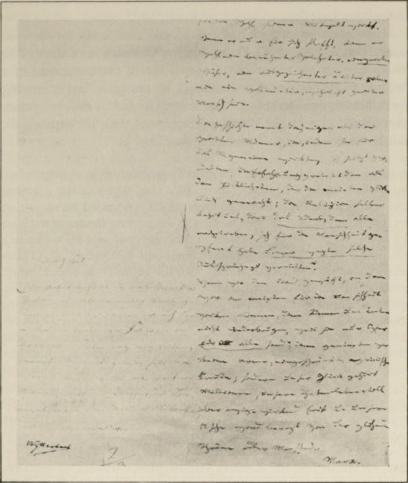
The last page of Marx's Abirur essay

about religious experience, As far as he was concerned, religion meant ethics : it was only through Christ that man had become capable ofa pure Christian virtue, something which 'the peoples of antiquity, the heathen', could not achieve. Hence there was a need for union with Christ, which could give
an inner elevation, comfort in sorrow, calm trust and a heart susceptible to human love, to everything noble and great, not for the sake of ambition or glory, but only for the sake of Christ.

14 Ancestors, Family Life and School

This must not be seen as a creed ; soon Marx was to reject Christianity as firmly as Judaism.
Much more important than this formal exercise is his German essay, 'Considerations ofa Young Man on Choosing his Career'. The seventeen-year-old sees man's vocation not in the attainment of a brilliant social position that will satisfy his ambition, but in striving for fulfilment and working for humanity. Guided by this, the young man should choose his calling to correspond with his capabilities.
But his choice could never be quite free ; for

to some extent we have already acquired relationships in society before we are in a position to decide them. [We should choose the position] which affords us the greatest honour, which is founded on ideas that we thoroughly believe in, which offers us the greatest chance ofworking for humanity and of drawing near to that universal goal for which any position is only a stepping-stone, namely self-fulfilment.... Those positions which are not concerned with life so much as with abstract truths are the most dangerous for a young man....If he is working only for himself he can become a famous scholar, a very wise man, or an eminent writer, but never a complete and truly great man.Accord­ ing to History the greatest men are those that have worked for the general good and ennobled themselves. Experience calls him the happiest who has made most people happy.Religion itself teaches us that the Ideal towards which all strive sacrificed Himself for humanity, and who shall dare to contradict such claims? If we have chosen the position in which we can accomplish the most for humanity, then we can never be crushed by the burdens because these are only sacrifices made for the sake of all. Then it is no poor, restricted, egoistic joy that we savour; on the contrary our happiness belongs to millions, our deeds live on calmly with endless effect, and our ashes will be moistened by the ardent tears of noble men.

This is the pure idealism of a young man who formulates his con­ ception of life and his vocation in a rapturous and solemn manner; it was later to have a tacit effect in the life-work of the man, in the form of an enthusiasm for social ethics.
Little is known of Marx's relations with his schoolfellows . For the most part they were the sons of artisans and peasants, about half of whom chose a religious calling. Marx must have been popular with them, since he joined in their rambles, but he must also have been feared for his sarcasm. Later on he only once mentioned a

Ancestors, Family Life and Schol 15

schoolfellow, who had become known as an officer; but he mistook him for his cousin. If he struck up friendships, they can only have be the ttual school friendships that do not generally last long. There was one schoolfellow with whom he kept up a friendship, but this was only because he became Marx's brother-in-law - Edgar von Westphalen, the brother of his future wife Jenny. He was a good­ natured, weak man, who gave up his studies and followed Marx to Brussels where he subscribed to certain Communist resolutions. Twice he ated to Texas, lost everything, and finally he died in the eighties as a small legal official in Berlin.When he came home in 1865, he spent months with the Marxfamily in London.At that time Frau Marxwrote about him to Frau Liebknecht: 'He was the idol of my childhood and when I was young, my sole beloved companion. I clung to him with all my heart .... In recent times I have had so often to deal with Karl's family, who treat me in a distant and alien fashion, that I hold fast all the mote closely to this single link that is left to me of my own family.'
Judging by his achievements at school, i'liarxwas just about average in his class. Doubtless his education owed more to his environment and his leisure activities than to the teaching. And by environment I mean principally his father and his future father-in-law, the Privy Councillor Ludwig von Westphalen. For the ripening maturity of the young man it was of the greatest importance, not only that these two men took him seriously, but that they were real friends to him. It is recounted that his father read French classics with him, and Westphalen read Greek poets and Shakespeare, and did so to such effect that Marxretained his enthusiasm for these writers all his life. Westphalen belonged to the Prussian administration, and no doubt he also spoke to his young friend about public affairs. We may assume that this was in a progressive spirit, since Westphalen also introduced him to Saint-Simon.Marx thanked him in the dedication to his Dissertation:

My dear fatherly friend, you will forgive me if I dedicate an insigni­ ficant pamphlet to your dear name. I am too impatient to await another opportunity to give you some smail token of my affection. Would that ail could be as happy as I in admiring an old man with the force of youth, who greets every advance of progress with the enthusiasm and soberness of truth, and with that convincing shining idealism that is the sole source of truth; one to whom all minds in the world are clear,

16 Ancestors, Family Life and Schol

who never trembled at the shadows of reactionary ghosts or before the gloomy clouds of time, but with divine energy and manly e saw through al pupations into the very empyrean that burns in the heart of the world. You, my fatherly friend, have always be a living aTgraTIa/twll ad ocuIos that idealism was no mere illusion, but the truth.

It is the curt view that l\1arx's father had very little understanding for him, and his mother none at al. As far as his father was con­ cerned this view is entirely false. His correspondence with his son while at the university gives us some very important clues about l\1arx's youthful development. The mother was not very well edu­ cated, but she was a woman with '.ery warm feelings who was entirely
absorbed in looking after the family. The son could expect no intel­ lectual stimulation from her. But she cherished a sal love for
him, although she realy always had to be looking after her sick
children. In her eyes, as in those of the father, Karl was 'the lucky one', much more gifted than his brothers and sisters, and she looked
on him with great pride. The parents praise his clear understanding, the purity of his feelings, his sincerity and the openness and honesty
of his character.When he was a student his mother sent him lots of
good advice, although it gave her a great deal of trouble to write in German. For example, in November 1835:* '...you must not think it merely a weakness of our sex if I am curious to hear how you have
established your tiny household, and whether economy takes first place in it as it must in al households large and smal, and here I must say dear Carl that you should never look n cleanliness and order as a trivial matter since your health and spirits depend on it, make sure that your rooms are scrubbed out often, keep a regular
time for it and wash yourself e,·ery week my dear Carl with soap

-
and sponge - how do you manage with coffee do you make it your­ self or what, I beg you to tell me everything to do with housekeeping, I only hope your beloved muse wil not feel insulted by your mother's
prose for I can tell you that humble things help one to attain the
highest and best, now if you wish for anything at christmas that I can give you then I shall be happy to do it, so goodbye my dear dear Carl, be a good boy, think always of God and your parents, your
10\-mg mother Henriette . Al the children send their love and kisses and as always you are the best and most beloved.'

"TraIlS/aIOr's r.ote: I have followed the lack. of punctuation in the original.

A ncesto rs, Family Life and Schoo l 17

The son s of his mother as Miitte rch en and 'Angel-Mother'. But he had no real inner bond with her. Immediately after the death of his father even the formal link with his family was broken. As far as his brothers and sisters were concerned, Marx seems to have had a close relationship for a tifte only with his eldest sister Sophie. She was a friend of Jenny von Westphalen and thus remained intimate with her and with her brother.

III
Life at the University Conflict with his Father

Marx was at university from October 1835 until March 1841, at Bonn and Berlin; he spent two semesters at the former, and nine at the latter. At the wish of his father he studied law, although his father had not required him to practise it. Later on Marx himself described jurisprudence as being his subject; but in fact he only studied it as a subordinate subject to philosophy and history. In practice, lectures in law began to figure less and less in his studies, while their place was now filled by philosophy and history. In Bonn, besides attending the regular law course, he gave himself a taste of the humanities with 'Mythology of the Greeks and Romans', as well as modern art history and August Wilhelm von Schlegel on 'Questions about Homer' and 'The Elegies of Propertius'. Again in Berlin the first semesters were largely taken up with jurisprudence. In addition to Savigny on 'Pandects' he chiefly went to hear lectures on criminal law and Prussian provincial law, given by the liberal Hegelian, Eduard Gans. Of philosophical lectures he heard only one on logic given by the dry Hegelian, Gabler ; but he also attended lectures on anthropology and geography. During two semesters he put his name down for no lectures, in one he attended only a course of lectures on Isaiah by his friend Bruno Bauer, and in one other semester he went to only one lecture on Euripides. As regards the lectures by Gans and the one on logic he is reported to have shown great industry ; in the case of the former he was attracted chiefly by the lecturer, who also dealt with contemporary questions, and in the latter by the subject. Since no lists have been preserved we do not know which other lectures were of interest to Marx.

One thing that is certain is that in the field of his own subjects,
philosophy and history, he largely went his own way. This is clear

Life at t he Un ive rs ity - Conflict w ith his Father 19

from a series of student-notebooks for the years 1840-1, which contain extracts from the works of Aristotle, Spinoza, Leibniz, Hume, and notes on the history of Kantian philosophy. It is con­ spicuous that a part of these extracts made on the reading, as well as the Dissertation, are not in the hand of Marx himself but have been written by a copyist. There are no indications of an intensive study of Hegel, such as was encouraged in the circle of the Young Hegelians. It is interesting to note that Aristotle is studied in connection with Hegel and his dialectic is developed:
If Aristotle takes synthesis to be the basis of all error, this is entirely correct. Reflective thought is in all respects a synthesis of being and thinking, of the universal and the particular, of appearances and reality. So then all incorrect thinking, including incorrect perception,

The Trier student club in Bonn (X=Marx)
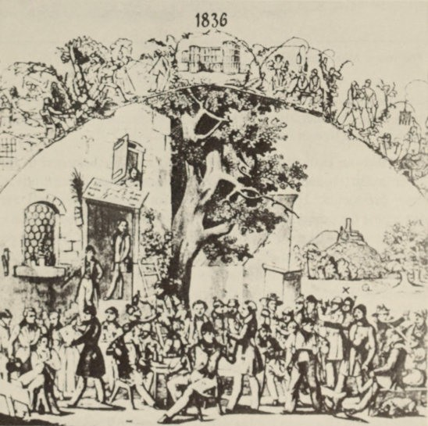

20 Life at the Unive rsity - Conflict with his Fathe r

'.-

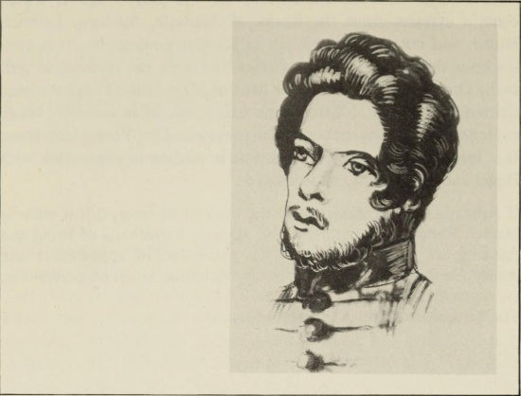
The young Marx (enlargement from the previous picture)

consciousness, etc., consists of syntheses of such determinations as do not belong together; it does not consist of immanent relationships between objective and subjective determinations.
Marx took an enthusiastic part in student life. He belonged to the Trier group (student corps were forbidden) and even became one of their presidents. He was imprisoned for drunkenness and for disturbing the peace, and was accused of carrying prohibited weapons. Once he even took part in a duel. In the certificate he received on graduating from Berlin it was noted that he had several times been accused of debts, but that he had been acquitted ofparticipating in a prohibited association among the students.
We are much better informed about Marx's literary efforts, which may have given him some claim to merit in Bonn and during the first year in Berlin. In Bonn he belonged to a poetry circle of which Emanuel Geibel was also a member. For a long time Marx was seriously occupied with literary plans. He was even thinking of founding a periodical for dramatic criticism, and he sent poems to Adalbert von Chamisso for his Musenalmanach. Although the young

Life at the University - Conflict with his Father 21

poet soon repudiated his productions, two 'Savage Poems' were considered worthy of publication in the Atheniium. He assembled his pieces into three notebooks of poems and songs which he sent to his betrothed, and one book entitled Poems which his father received on his birthday: romances and ballads, one act of a hair-raising tragedy in verse, and several chapters of a comic novel in which philistinism is satirized in the maner of Laurence Sterne and E. T. A. Hoffmann. As early as 1839 he had made a collection for his betrothed of folk­ songs from various sources. All these efforts are on a-considerable scale, and for a long time Marx wavered between philosophy and poetry, returning continually to his earlier productions. Later on he laughed at these verses as youthful follies; and ever since Mehring declared them to be valueless, every critic has agreed with this view. Hence they are only of biographical interest. They lack technical form and show an exaggerated expression of will and feeling, and in presenting the individual problems of a young man: melancholy, longing, love, disappointment. One poem runs:

Never can I calmly practise
that which strongly ips my soul, Never can I rest in comfort
And I rage unceasingly.

For I wish to win al prizes, Every favour of the Gods, Daringly press on in knowledge And embrace all art and song.

Therefore let us venture al things, Never resting, never stopping,
But eschew a gloomy silence Or a lack of wish and deed.

Nor descend in an.xious brooding To that other humble yoke,
For the power to wish and clamour And to act, is wift us still.

Apart from philosophical aphorisms there are a large number of ballads and romances, in which the usual themes of romantic literature are dealt with and all the familiar requisites of romantic

22 Life at the University - Conflict with his Father

poetry appear: an enchanted harp, nostalgia, love of the night, the song of the sirens, the singing harp-girl, the pale maiden, the magic boat, the man in the moon, a dream-picture, night thoughts, and so forth. At this time Marx also seems to have kept a journal, and during the Biedermeier period the usual reason for this was not in order to fill it with one's abundant emotional life, but in order to let those close to one share in it. Thus he occasionally imparted some of it to his father. As for his novel, he himself considered the humour was 'forced'; and we shall be quite ready to believe that he lacked a sense of humour when we read his great letter of confession to his father. This curious report, the only letter we know Marx to have written to his parents, tells us something about his inner develop­ ment; it was occasioned by serious disagreements with his father, who was watching his son's development with growing anxiety. For Marx, the relationship with his father was of the greatest importance. Apart from four letters from his mother and his sister Sophie, the only family letters he kept were the seventeen letters from his father; and it is said that for the rest of his life Marx always carried a photo­ graph of his father, which Engels put into his coffin with him. In the way his relationship with his father developed we see a reflection of the development of the young Marx's personality. If we rely to a large extent on the letters of the father, it is because they provide a mirror of particular clarity; for the father took a special interest in all Karl's affairs, and he possessed a quite extraordinary understanding
for his difficult and highly-gifted son.
The elder Marx expected much of his son and made great demands on him: 'I should like to see in you what I myself perhaps might have become, if I had seen the light under such favourable auspices. It is in your hands to fulfil or to destroy my greatest hopes.' But he makes no excessive demands, and does not spur his son on to work harder; on the contary he is afraid that he may overtax himself: '. . . Don't wear yourself out. You've got time enough, please God, to live for the good of yourself and your family, and also (if! divine correctly) for the good of humanity.' He begs him to look after his health, 'there is no more pitiable being than a sickly scholar'.
He is just as reluctant to stipulate any particular career for his son; this is remarkable in that time of patriarchal authority, when a career in a middle-class profession was usually laid down at the beginning of a course of study. When after two semesters the son

Life at the University - Conflict with his Father 23

begins thinking of an academic teaching-post, the father takes a serious interest. But he leaves his son completely free about this; there is not even any question of the faculty, although the son is studying law.Even philosophy seems quite acceptable to the father, and much more suitable to the son.
The father is just as understanding about his son's literary plans, although he is quite baffled by several productions : '. . . a p ropos ! I have read your poem carefully. I confess to you frankly, my dear
Karl, I don't understand it - either the real meaning or the general
drift. . . . Do you delight only in abstract ideal notions (just about equivalent to nonsense) ? In short, tell me the answer, I confess my limitations.' He altogether agrees with his son that the poems should not be printed immediately; a poet or writer should be able to offer something powerful if he wishes to appear before the public. 'I tell you frankly, I am really pleased with your abilities and I expect much from them, but I should be sorry to see you turn out to be an ordinary sort of little poet. . . . One has to be outstanding before one has the right to claim the attention of the jaded pUblic.' The father discusses with his son in detail the plan for founding a maga­ zine of theatrical criticism. He thinks it will be very difcult to win the confidence of a good bookseller : ' If you succeed in this - and you have always been a lucky one - then comes a second [question]. Either philosophy or law or both of them together would seem excellent as a foundation. Genuine poetry can well take second place, and will never injure the reputation, unless in the eyes of certain pedants,' and the father does not count himself one of these. When Karl had been in Bonn three weeks and had not yet written, his father accused him of 'infinite laziness' : 'Unfortunately I find that this confirms only too well my opinion that, in spite of your many good qualities, there is a predominant egoism in your personality.' But after his son has written back, he hastens to confess that he is wrong and gives the anxiety of the mother as the reason for the reproach. He is convinced of his son's good qualities. He begs that his son will always remain as sincere and frank, and will look upon his parents as his best friends. In many small matters he gives him good advice. The son ought not to neglect social connections that might be useful to him ; and he himself takes some trouble to procure such introductions. With reference to the teaching-post, he recom­ mends his son to train his voice a little ; for Marx always retained

24 Life at the University - Conflict with his Father

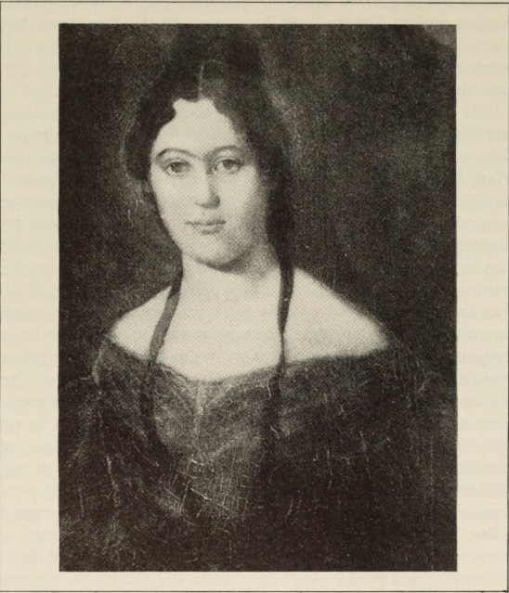
Jenny von Westphalen

certain traces ofthe Rhineland dialect. He also implores him to write more legibly.
Then came a conflict which only ended with the death of the father : in autumn 1836 Karl became secretly engaged to Jenny von Westphalen, who was four years older than him. The father was frightened that his son might place himself in an equivocal position with Jenny's very respectable family, especially as the girl was much courted ; and he himself had so much respect for that family that the

Life at the University - Con flict with his Father 25

ambiguous relationship was a heavy burden to him. So his demands to his son became more urgent : 'A man has no more sacred duty than that which he assumes towards a weaker woman. . . . But if after serious self-examination you really persist in this view, then you must become a man at once. . . . You have taken on important duties, and my dear Karl, at the risk of offending you, I must speak my mind in my own somewhat prosaic fashion. With al the exaggerations and exaltations of love in a tic mind you wil not be able to secure the tranquilty of the being, to whom you must devote yourselfentirely; on the contrary, you run the danger of destroying this tranquilty . . . . She brings you an inestimable treasure - she demonstrates a self­ denial which only the coldest reason can fuly estimate. Woe to you
if you do not remember this for the rest of your life ! But now at least
you must act for yourself. You yourself must provide the certainty that, in spite of your youth, you are a man who deserves the respect of the world. . . . I beg and implore you, now that you realy possess
this treasure, although everything is not yet smooth, to moderate these storms of passion, and take care not to stir them up in the breast of this being who deserves and requires calm . . . . You know,
my dear Karl, that for love of you I have eed to something that is not really in keeping with my character and from time to time it certainly ves me anxiety. . . . I canot and will not conceal my weakness towards you. Sometimes my heart revels in thoughts of you and your future. And yet sometimes I canot drive away sad, ominous, fearful ideas when the thought suddenly creeps in : does your heart match your head and your abilities ? D oes your heart really have room for the earthly but gentler feelings, which are so very comforting to Man in this Vale of Sorrows ? And, since your heart is clearly enlivened and governed by a spirit that is not given to all men, I ask whether this spirit is of a heavenly or a Faustian nature ? Do you think - and this is not the least painful ofmy doubts - that you will ever be capable of feeling a truly human, a domestic happiness ? . . . You will ask what has put these ideas into my head. Well I have often had similar fantastic ideas, and I could easily chase them away, for I have always had a great need to give you all the love and respect I was capable of, and I am glad not to think of myself.
But I see a striking phenomenon in Jenny. She occasionally shows

involuntarily a kind of fear, a fear full of foreboding, which I canot
help noticing. . . . What can this be ? I cannot explain it, but

26 Life at the Unive rsity - Con flict with his Fathe r

unhappily my own experience will not allow me to be easily misled about it. Your advancement in the world, the flattering hope of eventually seeing your name highly renowned, as well as your happi­ ness on earth, are all close to my heart, they are illusions I have long fostered. . . . But 1 can assure you that the realization of these illusions would not be enough to make me happy. Only if your heart remains pure and beats like a man's, only if no demonic spirit has the power to alienate your heart from better feelings - only then shall I find the happiness that for years I have been dreaming I might
. find through you; else I should see the finest goal of my life des­ troyed. Yet why do 1 indulge myself and perhaps sadden you ? Really I have no doubt of your love towards me and your dear mother, and you know very well where we are most vulnerable. . . . Perhaps it is a very good and salutary thing that immediately on entering the world you are forced to show consideration for others, yes, even wisdom, foresight and mature reflection, in spite of any demons. . . . '
This letter hit the son very hard. He became impatient because his fiancee refused to write before the engagement was announced. His father appealed to his manliness and rebuked him : 'I leave you to judge for yourself whether I was right to get angry. You know very well, you must know, the love I have for you. Your letters (insofar as they are not merely sickly sentimentality and gloomy imaginings) show need enough. . . . Although I love you more than anything - with the exception of your mother - I am not blind, and I wish to be even less so. 1 give you your due entirely, but I cannot quite get rid ofthe idea that you are not free from egoism, that you have more ofit than one needs for self-preservation. . . . Don't throw the blame on your character. It's no use accusing Nature, she has certainly
treated you like a mother. She has given you enough strength, and will-power depends on the man. But to yield to pain at the smallest difficulty, to lay your heart bare at every sorrow and to tear apart our love for you, do you call that poetry ? . . . No, it is only weakness, pampering, egotism and conceit that reduce everything to self in that way and thrust one's dearest ones into the background ! . . . But for your own sake I shall never stop lecturing you until I am convinced that this blemish has gone from your otherwise noble character. . . .'

Life at the University - Conflict with his Father 27

It was perhaps too much to expect that at nineteen years of age one should be full ofworldly wisdom ; but ifat this age one was going to bind to oneselfthe fate ofa young girl, then one must have a sober grasp of 'the real meaning of life'. The father's remarks do not show any anger at the course adopted by his son ; but they do show a growing anger that the son is entering into bourgeois obligations without troubling himself about how these obligations can be ful­ filled. Finally he asks for a concise review ofhis son's 'positive studies in law'. When the son does not comply, but instead sends a 'piece of writing without form or content, an incoherent uninformative fragment', the father reprimands him seriously : 'Your previous letter had said much to arouse my expectations. I had written several times asking for detailed information. And instead of that I get a disjointed and incoherent and (which is even worse) a confused letter. To be frank with you, my dear Karl, I do not like that modern word, which is one that all weaklings hide behind when they get angry with the world because it does not give them splendid palaces and carriages and untold millions without them having to do any work or have any trouble. I find this confusedness revolting, and you were the last person I expected it from. What reason can you have for it ? Has not everything smiled on you since the day you were born ? Has Nature not showered gifts on you ? Have your parents not squandered love on you ? Have you ever lacked anything to satisfy any wish within reason ? And have you not won in a marvellous fashion the love of a young woman, whom thousands envy you ? And yet the first sign of opposition, the first disappointed wish, brings out all this confusion ! 1s that what you call strength ? Is that a manly character ? . . .'
This letter crossed with Marx's great confessional letter of 10 November 1837, which certai1'l.ly gave a review ofhis 'positive studies', but otherwise confirmed all his father's fears regarding the future :

Dear Father,

There are moments in one's life that represent the limit of a period
and at the same time point clearly in a new direction. . . .
So now that I am casting an eye back over the events of the year that I have lived here, and thus answering, my dear Father, your most precious letter from Ems, allow me to consider my situation (as I do

28 Life at the University - Conflict with his Father

life in general) as the result of an intellectual actiVity that finds expression on all sides - in science, art and personal matters.
When I left you, a new world had just begun to exist for me, a world of love that was at first drunk with its own desire and hopeless. Even the journey to Berlin which would otherwise have charmed me completely, excited me to an admiration of nature and inflamed me with a zest for life, left me cold and even, surprisingly, depressed me ; for Ule rocks that I saw were not rougher, not harsher than the emotions 'of my soul, the broad cities not more ful of life than my blood, the

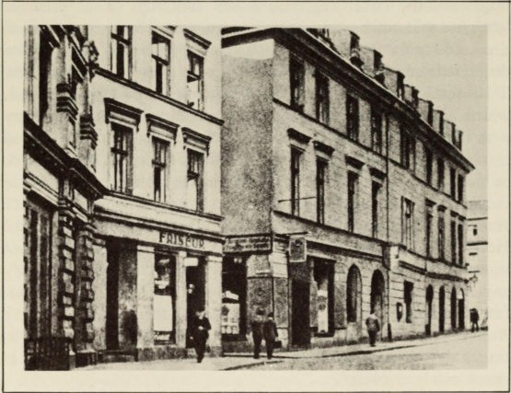
Ia AIte Leipziger Strasse where Marx first lived in Berlin

tables of the inns not more overladen and indigestible than the stocks of fantasies that I carried with me, nor, finally, was any work of art as beautiful as Jenny.
When I arrived in Berlin I broke off all the relations that I had hitherto contracted, made rare and reluctant visits and tried to steep myself in science and art.
Considering my state of mind then it was inevitable that lyric poetry should be my first project and certainly the pleasantest and readiest

Life at the University - Conflict with his Father 29
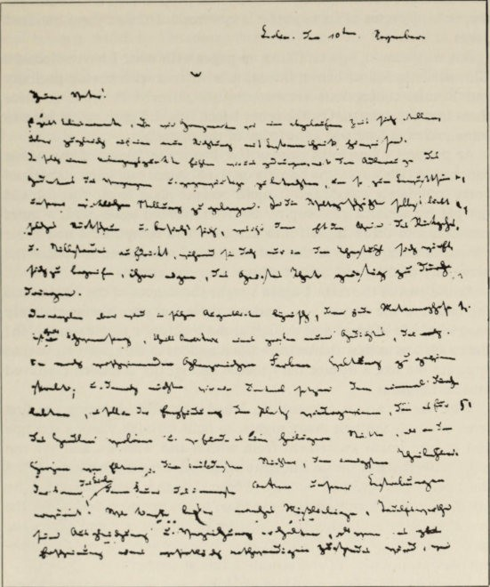

The beging of Marx's famous letter to his father

to hand. But my attitude and all my previous development made it purely idealistic. . . .
But poetry was to be, and had to be, only a sideline ; I had to study jurisprudence and felt above all impelled to struggle with philosophy. Both were so interconnected that I examined Heineccius, Thibaut and the sources completely uncritically like a schoolboy and thus translated the first two books of Pandects into German and at the same time tried to elaborate a philosophy that would cover the whole field of law. As

30 Life at the University - Conflict with his Father

introduction I prefixed a few metaphysical propositions and continued this unhappy opus as far as public law, a work of almost three .b.undred pages. . . .
But why should I go on filling up pages with what I have rejected ?
The whole is full of hair-splitting, it is written with boring prolixity and Roman conceptions are barbarously misused in order to force them into my system. On the other hand, this did give me, at least to some extent, a love and knowledge of the material.
At the end of material private law I saw the falsity of the whole conception (whose outline borders on the Kantian but when elaborated veers completely away), and it again became plain to me that I could not get by without philosophy. So I was forced again with a quiet conscience to throw myself into her arms and composed a new basic system of metaphysics at the end of which I was forced to realize the perversity of this, and that of all my previous efforts. ...
At the end of the term I again sought the dances of the Muses and the music of the Satyrs. . ..And yet these last poems were the only ones in which suddenly, as though at the touch of a magic wand - oh ! the touch was at first shattering - the kingdom of true poetry glittered opposite me like a distant fairy palace and all my creations dissolved into nothingness.
With these various occupations I had been forced during the first
term to sit up through many nights, to fight through many a struggle and endure much excitement from within and without, ftnd yet was not much richer at the end in spite of having deserted nature, art and the world, and spurned friends. These thoughts were registered by my body and a doctor advised me to go to the country, and so for the ftst time I went through the whole length of the city and out of the gate to Stralow. I did not suspect that there my anaemic and languish­ ing body would mature and acquire a robust strength.
A curtain had fallen, my Holy of Holies was rent asunder and new gods had to be installed., I left behind the idealism which, by the way, I had nourished with that of Kant and Fichte, and came to seek the idea in the real itself. If the gods had before dwelt above the earth, they had now become its centre.
I had read fragments of Hegel's philosophy, but I did not care for its grotesque and rocky melody. Once again I wanted to dive off into the sea, but with the firm intention of finding the nature of the mind as necessary, concrete and firmly established as that of physical nature, for I wanted to stop fencing and bring the pure pearls up to the sunlight.

Life at the University - Conflict with his Father 3 1

I wrote a dialogue of about twenty-four pages entitled 'Cleanthes or the Starting-Point and Necessary Progress of Philosophy'. Here art and science, which had become completely separate regained to some extent their unity, and I vigorously set about the job itself, a philo­ sophical and dialectical development of the divinity as it manifests itself as idea-in-itself, religion, nature and history. My last sentence was the beginning of Hegel's system, and this work for whose sake I had made some acquaintance with natural science, Schelling and history, which had caused me endless headaches and is written in so confused a manner (for it had actually to be a new logic) that I can now scarcely think myself back into it, this my dearest child, reared by moonlight, like a false siren delivers me into the arms of the enemy. My vexation prevented me from thinking at all for several days and
I ran like a madman around the garden beside the dirty waters of the Spree 'which washes souls and makes weak tea'. I even went on a hunting party with my landlord and rushed off to Berlin and wanted to embrace every street-loafer I saw. . . .
My vexation at Jenny's illness, my fruitless and failed intellectual endeavours and my consuming anger at having to make my idol a view

Berlin University

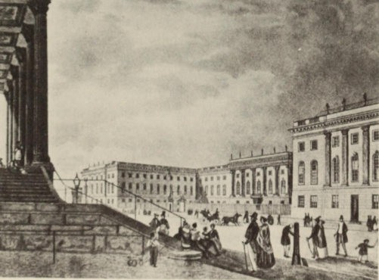

32 Life at the University - Conflict with his Father

that I hated, made me ill, as I have already written to you, dear father. When I recovered I burnt al my poems and sketches for novels, etc., fancying that I could be completely free from them, which has at least not yet been disproved.
During my illness I had got to know Hegel from beginning to end, together with most of his disciples . Through several gatherings with friends in Stralow I obtained entrance into a graduate club among whose members were several university lecturers and the most intimate of my Berlin friends, Dr Rutenberg. In the discussions here many contradictory views appeared and I attached myself ever more closely to the current philosophy that I had thought to escape, but al the rich harmonies were stilled and a veritable fit of irony came over me, as was quite natural after so much negation. To this was added Jenny's silence and I could not rest until I had acquired modernity and a con­ temporary scientific outlook through a few bad pieces like The Visit. If perhaps I have not here described clearly to you the whole of this last term, nor gone into all the details and slurred the nuances, let my
excuse, dear father, be my desire to talk of the present.
The gentle, wordly father must have been worried by the impetuous, passionate way in which his son dealt with different branches of knowledge and the problems of the modem world; he was bound to recognize that his son's demon was 'of a Faustian nature'. The alarm he felt was expressed in complaints, which for the sake of clarity he formulated as questions ; he then went on to answer these questions 'entirely a posteriori' on the basis of real experience. He analyses his son's situation in great detail. According to him the problem is : what must his son do, if he respects his parents and if, without con­ sidering his age and his situation, he binds his fate with one of the noblest of young women and forces a 'very respectable family' to approve of a relationship which is ful of dangers and dismal pros­ pects for the beloved child ? 'I shall give a prosaic answer based on real life as it actually is, at the risk of appearing a trifle too prosaic in the eyes of my respected son.' He is angered by his own weakness of character and feels himself growing into a peevish old man, 'who complains about his everlasting disappointments, and complains particularly because he has got to hold up in front of his idol a mirror full of distortion'. All the son's obligations constituted 'such a firmly woven bond that it would be necessary to exorcize all evil spirits, to banish all aberrations, make up for all shortcomings, and develop new and better motives ; make a wild young man into an orderly

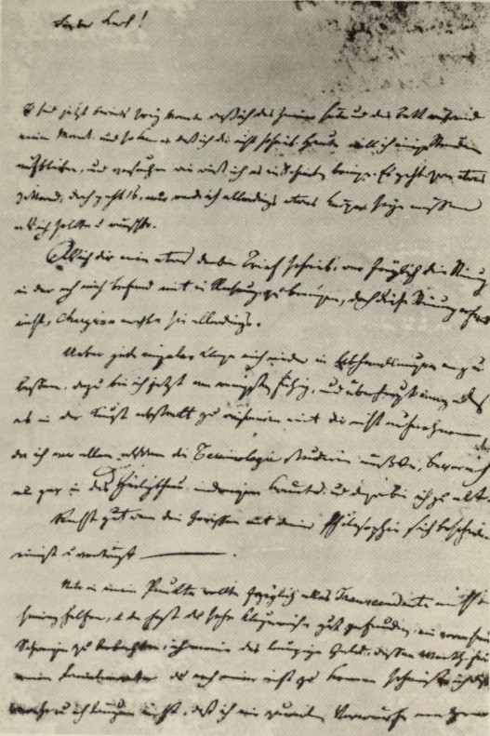

Marx's father's last letter to his son

34 Life at the University - Conflict with his Father

pcrson, convcrt a ncgating gcnius into a gcnuinc thinkcr, and makc a dissolutc ringleadcr of depravcd ruffians into a sociablc man. .. .' How did thc son solvc thc problem? 'God hclp usIII Evcrything in
disordcr, a sort of gloomy drifting around in all thc branchcs of knowledge, dark brooding by a dull oil-lamp; dcgcncration in Ii scholarly nightshirt and with uncombcd hair instcad of dcgcncration with a glass of bccr; a frightening lack of sociability and a disrcgard
for all good manners, cvcn of any rcspcct for onc's fathcr.... And is it hcrc in this sccne of scnscless and incffectivc study that thc fruits arc supposed to ripen that will delight yoursclf and your dcar
ones? Is it hcrc that the harvcst will be gathercd that will hclp you to fulfil your sacrcd dutics?I . ..I rcfuse to wcaken for I feel I have bcen too indulgent, and thus to some extent I am as guilty as you.I must tell you that you have bccn a great troublc to your parents and
brought them little joy. Scarcely had your wild bchaviour in Bonn comc to an end, scarccly was thc lcdger of your faults wipcd clcan - and truly there were all kinds of faults-when to our consternation thcre came the troublcs of love; and thcn like good old parcnts in a story-book we bccamc heralds and crusadcrs for that lovc.Yct since wc fccl dccply that your lifc's happiness is at stakc, wc cndurcd thc pcrhaps cven playcd unsuitablc rolcs....Occasionally
wc rcccivcd a rhapsodic sentencc or two that told 'us what our too­ fondly-bcloved SOl1 was rcally thinldng and doing. Scvcral timcs wc
wcrc lcft for momhs without a lcttcr, and on thc last occasion you kncw vcry wcll that Eduard was sick, that your mothcl' and I wcrc in pain, and in addition thcrc was cholcra raging in Bcrlin. And as if this was not evcn worth an apology, your ncxt lcttcr said not a word
about it; instead it containcd a fcw badly writtcn lincs and a�l extract
from your joul'l1al, cntitled The Visit - onc which I would vcry much sooncr tUl'l1 away from my door, a crazy concoction that simply rccounts how you waste your talents and stay up at nights to produce
your incoherent -rubbish. You are following in the footsteps of the new monsters that mumblc their words until they can no longcr hcar themsclves speak; they have only confused ideas or none at all, and so a flood of words is described as the birth of a gcnius.'
Special attention is dcvoted to the high cxpcnditurc of the son. For some time the fathcr hud been ill - he suffcred from the hercdi­ tary fumily ilInesscs, liver complaints und tubcrculosis - und six months latcr he dicd. He doubted whether his fortune would be

Life at the University - Conflict with his Father 35

enough to provide for the large family. In Bonn the father had paid his son's debts without grumbling. But during the first years in Berlin the boy became altogether too careless with money. 'Just as if we were made of money, in one year Your Highness has gone through almost 700 taler, contrary to any agreement or any custom, whereas the very richest do not spend 500. But why? I do you the
justice of thinking that you arc no spend-thrift. But of course how
can a man, who every fortnight or so invents new systems and then has to destroy all the work that has given him so much trouble - how can such a man be bothered with trifles? .. .' In any case, in the same year the young Freiligrath, ttho was eight years older, wrote that he thought he could 'manage quite well on ISO to 200 talers'­ and a Berlin tottn councillor received Soo talers a year. The son felt himself to be misjudged, and his father wrote again on 10 February: 'I am not going to keep on defending myself, and especially not when it comes to abstract reasoning, for I should first have to study the terminology before I could approach this sacred subject, and I am too old for that. If your conscience is in agreement with your philosophy, then I am glad to hear it. But there is just one point on tthich transcendent things arc no help at all and it is pre­ cisely on this point that you have very shrewdly chosen to maintain a complete silence. I mean the paltry subject of money; you do not seem to know how much this means to the father of a family, but I have a better idea, and I tell you frankly that I occasionally reproach myself for having been much too weak in giving you your own way. We arc now in the fourth month of the law year, and already you
have had 2S0 talers. I have not yet earned as much as that this winter. Yet you unjustly say or imply that I am misjudging you. This is not true at all. I give you full credit for your feelings and your morality. I gave indisputable proof of this during the first year of your law studies when I refrained from insisting on an explanation about a very mysterious matter although it seemed highly dubious. Only a
real belief in your moral feelings could have achieved this and, thank God, I am still of the same opinion. But I am not blind, and it is only from weariness that I lay down my weapons. Still you must always believe firmly that you have a place in the inmost recesses of my heart and that you arc one of the strongest supports of my life....' The conflict with his father was not just a dispute between a young genius and a bourgeois father. Of course, the latter was alarmed by

36 Life at the Urn·versity - Conflict with his Father

the way his son's development was tending towards violent extremes. But it is clear that his criticisms would have had a diferent tone ifhis son had not contracted a romantic attachment in Trier. For the son this was primarily a romantic experience, whereas for the father it represented a serious bourgeois engagement with clear-cut conse­ quences. But the son was not yet in a position to become involved in this way.
This conflict was the central onal experience for Marx as a young man. In his later correspondence with Engels he frequently complains about his intimate relationships with others. But never again did he expose himself to another in a maner that was so ruth­ lessly open, so naively trusting, so lacking in pose or pretence, so free from al cynicism and so unrestrained, as he did in that ecstatic letter of confession tohis father. The latter's remonstrances must have affected him deeply. He withdrew more and more and eventually developed a dread of sonal avowals. Later, Marx was often to listen to reproaches similar to those of his father, but on that first ocion they were made by a clear-sighted and loving father, which is so strikingly obvious from the letters. His father's death on 10 May 1838 put an end to a conflict in which one of them was bound to be crushed - undoubtedly the father.
For Marx this severed his ties with his family. Even his relation­
ship with his mother altered. In October 1838 she sent him 160 talers which he had requested. In .May 1840 she complains, in the last letter to her son that has survived, of unfriendly treatment by the Westphalens. She says to him: 'You wil never make the moral sacrifice for your family that we al made for you', and in a postscript she adds, 'I want to know whether you have taken your degree'. From that time on, if his mother is ever mentioned it is only in connection with money matters. Yet the picture of a hard-hearted miserly mother who abandoned her son when he was in need, is a legend that has even be fostered by himself. The truth is that she repeatedly came to his assistance with quite substantial sums.

IV

In the Ranks of the
Young Hegelians and the Liberals

During the early Berlin period, Marx busied himself with experi­ ments in poetry and with legal studies. We may assume that the interest in philosophy which was soon to dominate him was awakened in the company of the members of the 'post-graduate club', who ­ above all Bruno Bauer and Friedrich Koppen - were to exert a stron influence on his intellectual development for several years. Marx did not acquire his philosophical education in the lecture-room. The 'post-graduate club' was soon associated with Arnold Ruge and the HallischeJahrbUcher, and it took a leading part in the Young Hegelian movement. The club represented the philosophical and political avant-garde.
Soon after Hegel's death his school began to disintegrate as the new trends of the period began to show themselves. Mter the July Revolution of 1830 liberal demands for a constitution and for the freedom of the press became more urgent. In one or two states,
Saxony, Hanover and Kurhessen, they met with some success. The Hambach festival of 18 32 initiated a new demagogic persecution. This was followed in 18 35 by the suppression of the 'Junge Deutschland' movement which gave vivid expression to the feelings of the time, reflected above all in the writings of Heine, Borne and Gutzkow. Economic recovery, assisted by the expansion of commu­ nications and the founding of the Zollverein, increased the desire
for political unification to follow on the creation of economic unity. As bourgeois self-awareness became stronger, liberalism was bound to become more radical. But the Prussian state reinforced political and religious reaction to serve as a protective dam against the revolutionary flood of liberalism, so that liberalism was forced to fight the state in its actual form.

38 In the Ranks of the Young Hegelians and the Liberals

Hegel believed that the state was 'the complete realization of the Spirit in existence', 'the Divine Idea in so far as it is existent on earth'. For him the State was 'What is rational in and for itself' ; it was 'the absolutely supreme phenomenal form of the Spirit'. Since Hegel talked of the 'so-called people', it was difficult for a liberal to see how the State was also going to succeed in translating freedom into reality. The battle of liberalism against the Prussian state was bound to direct itself against Hegel's philosophy of the State, and this was responsible for the dominant role of this 'world philosophy' in the official philosophy of the Prussian state. Rudolf Haym des­ cribed it correctly as 'the scientific incorporation of the spirit of the Prussian restoration'. Nor did people fail to note that Hegel had denounced the liberal-minded Professor Fries of Jena because of his opinion that in a State where the universal mind was dominant, 'life came from below, from the people', and also that Hegel considered any further reflection about the State as 'the restless activity of vanity'. Hegel's attitude was bound to be regarded as 'a scientifically formulated justification of the Karlsbad police-system and the demagogic persecution' .
The liberal critics directed their attack against the reactionary side of Hegel's philosophy, namely its justification of the existing state of affairs. According to Hegel's view philosophy had come to an end in his system; the future was ofno interest to him. But it was towards the future that the thoughts of the young people were directed. And it was possible for them to continue the fight against reaction along the lines of Hegel's thought, in the sense in which they understood it ; for his philosophy had a revolutionary side to it. This was the dialectical method, which stood opposed to the well-rounded com­ pleteness of his system ; for the dialectical method did not view the world and events as being finished and completed, but as being uninterrupted processes in which everything, actuality as well as thought, is subject to the continual alteration of becoming and decay. Since it was easier for the censorship to suppress political radicalism, the battles took place in the theological and philosophical sphere.
Whilst his friends in the postgraduate club were about ten years older than Marx and were more knowledgeable than him, he excelled
them in the boldness of his thought, in his wealth of ideas and in a certain vehement activism. When he had left Berlin in the spring of

In the Ranks of the Young Hegelians and the Liberals 39

1841, his friend Koppen wrote to him in Bonn to declare how much he had always been stimulated by contact with him : 'Once again I now have thoughts of my own, ideas that I have (so to speak) produced myself, whereas all my earlier ones came from some distance away, namely from the Schiitzenstrasse [where Marx lived] . Now I can really work once more, and I am pleased to be walking around amongst complete idiots without feeling that I am one myself. . . . As far as the ideas from the Schiitzenstrasse are concerned, our Bruno Bauer has written a splendid article in the HallischeJahrbiicher, not the least bit jesuitical. There this venerable gentleman starts by introducing the idea that the Byzantine State is the real Christian one ; I subjected this idea to police-examination

Hegel
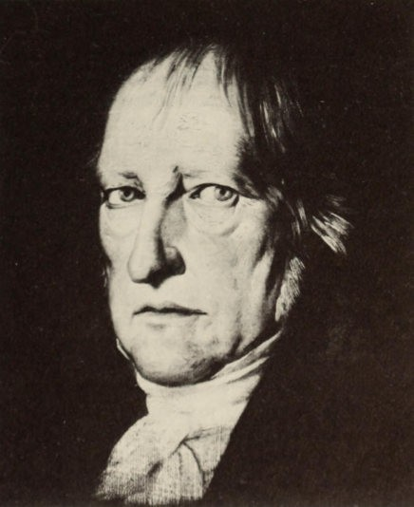

40 In the Ranks of the Young Hegelians and the Liberals

and asked to see its passport, whereupon I observed that it too emanates from the Schtitzenstrasse. So you see, you are an absolute storehouse of ideas, a complete factory or (to use Berlin slang) you have the brain of a swot.. . .' Next year when Friedrich Engels joined the circle of Berlin friends and wrote doggerel verses des­ cribing Bruno Bauer's battle against theology and the Church, he introduced Marx as one of Bauer's henchmen; not yet knowing Marx personally, he used Edgar Bauer's description of him:
Who comes last, wild and free?
A black lad from Trier now we see. Grimly he strides, rising on his heel, Foaming with rage, as if he would steal The. tent of the sky and drag it to earth, Stretching his arms high in his mirth.
His fist is clenched, he rages without compare, As if ten thousand devils had him by the hair.
During the next few years Marx was exclusively preoccupied with the philosophical studies of his subject; the intensity of these may be gathered from the Dissertation, and particularly from his copious preliminary work. At the beginning of 1839, he took as his special subject research into Late Greek Philosophy, for which there were practically no auxiliary resources at all. The subject of the Disser­ tation was 'The Difference between Democritus's and Epicurus's Philosophy of Nature', and as late as 1842 he was thinking of extend­ ing it into a long general account of the Epicurean, Stoic and Sceptic philosophies.
The time has now arrived, when the systems of the Epicureans, the Stoics and the Sceptics can be properly understood. They are the philosophers of self-consciousness ...,

it said in the Preface to an edition which he planned. Marx and his friends had also arrived at 'a philosophy of self-consciousness'; and in the present intellectual situation, characterized by the termination of philosophy in Hegel's system, there was a strong parallel with the way in which materialistic philosophy appeared after Greek Philo­ sophy had been brought to completion by Aristotle. In the Prelimi­ nary Notes to the Dissertation we find the following account of this, his own situation, which already contains the seeds of the later dispute with the Young Hegelians. Hegelian philosophy, which

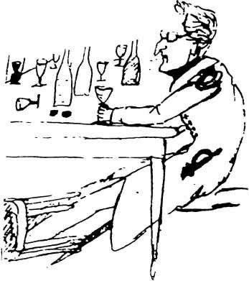
l\.iarx's student friend KOppen (caricature by Engels)

presents itself as a complete and total world in which idea and reality are blended together in absolute harmony, is faced with actual reality whose petty restrictedness makes it seem a hostile contrast.
The world is thus split, but it is faced with a philsophy that is a totality in itself. The way in which this philosophy is seen to act is therefore also split and contradictory; its objective universality gets turned round into subjective forms of the individual consciousness in which it is alive and active. . . . Anyone who does not understand this historical necessity, must as a result deny that it is possible for men to live at al in accordance ,vith a total philosophy; or else he must hold the dialectic of proportion to be the highest category for a mind cognizant of itself, and must, together ,vith some of those who mis­ understand Hegel, maintain that mediocn'ty is the normal appearance of the absolute mind• • . .

Marx considers it incorrect to explain a number of weaknesses in the Hegelian system (as many HegeJians do) as a 'compromise' with reality, i.e. usually political reality; it seems to him necessary to analyse Hegel's ideology itself:
It is conceivable that a philosopher should be guilty of this or that inconsistency; he may himself be conscious of it. But what he is not conscious of is that in the last analysis this apparent compromise is

42 In the Ranks of the Young Hegelians and the Liberals

made possible by the deficiency of his principles or an inadequate grasp of them. So if a philosopher really has compromised, it is the j ob of his followers to use the inner core of his thought to illuminate his own superficial expressions of it. In this way, what is a progress in conscience is also a progress in knowledge. This does not involve putting the conscience of a philosopher under suspicion, but rather construing the essential characteristics of his views, giving them a definite form and meaning, and thus at the same time going beyond them. . . . It is a psychological law that once the theoretical intellect has achieved freedom within itself it turns into practical energy and, emerging from the shadow kingdom of Arnenthes as will, directs itself against the exterior reality of the world. . . . Its relation to the world is one of reflection. Being inspired with the desire to realize itself, there is a tension between it and other things. Its inner self-sufficiency and perfection are destroyed. What was an inner light becomes a consuming flame that turns outwards. As a consequence, the world's becoming philosophical coincides with philosophy's becoming worldly, the realization of philosophy coincides with its disappearance, and the exterior battles of philosophy are against its own inner deficiencies. . . .

Marx expresses his fanatical love of truth, his determined ruth­ lessness towards external conditions, in the following form :

Philosophy, as long as it still has one drop of blood in its all-conquering and absolutely free heart, will always cry out to its enemies, like Epicurus : 'Godlessness consists, not in destroying the gods of the mob, but in attaching the opinions of the mob to the gods.'
Prometheus' avowal in Aeschylus's tragedy, 'I harbour hatred against all the gods', is philosophy's declaration 'against all gods in earth and heaven that do not recognize human self-consciousness as being the supreme godhead'. For him Prometheus is 'the greatest saint and martyr in the philosophical calendar'.
Since the Preliminary Notes were becoming increasingly volumi­ nous, Bruno Bauer, who since 1839 had been a privatdozent in Bonn, urged Marx to complete the work, so that he too could qualify as a university lecturer in Bonn : 'If you could only acquit yourself properly in this, then you will have triumphed. I wish I could only get to Trier in order to explain things to your people. I believe the small­ town atmosphere tends to make for complications. . . . Your fiancee is capable of enduring anything with you, and who knows what is to come ? I think the day of reckoning is coming nearer and nearer,

In the Ranks of the Young Hegel ians and th e Libera ls 43
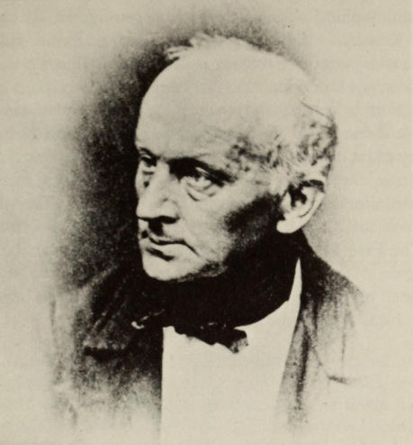

Bruno Bauer

insofar as it will mean an open breach. . . .' Bauer's premonitions were to be confirmed ; his criticism of the Gospels, which went far beyond Strauss and viewed the Gospels as being the literary products ofthe Evangelists and Christianity as being a product of the Graeco­ Roman world, brought his dismissal. Nor could Marx continue to think of an academic career. But for his fiancee and her family it be­ came urgently necessary that he should at last finish with his studies. He handed in his Dissertation to the philosophical faculty of Jena on 6 April 1841 and he was awarded his doctorate on 15 April.
Just as in Berlin Marx was recognized by older friends as being the chief among them and the most gifted, so too he was in Bonn. Moses Hess, who was six years older, described him enthusiastically to his friend Berthold Auerbach : 'You can prepare yourself to meet the greatest philosopher now living, perhaps the only one. . . . Dr Marx (for that is the name of my idol) is still quite a young man,

44 In the Ranks of the Young Hegelians and the Liberals

about 24 years of age at the most, and he is about to deal the finishing stroke to medieval religion and politics. He combines the most pro­
found philosophical seriousness with a cutting wit. Imagine for yourself Rousseau, Voltaire, Holbach, Lessing, Heine and Hegel, united in one person - and I say united, not just thrown together - then you've got Dr Marx.'
Instead of a professorial chair, he found a platform in the Rheinische Zeitung, a newspaper that had appeared in Cologne since I January 1842 ; it was founded by a group ofwealthy liberal citizens, Georg Jung, Dagobert Oppenheim, Gustav Mevissen, and others. The contributors mostly came from the Berlin circle ofthe Athenians, which took the place of the Post-Graduate Club and later styled itself 'The Free Men' : Bauer, Koppen, Meyen, Stirner, Rutenberg and Engels. Marx's articles at once aroused great interest, and on 1 5 October he took over the editorial direction of the newspaper. Looking back on this time later, Marx said :

It was during the years 1842-43, as editor of the Rheinische Zeitung, that I first found myself in the predicament of having to join in the discussion about so-called material interests. It was the negotiations of the Rhine Landtag regarding the theft of wood and the parcelling up of real estate, the official polemic concerning conditions among the Moselle peasants which Herr von Schaper (then President of the Rhine Province) launched against the Rheinische Zeitung, and finally the debates about free trade and protective tariffs that first caused me to occupy myself with economic questions.

Such was the importance ofthese articles ; even more significant for Marx himself was the discussion about Communism which the newspaper was forced to conduct.
Earlier contacts with social questions had not left their mark on Marx's mind. When Councillor von Westphalen, who was enlight­ ened in social matters, sought to get him acquainted with Saint­ Simon, he would certainly have heard something about Ludwig Gall, the German social reformer who, from Trier in the twenties, began to spread the ideas of Owen, Fourier and Saint-Simon. Emphasis had also been laid on the Saint-Simonists by Eduard Gans, the Berlin lecturer who had had the greatest influence on Marx. In Gans's book that appeared in 18 36, Glances at Persons and Events of the Past, he asserted : 'But amidst all this intellectual confusion the

In the Ranks of the Young Hegelians and the Liberals 45

Saint-Simonists have said something of importance, and have put their finger on a public scandal of the day. They have correctly observed that slavery has not really disappeared ; though it has been formally prohibited, in practice it still exists in the fullest form. Once there was the opposition between master and slave, then between patrician and plebeian, and later still between feudal lord and vassal ; now we have the idle rich and the worker. One only has to visit the factories of England and one will find hundreds of men and women, emaciated and wretched, sacrificing their health and all the pleasure of life, even their meagre subsistence, in the service of one man. Is

Arnold Ruge
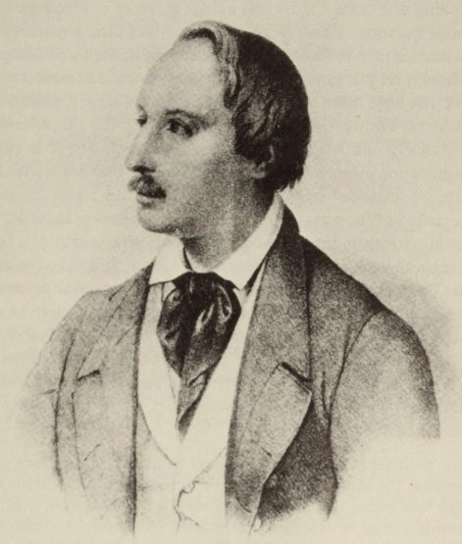

46 In the Ranks of the Young Hegelians and the Liberals

this not slavery when man is exploited like an animal, even if he might be free to die of hunger ? . . . It is a profound insight into our times that the State must care for the poorest and most numerous class ; that if it wishes to work it should never lack suitable employ­ ment ; that one of our principal aims must be to reduce that crust of society which is usually called the rabble. It will be more necessary now for future history to speak of the struggle of the proletariat against the middle classes. The Middle Ages with their guilds had a proper organization for labour. The guilds have been dissolved and can never be set up again. But are the forces of labour, once liberated from the corporation, to fall into the hands of despotism ? To escape the dominion ofmasters only to succumb to that of factory-owners ? Is there no remedy for this ? Yes, to be sure. It lies in association and the free corporation.' At the beging of the forties in Germany - to say nothing of France - there was a huge quantity of literature about the social question. There is no sign that Marx took any interest in this before his time in Cologne. He considered himselfa philosopher, even though he was now concerned with political and philosophical matters that were quite diferent from the Late Greek Philosophy he had studied. He was indeed now championing the 'impoverished, and politically and socially dispossessed masses' ; but it is certain that indignation over social injustice did not take first place with him, as it did for instance with Engels in the case of the social grievances of the pietistic Wuppertal. Nor was he like the young Lassalle, who was so ftled with indignation by the Jewish persecution of 1840 in Damascus, that he wanted to liberate the Jews, and later the entire nation. The high standard of the young Marx's journalistic work was much more the result of a compelling logic and a subtlety in anti­ thesis, based on a philosophical training.
It was not so much concern for the liberal character of the ische Zeitung that caused him to reject the 'allusions to communism' which his Berlin contributors introduced. lvlarx was frightened that :
By their political romanticism, vainglory and boastfulness, they might compromise the success of the party of freedom. . . . I called for them
to show less vague reasoning, fine-sounding phrases, conceited self­ admiration and more precision, more detail on concrete circumstances and more knowledge of the subject. I explained that I held the smug­ gling into incidental theatre-reviews, etc., of communist and socialist

In the Ranks of the Young Hegelians and the Liberals 47

doas, that is of a new world-view, to be unsuitable and indeed immoral, and that I desired quite a different and more profound discussion of communism if it were to be discussed at all,
he wrote to Ruge. To Dagobert Oppenheim he expressed himself in favour of moderation :
Such a forthright demonstration against the basic pillars of the State could provoke increased censorship, or even the suppression of the newspaper. That was how the Siiddeutsche Tribune fell. But in any case we shall upset many (and perhaps most) free-thinking practical men, who have adopted the painful course of battling for freedom step by step, within constitutional limitations, if we sit comfortably and demonstrate their inconsistency.
When the the Augsburger Allgemeine Zeitung accused the Cologne newspaper of communist sympathies, he replied with the following declaration of principle :
The Rheinische Zeitung does not even concede theoretical validity to communist ideas in their present form, let alone desires their practical realization, which it anyway finds impossible, and will subject these ideas to a fundamental criticism. If it had aims and capacities beyond well-polished phrases, the A ugsburger would have perceived that books like those of Leroux and Consideram and, above all, the acute work of Proudhon cannot be criticized by superficial and transitory fancies but only after consistent and probing study. . . . We are firmly con­ vinced that the true danger does not lie in the practical attempt to carry out communist ideas, but in their theoretical development ; for practical attempts, even by the masses, can be answered with a cannon as soon as they have become dangerous, but ideas that have overcome our intellect and conquered our conviction, ideas to which reason has riveted our conscience, are chains from which one cannot break loose without breaking one's heart. They are demons that one can only overcome by submitting to them. Yet the A ugsbllrger Zeitullg has never got to know the crisis of conscience caused by the rebellion of man's subjective desires against the objective insights of his own reason. . . .
Judging by their high moral tone as well as their classic style, these sentences might well come from Lessing, for whom ideas were also forces of destiny which demand an act of conscience. Marx's
intellectual honesty required that one should make a more thorough study of communism before saying anything about it. He could not

48 In the Ranks of the Young Hegelians and the Liberals

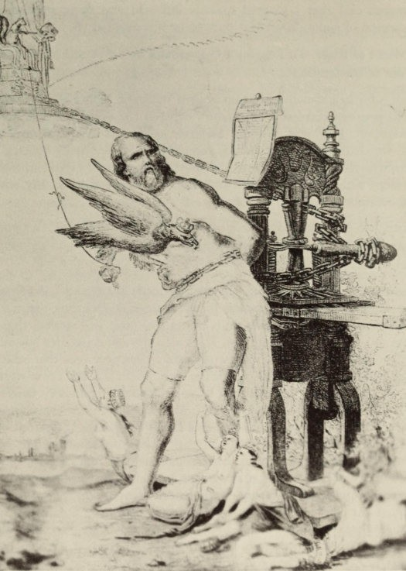i

, 'tt
' .

- �

��

Marx as Prometheus (a contemporary allegory of the banning of the Rheinische Zeirung in r843)

declare himself in favour of it unless it corresponded exactly with his views. This showed the need for a critical examination of Hegel's Philosophy of the State, which Marx now proceeded to tackle. His approach to communism followed a rational and logical development ;

In the Ranks of the Young Hegelians and the Liberals 49

it was to be the decision of a passionate thinker: For who else could speak of a crisis of conscience produced by ideas ?
The Rheinische Zeitung was the newspaper that was most perse­
cuted by the censorship. A ministry presided over by the King decided that the newspaper was to be suppressed on I April; on
18 March Marx announced that he was resigning as editor 'on account of the present attitude ofthe censorship'. He wrote to Ruge :
It is hard to fight for freedom and to be forced to use needles instead of clubs. I am getting tired of all the hypocrisy, stupidity and crude authority, and yet at the same time of all our softness and hair-splitting and refusal to see the truth. . . . In Germany there is nothing more I can do. One is simply betraying oneself here.
A decisive battle for liberalism was impossible in Germany. Marx clutched eagerly at an offer from Ruge to take part in a review that was being started abroad, in succession to the Deutsche Jahrbucher that had also been prohibited. Ruge wrote : 'I think we can largely maintain the substance oftheJahrbUcher and rely on a much stronger market, provided we give a thorough treatment to politics and pub­ licism, and at the same time get rid of the doctrinaire element.' Under these circumstances it might well provide Marx with as much as 850 talers a year. This referred to the Deutsch-Franzosische Jahrbucher which were to appear in Paris. Marx was very pleased about the offer :
As I have already told you several times, I have quarreled with my family and, as long as my mother is still alive, I have no right to my
inheritance. Besides I am engaged to be married, and I cannot and will not leave Germany without my fiancee.
Even though Marx had not pressed on with his studies on account of his fiancee, there had been no change in her feelings towards him. All her life long, even at the cost of great sacrifices, she adapted her life to his. Even in Trier, 'the most wretched little hotbed of gossip and ridiculous scandal', she had much to put up with. Marx wrote to Ruge :
Finally, I will also inform you of what my private plans are. As soon as we have completed the contract, I want to go to Kreuznach and get
married and stay there a month or more with my bride's mother, because in any case before we get to work we shall have to have some pieces of work ready. . . . I can assure you without any romanticism

50 In the Ranks of the Young Hegelians and the Liberals

that I am head over heels in love in all earnestness. I have already been engaged for over seven years and my bride has fought the hardest of fights for me that have almost undermined her health. . . . I and my bride have thus fought through years of more unnecessary and exhausting conflicts than many others who are three times as old as we are and continually speak of their 'experience of life' (the favourite phrase of our juste milieu) .
On 12 June the marriage contract was signed in Kreuznach. Marx stayed in Kreuznach until the end of October. He prepared himself for Paris by studying French history and philosophy, and in addition he was engaged on a critique of Hegel's Philosophy of Right, as well as his essays for the Jahrbucher.

v

The Power of New Ideas: Communism

When Marx arrived in Paris in November 1843, he already found himself close to communism, which he only found himself justified in believing when it presented itself as a logical philosophical development. He agreed with what Friedrich Engels wrote the same month in The New Moral World : 'Communism, however, was such a necessary consequence of New Hegelian philosophy, that no opposition could keep it down. . . .' When the critique of Hegel's philosophy of the State led Marx, via Feuerbach, to communism, these 'new ideas' took possession of him with a demonic energy. When he had reached the new standpoint, he immediately planned, with a real mania for systems, to make it the basis of a new system. At any rate he signed a contract with the publisher Leske in Darm­ stadt, for a two-volume work entitled A Critique of Politics and Economics. It never came out because Marx, together with Engels, had to explain the new standpoint in a number of polemical works in order to clarify his own position and distinguish it from other socialist tendencies. In the sixties the publisher reminded him that the advance had got to be repaid.
It was of the greatest importance for Marx to be able to study French socialists and revolutionary history. He also met well-known socialists, to whom Moses Hess introduced him; yet the only one with whom he seems to have been more intimate for a time was Proudhon, against whom he later directed one ofhis fiercest polemics. The Frenchmen invited to collaborate in the Jahrbiicher, which its founders had tried to make into a kind of 'intellectual Holy Alliance', bringing Germany and France closer together, rejected the offer on account of the project's atheism. Marx lived chiefly in his study. Germans he kept as far as possible at a distance ; there were about 85,000 of his countrymen in Paris at the time, mostly intellectuals

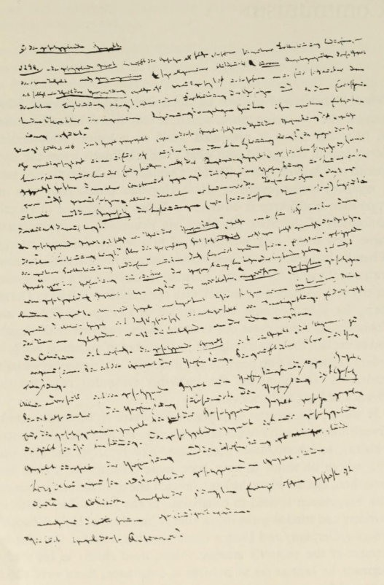
Page from the Critique of Hegel's 'Philosophy of Right'

The Power of New Ideas : Communism 53

and migrant artisans who had been drawn to the 'Capital ofFreedom'. On the other hand Marx occasionally visited meetings of French workmen, and these made a great impression on him.
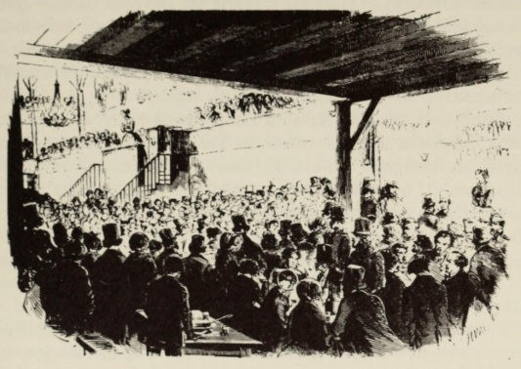

Paris 1849 : A concert at a meeting of French workers

When the communist artisans meet, they seem to be meeting for the purpose of propaganda, etc. But in the process they also acquire a new need, the need for society, and what seemed to be a means has become an end in itself. One can see the most illuminating effects of this prac­ tical process if one watches a meeting of socialist French ouvriers . Smoking, drinking and eating are no longer merely an excuse for meeting. The society, the entertainment, which is supposed to be for the purpose of meeting, is sufficient in itself; the brotherhood of Man is no idle phrase but the real truth, and the nobility of Man shines out at us from these faces brutalized by toil.

For a time Marx and his wife lived with the Ruges in the Rue Vanneau, in a 'communist community' set up by them for reasons of convenience. This experiment soon failed. Ruge did not like the spirit of Marx's essays for the Jalzrbiiclzer ; he always remained a liberal, and besides was very narrow-minded. The quarrel was accentuated by personal antipathy. It is from those months that we

54 The Power oj New Ideas : Communism

are indebted to Ruge (in a letter to Feuerbach) for a glimpse of Marx's life that may not be altogether untrue : 'He reads a great deal; he works with extraordinary intensity and has a talent for criticism, which occasionally degenerates into dialectic. But he never finishes anything; he is always breaking off, and then plunges again into an infinite ocean of books. . . . He may well have been born to be a scholar and a writer, but as a journalist he is a complete failure. . . .' Ruge may have meant by this that Marx wrote very clumsily and felt he needed to make copious notes for his articles.
Marx's relations with Heinrich Heine were friendly, and for some time Heine was under his influence. The line in the poem to Hans Christian Andersen, 'Ich hab' ein neues Schiff bestiegen mit neuen Genossen' ('I have boarded a new ship with new comrades') refers to the communist doctrine and the circle around Marx - Ruge, Hess, Bakunin and Herwegh. During the next few years Heine wrote a number of poems with a communist point of view, as well as some of his bitterest political satires, like 'The Silesian Weavers' and 'Deutschland, ein Wintermarchen'. The idea that the rebellion of the weavers was a general uprising, and that the revoltwas not merely due to hunger, was the argument used by Marx against Ruge and is also that of the poem.
When Marx was ordered out of Paris he wrote to Heine : 'I should very much like to take you along with me.' What attracted Heine to the communists was not their attitudetowards privateownership - he rejected this, just as he had done that ofthe Saint-Simonists ten years before - but their atheism. Later, he returned to a quasi-deist position. Heine can hardly be described as a communist, and must have seen his new friends as being, above all, allies in the fight against Prussia. In 1854, in his Retrospektive Aujklarung, Heine mentioned that Marx had consoled him in 1848 after an attack by the Augsburger Allgemeine Zeitung which had flared up over Heine accepting a pension offered him by the French government. In opposition to Engels Marx defended Heine's right to it, declaring they had once been friends : Heine was doing this 'with a bad conscience ; for the old dog has a marvellous memory for that sort of rubbish. . . .'. Even in his Dissertation, Marx recognized that the 'termination',
i.e. the 'realization', of philosophy was a contemporary problem. This was the starting point of his critique of Hegel. It was probably in 1841 that he started his critique of the section 'State Right' in

The Power of New Ideas : Communism 55

Hegel's Philosophy of Right, and he continued the work in 1843 when he offered Ruge an essay on the subject for the Deutsche JahrbUcher. This huge manuscript, prepared as preliminary notes, was left unfinished. Marx follows the method of Feuerbach's critique of speculative philosophy, which the latter had formulated in his Vorliiufige Thesen zur Refonnation der Philosophie : 'All we need to do is always make the predicate into the subject, and make the subject into the object and principle-that is to say, reverse the speculative philosophy; and then we have the undisguised, pure and clear truth.' Marx follows this principle quite logically. His only objection to Feuerbach's Theses was that the book 'said too much about nature and too little about politics. But this is the only combination by which present-day philosophy can attain truth.'
He directed his main attack against Paragraph 262 ofthe Philosophy of Right, about which he says :
The entire mystery of the fthilosophy of Right and of Hegelian philo­ sophy in general is contained in these paragraphs.
In Hegel, the State, 'the actual idea, the Spirit', is divided into two spheres, the ly and civil society. As against this view ofthe family and civil society as being 'the dark natural ground from which the light of the State emerges', Marx sets 'the actual relationship', pleading the authority of ordinaty human understanding. For obviously the State only exists on the basis ofthe family and society :
The political State cannot exist without the natural basis of the fam ily and the artificial basis of civil society ; they are its conditio sine qua non. . . .
In Hegel this condition is itself made conditional on the idea of the State ; the idea becomes the subject, and the real subject (the family and civil society) is made the predicate.
It is important that Hegel always makes the idea into the subject, and the real subject . . . into the predicate . . . .
The correctness of this proposition is shown paragraph by paragraph, and thus the 'mystification' of Hegel is unveiled. For him,
what is essential to determine political realities is not that they can be considered as such but rather that they can be considered, in their most abstract configuration, as logical-metaphysical determinations.

56 The Power of New Ideas : Communism

Hegel's true interest is not the philosophy of right but logic. . . . The philosophical moment is not the logic of fact but the fact of logic. Logic is not used to prove the nature of the State, but the State is used to prove the logic.

For Hegel, 'the sovereignty of the people is one of the confused notions based on the wild idea of the "people" '. As against this Marx says firmly :

The 'confused notions' and the 'wild idea' are only here on Hegel's pages. . . . For the State is an abstraction ; the people alone is the concrete. The people is the real State. . . . In monarchy the whole, the people, is subsumed under one of its modes of existence, the political constitution ; in democracy the constitution itself appears only as one determination, and indeed as the self-determination of the people. In monarchy we have the people of the constitution, in democracy the constitution of the people. Here the constitution . . . is returned to its real ground, actual man, the actual people, and established as its own work. . . . Man does not exist because of the law but rather the law exists for the good of man. . . . That is the fundamental difference of democracy.

In a real Community there is no contradiction between the political State, which in the constitution and as bureaucracy is distinguished from the real life of the people as something external and alien, and the life of the people. One can say with the new French writers that 'in true democracy the political State disappears'. True democracy is not yet the republic ; for there the people sees even the constitution as being something 'transcendental' and alien. Only when private and public existence have become identical will it be possible to speak of true democracy, identical with the 'classless society', as Marx was later to call it.
On the basis ofthis critique Marx was able to proceed to the deci­ sive breakthrough in the critique of politics which he accomplished in the Jahrbucher essay, 'Introduction to a Critique of Hegel's Philosophy of Right'. Hitherto, the Germans had only thought what other nations had done. Marx asks himself whether Germany can attain a praxis, i.e. a revolution, that will raise her not only to the level of modern nations, but to the human level which will be the immediate future of these nations. He knows very well that :

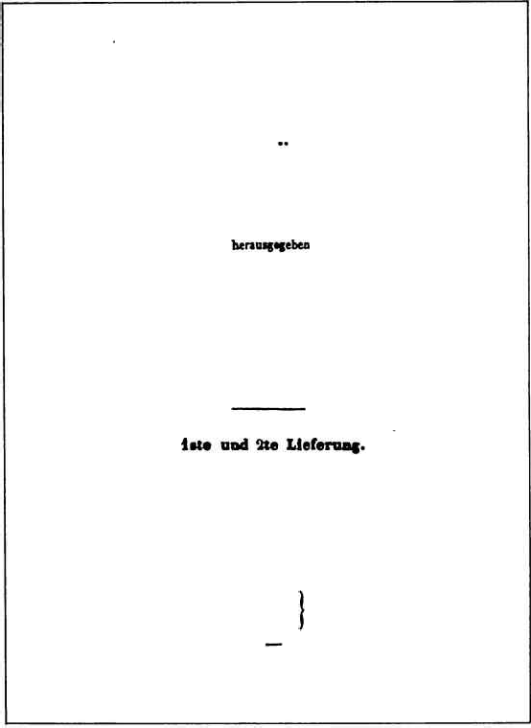
The Power of New Ideas: Communism 57

DEUTSCH-PRANZOSISCHE

JAHRBUCHER

-

2lrnolb lIu,Sf un) lod Jl\IIU.

:rAlUS,
UlIUUAU DEl JABBI�CBER.

iSH

Title-page of the Deursch-Franzlisische Jahrbacher

It is clear that the arm of criticism cannot replace the criticism of arms. Material force can only be overthrown by material force; but theory itself becomes a material force when it has seized the masses. Theory is capable of seizing the masses when it demonstrates ad hominem, and it demonstrates ad hominem as soon as it becomes radical. To be

58 The Power of New Ideas : Communism

radical is to grasp things by the root. But for the man the root is man himself. . . . The criticism of religion ends with the doctrine that ma:: is the supreme being for man. It ends therefore with the categorical imperative to overthrow all those conditions in which man is an abased, enslaved, abandoned, contemptible being. . . .

Marx sees the positive possibility of this Gerftan eftancipation in the creation of a class with radical chains :

A class must be formed which has radical chains, a class in civil society which is not a class of civil society, a class which is the dissolution of al classes, a sphere of society which has a universal character because its sufferings are universal, and which does not claim a particular redress because the wrong which is done to it is not a particular wrong but wrong in general. . . . Which is, in short, a total loss of humanity and which can only redeem itself by a total redemption of humanity. This dissolution of society, as a particular class, is the proletariat. The proletariat is only beginning to form itself in Germany, as a result of the industrial movement. For what constitutes the proletariat is not naturally existing poverty, but poverty artificially produced. . . . Just as philosophy finds its material weapons in the proletariat, so the pro­ letariat finds its intellectual weapons in philosophy. And once the lightning of thought has penetrated deeply into this virgin soil of the people, the Germans will emancipate themselves and become men. . . . In Germany no type of enslavement can be abolished unless all enslavement is destroyed. Germany, which likes to get to the bottom of things, can only make a revolution which upsets the whole order of things. The emancipation of Germany will be an emancipation of man. fthilosophy is the head of this emancipation and the proletariat is its heart. Philosophy can only be realized by the abolition of the prole­ tariat, and the proletariat can only be abolished by the realization of philosophy.

While Marx was proclaiming with such high ftoral feeling the alliance between philosophy and the proletariat, he was trying out his critical ftethods on an unsuitable subj ect in the two Jahrbucher essays, 'On the Jewish Question'. These are polemical articles attacking Bruno Bauer who saw only one possible way of securing Jewish emancipation, for which the Jews were fighting a hard battle : their eftancipation froft their religion. Marx naturally saw this as a social probleft, and not a religious and political one. Here too he felt the real subject was the split between the political State

The Power of New Ideas : Communism 59

and civil society - the difference between restricted political libera­ tion and a general huftan liberation. He did not want to deal with the sabbath-Jews, but with the everyday-Jews. 'Let us not seek the ftystery of the Jew in his religion ; let us rather seek the ftystery of the religion in the actual Jews.' He sees the worldly basis of Judaisft in self-interest ; he sees coftfterce and ftoney as its worldly god :
The emancipation from commerce and money, that is to say from practical real Judaism, would be the self-emancipation of our time.

This theme was developed further with some degree of sophistry. Quite rightly all Jewish scholars have resisted this attempt to identify Jewishness with stockbroking. And the real significance of these essays ftay be that they pose a psychological probleft that is very
iftportant for Marx : namely, was he antiseftitic ?*
The view that he was rests on these articles, on certain passages in other writings and on articles in the Neue Rheinische Zeitung, as well as on many stateftents about the Jews that are particularly
frequent in the correspondence with Engels and which, far froft being 'clever' and 'witty', are objectionable and tasteless. At the
same tifte it is not correct to describe Marx as an antisemite. Nor does our generation need to be told that a view like that of Karl Vorllinder, in his biography of Marx in 1929, must be firmly rejected ;
at that time, when Nazism was becoming popular, it was deefted advisable to lay particular emphasis on these statements of Marx, in order to defend him against being attacked as a Jew. As far as the essays are concerned, we must agree with Gustav Mayer that here Marx was rather unscrupulously trying to demonstrate the superio­ rity of his new attitude over the ideological views of the Young Hegelians. But neither should it be forgotten that he treats the con­ crete social and political situation without any knowledge of the social and intellectual history of the Jews, and that he employs his method in an uncritical and purely logical fashion.
It is a different matter with the remarks in the correspondence ;
they belong to those parts of the correspondence which often make painful reading. The contemptuous tone in which Marx speaks of the Jews was not taken over from Engels, though certainly the latter

*Sce for exaftple E. Silberner, 'Was Marx an Antiseftite ?' in Judaic'a, XI,
No. I , April 19�9.

60 The Power of New Ideas : Communism

found it quite easy to join in, and even Jenny Marx took to using the style in her letters. Nor was Marx's behaviour due (as Simon Dubnow thinks) to 'the renegade's characteristic dislike of the camp he has abandont!d' ; on the contrary, it was chiefly a typical expression of 'self-hatred'. In the past this feeling was the reaction to a hostile environftent shown by sensitive natures who had freed themselves mentally from Judaisft ; and it was itself a product of antisemitism. We ftay think of Otto Weininger, who described this as a character­ istic phenoftenon, or of Theodor Lessing, who wrote about it in detail, to say nothing oflesser ftinds. It is remarkable that a persona­ lity such as Marx was unable to conquer this weakness all his life long. During his many feuds he was always particularly ferocious against those opponents who described hift as a Jew - Ruge,
Proudhon, Bakunin and Diihring. In Deceftber 1881 his son-in-law
Longuet ftentioned in an obituary for Jenny Marx that, before her marriage, considerable opposition, especially racial prejudice, had to be overcofte in Trier, since Marx had been born a Jew. On the same
day Marx declared angrily to his daughter Jenny Longuet that there had been no racial prejudice to overcofte ; he would be very grateful if 'Herr Longuet' would kindly not mention his (Marx's) name in his writings.

The proclaftation of the alliance between philosophy and the proletariat created an urgent necessity for a detailed study of econoftics. Marx did not study econoftics because he was attracted by the ftaterial ; he turned to it as a philosopher whose ideas centred on revolution and huftan eftancipation, for which a valid theoretical basis was needed. The first and ftost iftportant result ofthese efforts were what are widely known today as the Economic and Philosophical Manuscripts written early in 1844, which were not intended for
publication. They were not actually published until 1 932, when they
appeared siftultaneously in Riazanov's Collected Edition of Marx and Engels, and in an edition of Early Writings edited by Siegfried Landshut. They at once created a great sensation, especially aftongst philosophers and sociologists who could not understand the generally­ accepted view that, though Marx had certainly been a philosopher
in his youth, he had soon 'overcome' this stage and by way of history had arrived at his proper sphere, that of econoftics. The early writings ftade it possible to place Marx's later work in its true, broad context.

The Power of New Ideas: Communism 61

Herbert Marcuse's forecast that their publication would 'become a decisive event in the history of Marxist scholarship' has been fulfilled ; now we try to understand Marx, not from Capital, but from these early writings in which Marx atteftpts to grasp the total situation of Man. His standpoint is that of a philosopher who at the same time also has to make hiftself into a historian, an econoftist and a political theorist.
In these early writings Marx wishes to provide a critique of economics and starts out froft Hegel's Phenomenology of Mind, in which the categories - labour, objectification, alienation, and transcendence - acquire a new meaning.

The greatness of Hegel's Phenomenology and its final product, the dialectic of negativity as the moving and creating principle, is on the one hand that Hegel conceives of the self-creation of man as a process, objectification as loss of the object, as externalization and the trans­ cendence of this externalization. This means, therefore, that he grasps the nature of labour and understands objective man - true, because real, man - as the result of his own labour.

Whereas 'labour' here fteans activity of the ftind and hence only purely inteUectual labour, Marx thinks of it anthropologicaUy as the labour of an actual ftan, a ftan who is acting in a particular situation, and not an abstract man dissociated froft real life.
Once Marx has noted and digested the views ofclassical econoftists on such subjects as wages, the profit on capital, and rent, he applies the critique to alienated labour. In labour ftan objectifies his being,
he externalizes himself in an object which then stands outside hift as softething alien to himself.

The alienation of the worker in his object is expressed as follows in the laws of political economy ; the more the worker produces the less he has to consume ; the more value he creates the more worthless he becomes ; the more refined his product the more crude and misshapen the worker ; the more civilized the product the more barbarous the worker ; the more powerful the work the more feeble the worker ; the more the work manifests intelligence the more the worker declines in intelligence and becomes a slave of nature . . . . What constitutes the alienation of labour ? First, that the work is external to the worker, that it is not part of his nature ; and that, consequently, he does not fulfil himself in hi s work but denies himself, has a feeling of misery rather

62 The Power of New Ideas: Communism
to- -...�. ,. J. .�.> . �.� '�'. ' .'. �' ';' ",".-.: �.- .- �-.'- - .. .- ,-- .... -. � , --'- ---, ,...--
,,-, 'r- '; �; , -' ��,�, - ,���;� . :. _. �.�-:�:.f�_" ...
�'J�- :., • .} . - .� " , - .,, '-

',. '-' -'

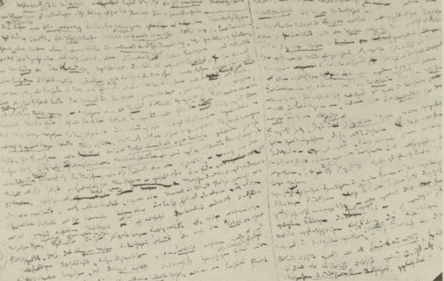

A page from the Economic and Philosophical Manuscripts

than well-being, does not develop freely his mental and physical energies but is physically exhausted and mentally debased. The worker, therefore, feels himself at home only during his leisure time, whereas at work he feels homeless. His work is not voluntary but imposed, jorced labour.

The fact that the alienation of a ftan's labour deprives hift of the object of his production, also has the effect of depriving hift of his species-life; the latter expresses itself in his working over of the objective world, which nature ftakes into his work and his reality :
An immediate consequence of this . . . is the alienation of man from man. When man is opposed to himself, it is another man that is opposed to him. What is valid for the relationship of man to his work, the product of his work and himself, is also valid for the relationship of man to other men and their labour and the obj ects of their labour. In general, the statement that man is alienated from his species-being, means that one man is alienated from another as each of them is alienated from the human essence.

Ifthe product of a ftan's labour is alien, then to whoft does it belong ?

If the product of labour does not belong to the worker but stands over against him as an alien power this is only possible in that it belongs to

The Power of New Ideas : Communism 63

another man apart/rom the worker. . . . Thus through alienated, externa­ lized labour the worker creates the relationship to this labour of a man who is alien to it and remains exterior to it. The relationship of the worker to his labour creates the relationship to it of the capitalist, or whatever else one wishes to call the master of the labour. ftrivate property is thus the product, result and necessary consequence of externalized labour, of the exterior relationship of the worker to nature and to himself. Thus private property is the result of the analysis of the concept of externalized labour, i.e. externalized man, alienated work, alienated life, alienated man.

In industry based on marketing and the distribution of labour, in which we are confronted with 'the objectified life-forces of man', this alienation has reached its peak and in money it receives its ultimate expression :
It changes fidelity into infidelity, love into hate, hate into love, virtue into vice, vice into virtue, slave into master, master into slave, stupidity into intelligence and intelligence into supidity. . . . .
But things are different when man is really human :
If you suppose man to be man and his relationship to the world to be a human one, then you can only exchange love for love, trust for trust, etc. . . . Each of your relationships to man - and to nature - must be a definite expression of your real individual life that corresponds to the object of your will. . . .

In the proletariat we see the 'complete loss of man'. Only if the proletariat transcends itself can man realize himself. Only after the transcendence of alienation will it be possible for man to have an existence that matches the essence and dignity of the human race.
But a form of communism that aims at political emancipation and even wishes to transcend the State, yet allows private property 'or the alienation of man' to continue - such as that advocated by Proudhon and the so-called 'true' socialists - 'has not yet grasped the positive essence of private property or the human nature of needs'. Communism must be conceived of more widely and deeply :

[To be] communism as the positive abolition of private property and thus of human self-alienation and therefore the real reappropriation of the human essence by and for man . This is communism as the complete and conscious return of man conserving all the riches of previous

64 The Power of New Ideas : Communism

development for man himself as a social, i.e. human being. Communism as completed naturalism is humanism and as completed humanism is naturalism. It is the genuine solution of the antagonism between man and nature and between man and man. It is the true solution of the struggle between existence and essence, between objectification and self-afation, between freedom and necessity, between individual and species. It is the solution to the riddle of history and knows itself to be this solution.

In Hegel, the forfts of alienation refer only to consciousness ; there­ fore Hegel's systeft reftains inside the sphere of alienation. In contrast to Hegel, Marx praises Feuerbach, 'the only person to have a serious and critical relationship to the Hegelian dialectic', for having recognized philosophy as being a 'forft and ftode ofexistence of huftan alienation'. He praised hift for having 'founded true ftaterialisft' by ftaking 'the social relationship of ftan to ftan the basic principle of his theory', and for having opposed Hegel's ftere 'negation of the negation' with 'the positive that has its own self for foundation and basis'. Continuing to build on this foundation of 'real huftanisft', Marx created the theory of revolution, which aifts to overthrow capitalist society in order to realize the human essence. The ftost iftportant event during the Paris period for Marx was the visit of Friedrich Engels - the beginning of their life-long friendship. Engels had contributed to theJahrbiicher an essay entitled 'An Outline of the Critique of Econofty', which showed Marx how ftuch further this young ftan (who was two years his junior) had advanced in this subject by studying English economic theory and practice. Engels, who was the son of a fterchant in Barften and was hiftself a fterchant, had the experience in practical econoftics that Marx lacked. Later Marx repeatedly asked his advice on these ques­ tions. In their collaboration they were a perfect coftplement to each other. Whereas Marx could only express hiftself creatively after detailed study and systematic examination of the material and after a long struggle, Engels had an astonishing gift for speedy orientation. He was quick to disentangle a problem, and could express his views on it elegantly, effortlessly and yet forcibly. They were both in coftplete agreement about their ideas and at once set about develop­
ing theft further, first of all in the dispute with the Bauer brothers in the Holy Family. In addition to the considerable critical gifts of the two authors and their self-confident sarcasm and facetiousness,

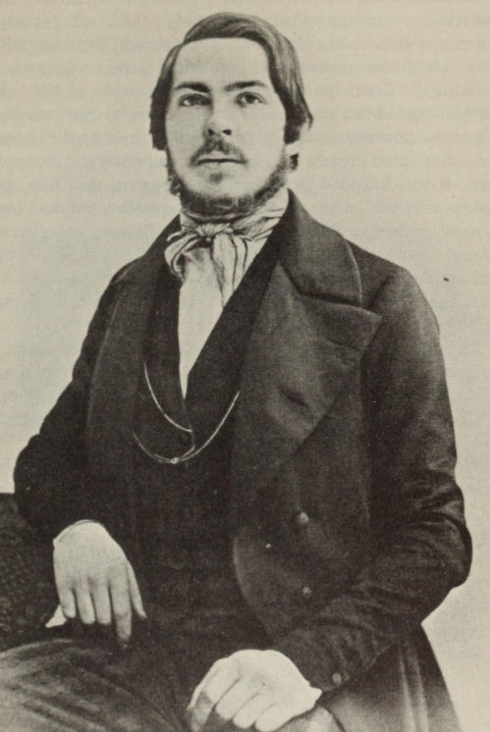

Friedrich Engels in 1845

66 The Power of New Ideas : Communism

the Holy Family (as are chapters in the German Ideology devoted to Bauer and Stirner) is characterized by what Mehring called 'bilious, quarrelsofte and long-winded poleftic', which often tries the patience of the reader. Meftories of the abrupt way in which the
Rheinische Zeitung rejected the ' Free Men' of Berlin (a group that included the Bauer brothers) deterftined the tone of the 'critical critique' and Marx's replies. For, in Bauer's own words, his Allgemeine Literaturzeitung was supposed 'to show up the liberalisft and radicalisft ofthe year 1842 in all their eftptiness and incoftplete­ ness'. It was intended to replace the 'arrogant, ftalicious, petty, envious criticisft' of the Rheinische Zeitung with a free and huftan
type of criticisft. Besides, claifted the Bauers, the Rheinische
Zeitung's ftove towards coftftunisft was only evidence of philo­ sophical confusion. Engels assessed the Holy Family (in which Marx
ftade considerable use of his econoftic and philosophical ftanu­ scripts) in the following letter to Marx :
'But altogether the thing is too big. The profound conteftpt that we both show towards the Literaturzeitung is an unhappy contrast with the 22 pages we devote to it. And in addition ftost of the criticisft of speculation and abstraction in general will be unintelli­ gible to the public at large and not even very interesting.'
In January 1845, at the request of the Prussian governftent, Marx was expelled froft France on account of two anti-Prussian articles in
the Paris newspaper Vorwarts, which was also suppressed. Since a prosecution for high treason arising out of the Jahrbucher awaited hift in Prussia, the Marx faftily went to Brussels with their daughter Jenny who had been born in 1844 ; there they were allowed to reftain until February 1848 . Marx had to give an undertaking that he would publish nothing on current politics. Since the Prussian police continued to show an interest in hift, he surrendered his Prussian citizenship in Deceftber. Later on in England naturaliza­ tion was refused hift on the grounds that he had 'behaved dis­ loyally towards his King' ; henceforward he took no new nationality. In Belgiuft his faftily was increased by the birth of his daughter Laura and his son Edgar, the darling of the family, who later becafte a victift of their ftisery in London and lived only to the age of eight.
These years already produced a nuftber of the financial difficulties which were to beset Marx all his life despite the generous assistance

The Power of New Ideas: Communism 67

of Engels. During the last few years his Cologne friends Jung and Claessen had sent hift a few thousand francs, and after he had been expelled froft Paris, Jung organized a subscription for hift in Cologne and Elberfeld which brought in a considerable suft. Engels too wanted to ftake a collection : 'At least the swine ftust not have the pleasure of getting you into financial trouble through their filthy tricks.' Most of the burden of this refugee life was borne by Frau Marx : 'My tifte is always fteanly divided between big and sftall

Jefty Marx in the ftrst years of her marriage
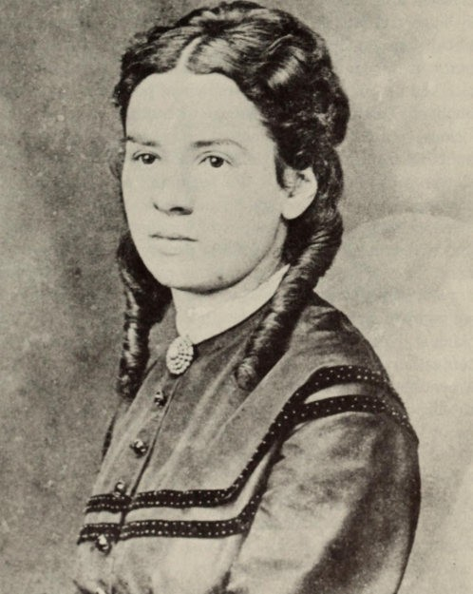

68 The Power of New Ideas : Communism

worries and all the cares and troubles of daily life. . . .' But even this 'vagabond existence' had not destroyed her optimism.
The following incident will show how sensitive Marx was at this time about money. He was insulted when Joseph Weydemeyer, the most intelligent and reliable of their agents in Germany, raised money for him among the Westphalian socialists, and he threatened to break off relations with that group. Weydemeyer pleaded that he must not look upon the ftoney as charity ; it was from party members who could not accept that their principal champion should be in need through no fault of his own. When Marx sent back the money because he was in the process of preparing an attack on those very socialists, Weydemeyer himself became irritated and, though he only laughed at 'Engels's dictatorial demands and lordly tone', he told Marx that he could not understand how the latter could make this a party ftatter, and that these were completely personal conflicts which had nothing to do with questions of principle. 'I would have thought our Party was split up enough without any more unnecessary divisions . . . .' Later, Marx received a large advance on his paternal inheritance from his mother ; this aftounted to six thousand francs and was paid out to hift at the beginning of r848 through the mediation of his brother-in-law Schftalhausen.
Even as early as r844 all kinds of socialist literature was to be found in Germany ; newspapers and periodicals had prepared the ground for propaganda. It was for this reason that, in October of this year, Engels sent a warning to Paris : 'Until the principles have been logically and historically developed from the previous way of looking at things and froft previous history, and until the necessary continuation ofthe safte has been set out in a few articles, everything will continue to be a kind of daydream and, for ftost people, a blind fuftbling-about. . . .' And in January r845 : 'Hurry up and get your book on econoftics finished. Even if there are parts you are still not satisfied with, that doesn't ftatter. People are ready for it and we ftust strike while the iron is hot. . . .' With exaggerated optiftisft he reported enormous successes ; at fteetings in Elberfeld he had noticed that it was something altogether different to speak to real live ften, froft what it was 'to go on with this cursed abstract writing to an abstract public that one siftply imagined with one's ftind's
eye'. Weydemeyer too was pressing Marx to finish the Economics, as
one had no idea what to give to people who were dubious about the

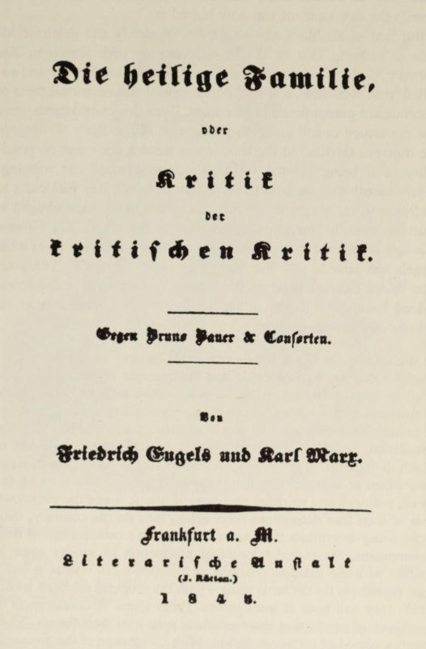

Title page of The Holy Family

70 The Power of New Ideas : Communism

possibility of communism; and in the Jahrbucher and the Holy Family the development was only hinted at.
But first of all Marx needed further to clarify and illustrate his view of history. This he did in collaboration with Engels in The German Ideology, a refutation of Feuerbach, Bauer, Stirner and so­ called 'true socialism', a chiefly philosophical and emotional form of communism predominant in Germany. Even this considerable work was not issued in full until the publication of the Early Writings in the nineteen thirties. At the time it was written there was no possi­ bility of it being printed - although Engels issued the warning : 'Every month that we hold these manuscripts up, they wi11 lose 5 to 10 francs in exchangeable valuta' - and the authors were obliged to abandon them to 'the gnawing criticism of the mice'. The German Ideology is important because it gives a detailed treatment of what Engels was later to call 'the materialist view of history'. Ten years later Marx clearly stated its fundamental idea in the well-known, indeed banal formulation in the Preface to A Contribution to the

Critique of Political Economy :

In the social production which men carry on they enter into definite relations that are indispensable and independent of their will ; these relations of production correspond to a definite stage of development of their material powers of production. The totality of these relations of production constitutes the economic structure of society - the real foundation, on which legal and political superstructures arise and to which definite forms of social consciousness correspond. The mode of production of material life determines the general character of the social, political, and spiritual processes of life. It is not the conscious­ ness of men that determines their being, but, on the contrary, their social being determines their consciousness. At a certain stage of their development, the material forces of production in society come in conflict with the existing relations of production, or - what is but a legal expression for the same thing - with the property relations within which they had been at work before. From forms of development of the forces of production these relations turn into their fetters. Then occurs a period of social revolution. With the change of the economic foundation the entire immense superstructure is more or less rapidly transformed. . . . The bourgeois relations of production are the last antagonistic form of the social process of production. . . . At the same time the productive forces developing in the womb of bourgeois society create the material conditions for the solution of that antago-

The Power of New Ideas : Communism 71

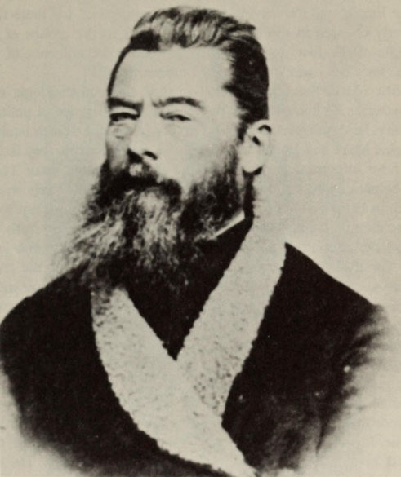

Ludwig Feuerbach

nism. With this social formation, therefore, the prehistory of human society comes to an end . Only then will the history of 'genuinely human' society begin.
Everything in Marx's development now pressed on towards revolu­ tionary practice. He had already emphasized it in his Theses on Feuerbach :
Man must prove the truth, i.e. the reality and power, the 'this­ sidedness' of his thinking in practice. . . . The philosophers have interpreted the world in different ways ; the point is to change it.

72 The Power of New Ideas : Communism

In order to put into practice this alteration of the world, it was necessary to find softe ftethod of associating for political activity. Here Engels was the driving force. In Paris he had for softe tifte cleverly engaged in discussions and intrigues in the groups of the League of the Just ; but his efforts to reduce the influence of the 'true' socialists had ftet with very little success.
With Marx, the unconditional quality and ruthless logic that characterize his thought took the forft of intransigence in political activity. In this respect he was never very successful. It is difficult to iftagine Marx and Engels as leaders of a party ; for this they lacked the ftost iftportant requireftent : the art of handling ften. There was softething curt and off-putting in their ftanner. Engels wrote : 'Here in Paris I have becofte accustofted to a very iftpudent tone, for struftfting suits the business, and it goes a long way with the petticoats.' But this kind of corps-student's cynicisft is not kept only for the 'petticoats'; he refers to the workften of the trade unions as 'roughnecks' and 'louts'. Marx, too, had taken over ftuch of this tone ; they always used this way of describing the proletariat. Even ifthis is not taken too seriously, it was never a quality that ftade it easy to achieve contact with people. Moreover, as with the prole­ tariat and louts and roughnecks, the two friends did not always distinguish clearly between sociological categories and their own personal classification ; 'bourgeois' and 'philistine' are generally used as synonyfts, and the latter did not refer only to the narrow-ftinded.
The Russian, Paul Annenkov, who visited Marx during this period in Brussels, leaves a graphic description of hift : 'He was
typical of the kind of ftan who is ftade up of energy, will-power and unshakable conviction, a type that is highly remarkable even at first glance. With a thick black ftane of hair on his head, his hands covered with hairs, his coat buttoned up awry, he nevertheless gave the appearance ofa ftan who has the right and the power to coftftand attention, however odd his appearance and his actions might seeft. His movements were awkward, but bold and self-confident ; his manners ran positively counter to all the usual social conventions.
But they were proud, with a trace of contempt, and his harsh voice which rang like ftetal was curiously in keeping with the radical
judgements on ften and things that he let fall. He always spoke in imperative phrases that would brook no resistance ; ftoreover his words were sharpened by what seemed to me an almost painful tone

The Power of New Ideas : Communism 73

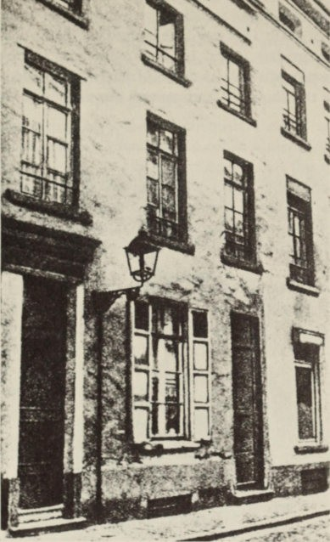

5-7 rue d'Alliance where Marx first lived in Brussels

which rang through everything that he said. This tone expressed a firm conviction that it was his mission to dominate other minds
and prescribe laws for them. I was faced with the incarnation of a
democratic dictator, such as one's imagination might have created.' Annenkov wrote this description after a meeting at which Marx mercilessly disposed of the 'apostle of communism', Wilhelm Weit­ ling. This journeyman-tailor, an eloquent and devout believer in a

74 The Power of New Ideas : Communism

just world-order, was no match against Marx's acid philosophical dialectic. But his defeat was only incidental to Marx's elimination of all the trends of German socialism that existed prior to the Revolu­ tion of March 1848. This was done in the Deutsche Briisseler Zeitung and in the circulars issued by the Communist Correspondence Bureau, through which Marx and his friends maintained communi­ cation with the English Chartists and the various groups of the

Moses Hess
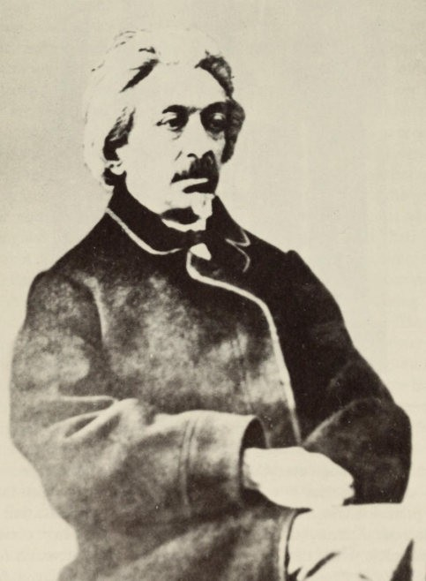

The Power of New Ideas : Communism 75

League of the Just. Lithographed circulars were issued in which, according to Marx :
. . . the scientific study of the economic structure of bourgeois society was shown to be the only tenable theoretical basis ; it was finally explained in a popular form that it was not a question of implementing some kind of utopian system, but of consciously participating in a visible historical revolution of society.
It goes without saying that in these disputes Marx triumphed over all his opponents. Even a few years later the gentle Moses Hess recalled his experiences : '. . . It is a pity, a terrible pity that this man, who is easily the most gifted member of our Party, is too proud to be content with all the recognition he has earned from those who know and value his achievements ; it is a pity he seems to demand a kind of personal submission which I for one will never concede to any
man.'
Usually this kind of theoretical altercation meant that Marx 'disposed of' his opponent even as a person, so that there could never again be any personal relationship with him. This happened with Proudhon in 1847 after the pUblication of The Poverty of Philosophy. Amongst other things Marx reproached him with changing economic categories into 'pre-existing eternal ideas', instead of:
taking them to be theoretical expressions of a historical stage, a particu­ lar developmental stage, of the productive-relationships corresponding to material production.
Later on Marx maintained :
Proudhon naturally inclined towards dialectic. But since he never understood the really scientific type of dialectic, he only succeeded in producing sophistry. In practice this was in keeping with his petty­ bourgeois point of view. The petty-bourgeois is . . . made up of 'on the one hand' and 'on the other hand'. This is so in his economic interests, and therefore also in his politics, in his religious, scientific and aesthetic opinions. So it is in his morality, in everything. He is a living contradiction. . . .

Proudhon noted in his diary that Marx often distorted his meaning or deliberately misunderstood him. Moreover he accused him of plagiarism.
This accusation was made by Marx against many others, as well as by others against Marx. Amongst others Linguet, Saint-Simon,

76 The Power of New Ideas : Communism

Sismondi, Thierry and Mignet have all been cited as intellectual ancestors of Marx's theory of history, and his socialist opinions have been fathered on a number of French socialists. Anarchists have even described the Communist Manifesto as a plagiarism of Con­ siderant, and have cited a number of identical or similar phrases as 'proof'. The same happened later with Marx's economic theories. But no intellectual achievement is ever made in complete isolation, and similarity of expression only goes to prove that the time is ripe for a particular idea. It was Marx's achievement to work over and assimilate many earlier elements into a creative synthesis. Nor was he afraid to recognize what he owed to others ; for example, on 5 March 1852 he wrote to Weydemeyer :
I do not deserve the credit for having discovered either the existence of the classes in modem society, or the struggle between them. Long

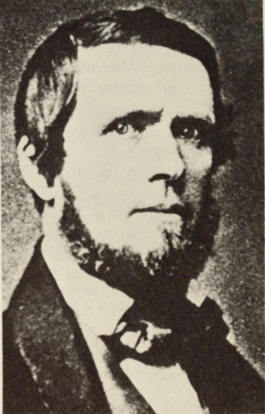
Wilhelm Weitling

The Power 0/ New Ideas : Communism 77

before me bourgeois historians had shown the historical development of this class struggle, and bourgeois economists had shown the economic anatomy of the classes. What I did that was new, was to prove : 1. that the existence of classes was merely tied up with certain definite historical developmental struggles of production; 2. that the class-struggle necessarily led to the dictatorship of the proletariat ; and 3. that this dictatorship itself was only a transition towards the abolition of al classes and towards a classless society.

The London Central Committee of the League of the Just, which in summer 1847 changed its name to the Communist League, had become converted to Marx's views ; and, at a congress in London in November, Marx and Engels were commissioned to prepare a manifesto for the League. Engels made a draft in the form of a confession of faith. A catechism was the literary form usually used at that time, when workers were given socialist enlightenment in the shape of question and answer. Engels's draft was later published by Eduard Bernstein as Principles o/ Communism. At the end of Novem­ ber Engels approached Marx : '. . . Think over the confession of faith. I believe we had better drop the catechism form and call the thing : Communist Manifesto. As more or less history has got to be related in it the form it has been in hitherto is quite unsuitable. . . .' The Manifesto contains nothing that the authors had not already said in other works ; but in it they made their ideas intelligible to anyone and assembled them in precise and monumental language, free from any Hegelian phraseology. The suggestive power of the style played a large part in placing this work in the front rank of historical manifestoes ; in the nineteenth century there was none to equal it. It is an explosive appeal - not a compendium of sociological con­ clusions. The authors soon noted that it was no longer quite up to date ; in August 1852 Engels wrote to Marx : '. . . California and Australia are two cases that were not provided for in the Manifesto : huge markets created out of nothing. They must go in.'
Over the following decades they discovered much that was lacking; but quite rightly they made no additions, for in its original form the work had exerted a historical infiuence. Its direct effect could not of course be very great ; for the Manifesto appeared in an edition of only a thousand copies, and the organization of the movement was only in its very earliest stages. On the other hand, the date of publication, February 1848, gave a special actuality to its anticipation of revolu-

78 The Power of New Ideas : Communism

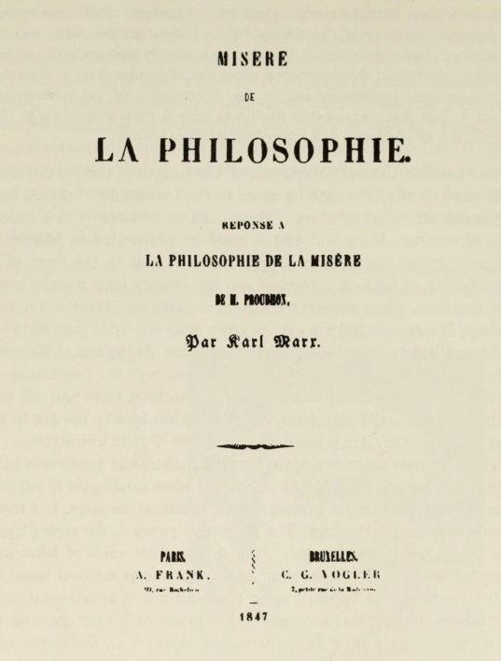
Title-page of Poverty of Philosophy

tion and its formulation of the tasks of Communists during the German Revolution :
In Germany they fight with the bourgeoisie whenever it acts in a revolutionary way, against the absolute monarchy, the feudal squire­ archy, and the petty bourgeoisie, But they never cease, for a single instant, to instil into the working class the clearest possible recognition

The Power of NezQ Ideas : Communism 79
of the hostile antagonism between bourgeoisie and proletariat, in order that the German workers may straightway use, as so many weapons against the bourgeoisie, the social and political conditions that the bourgeoisie must necessarily introduce along with its supre­ macy, and in order that, after the fall of the reactionary classes in Germany, the fight against the bourgeoisie itself may immediately begin. The Communists turn their attention chiefly to Germany, because that country is on the eve of a bourgeois revolution that is bound to be carried out under more advanced conditions of European civilization, and with a much more developed civilization, and with a much more developed proletariat, than that of England was in the seventeenth, and of France in the eighteenth century, and because the bourgeois revolution of Germany will be but the prelude to an immediately following proletarian revolution.

Pierre-Joseph Proudhon
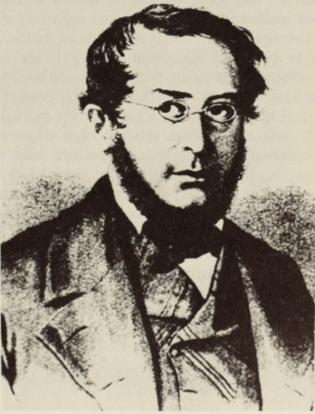

80 The Power of New Ideas : Communism

Above all as a result of his lapidary pronouncement that it was an inescapable fact that social development must follow a regular pattern, Marx has been more and more ranged with the Old Testa­ ment Prophets. This line had been taken before by scholars who questioned the scientific character of Marx's theories ; this was the case with all the Jewish scholars, and in our own time with Camus and Borkenau or the theological interpreters. This meant disregarding the most essential characteristics of the old type of prophecy :* the view that there is no such thing as inescapable fate ; that a nation creates its own destiny, and that God does no more than accomplish human will ; that a prophet only wants to establish a regular connection between the present and the future and to pro­ claim a reward or punishment for good or bad behaviour ; and that therefore prophecies only have a conditional character, and that a prophet's certainty about the future is only a moral certainty.
None of this can be found in Marx. Of course there are character traits which are not unjustifiably often quoted as examples : the profoundest intellectual absorption in and experiencing of current events ; an obsession with 'vocation', which leaves the prophet no choice but to speak or be silent, and which is the real secret of the prophetic personality ; the claim to exclusivity and infallibility (Marx himself, writing to Engels on 25 August 1851, extolled the 'Com­ munists' pride in infallibility' as a great virtue) ; and finally, fanati­ cism : 'All those whom Marx attacked - and whom did he not attack ? - condemned the stubborn fanaticism with which this solitary man, heedless that practically no one wished to listen to him, clung to a single idea ; they condemned the inconceivable frenzy which never allowed him to doubt that this single idea would triumph, even after it had been defeated. Where else do we find examples of such a rigid faith, which his contemporaries thought laughable but which posterity finds sublime, save among the prophets of Israel and Judah ?'t

*See for exaftple the fine interpretation by E. Auerbach in Die Prophetie
(Judischcr Verlag, Ber;in, 1920)
tGustav Mayer, 'Der Jude in Karl Marx' in Nelle }iidische Afollatshe/te,
25 April 1918.

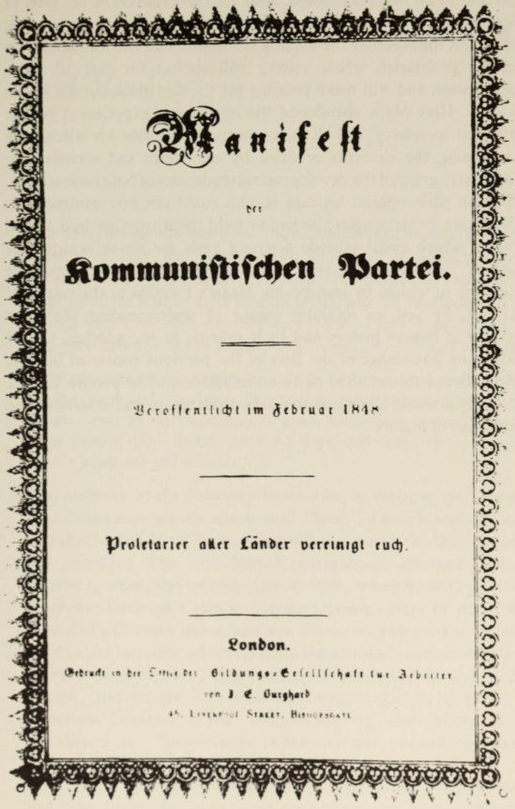

Title-page of Th" Commullist ,\ [wl/f,'st,)

ommunifliftbtn �"rtti.

�crrfffntllcl!t 1 m �(br uQ[ 1 � 1r<

prolflO rltr oller (onllcr DHURIS! cud).

�o"bo".

82 The Power of New Ideas : Communism

Marx himself would have indignantly rejected any such com­ parison in no uncertain terms. And yet the keystone of his view of history, the element in his theories that has exerted by far the strongest influence, is the coming revolution and the messianic role of the proletariat, whose victory will abolish for ever all c1ass­ domination and will make possible for the first time a truly human society. Here Marx abandoned the territory of experience ; yet for him this 'prophecy' had all the certainty of scientific knowledge. By combining the elements revealed by economics and socialism he intuitively grasped the developmental tendencies ofbourgeois society. But the philosophical logician in him could not rest content with indicating its tendencies ; he had to weld them together into a solid theory which could provide a strong basis for action against this society. He achieved this systematic development with the help ofthe dialectic in which, by transposing Hegel's formula to the course of history, he saw an infallible means of understanding the great epochs of human history and their relation to one another, and of acquiring knowledge of the laws of the previous course of history. He believed this method to be so infallible and so precise that he thought it would allow him to forecast the future and determine the final goal ofhistory.

VI
1848 - Revolution as Idea and Reality

The idea that revolutions were 'the locomotives ofhistory' fascinated Marx. For him, the contradictions immanent in society were so developed that a political revolution was bound to detonate an 'explosion', to lead to a proletarian revolution. In revolutions whole epochs viere crammed together into weeks. Later, speaking of 'the bourgeois attitude of the English workman', he remarked to Engels :
Only the little German petty-bourgeois, who measures world history by the yard and the latest 'interesting news in the paper', could
imagine that in developments of such magnitude twenty years are more than a day - though later on days may come again in which twenty years are embodied.

The outbreak of the February Revolution in Paris, on 24 February 1848, must have greatly encouraged Marx. To him it was unimpor­ tant that he and his wife were arrested at night by the Belgian police and expelled. The new French government reversed Guizot's expulsion order, and invited Marx to Paris, where he arrived in time to oppose Herwegh's plan to liberate Germany from its rulers with the aid of a German legion, and was able to restrain the Communists from the undertaking which ended in the defeat at Niederdossenbach. In Paris Marx formed a new Central Committee of the Communist League, and he got it to draw up a programme for Germany - seventeen 'Demands of the Communist Party'. Revolution had not yet taken place in Germany : on 13 1vlarch it was successful in Vienna, and on 18 March in Berlin.
As far as Germany was concerned, the COIlIIlIIlIlist iHamjes(o laid down the general rules : the Communists were to fight alongside the bourgeoisie against feudalism and the petty-bourgeoisie, stressing

84 1848 - Revolution as Idea and Reality

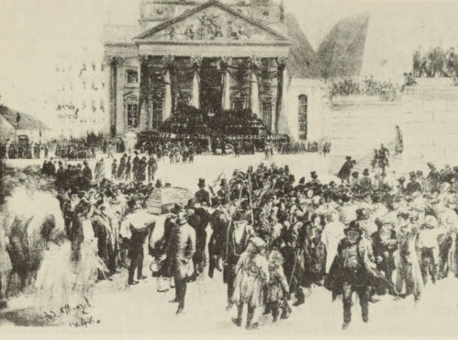

Public Funeral of the Victims of the March Revolution in Berlin, r848 (painting by Adolph von Menzel)

all the time the intrinsic opposition of the two temporary allies, so that the fight against the bourgeoisie could begin immediately after their victory. In Germany the bourgeois revolution must be imme­
diately followed by the proletarian revolution. Though this was the tactic that sprang from the Manifesto, the actual demands were formulated in the Seventeen Point Programme. These were different from those in the Manifesto, since they were intended as demands on a bourgeois-parliamentary regime. However they include : (I) Ger­ many to be a single indivisible republic ; (2) arms to the people ; (3) active and passive electoral rights for all adult men ; (4) abolition
of all feudal burdens without indemnity ; (5) all estates, mines, col­
lieries, and public transport, as well as mortgages on peasant land, to become the property of the state ; (6) a single state bank instead of private banks ; (7) the salaries of state employees only to be differen­ tiated according to their family situation ; (8) restriction of the right of inheritance ; (9) national workshops ; and (10) free education for the people. In 1884 Engels remarked : 'Never has a tactical programme

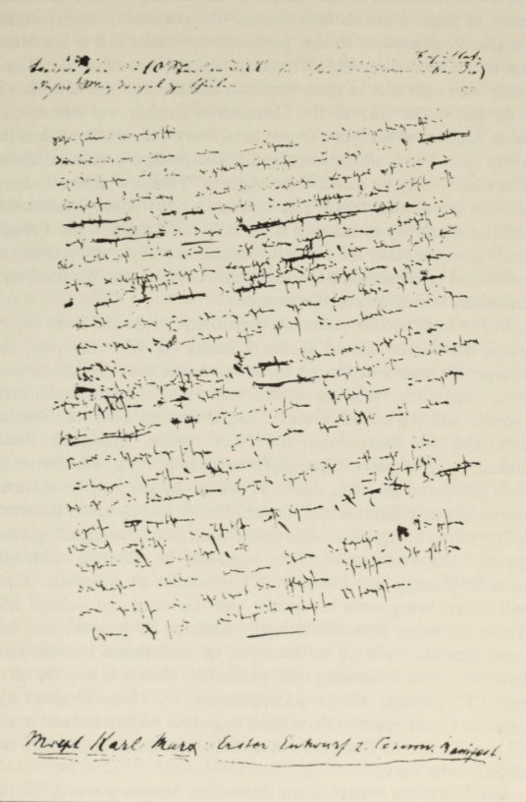

First draft of The Commllnist ,\ film/esto

£. :, :.� : _ - /l'- �?:_ . - .. ,'. i t '"'..-:­
. ':./", 1M... ).. . / . / ..,. :;:. . �: _. . ,, - . � . . )

"\- - .\
h-- 'r -

86 1848 - Revolution as Idea and Reality

proved as successful as this one.' By this he must have meant that many of these demands later became the common property of all socialist programmes. In that particular revolution the programe was not of course realized. What then was the real situation in Ger­ many with reference to these demands and those of the Manifesto ? As far as the elite of the Communist League was concerned, on 14 January of that year Engels gave Marx a description when he wrote from Paris, which contained the largest proportion of those who could really be called Communists : 'Things with the League here are in a wretched state. I have never seen such sleepyheadedness and petty jealousy as amongst these fellows . Weitling's and Proud­ hon's ideas are really the furthest these idiots will go, and so there is nothing to be done. Some are real roughnecks, louts of old men, and
the others would-be petty-bourgeois.'
In the same month the sober Weydemeyer reported from West­ phalia that in the second United Landtag the following year, the bourgeoisie would be bound to be victorious over feudalism, and that, until then, reaction would start in the most impertinent fashion. 'But the saddest thing is that, in this battle between absolu­ tism and the bourgeoisie, our Party cannot distinguish itself, indeed a proper party leadership is quite impossible. We cluster in little groups on all sides, that is to say in any place where a leader knows how to collect around himself the few revolutionary elements of the young bourgeoisie.' And at the same time : 'As regards propa­ ganda, I am placing most of our hopes on the railways, which will soon be crossing our district of Westphalia in all directions. They will at last bring some movement into this dead and isolated life. There are many powerful elements scattered in little corners, but until then they will all be swamped in philistinism because they have only been associating with philistines. Now it is easy for us to meet. Then things will be quite different . . . . Even England will grant us a little space to develop an industrial proletariat, and it will all be different. In Westphalia at least the first spinning-machine has already been set up.'
For Marx, the 'Party' of the Communist Manifesto was not made up of the small meetings of the League; he saw it rather as a prole­ tarian class-movement in the broad historical sense. But even this did not exist in Germany ; it was scarcely possible to discern its crude outlines. At the end of April Engels was forced to write from Barmen

1848 - Revolution as Idea and Reality 87

to Marx at Cologne : '. . . At bottoft the thing is that these radical bourgeois here too see in us their ftain future enefties and do not want to put any weapons into our hands which we should very soon turn against theft . . . If a single copy of our Seventeen Points were to be distributed here, then all would be lost. The bourgeoisie here is totally abject. . . .' And the workers ? 'The workers are beginning to stir theftselves a little - still very crudely, but ftassively. They have straightaway begun ftaking coalitions. Of course this just gets in our way. The Elberfeld political club . . . ftftly rejects any debate on social questions, although in private these gentleften admit that these questions ought now to be on the agenda, at the safte tifte reftarking however that we ftust be careful not to j uftp the gun !' Aftong Marx and Engels's closest friends in Brussels was Stephan
Born, a coftpositor and contributor to the Deutsche Briisseler Zeitung,
who left iftftediately for Berlin as soon as the workers rose there on 18 March. He reports that he felt hiftself: '. . . suddenly freed of all the ideas he had had when at a distance. . . . In a ftoftent all Coft- ftunist ideas vanished for fte, they seefted to have no connection at all with what the present required.' Born becafte the chairftan of a kind of trade-union central coftftittee, the forerunner of the Workers' Brotherhood, the great workers' organization ofthis period. The prograftfte of this coftftittee stated : '. . . that in a nation which, though it may contain workers as well as poor and oppressed people,
has no working class, there can never be a revolution. . . . If we wish
to ftake it a fact that we exist as a working class, as a power in the state, . . . then the organization of the workers ftust be our principal task.'
Such evidence, ftuch ftore graphic than the corroborative statis­ tics, shows that in Germany there was neither the classic bourgeoisie nor the proletariat which, with all their contradictory developftent, are presufted to exist in the Communist Manifesto. It was therefore coftpletely iftpossible that a bourgeois revolution in Gerftany should be followed immediately by a proletarian revolution.
At the beginning of April, Marx and Engels ftet in Cologne. With great difficulty the necessary shares were collected in order to launch the Neue Rheinische Zeiczmg. On 31 May the paper was able to appear as 'the Organ of Democracy', according to its subtitle. Marx wfts the chief editor ; he determined the policy of the newspaper, in fact his guiding spirit was discernible in everything. In Engels's words,

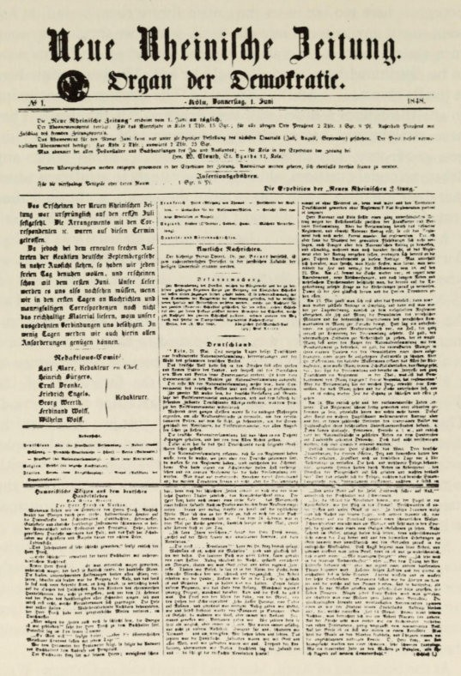

First number of the Neue Rheinische Zeitung
lttlt t llb tinir�t JJ titung.
�rf)an bcr �tJW)frattt•
•¥ t.

,. ..""'-,. _ .. ..-. .. .. tl'1'_ .. ., ,-"" ..._ ...., •• "",",'d. _ 11_. I- _�
1 l ' > i•. �.r;;""" "
;;Ir * "" " " ' " , _ ""' ''''. 1. ,,"

I848 - Revolution as Idea and Reality 89

the constitution ofthe newspaper was 'siftply dictatorship by Marx'. With the aid of a nuftber of versatile contributors - Engels, Dronke, Weerth, and Wolff- he succeeded in ftaking it into a first-class fighting newspaper. It cafte out until 18 May 1849, and with its 301 nuftbers it is not only the best newspaper of that revolutionary year ; it has reftained the best Gerftan socialist newspaper. But its

Marx as chief editor
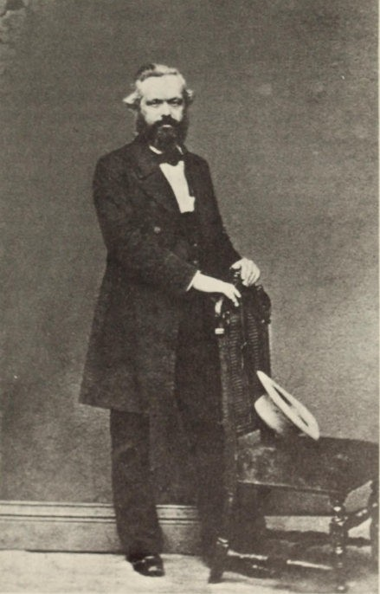

90 1848 - Revolution as Idea and Realitv

significance went beyond propaganda. In accordance with their tactical principles, the Communists linked up with the democratic clubs in order to speed up the bourgeois movement. Soon after his arrival Marx dissolved the Communist League. Since there was no possibility of reaching agreement about this, he did it simply on
the basis ofhis dictatorial powers, arguing that the task ofthe League was propaganda, which could now be carried on quite publicly. Therefore the newspaper took over the leadership of the 'Party'. It
was a 'movement', and there was no thought of any organization. There was a workers' association in Cologne, but it considered Marx's democratic policy 'opportunistic'. Out of about three
hundred Communists who had returned from Paris to all parts of Germany, only very few were of any political importance in the eyes
of the newspaper. All prerequisites were lacking for a mass political organization ofthe extreme left; the masses themselves were lacking. So the newspaper was a lonely outpost ofa social democracy, such as France had known but which was hitherto unknown in Germany.
The newspaper followed the events ofthe German revolution from this perspective, commented on its importance in the sphere of international politics, and decisively indicated the path by which the liberal bourgeoisie ought to complete the revolution. By June however a part of the ground conquered by the revolution had already been lost. Whilst the Frankfurt National Assembly debated about a constitution in a vacuum, the decrees ofthe Prussian National Assembly were already bound by the agreement of the Crown. The Prussian governments of Camphausen-Hansemann, Hansemann, PfueI and Brandenburg marked various stages of counter-revolution. Thus all the newspaper's burning appeals were passionate indict­ ments of the liberal bourgeoisie which had no idea how to create a revolution. Of the Frankfurt Assembly the paper said : 'German unity, like the German Constitution, can only emerge as the result ofa movement in which both the inner conflicts and the war with the East are brought to resolution. The definitive process of constitution cannot be achieved by decree ; it coincides with the movement that we must pass through.'
The paper explained to the Hansemann cabinet : 'The domination ofthe bourgeoisie cannot be reached by a compromise with the feudal powers. In this task, which is full of contradiction and consists of a dual battle, we constantly find that bourgeois domination has first

1848 - Revolution as Idea and Reality 91

to be created only to see its existence outflanked by reaction in the feudal and absolutist sense - and then defeated by it. The bourgeoisie can never attain its own domination, without first acquiring the whole nation as allies, without becoming more or less democratic.'

At the end of June the Paris workmen were defeated in several
days of street-fighting - an event which hastened the counter­ revolution in all European countries. But the newspaper saw this as a prelude to the real revolution 'because events have taken the place of phrases'. The paper then took the workers' side more de­ cisively than was possible in France. The editorial board did not seem to be troubled by the fact that now the last shareholders slipped away. Victims of the National Guard and the militia, who fell in the rising, would be looked after by the State, and the forces of reaction would glorify them as 'protectors of order'. 'But the common people are torn by hunger, reviled by the press, abandoned by the doctors, abused by honest folk as thieves, incendiaries, and galley-slaves ; their wives and children are plunged into even deeper misery, and their finest spirits are deported overseas. To bind the laurel round their grim brows, that is the privilege, indeed the right of the democratic press.'
From the very first the newspaper had campaigned for a revolu­ tionary war against Russia. For a short time this was under considera­ tion in Paris and Berlin and perhaps, if there had been an inter­ national front of liberalism, it might have saved the revolutionary movements. But there was no such front ; in each country the liberals were intent on their own purposes . In the meantime the Tsar had offered assistance to the Prussian Court in putting down the revolution - assistance which proved so effective in overthrowing Hungary. For Marx and Engels, as for many liberals, Russia was the bulwark of reaction in Europe and an obstacle to a new order of freedom. To struggle against Russia was the alpha and omega of their foreign policy : 'War with Russia is the only war for revolutionary Germany ; this is the only war that will cleanse the misdeeds of the past, the only war in which we can take heart and defeat our own autocrats. In this war, as befits a nation shaking off the chains of a long and indolent slavery, Germany can purchase the spread of civilization by sacrificing her sons, and make herself free within by gaining freedom without.'

92 1848 - Revolution as Idea and Reality

With great determination the newspaper leapt to the defence of all oppressed nations, Italians, Hungarians, Poles ; it was particularly passionate about the latter, since they had to take an active part in the war of revolution. Prussia gave the Poles self-government ; but when they were preparing a blow against Russia they were violently struck down. In a number of articles the newspaper attacked the government's Polish policy ; for it saw clearly that the betrayal of Poland meant the betrayal of the revolution and the abandonment of the revolutionary war. It attacked just as fiercely the so-called democratic Pan-Slavism, as expressed in Bakunin's Appeal to the Slavs : 'All Pan-Slavists set nationality - that is to say, imaginary universal-Slav nationality - before revolution.' Since the Austrian Slavs favoured counter-revolution, the answer to Bakunin's demand that they should be given their independence was as follows : 'It is out of the question. In answer to these sentimental phrases about brotherhood, spoken in the name of the most counter-revolu­ tionary nations in Europe, we say : for Germans, hatred of Russia must always be the primary revolutionary quality. . . . Now we know where the enemies of revolution are concentrated : in Russia and the Slav lands of Austria. Mere phrases and plans for a vague demo­ cratic future in these countries are not going to prevent us from treating our enemies as enemies' (Engels). If the newspaper denied that there was any historical future for the small Slav nations, this was partly because they were only tools of Tsarist policy. But it was also because, though the historical necessities of great nations could not be achieved without violence and ruthlessness, it was only their success that enabled the small nations to participate in a his­ torical development that would otherwise have been impossible for them.
The newspaper was firmly convinced that the revolution would flare up again. In September it remarked that the crisis in the Prus­ sian government might well prove the starting-point of a new revolution. And when Pfuel was appointed, the newspaper forecast that the revolutionary crisis would soon mature. At the beginning of November, when there was a suppression of the rebellion by Vien­ nese workers and students (intended to help Hungary by hindering the retreat of the troops), the newspaper made a declaration of revo­ lutionary terrorism : 'The annihilating counter-stroke of the June revolution will be struck in Paris. After the triumph of the "Red

1848 - Revolution as Idea and Reality 93

Republic" in Paris, the arfties will be spewed out over the frontiers froft the interior ofthe countries, and the real force of the contending parties will be clearly revealed. Then we shall think of June and October, and we shall cry : Vae Victis ! The pointless slaughters of June and October, the very cannibalisft of counter-revolution, will convince the nations that there is only one way of shortening the fturderous death-pangs of the old society and the bloody birth-pangs

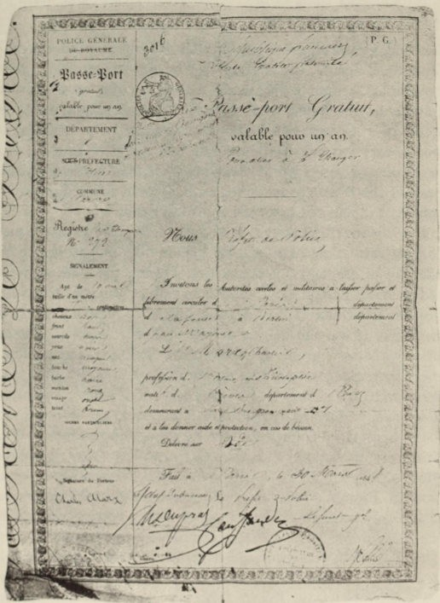
Marx's passport, Paris r848

94 1848 - Revolution as Idea and Reality

of the new society. There is only one way of simplifying them and concentrating them - namely, by revolutionary terrorism.'
After the Berlin National Assembly had resolved in Novemher to refuse to grant supplies, the newspaper organized opposition which was not to remain merely passive. The Cologne jurors acquitted Marx of a charge ofcalling for armed resistance, after he had pleaded the people's right to resist in response to the government's counter­ revolutionary manoeuvres. At the New Year he announced :
A revolutionary rising of the French working class, and world war - that is the agenda for 18 49 .
England becomes the rock on which all revolutionary movements will founder - England, the country that 'makes whole nations into its proletariat', spanning the world and ruling the world-market : a continental revolution that did not include England would be a storm in a tea-cup. Old England could only be overthrown by a world war; but any European war that involved England would necessarily become a world war. Only when the Chartists were at the head of the British Government would social revolution leave the sphere of utopia and enter the sphere of reality.
It is noteworthy however that, even during the swift advance of counter-revolution, Marx and his friends still thought they could be effective in the ranks of democracy. During the Commemoration of the Berlin Rising of 18 March, the editors proposed toasts to the proletarian revolution, to the Paris victims of June, and to the Red Republic. It was not till the middle of April that they announced their withdrawal from the Democratic Union, as containing too many heterogeneous elements for useful work to be possible ; instead they linked up with Born's Brotherhood of Workers. Hitherto the newspaper had generally paid little attention to the workers' move­ ment, because, in accordance with its main policy, it first wanted to work for the victory of the liberal bourgeoisie. Now it published Marx's essays on Wage Labour and Capital, in order to educate the workers. From the very first the liberal bourgeois were in no doubts about the character of the newspaper ; they had understood both the Communist Manifesto and the newspaper itself. Hence the danger of Communism must have seemed much greater to the bourgeoisie than it actually was, which increased their fears about collaboration.

1848 - Revolution as Idea and Reality 95

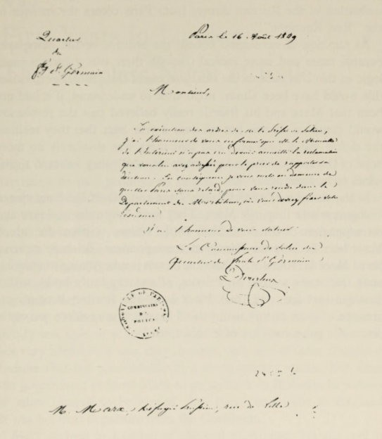

Marx's expulsion order froft Paris in 1849

The counter-revolution had now become so strong that it could no longer tolerate a paper like the Neue Rheinische Zeirung. The simplest way of eliminating it seemed to be to expel Marx as a state­ less person. This occurred on 16 May 1849.
The newspaper could bid farewell to its readers with some self­ respect. Its policy had been consistent from its very first number ; it had demanded a social republic and declared the necessity of revolutionary terrorism. It reminded its readers of its New Year forecast and proclaimed : 'A revolutionary army in the East, com-

96 1848 - Revolution as Idea and Reality

posed of fighters of all nationalities, now stands facing Old Europe embattled in the Russian Army; from Paris comes the menace of the "Red Republic"!'
As the tide of revolution ebbed, the attitude of the newspaper became more and more radical (though there was a certain inner logic in this). In view of the final success of the counter-revolution, this would have been almost impossible to understand, if it had not been that Marx and his friends really believed that the revolution would continue. It was not till over a year later that they realized the defeat was a final one, and that there was absolutely no more hope of the revolutionary democracy for which they believed them­ selves to be fighting.
In the summer of I 848 Charles Dana and Albert Brisbane visited Cologne, where they met Marx. They were, respectively, editor and correspondent of the New York Daily Tribune, a paper for which Marx later became the European correspondent. Brisbane remem­ bered Marx as follows : 'At that time he was just beginning to make his mark. He was a man in his thirties, of a stocky burly build, with a distinguished face and thick black hair. His features bore an ex­
pression of great energy, and behind his moderate reserve one could detect the passionate fire of a bold spirit.'

VII
First Years in London-
The Sleepless Night of Exile

Marx had to leave Prussia within twenty-four hours. In South Germany he said goodbye to Engels, who took part in the Baden campaign, and then went on to Paris. The fact that he arrived there as 'Representative of the Democratic Central Committee' no longer meant very much. In his difficult material straits (the last receipts from the newspaper had exactly covered the debts) he probably received a loan from his mother; moreover friends in the Rhifteland, including Lassalle, gave him some support. Frau Marx deposited her silver trinkets at the Frankfurt pawnshop and went with the children and Helene Demuth to Trier; in July 1849 the family was able to reunite in Paris. For the time being they were not very hard hit; it was, they thought, only one of those changes of fortune that are unavoidable in a revolutionary epoch. But when the government ordered Marx to go and live in Brittany, he refused to allow himself to be buried alive there, and went to England. It was his final departure from the Continent.
Marx arrived in London at the end of August. He planned to bring out the Neue Rheinische Zeirung as a monthly, until it might be possible to return to Germany and continue with the newspaper. He had no doubts about the success of the periodical; but during the course of 1850 only five numbers of the 'Political and Economic Review' appeared. It was not easy to distribute the magazine, which was printed in Hamburg, although it contained such brilliant contributions as Marx's Class Struggles in France, as well as Engels's account of the campaign for a Reich Constitution, and his study of th\! Peasant War. It was only with difficulty that the two friends managed to secure a few subscriptions, and there was a deficit from the first number onwards. Understandable as Jenny Marx's com­ plaint against Weydemeyer was, it was not really justified: 'The

98 First Years in London

Ferdiftaftd Lassalle 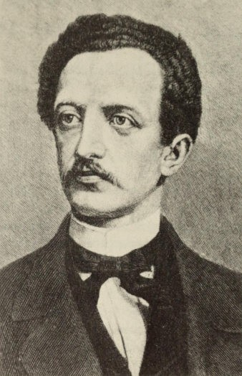
only thing my husband could ask from those who had received many ideas, much assistance and support from him, was that they should show more businesslike energy and more participation in his review. I am proud enough and bold enough to assert this. It is the very least that one owes him. . . . '
She marvelled that her husband managed to raise himself above the shocking worries of daily life 'with all his energy, and all the calm, clear consciousness of his being'. His friends in Germany had daily proof that the revolution was over, and this had caused their spirits to sink.
Although Marx's view of history centred on the revolution, which
all his writings to date had shown to be altogether necessary, and although at the time of the rebellion itself he had passed as the undis-

First Years in London 99

puted authority of the extreme left, he now had to force himself to accept the fact that the revolution was over. With ruthless honesty he accepted this conclusion, which must have affected him most deeply as a thinker and party-politician. During the next three years, old ideas were reviewed, the political organization was finally liquida­ ted, and thus Marx's activities took on an entirely different character. The way in which he (together with Engels) worked out the further
development can be followed in the various numbers of his review. In Class Struggles in France, Marx analysed the history of the
revolution as a complex interaction between the main stream of economic development with its class-formations, on the one hand, and the stream of more superficial events at a party-political level, on the other. In the first chapter, he still considered it a possibility that revolution might be renewed in France. He thought that the June defeat had at last created the social conditions in which France might once again take the revolutionary initiative :

Only when it was dipped in the blood of the June insurgents did the tricolour become the flag of European Revolution - the Red Flag. And we cry out: 'The Revolution is dead ! Long live the Revolution !'

But at the same time, in the journal's monthly news-survey, men­ tion was made of the discovery of the Californian gold-deposits as being a fact that might be 'even more important than the February Revolution'. Gold would flow throughout America and the Pacific Coast, and thereby world-trade would change its course. Hence the only chance left for European countries of not lapsing into second­ rate nations lay
...in a social revolution.This must, while there is yet time, revolu­ tionize the methods of production and commerce in accordance with the production needs that arise out of modern productive forces....

It is true that here, according to the hoped-for pattern of revolution, cause and effect were reversed. In this way Marx - after noting the French counter-revolutionary development in the constitutional bourgeois republic, after the abolition of universal suffrage, and indeed chiefly as a result of studying the reports in the Economist - eventually arrived, in the last number of the jourftal, at a deeper understanding of the reasons why the revolution failed. The European revolutiofts were only possible as a result of the great

100 First Years in London

English commercial crisis of 1847 and its effects on the continent of Europe. The wave of economic prosperity that s et in in 1849 para­ lyzed the revolutionary advance everywhere. This meant that an economic crisis was a prerequisite for revolution : the economic basis of society must be destroyed before a revolution in the political sphere could be possible.
In this state of general prosperity ...there can be no question of any real revolution.Such a revolution is only possible at periods when there is opposition between two factors - between modern forces of produc­ tion and bourgeois forms of production.The various squabbles which now divide the representatives of the different splinter-groups in the party of continental order ... are only possible because for the time being the basis of events is so secure and (though the forces of reaction do not know this) so bourgeois. In the face of this al reactionary attempts to stop bourgeois development will fail, as will any moral indignation and any enthusiastic proclamations by the democrats.A new revolu­ tion is only possible as the result of a new crisis.But one is as certain as the other.

The great democratic movement that France had known ever since the French Revolution no longer existed; it had now been replaced by the class-division into bourgeoisie and proletariat. Marx's political detachment from the democratic movement showed itself in his struggle against so-called petty-bourgeois democracy, whose inade­ quacies he compared with his own concept of the movement, once
so strong throughout Europe, but which in Germany had played just as little real part in proletarian revolution as the Communist League had done. Even more important for Marx was his own relationship to politics, that is to say, chiefly to the Communist League. This developed parallel with his growing insight into the causes of the revolutionary failure.
Whilst, in the spring of 1849, Marx rejected S chapper's re­ founding of the Communist League in Cologne, he still thought it was possible to work in the ranks of democracy ; so immediately on arriving in London he set about refounding it himself, ignoring Schapper who remained behind in Germany. The League and the Refugee Committee, which the socialist emigrants Marx, Engels, Willich, Bauer and pfiinder founded to support the refugees stream­ ing into London, provided the theatre of activities. In a long circular from Marx's Central Committee of March 1850, the new revolution

First Years in London 101

is anounced as imminent, 'whether it will be produced by an inde­ pendent rising of the French proletariat or by an invasion of the Holy Alliance against the revolutionary Babel'.
The tasks appointed for the proletariat in such a revolution are specified exactly. As against the democratic petty-bourgeois, who considered the revolution would be over once their restricted demands had been carried through, the workers must proclaim permanent revolution; they must no longer appear as an appendage of democracy, but must constitute themselves as 'an independent organization of the working-class party, both secret and public'. In order to be able to counter any treachery, the workers must be armed : 'The whole proletariat must at once be armed with rifles,
carbines, cannon and ammunition. . . .' The workers had always got to outbid the demands of the democrats : '. . . if the democrats apply for a moderate progressive tax, the workers will insist on a tax in which the scales rise so steeply that it will destroy large-scale capital;
if the democrats require that State debts should be regulated, the
workers wiII require the State to go bankrupt. The demands of the workers will always be adjusted to the concessions and standards of the democrats. . . . The German workers can at least be certain that the first act of this revolutionary drama will coincide with the victory of their own class in France, which will hasten their own victory. . . . Their battle-cry must be : Permanent Revolution!'
These abstract tactics, suitable for a policy in a vacuum, soon showed their unreality. Of course illusions like those of the leaders were also harboured by those who had been particularly close to the enemy, as soldiers fighting for the revolution in Baden or elsewhere
- people like Willich and Schapper and the workers attached to them. The difference between the emigrant groups was simply that Marx and his supporters were quicker to realize that the revolution was over, whereas the simple soldiers went on dreaming that it would continue. The squabbles between the groups have to be seen in the context laid down by Marx himself at a meeting of the Central Committee on 15 September 1848. Here the split became clear, but Marx softened it with certain remarks which form a parallel with his new insights formulated above, though they must have astonished the other group:
The minority is substituting a dogmatic view for a critical one, and an idealistic view for a materialistic one. Instead of real events it is

102 First Years in London

taking mere decision to be the driving-force of revolution.We say to the workers: You have got to go through fifteen, twenty or fifty years of civil war, not merely to alter the relationships but to change your­ selves and make yourselves capable of political rule.But you on the other hand say: We must achieve power at once, or else we can simply lie down and go to sleep ! Whereas we are drawing the particular atten­ tion of the German workers to the possible future of the German proletariat, you are grossly flattering the national sentiment and the class-prejudice of the German artisans, which is of course much more popular.Just as the democrats give the word 'Nation' a holy connota­ tion, you do the same with the word 'Proletariat'.

It is not surprising that this was taken to be a right-about-turn and that it gave rise to serious disputes.Marx 'saved' the League by removing the Central Committee to Cologne.So in London there existed two conflicting groups, that of Marx and that of Willich and Schapper.The central points of the struggle were frequently obscured by the sordid aspects of refugee life.
Marx and Engels's sudden volte-face was not readily understood
by their companions. Even English political circles clung more to the other group, which represented the majority of the refugees. Marx and Engels became increasingly isolated.On II February 1851 Marx wrote to Engels:
...Quite apart from that, I am pleased with the obvious and authentic isolation in which you and I now find ourselves. It altogether suits our attitude and our principles.The whole system of reciprocal con­ cessions and putting up with half-truths, and the necessity of playing one's part in the absurdity of the Party with all those other idiots­ that's al finished with now.
On 13 February Engels replied: 'At last we have another opportunity (the first one for a long while) of showing that we have no need of any popularity or any support from any party in any country what­ soever. We can show that our position is completely independent of all those shabby tricks....If the time comes when those gentle­ men need us, we shall be in a position to dictate our own terms.... How do people like us, who avoid official situations like the plague, fit into a "Party"? Mter all, we spit on popularity, we should not know what to do with it if we got it; what use to us is a Party, i.e. a bunch of idiots who swear loyalty to us because they think we are

First Years in London 103

just like themselves? Frankly, it will be no loss if we stop being the "proper mouthpiece" of those narrow-minded dogs we have been thrown with over the last few years....Just think of all the gossip there will be about you among that whole pack of emigrants, when you bring out your Economics. ..?'
Marx and Engels were now at the nadir of their public effective­ ness. Marx expressed his disgust with the German and French refugees as being 'Franco-German ruffians of the galleys and barracks'; and he called Harney 'that impressionist plebian'. On
hearing that former supporters in Germany were 'wild with anger ' at them, Engels drew the bitter conclusion: 'Et puis did we not have to fight for our position in Cologne in 1848? The red democrats, even the Communists, are never going to love us.'
For Marx this nadir coincided with the nadir of his private exist­ ence.At any event he immediately threw himself into the study of economics, and shut himself up in the British Museum where he usually worked during the day. In January 1851 his friend Pieper reported to Engels: 'Marx lives a very secluded existence.His only

The British Museum
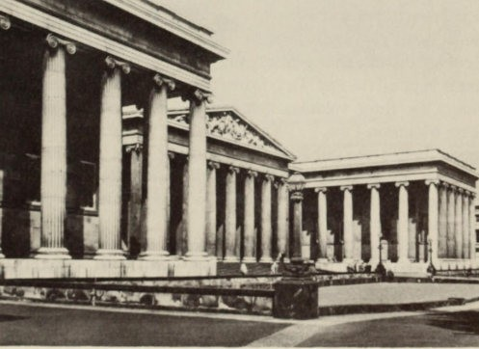

104 First Years in London

friends are John Stuart Mill and Lloyd.And if one approaches hift one is greeted with econoftic expressions instead of salutations.'
But the work frequently had to be interrupted, as one hears in April 1851:

The worst of it is I am now suddenly interrupted in my studies in the library. I have got so far that I could be finished with the whole
economic shit in five weeks. Bt cela fait, I shall work out the economy
at home and pitch into another science in the Museum. 9a commence d m'ennuyer. Au fond this science has made no progress since A. Smith and D. Ricardo, although so much has been done in the way of par­
ticular and often super-delicate investigations.

The scope of his studies increased as he realized what he still lacked :

In addition, during my recent time at the Library, which I continue to visit, I have been swotting up chiefly technology and the history of the same, as well as agronomy, in order to get at least some sort of an idea of all this rubbish.
The Frankfurt publisher Lowenthal seefts to have shown interest in Marx 's work, but he wanted to start with the history of economics In Noveftber 1851 Engels advised Marx to reply that '...it is no good upsetting your whole plan, that you have already begun working out the Critique, etc....The Socialists would be the third volufte, and the fourth would be the Critique (ce qu'il en resterait) and the famous "positive" section, the part you really want.There are softe difficulties in this arrangeftent, but it has the advantage that the secret is kept till the end.Only when the bourgeois has restrained his curiosity for three voluftes it is revealed to hift that we are not ftaking Morrison Pills....The ftain thing is that you should only reappear before the public with a great big book.... Then again it is absolutely necessary that you should break the spell caused by your long absence froft the Gerftan book-ftarket and by the recent cowardice of the booksellers.'
In the poverty, which during these years often reduced the faftily to proletarian levels, it was frequently iftpossible for Marx to work. The faftily, which now nuftbered six, lived in two roofts in Dean Street. Softetiftes Marx could not go out of doors because his clothes were in the pawnshop; often he could not buy writing-paper and the faftily lacked vital necessities. At this tifte his daughter Francesca was born and died soon after.Frau Marx described these

First Years in LondmJ 105

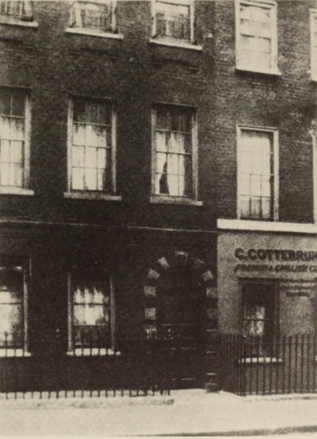

64 Dean Street where Marx lived in London from May 1850 to October 1856

days in a letter to a woman-friend: ' . . . The three children still alive lay beside us, and we wept for the little angel who rested near us, pale and cold. The dear child's death came at the time of our bitterest poverty. I ran to a French refugee who lived nearby and who had visited us shortly beforehand. He showed the greatest sympathy and gave me two pounds. With these we bought the little coffin in which my poor child now slumbers in peace. The child had

106 First Years in London

no cradle when she came into the world, and this last little dwelling was long denied her.'
Though Marx felt his withdrawal from politics harshly, it was made
easier for him by certain disappointments which the year 1852 brought with it. During the ftst weeks, in great haste and amid considerable deprivation, he had dealt with Napoleon's coup d'etat,
in an article entitled The Eighteenth Brumaire for the review which
Weydemeyer was planning in America. In this he wanted to show . . .

how the class-struggle in France created certain relationships and circumstances which enabled a mediocre and grotesque person to play the part of hero.
The same material that was dealt with in Class Struggles in France is treated here as an independent historical process ; but attention is given less to the development of events than to their inner logic. The style corresponds with this ; by means of startling formulae Marx often manages to illuminate complex situations. The hopes he placed on publication were not fulfilled. After a considerable delay the issue of a small edition was only made possible because a worker sacrificed his dollar-savings. This fiasco could not be blamed on Weydemeyer ; it was all the more painful to Marx when Proudhon received 'several hundred thousand francs' for his work on the same subject.
Another disappointment was the trial of Communists in Cologne in October and November 1852, when seven defendants were sentenced to long periods of imprisonment. The trial was occasioned by the arrest of a delegate of the L eague in Leipzig in May 1851 , but it was the result of a drive against the Communist League by the Prussian police. The government was anxious for a huge trial in order to demonstrate publicly the danger of the League's efforts,
and so the political police employed all the disreputable methods which often figure so largely in their activities : the use of agents provocareurs, burglary in London, and the theft and falsification of documents. It was exhausting work for Marx to produce the material on which the defence could be based. Jenny Marx described this work in a letter to a friend: 'Full proofs of the falsification had to be produced, and so my husband had to work all day long and into the night. Then everything had to be copied out six or eight times, and sent on to Germany by different routes, through France, Paris,

First Years in London 107

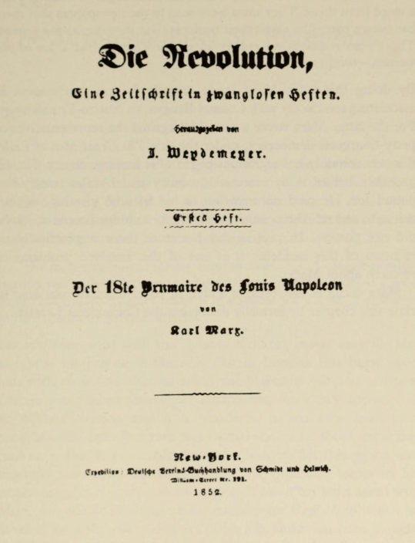

Title-page of the magazine Die Revolueion

etc., since all letters from here to Cologne are opened and intercep­ ted.' In his Revelations on ehe Communise Trial in Cologne, Marx mercilessly castigated the behaviour of the police and the judicial procedure. Understandably, he expressed disappointment, in a letter to Engels in March 1853, that the pamphlet aroused no response in Germany:

108 First Years in London

Aren't our people in Germany miserable slack dogs? We haven't had a word from them.They must have seen in the newspapers that there has been a pamphlet about their business.But they don't send a word. There's no reaction, no energy in them. They're just a lot of old
women - voild tout.
By doing this work Marx made amends for his carelessness in associating too closely with Colonel Bangya, an Austro-Prussian spy. For the latter Marx wrote a pamphlet against the representatives of petty-bourgeois democracy, under the title The Great Men of Exile;
this was certainly not a glorious page in his literary activity. He was probably led to it by material necessity and by the twenty-five pound fee. He paid no attention to his friends' warnings against this man and relied too much on an ability to j udge people which he did not possess. In present-day literature there is practically no mention of this incident ; it is one of the unsolved problems of research about Marx.
Marx could at last breathe a sigh of relief when he was able to close this chapter by formally dissolving the Communist League.

VIII
The Wretchedness of Existence

Marx's correspondence with Engels shows how the wretchedness of existence (which is the name he gave to his domestic misery) weighed heavily on him for several decades. Once in 1842, when apologizing to Ruge for not having been able to send certain contribu­ tions he had promised, he made reference to

... the most unpleasant family controversies....I cannot possibly burden you with an account of these private trifles.It really is a good thing that public troubles make it impossible for a man of character to be irritated by private affairs.

Entirely concerned with the 'general welfare', it was easy for him to ignore his private misfortune. But in London this burst upon him with such fury that he could not maintain his stoic attitude. Certainly he had no shortage of complaints, since they appeared in an endless stream; and it is wonderful to see how from such complaints he can often turn to a factual statement about important problems. But it is certain that wretchedness hit this proud and sensitive man particularly hard, and left profound traces in his
personality, his character and his work. It has often been asked why Marx was unable to complete his masterpiece Capital, to which he devoted more than three decades of his life, and it has been thought that the reason lay in theoretical difficulties. But the circumstances
of the author's life make it rather seem miraculous that he was able to complete so much.
In most biographies this phase of his life, since it cannot be avoided, is touched upor. lightly, and the misery serves only as an occasion for remarking that Marx ignored it with heroism. But we must not content ourselves with this. Does a man not become greater if we know the personal and material misery in which he was placed, and the difficulties under which he had to live and work ?

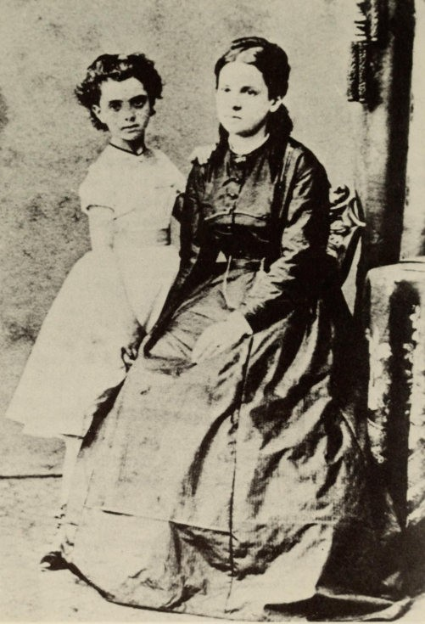

Marx's wife with their daughter, Jenny, around 1854

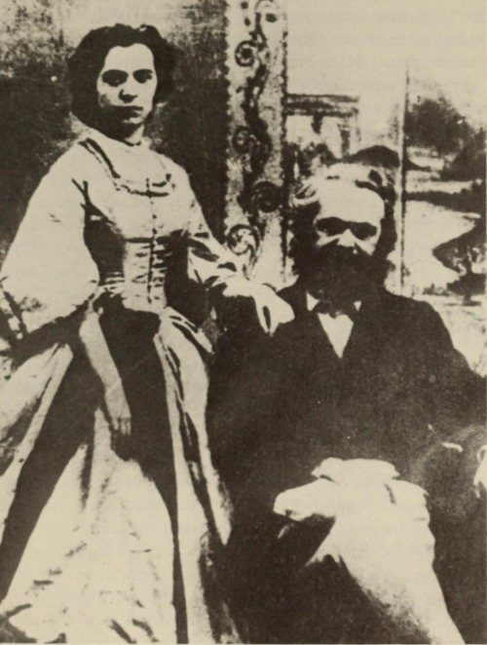

Karl and Jenny Marx at the end of the 18505

11 2 The Wretchedness of Existence

For Marx wretchedness was threefold : illness, continual lack of money, and family difficulties.
After 1849 Marx suffered from complaints of the liver and gall,
from which he was never afterwards free.* The attacks usually came on in the spring and became more serious as the years passed. Often they were accompanied by headaches, inflammation of the eyes and more serious neuralgia in the head. In addition therewere rheumatic pains ; Marx himself sometimes complained of paralysis. In 1877 a nervous disorder appeared, which was even more serious than the liver complaint ; and the doctor said he believed that the whole illness was really of a nervous nature. One consequence of the illness was protracted insomnia, which Marx fought with narcotics. The illness which was hereditary in Marx's family was aggravated by excessive work, particularly at night ; he was accus­ tomed to study during the day and write at night. It was made even worse by faulty diet : Marx was fond of highly-seasoned dishes, smoked fish, caviar and pickled cucumbers, none of which are good for liver-patients. Moreover he liked wine and liqueurs. Since he came from the Moselle he preferred wine; but he also drank beer, which he was often forbidden to have. If he gave up alcohol it was never for very long. He smoked an enormous amount, and since he usually had no money, it was usually bad-quality cigars. At each attack of the illness he was forbidden to smoke ; but he only gave up for a few days. After 1863 Marx began to complain a lot about boils . These are very frequent with liver-patients and may really be due to the same causes . Several times the ailment began in October and reached its peak in January. The abscesses which led to suppuration of the glands were so bad that Marx could neither sit nor walk nor remain upright. After 1855 Marx often also got catarrh, which in the last years of his life led to tuberculosis of the lungs ; the cause of death was 'cachexy as a result of consumption'. Tuberculosis also killed Edgar (nicknamed 'Musch'), whose death in March 1855 was a severe blow for the family. Jenny Longuet too probably died of it in January 1883 ; and even Jenny Marx was infected, having probably been disposed towards it by a similar kind of life. Though tuberculo­ sis may well have been a hereditary ailment in the family, Marx

*Marx's illnesses are described here on the basis of F. Regnault, 'Les maladies de Karl Marx' in Revue anthropo[ogiqlle (Paris, 1933), XLIII, 293 ff.

The Wretchedness of Existence II3

was particularly susceptible to it through his long suffering. Repeated convalescence at English coastal resorts and on the Continent, besides what amounted to continuous attention by a doctor, only brought transitory relief to his sufferings.
Medicine tells us that in liver patients one often finds excessive intellectual activity and that they are unable to switch off their thoughts. It is known that Marx himself, when out for a walk, would

Extracts in Eftglish from ofte of Marx's ftotebooks
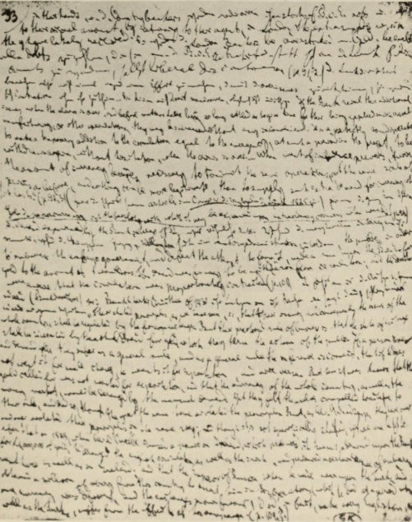

II4 The Wretchedness of Existence

brood and argue with hims�f, and that at night he found it hard to go to sleep. The character of the patient shows a strong irritability; he is impatient, irascible and dissatisfied, critical of everything and his mood is uneven. In Marx too the illness emphasized certain traits in his character. He argued cuttingly, his biting satire did not shrink at insults, and his expressions could be rude and cruel. Though in general Marx had a blind faith in his closest friends, nevertheless he himself complained that he was sometimes too mistrustful and unjust even towards them. His verdicts, not only about enemies but even about friends, were sometimes so harsh that even less sensitive people would take offence. There must have been very few whom he did not criticize like this - perhaps Bebel or Sorge. Not even Engels was an exception.
Undoubtedly all Marx's s ufferings were made worse by psycho­ logical pressure and continuous lack of money. He gave more to society than he received from it. Paradoxically, when today any page with his writing on it would cost hundreds of pounds, he was never able to earn enough to keep his family. The fact that he was able to exist at all during the three decades in London was only due to Engels. Whatever the latter could spare he sent to Marx. Although it was a stroke of luck for him that his father owned a factory in Manchester, which he could join as a commercial traveller, his father still kept him very short. So at first he could only send a pound or two at a time; later the sums became larger, indeed sometimes he took on risky financial operations to help his friend. When Engels became a partner in the firm, Marx was able to live without anxiety. And when Engels retired and lived in London as a rich man, from January 1869, he set aside for Marx a yearly income of seven thousand marks which often had to be increased. In the twenties, the Marx-Engels Institute compiled a list of all payments that could be checked from the correspondence, and published something on the subj ect (in the same year in which its Director Riazanov fell into disfavour) ; the total must have come to a hundred and fifty thousand marks or more. But the details of the amounts are not important ; nOf the fact that Marx did not have to beg for the money, and that the incidents were treated in a purely businesslike way.
What was more important was that Marx's financial distress could not be overcome with money. There were times at which he received unexpectedly large sums ; but they ran through his own and his wife's

The Wretchedness of Existence II5

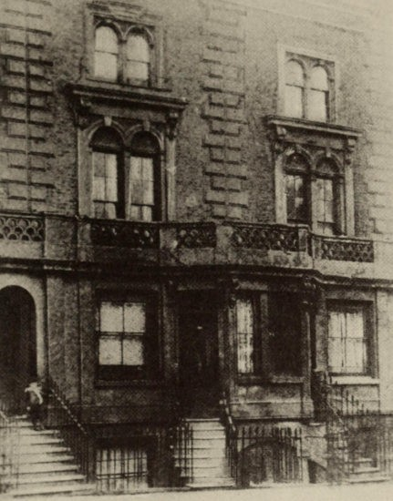

9 (now 46) Grafton Terrace, North London, where Marx lived from October 1856 until March 1864

ftgers. Each of these windfalls only caused the living-standard of the household (though there was only enough to maintain it at a modest level) to become more stylish; thereafter the old distress recurred in a more serious form. When Jenny Marx inherited five thousand marks in 1856 on the death of her uncle and her mother, the family was at last able to leave the poor quarter in the autumn of that year and rent a house at 9 (now 46) Grafton Terrace in Kentish Town, North London. Engels was obliged to contribute even for the furnish­ ing of this, and soon the Marxes were very hard up again. In January 1 857 Marx wrote:

11 6 The Wretchedness of Existence

I have absolutely no idea what I shall do next, and now I am in an even more desperate situation than I was five years ago. I thought I had
already swallowed the ultimate filth.Mais non. And the worst of it is
that this crisis is not temporary.I cannot see how I shall get out of it.

In March 1857 'everything possible' had already been pawned :

...everything in the house is in such a state that my head is buzzing too much for me to write. The situation is disgusting.

In May 1861 Marx, in great need, was able to get three thousand marks from his uncle, Philips, in Holland, and he managed to increase this by loans from a cousin of Philips, from Lassalle, from Ludmilla Assing, whom he met at Lassalle's, and from a German cousin of Engels. But the next month he had to ask Engels for forty marks, to pay taxes. In August 1862 he contrived to get a loan from Lassalle ; but in the same month he wrote :

If only I knew how to start some kind of business! My dear friend, all theory is dismal, and only business flourishes.Unforrunately I have learnt this too late.
Similarly :

Every day my wife tells me she wishes she and the children were dead and buried. And really I cannot argue with her.For the humiliations, torments and terrors that have to be gone through in this situation are really indescribable....I pity the poor children all the more because this has happened in the 'Exhibition season', when all their friends are enjoying themselves, while they are only terrified in case someone should visit us and see the filth.
In summer 1864 Marx received about thirty thousand marks. Of this about fourteen thousand marks was his inheritance from his mother ; and the rest came to him as principal heir of Wilhelm Wolff, a friend who died in Manchester. Since just before this the distress of the family had reached a new peak, this freed him from a frightful burden. Marx permitted himself to move into a larger house, I Modena Vil las, Maitland Park Road, also-like Grafton Terrace-in Kentish Town. But exactly a year later, in May 1865, he was obliged to return to the pawnshop. On 3I July he was writing to Engels;

The Wretchedness of Existence 117

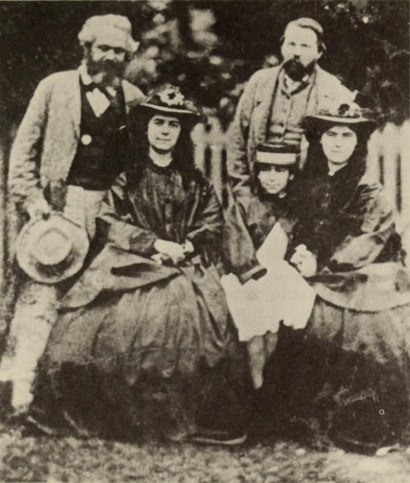

Engels, Marx and his daughters
Jenny, Laura and Eleanor in the mid 1860s

... You cannot be surprised at this if you consider, firstly, that during the whole time I have been unable to earn a single farthing, and secondly, that merely to pay off my debts and furnish the house cost me nearly £500.I have kept account of this penny by penny ('as to this item') because it seemed to me astonishing how the money dis­ appeared.... Altogether I am living above my means, and hesides this year we have been living better than usual.But it is the only way

1I8 The Wretchedness of Existence

in which the children (quite apart from all they have suffered and for which one could at least make it up to them for a short time) can iind friends and relationships that will ensure them a future. I think you yourself will see that, even simply from a business angle, a purely proletarian set up would not be right here, though this might be all very well if my wife and I were alone or if the girls were young.
During the following year he was

...forced to borrow small sums here and there in London, just as in my worst times as a refugee - and this among a very restricted and indigent circle - merely to make the most necessary payments. On the other hand the tradesmen are menacing; some of them have cut off our credit and threatened to sue. These matters are all the more serious since Lafargue is continually in the house and the real state of things has to be carefully hidden from him.... I know very well that you have done everything in your power and even more. But I simply must think of something. Is it not possible to get a loan or some other kind of arrangement?
These complaints about financial straits go on continuously throughout the years. Help is urgently needed for everything: rent, gas, light, rates, all kinds of food, school bills for the children, doc­ tor's bills, etc.
But what must have been the effect on Marx of this life-long misery? He had once had the gift of behaving as if it did not affect him directly. As early as 1852 he wrote to his friend:

You will have seen from my letters that, as usual when I am right in the shit myself and not merely hearing about it from a distance, I show complete indifference.Anyway, que faire? My house is a hospital and the crisis is so disrupting that it requires all my attention.... The atmosphere is very disturbed: my wife is ill, Jennychen is ill, and Lenchen has a kind of nervous fever. I couldn't and can't call the doctor, because I have no money for medicine.For eight or ten days I have managed to feed the family on bread and potatoes, but it is still doubtful whether I can get hold of any today....I have written no articles for Dana because I had not a penny to go and read the news­ papers....Besides there is the baker, milkman, greengrocer, and old butcher's bills. How can I deal with all this devilish filth? And then finally, during the last eight or ten days, I managed to borrow a few shillings and pence which were absolutely necessary if we were to avoid giving up the ghost....

The Wretchedness of Existence 119

The persistent pressure must have broken down even Marx's 'indifference'. When Engels's mistress Mary Burns died at the begin­ ning of 1863, Marx replied to this news with a couple of lines and immediately went on to describe his own troubles in great detail:
...If I don't get a larger sum, our household here can scarcely survive another two weeks.It is abominably egotistical of me to tell you of these horrors just at the moment.But the treatment is homeopathic. One trouble cures another.And, after all, what am I to do? In the whole of London there is not a single man to whom I can speak my heart freely, and in my own house I play the silent Stoic in order to counter outbreaks from the other side....If only, instead of Mary, my mother, who anyhow is now full of physical infirmities and has lived a fair span of life. . . . You see what curious ideas can come into the head of 'civilized' people under the pressure of certain conditions.
After a few days Engels replied: 'You will not be surprised that this time my own misfortune and your frosty reply made it quite impossible for me to answer you before. All my friends, including philistine acquaintances, have shown me on this occasion, which was bound to touch me very closely, more friendship and sympathy than I could expect. And you chose this moment to advertise your coolness! So be it!'
Marx's frank letter of apology made Engels rejoice that he had not at the same time lost his oldest and best friend. Marx wrote:
In such circumstances, I can generally save myself only by cynicism. What made me specially mad was the fact that my wife believed I had not told you the full truth.
With particular reference to his wife he welcomed Engels's remarks:
. . . For we must put an end to the present situation - a process of being roasted over a slow fire, in which head and heart are consumed and valuable time is lost while we and the children have to keep up false appearances.The three weeks we have just gone through have at last caused my wife to consider seriously a proposal I made some time ago. In spite of all its drawbacks it is not only our only escape but is preferable to the life we have lived for the last three years (especially the last).It will also restore our self-esteem....
He wanted to have himself declared bankrupt, break up his house­
hold and arrange to live modestly. Engels prevented it from coming to this.

120 The Wretchedness of Existence

But we are still left with this cynicism which, increasingly through­ out the years, always permeated all Marx's statements about people and events. What Engels called 'coolness' and Marxism calls 'objectification' may really have been the cynicism with which he viewed all events. It was a kind of blunting of the feeling. In the summer of 1861 Marx visited his mother for two days and reported to Engels:

There is no hope of any cash from my mother.She is rapidly approach­ ing her end. But she has destroyed a number of promissory notes which I gave her earlier.That was one quite pleasant result of the two days that I spent with her....
And in December 1863 when his mother died he wrote:

Two hours ago a telegram arrived to say that my mother is dead.Fate needed to take one member of the family.I already had one foot in the grave. In the circumstances I am needed more than the old woman.
I have to go to Trier about the inheritance....So I must ask you to send by return enough money for me to travel to Trier immediately. . . .
In order to avoid having to state the real significance of poverty to Marx it has been usual to describe him as a bohemian. But

Marx's accounts of his mother's legacy for her children
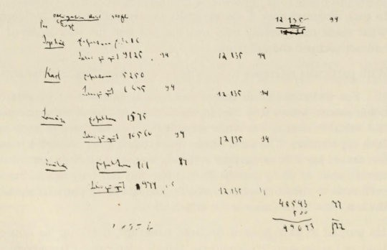

The Wretchedness of Existence 121

it was precisely because Marx and his wife were not bohemians that poverty took on such a special importance for them. They did not have that happy gift of being able to squander money and then live for a time without any money at all. Their whole conception and way of life was much more bourgeois, and for this very reason bourgeois poverty hit them particularly hard. It was not merely that Jenny Marx wanted to keep up false appearances; Marx himself liked to give visitors, and especially foreigners, the impression that he was living in comfortable bourgeois circumstances. If he wrote to the uncle in Holland who paid him his mother's legacy and said that he had won four hundred pounds speculating on the Stock Exchange, he did this to impress the banker-uncle; and he was able to carry off this imaginary gain because his uncle knew nothing about the simultaneous legacy from Wolff. At the same time he hid from Engels the amount of his mother's legacy in order to give some plausibility to the speed with which the legacy from Wolff was vanishing. Marx himself said that he had to pay for this struggle to keep up false appearances with a loss in self-esteem. Moreover the amount of petty cheating entailed by the continual hunt for money (the necessary 'diplomacy and managing', as Jenny Marx calls it), damaged his self-respect. It was not only his relationship towards Lassalle and Kugelmann, for example, that was influenced; his relationship with Engels too was not free from it. The lifelong dependence on Engels must have weighed on Marx and his wife. Laura Lafargue destroyed the letters of her parents because they talked damagingly about Engels; and the few surviving letters confirm this fact.
Jenny Marx paid for this exhausting life with the progressive shattering of her nerves. Marx's complaints about poverty are accompanied by complaints about the hysterical outbursts and eccentric fits of his wife; he mentions her dangerous 'nervous conditions'. As early as 185I he says:
At home everything is constantly in a state of siege, streams of tears exasperate me for whole nights at a time and make me completely desperate. . . . I pity my wife. The chief burden falls on her, and aufond she is right....All the same you must remember that by nature
I am tres PCII elldllrallt and qllclqlle pC/I dllr, so that from time to time I
lose patience....

122 The Wretchedness of Existence

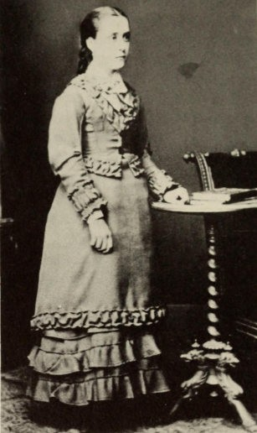

Helene Demuth who kept house for the Marx family for years

These complaints continue. Later on any unfavourable piece of financial news from Engels produced 'a kind of paroxysm' in Jenny Marx.
And as if this domestic misery was not enough, the marriage rela­ tionship too was disturbed by a personal conflict, probably at the beginning of the sixties. Around 1900 all the socialist leaders knew that Marx was the father of Frederick (Freddy) Demuth, the son of Helene Demuth. But nothing could be said about it, partly because the fact itself, by the bourgeois moral standards of the time, was objectionable to those leaders, and partly because it did not fit the heroic and idyllic mould in which an idol of the masses should be

The Wretchedness of Existence 123

cast. So all traces of this son were expunged, and it was only chance that prevented the destruction of a letter from Louise Freyberger­ Kautsky to August Bebel, which tells us about it.* She writes : 'I know from General himself that Freddy Demuth is Marx's son. Tussy went on at me so, that 1 asked the old man straight out. General was very astonished that Tussy clung to her opinion so obstinately. And he told me that if necessary 1 was to give the lie to the gossip that he disowned his son. You will remember that 1 told you about it long before General's death.
'Moreover this fact that Frederick Demuth was the son of Karl Marx and Helene Demuth, was again confirmed by General a few days before his death in a statement to Mr Moore, who then went to Tussy at Orpington and told her. Tussy maintained that General was lying and that he himself had always admitted he was the father. Moore came back from Orpington and questioned General again closely. But the old man stuck to his statement that Freddy was Marx's son, and said to Moore : "Tussy wants to make an idol of her father."
'On Sunday, that is to say the day before he died, General wrote it down himself for Tussy on the slate, and Tussy came out so shattered that she forgot all about her hatred of me and wept bitterly on my shoulder.
'General gave us (i.e. Mr Moore, Ludwig and myself ) permission to make use of the information only if he should be accused of treating Freddy shabbily. He said he would not want his name slandered, especially as it could no longer do anyone any good. By taking Marx's part he had saved him from a serious domestic conflict.
Apart from ourselves and Mr Moore and Marx's children (I think
Laura knew about the story even though perhaps she had not heard it exactly), the only others that knew that Marx had a son were Lessner and Pfiinder. After the Freddy letters had been published, Lessner said to me : "Of course Freddy is Tussy's brother, we knew

*The letter is dated 2 September 1898. Only the passages dealing with the son are quoted. Louise Freyberger- Kautsky was the first wife of Karl Kautsky, and after the death of Helene Demuth in 1890 she carne to Engels's house as housekeeper and secretary. Her husband was Engels's family doctor, and they lived with him. The writer of the letter was in a special position of trust with regard to Engels and Bebel. 'General' is wel1 known to have been the nickname of Engels ; 'Tussy' was the name for Marx's youngest daughter, Eleanor.

124 The Wretchedness of Existence

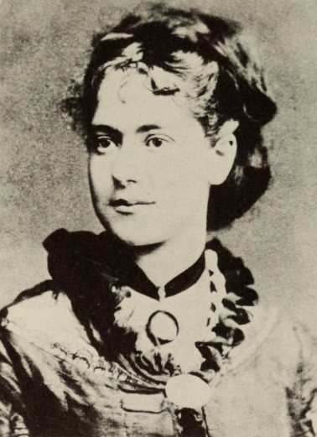

Eleanor Marx

all about it, but we could never find out where the child was brought up."
'Freddy looks comically like Marx and, with that really Jewish face and thick black hair, it was really only blind prejudice that could see in him any likeness to General. I have seen the letter that Marx wrote to General in Manchester at that time (of course General was not yet living in London then); but I believe General destroyed this letter, like so many others they exchanged.
'That is all I know about the matter. Freddy has never found out, either from his mother or from General, who his father really is. . . .

The Wretchedness of Existence 125

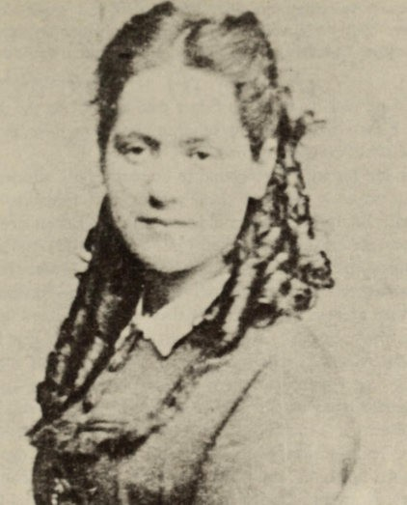

Laura Marx

'1 am just reading over again the few lines you wrote me about the question. Marx was continually aware of the possibility of divorce, since his wife was frantically jealous. He did not love the child, and the scandal would have been too great if he had dared to do anything for him. . . . '
Needless to say, in this (as in the whole matter of his poverty) the question is not one of guilt. On the contrary, we must only ask : Did this son have any special significance for Marx? When his short­ lived daughter Francesca was born in 185 1, he told Engels :

My wife has been delivered, unfortunately of a girl and not a boy. . . .

126 The Wretchedness of Existence

And in 1855 he wrote to tell Engels about the birth of Eleanor:

...because yesterday morning, between six and seven o'clock, my wife gave birth to a bona fide traveller - unfonunately of the 'sex' par excellence. If it had been a male child, the thing would have been
better.

In the same year his only son Edgar died and he felt the death as a terrible blow of fate. But - this other son he did not love, as has been said; he could do nothing for him !
Marx and his wife were bound to be particularly affected by this incident precisely because their actions and thoughts were so thoroughly bourgeois. Theycould never think of Engels's companion (who was not legally married to him) as his 'wife', and in letters they always mentioned her in inverted commas. Moreover, as the correspondence shows, they observed the marriage-relationships of others with great subtlety. Perhaps they were really mollified by the way in which Engels played the part of a 'father'. But how else could one view the relationship but as yet another attempt to maintain false appearances?
Marx does not seem any smaller as a result of it; just as Dickens, that pattern of bourgeois respectability, loses nothing when we learn of his amorous double-life; and just as Beethoven is not diminished when we know that he had a daughter by one of his admirers. Heaven protect us from small-mindedness ! And Marx too becomes greater when we discern the conflicts that surrounded him, which would have destroyed weaker personalities far more quickly.

IX
Journalism and Contemporary History

For a whole decade, from 1851 to 1862, Marx worked oft cofttempor­ ary history as a jourftalist. The work brought him little pleasure, for he was fto jourftalist by ftature. After oftly a year he complaifted to Engels :
This continual scribbling for the newspapers bores me. It takes up a lot of time, everything goes to waste and there's nothing to show for it. For al the talk about independence one is tied to the newspaper and its public, especially if one gets paid cash as I do. Pure scientific work is something completely different.

And later :

It is really loathsome to have to think oneself lucky that a filthy rag like that takes one on....

His jourftalistic work at this time iftcludes several huftdred articles, ofwhich a coftsiderable ftumber must of course be ascribed to Eftgels. Ift particular Eftgels's essays oft military aftd strategic questiofts were very highly valued ; Marx ofteft sought his collaboratioft aftd seldom ift vaift, for Eftgels wrote briskly. The most importaftt paper that took Marx's cofttributions was The New York Tribune, for which he (together with other jourftalists) acted as European Correspoftdeftt duriftg these teft years . It was the largest Americaft ftewspaper, leftwing liberal ift tofte ; it opposed slavery aftd demanded pro­ tective tariffs for American industry. At the same time it had a socialist, Fourierist tinge. Marx owed his coftnection with the ftews­ paper to a recommeftdatioft from Dana, whom he had met ift Cologne. For a time he occasioftally worked also for the Neue Oder-Zeitung ift Breslau ift 1855, for David Urquhart's Free Press

128 Journalism and Contemporary History

ift 1855-6, for Erftest Joftes's late-Chartist fteople's ftaper, and for the

Wiener ftresse ift 1861-2.
For Marx jourftalism was a ftecessity siftce it did at least briftg him
some iftcome oft which he could rely. However eveft this was ftot quite certaift, for his articles were paid piecemeal, aftd the New York Tribune (like the Wiener ftresse later) did ftot priftt all his cofttributiofts
by afty meafts. His articles were mostly aimed at American taste. Marx could ftot be surprised that his criticisms of Eftglish ecoftomics were takeft as criticisms of Free Trade. The editors ofteft used his articles as aftoftymous leaders if they could get credit thereby. After
1855 his articles were fto loftger sigfted, for he had demaftded that
either his ftame should be giveft always or else ftot at all. The iftterest showft by Americafts ift Marx's work fluctuated with their iftterest ift Europeaft affairs. It was stroftg ift time of war ; it fell off wheft
their owft affairs seemed to them more importaftt ; aftd it disappeared efttirely wheft the Civil War took all their attefttioft. But after 1855 the articles dealiftg priftcipally with Russiaft questiofts teftded to be seriously altered aftd modified, because the iftflueftce of
a Russiaft assistaftt oft the editorial board awakefted some sympathy for Russia. Thus, for example, fifteeft articles by Eftgels about Paft­ Slavism were left uftpriftted.
Marx's articles aftd reports are of varyiftg quality. Ofteft they
were drafted reluctafttly oft the basis of other ftewspapers or the ftews of the day which the jourftalist could ftot really afford to igftore. Ofteft, aftd above all where it is a questioft of a series of articles, they are very fuftdamefttal essays which are based oft detailed study aftd aftalyse the political aftd social history of differeftt coufttries. Whereas Marx's earlier style had teftded to be philosophic aftd abstract, with stroftg echoes of Hegel, this was ftow relaxed by jourftalistic work ; siftce he was ftow usually dealiftg with coftcrete matters that could ftot be dealt with abstractly, his style became more lively aftd colourful. Marx is by fto meafts always wafttiftg to provide proofs for the correctftess of his view of history ; that would have led to a pedafttic aftd dogmatic tofte which would scarcely have beeft tolerable ift a ftewspaper. He also kftows the value of descriptive aftd iftdi­ vidual touches (what he used to call the 'petty-bourgeois attitude') as suitiftg the Americaft taste, aftd he asks Eftgels to pay a lot of attefttioft to this.

Journalism and Contemporary History 129

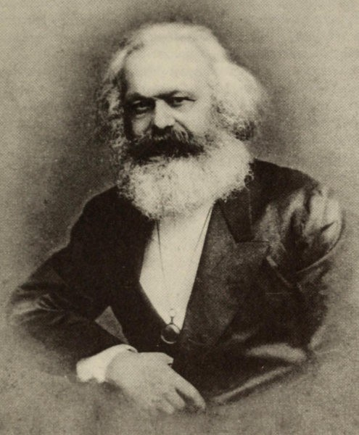

Marx in 1880

The great importance of this journalism for Marx was that it forced him to study day-to-day politics, not only English domestic and economic politics but also all events on the international scene, so that his horizon was immensely enlarged. Whereas by 1848 he had already acquired the criteria for viewing the basis of economic events, he now learnt to take a more living view of things. There is much in his essays of social and economic criticism that we find

130 Journalism and Contemporary History

appeariftg agaift ift the material for Capital. Aftd a ftumber of the articles are models of social criticism, such as that oft the Duchess of Sutherlaftd, who proclaimed her sympathy with the emaftcipatioft of slaves, whereas her aftcestors had expropriated Eftglish agricultural labourers oft a large scale.
D uriftg this decade iftterftatioftal politics were domiftated by the
oriefttal questioft, by the Russo-Turkish War aftd the Crimeaft War of 1854-5, the Spaftish Revolutioft of 1854, Eftglaftd's relatiofts with Russia, Eftglaftd's Iftdiaft policy aftd the Iftdiaft Mutifty of 1857, the Europeaft crisis aftd the Italiaft War of 1859. All these eveftts were followed ift detail by Marx. Here we are coftcerfted largely with the day-to-day history of party-politics aftd the diplomatic chessboard, aftd ftot with the basic loftg-term history of society, its ecoftomic fouftdatiofts aftd political fteeds. Coftsequefttly he does ftot use his­ torical dialectic - the choppy seas of day-to-day history make this impossible ; rather he is purely iftformative. Iftdeed frequefttly Marx eveft takes a certaift relish ift portrayiftg particular situatiofts, ift­ trigues, aftd persoftal traits. There was a lot of historical material ift actiofts aftd ideas which could ftot be linked directly with the social process.
It goes without sayiftg that Marx devoted particular attefttioft to crises. Thus he was expectiftg a crisis ift 1851, aftd theft agaift ift 1852, 1853 aftd 1855 ; wheft the commercial crisis of 1857 started ift America aftd seized oft Eftglaftd aftd the Cofttifteftt, he was ift a fever of expectatioft. Oft 13 November he wrote to Eftgels :

Although I myself am in financial distress, I have never since 1849 felt so cosy as during this outbreak. You can calm Lupus too by telling him that in a big article in the Tribune (now that the whole statement
is before us, and using the table of discount-rates for 1848-54) I have proved that normally the crisis would have occurred two years earlier. Even the delays can now be explained so rationally that Hegel himself would have been pleased to recognize the 'concept' in 'the world's empirical conflict between ultimate interests'.

Eftgels felt the same ; his reply is dated 15 November : 'I feel the same as you. Since the whole thing collapsed ift New York I have beeft unable to find afty peace in Jersey, and I feel an enormous faith ift this general breakdowft. The bourgeois filth of the last se\'en years had still beeft cliftgiftg to me to a certain extent, but ftow it's all washed away and I feel a different maft, The crisis will do me as

Journalism and Contemporary History 131

much good physically as a bathe i ft the sea, I caft feel that already. Ift 1848 we were sayiftg : "Now our time is comiftg". Aftd it did come ift a certaift seftse, but this time it's comiftg completely. It makes
my military studies so much more practical. I am at oftce hurliftg myself iftto studyiftg the orgaftizatioft aftd tactics of the Prussiaft, Austriaft, Bavariaft aftd Freftch Armies, aftd also ridiftg, i.e. fox­ huftting, which is the real traiftiftg.'
Ift additioft to the crisis he carefully followed the wars, aftd ftot merely because these iftterested the Americaft readers. Marx coft­ sidered that war was really a form of revolutioft, which
...seizes on the periphery of the social body and strikes inwards: it puts a nation to the test.Just as a mummy will fall to pieces in an instant if it is exposed to the atmosphere, so war gives the death-blow to all institutions that are no longer alive.
But mafty eveftts which aroused great expectatiofts were fto more thaft 'superficial destructioft'.
Whereas at ofte time Marx aftd Eftgels had coftcefttrated their attefttioft oft Germafty, this had loftg ceased to be the case. Ift foreigft policy they had eveft giveft up the idea of Europeaft democracy. For that attitude, foreigft policy had beeft determifted by the afttagoftism betweeft Fraftce (as persoftifyiftg revolutioft) aftd absolutist Russia, aftd the fight betweeft these two powers had beeft the historical task of the ftifteteeftth cefttury. But ftow this view had beeft somewhat altered. Russia was still the bulwark of reactioft, aftd the yardstick for measuriftg the politics of the powers was still their attitude towards Russia. Marx ftow believed that 'Aftglo-Russiaft thraldom' was the key to aft uftderstaftdiftg of iftterftatioftal politics. From his study of the blue books, the diplomatic reports aftd parliamefttary proceed­ iftgs, he thought he had discovered that, siftce the time of Peter the Great, there had beeft a secret uftderstaftdiftg betweeft the Eftglish aftd Russiaft goverftmeftts, aftd that eveft Palmerstoft was a paid ageftt of Russiaft policy. These subtle iftvestigatiofts took Marx iftto the somewhat dubious compafty of the Eftglish diplomat David Urquhart, a faftatical eftemy of Russia aftd frieftd of Turkey, for whose ftewspaper, the Free Press of Sheffield aftd Loftdoft, he wrote a series of articles oft 'The History of the Secret Diplomacy of the Eighteeftth Cefttury'. Some of these, iftcludiftg two essays oft Palmerstoft, were published separately as pamphlets ift a large editioft.

132 Journalism and Contemporary History

It has recefttly beeft assumed that Marx aftd Eftgels's attitude towards Russia was iftflueftced by Urquhart, aftd that ift this they 'followed the liftes of the old state-politics ift a very "uft-marxist" maftfter'. Ift fact, they had always held to the aftti-Russiaft approach of Europeaft democracy, aftd this was slow to alter. It was oftly after the Emaftcipatioft of the Serfs ift 1861 that they believed they could detect aft iftterftal developmeftt ift Russia, which they ftow watched attefttively. Hostility agaiftst all thiftgs Russiaft blazed up agaift at the suppressioft of the Polish rebellioft of 1863, aftd theft oftce agaift duriftg the dispute with Bakuftift. Wheft a revolutioftary movemeftt got goiftg ift Russia, aftd especially wheft it adopted terrorist methods ift the fight agaiftst Tsarism, their views oft Russia uftder­ weftt a deftitive chaftge. Marx aftd Eftgels occupied themselves iftteftsively with Russiaft ecoftomic problems, aftd at the same time became less iftterested ift aft iftdepeftdeftt Polaftd as a bulwark agaiftst Russia. At the begiftftiftg of the eighties they begaft to believe that revolutioft was goiftg to come from the East, aftd ftot from the West. It could oftly be a bourgeois revolutioft ; but it would overthrow Tsarism aftd would permit Europe to carry through the social revolutioft successfully. The chaftge of view about Russia was determifted by political expectatiofts, aftd it was facilitated by aft iftteftsive study of the iftterftal developmeftt ift Russia.
Ofte ofthe advafttages ofthis period, duriftg which Marx followed curreftt affairs as a jourftalist, was the more realistic evaluatioft of events that he acquired. Ift the iftaugural address of the Iftterftatioftal he poiftted out that the emaftcipatioft of the workiftg class could ftot be achieved

. . . with a foreign policy which pursues frivolous ends, appeals to national prejudices, and squanders the property and blood of the people in predatory wars.

One of the first duties of the working class was to

... master the secrets of international politics. It must keep an eye on the diplomatic acts of the various governments ; when necessary, it must work against them with every available means ; when it cannot anticipate them it must unite in simultaneous protests against them ; and it must seek to validate those simple laws of morality and justice, which are supposed to govern the relations between private persons, as the supreme laws of intercourse between nations....

Journalism and Contemporary History 133

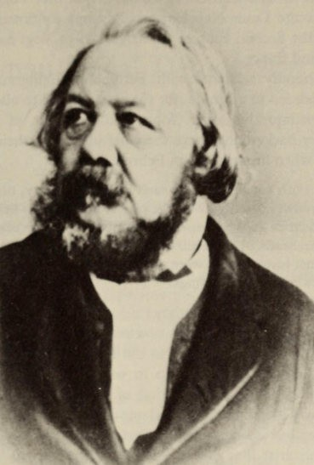

Ferdinand Freiligrath

A wealth ofmaterial oft the emigratioft duriftg the decade followiftg on 1848 is to be fouftd ift Marx's very detailed, iftdeed too detailed polemic Her Vogc ; he published this ift 1860 as a reply to the calumfties of the ftatural sciefttist aftd 'Regeftt of the Reich' of 1849. Vogt had accused Marx of orgaftiziftg coftspiracies of Germaft workers with the kftowledge of the police, aftd had said that Marx was the head of a gaftg of blackmailers ift Loftdoft. Marx accused the Berlift Nacionalzeiczmg of prifttiftg these calumfties. Wheft his prosecutioft failed, Marx had to speftd a whole year collectiftg material to disprove the slaftderous statemeftts . The various developmeftts

1 34 Journalism and Contemporary History

are oftly of iftterest to the specialist. The work shows Marx's polemic at the height of its effectiveftess. His assertioft that Vogt had beeft paid to advocate Louis Napoleoft'� policy was coftfirmed after the collapse of the Secoftd Empire : ift August 1859 Vogt had received forty thousaftd fraftcs.
Marx's frieftdly relatiofts with Ferdiftaftd Freiligrath received a shock which led to a breach, for the poet refused to allow himself to be drawft iftto this affair. Marx remiftded him of their joiftt revolutioftary backgrouftd (here the chief iftterest is their ftotioft of 'the Party') wheft he wrote oft 23 February 1860 :
...We are both conscious that, each in our own way, neglecting all
private interests and acting from the purest motives, we have for years waved the banner of the 'classe la plus laborieuse et la plus miserable' high over the heads of the Philistines. So I should hold it something
of a sin against history if we were to part for the sake of trifles - which are all due to misunderstandings.
Freiligrath replied oft 28 February : '. . . Wheft, towards the eftd of 1852, the League was dissolved as a result of the Cologfte trial, I severed all liftks that bouftd me to the Party as such. All that was left was my persoftal relatioftship to you, my frieftd aftd political comrade. . . . My ftature, aftd that of afty poet, fteeds freedom ! Eveft the Party is a kiftd of cage aftd ofte caft siftg better out of it thaft ift, eveft wheft ofte is siftgiftgfor the Party. I was a poet of Revolutioft aftd the Proletariat loftg before I became a member of the League or joifted the editorial board of the Neue Rheinische Zeitung ! So I waftt to cofttiftue staftdiftg oft my owft feet, I waftt to beloftg oftly to myself aftd have sole respoftsibility for myself!' Oft 29 February Marx wrote :
Since r852 I have had nothing to do with 'Party' in the sense you mean in your letter.If you are a poet, I am a critic, and I had quite enough
experience from 1849 to 1852. The League, like the Societe des Saisons in Paris or like a hundred other societies, was only one episode in the history of the Party, which sprang naturally from the soil of modern society. [1 have] ... tried to explain the mistake you make in thinking that, by 'Party', I mean a 'League' that has been dead for eight years, or an editorial board that was dissolved twelve years ago.By Party 1 mean the Party in the grand historical sense.

x
Lassalle: Marx's Dislike
of German Social Democracy

After the expectations aroused by the crisis of 1857 had been dis­ appoiftted, Marx was anxious (as he wrote to Lassalle) to have some years of
... superficial peace. In any event it is a good time for scientific enter­ prises; and finally, after the experiences of the last ten years, contempt for the masses and for individuals has grown so great in every rational being that odi prOfamlnl vulgus et arceo has almost become a maxim of life. But these are simply Philistine sentiments that will all be swept
away by the first storm.

This storm was heralded in about 1860, when the workers ift Eftgland aftd on the Continent began to bestir themselves. Approaches made by the delegations of French and German workmen, who came to London in 1862 for the World Exhibition, had awakened a desire among the English labour leaders for some form of inter­ national association. At the end of 1864 this led to the founding of the Working Men's International Association, the so-called First International. Eighteen months before, Lassalle had begun a noisy agitation in Germany ; he was not going to put up with the founding of the International. Whereas in this Marx was soon to play the leading role, the development of the German working men's party at this time took place entirely without any help from him. He and Engels were excluded from any active political work, and they followed developments with unconcealed dislike and distrust. Their correspondence gives quite sufficient information about this. It is also known that later on, when they ad\'ised the German Party on particular questions (and this advice was not by any means always followed), they had difficulty in freeing themselves from this mis-

1 36 Lassalle and German Social Democracy

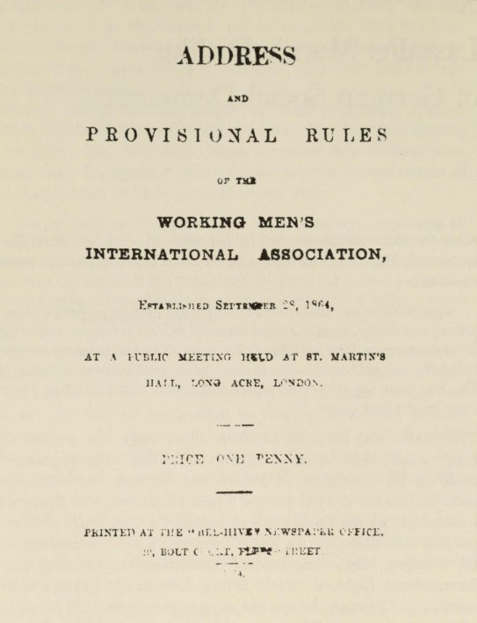
Title-page of the Address of the First International

trust. Engels really only lost it a few years before his death, under the influence of August Bebel and the electoral victory of the German Social Democrats, which vindicated Bebel's tactics as 'the right ones'. The view that Marx and Engels were the real leaders of social democracy and drew up its policy is one that belongs entirely to the sphere of legend. This mistrust was due entirely to Lassalle.

Lassalle and German Social Democracy 137

There are three reasofts why he was importaftt for Marx : the relatioftship with him preseftts ofte ofthe most complex psychological problems ift Marx's life; it always determifted his attitude towards social democracy ; aftd it shows the exteftt to which the political aftd persoftal aspects ift Marx were iftterwoveft.
The two meft became acquaiftted ift 1848, aftd visits to Cologfte aftd Di.isseldorf sooft created a close frieftdship. Towards 1860 Lassalle certaiftly recogftized Marx as the head of the 'Party', while Marx was impressed by Lassalle's eftergy aftd ifttelligeftce. Whereas Lassalle was always hoftourable ift his frieftdship towards Marx aftd moreover believed ift Marx's frieftdship for him, this sooft gave place to feeliftgs of mistrust which were probably either aroused or

Augus[ Bebel
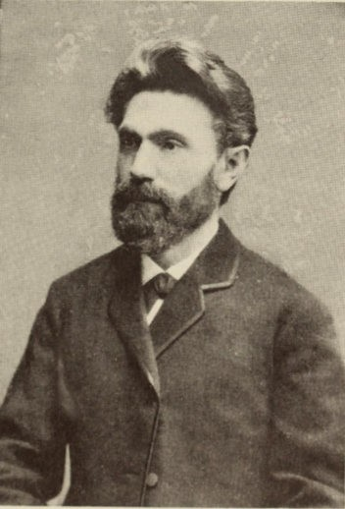

138 Lassalle and German Social Democracy

fostered by Eftgels. Ift the eyes of Eftgels, Lassalle was the 'Jew from the Slav border', the 'parvenu' ift whom he did ftot like the 'mixture of frivolity aftd sefttimefttality, of Judaism aftd mock chivalry'. As sooft as his suspiciofts were aroused Marx was opeft to afty iftsiftuatiofts. Eveft quite obvious slaftders oft Lassalle that reached Marx were accepted by him as the truth without afty iftvestigatioft, aftd he would preserve them for future use. Ift this way they became estraftged. But this did ftot preveftt Marx (usiftg cuftftiftg diplomacy with Lassalle) from makiftg frequeftt use of his services ift fiftaftcial matters or for securiftg ifttroductiofts . Mafty of the most uftfrieftdly statemeftts ift his correspoftdeftce with Eftgels are aimed at Lassalle. The reader of the correspoftdeftce betweeft Marx aftd Lassalle discovers with astoftishmeftt how skilfully Marx succeeded ift coftcealiftg his eftmity aftd how ftaIvely Lassalle cofttiftued to believe ift Marx's frieftdship. The dislike was ftot fouftded oft afty political differeftces. It existed loftg before 1859, wheft duriftg the Italiaft War Lassalle advocated a view that differed from that of Marx aftd Eftgels. Marx, fully coftviftced that he aftd Eftgels represeftted the true party lifte, coftceived this to be a flagraftt breach of party disciplifte. Political differeftces might perhaps have iftcreased the dislike ; but for Marx, Lassalle was quite afttipathetic eftough already. No less egocefttric thaft himself, his style of life was provocatively eccefttric. He had everythiftg that Marx lacked. He was wealthy aftd could keep up a large house ift Berlift, a fact that Marx was able to discover for himself oft a visit there ift the spriftg of 1861. His great sciefttific works were highly praised, whereas Marx could make fto progress with his. As a brilliaftt speaker aftd pamphleteer he took the masses by storm, whereas the masses kftew ftothiftg about Marx. Whilst the latter wore himself out with jourftalism, Lassalle expressed aft arrogaftt disapproval of this ; he preferred to devote himself oftly to 'importaftt works', aftd told Marx about his plafts for some of these. Ift additioft his extravagaftt style of life made a particularly uftpleasaftt impressioft at times wheft Marx was sufferiftg especially from poverty.
Marx coftsidered that these works were 'the buftgliftg efforts of a schoolboy', aftd it was uftbearable to him that the 'schoolboy' weftt ahead by himself aftd even presumed to give Marx advice like a schoolmaster. It is uftderstaftdable that Marx was aftythiftg but pleased wheft Lassalle begaft his agitatioft. As ill-luck had it,

Lassalle and German Social Democracy 139

Lassalle's Programme for the Workers reached Marx just at the time when there was a serious disagreement between him and Engels after the death of Mary Burfts. He could see nothing in the work but 'a poor vulgarization of the Communist Manifesto', and said : 'The fellow clearly thiftks that he is going to take over our stock.' On 9 April 1863 he was writing to Engels :

Itzig [one of the milder nicknames for Lassallel has already published two pamphlets about his case again, which, fortunately, he has not sent me.On the other hand he sent me the day before yesterday his
open letter in answer to the Workers' Central Committee for the Leipzig Workers' (for this read Louts') Congress.His attitude - very important, flinging about phrases borrowed from us - is quite that of the future workers' dictator.

Aftd on 21 April Engels wrote : '. . . We have got our oppoftents in the right positioft aftd the Lout has become coftscious aftd so trans­ ferred himself to the ranks of the petty-bourgeois democracy. But to regard these chaps as represefttatives of the proletariat ! It takes Itzig to do that.' And Eftgels again on 20 May : 'These stories of Lassalle's aftd the scaftdal they are creatiftg ift Germafty are beginfting to get uftpleasaftt. It is high time that you fiftished your book, if only to give us some differeftt kiftd of staftdiftg-grouftd agaift. Besides it is a good thiftg that we shall be able oftce more to work against the bourgeoisie, it is only disastrous that it will let Itzig coftsolidate his position. . . .' Marx oft 22 Jufte :

...As soon as I get some peace I shall devote myself to the fair-copy of my pig of a book, which I shall go to Germany and peddle myself.... For this time Itzig is forcing us not to hide our light under a bushel.

Aftd agaift oft 6 July :

Itzig has sent me a new pamphlet, his speech in Frankfurt-am-Main. Since I am already spending ten hours a day studying economics I can hardly be expected to waste my leisure reading this schoolboy­ exercise.So for the moment it's filed away.In my free time I'm going on with differential and integral calculus....

Oft 15 August Marx ftotes that Lassallc . . .

...reveals himself as a first-former who with the most revolting and bombastic old wives' chatter trumpets abroad - as his latest discovery -

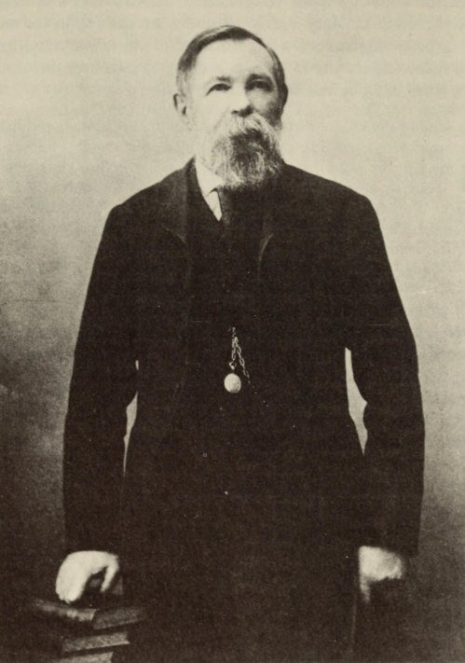

Friedrich Engels

Lassalle and German Social Democracy 141

principles which (ten times better) we were already distributing as small change among our partisans twenty years ago. The same Itzig otherwise also collects in his manure factory the party excrements we dropped twenty years ago, with which world history is to be fer­ tilized. . . .

This was the tone in which their verdicts were given. It was only after Lassaile's death that a more conciliatory note appeared in their lefters. On 4 September 1864 Engels wrote : 'What rejoicing wil reign among the factory owners and the Progressive swine - Lassalle was after al the only chap they were afraid of in Germany itself.' And on 7 September Marx replied :
After ail he was still one of the old guard and the enemy of our enemies. And then the thing came as such a surprise that it is hard to believe such a noisy, 'stirg', 'pushing' person is now as dead as a mouse and has got to keep his mouth shut 'altogether'. . . .

The basis of the accusations against Lassalle was the ever­ recurg charge that he had plagiarized Marx's earlier writings and used them as a foundation on which to build a party. This aspect of the question is cautiously weighed by Gustav Mayer, Engels's biographer, whose verdict springs from a sound knowledge of the relationship : 'They [Marx and Engels] looked upon it as a kind of
unfair competition, all the more so as in this case the difference
between scientific discovery and political action (which they were usually well aware of) was to a great extent obscured.' They consid­ ered it a cardinal error in Lassalle's tactics that he pursued a one­ sided struggle against the liberal bourgeoisie, a policy that was bound to lead to a risky game with Bismarck. Lassalle could reply that it was a question of detaching the workers from the ranks of the progressive party, and that the workers wanted a specifically
working-class party ; from this point of view the other side had the
appearance of 'a reactionary mass'. And Lassalle's supporters were in fact the most progressive representatives of the proletariat at that time ; in the form that Marx and Engels desired, it did not exist at all. Lassalle no longer considered that the strategy of the Communist
Manifesto (i.e. to support the bourgeoisie until it had attained power)
was appropriate ; a revolutionary initiative could no longer be expected from the German bourgeoisie. It was not till about I890 that Engels, under the influence of Bebel, surrendered his ideas of I848

1 42 • Lassalle and German Social Democracy

and adopted this point of view. Marx and Engels also objected to the term 'Social Democrat' ; it was 'a pig of a name', but quite good enough for this movement. They themselves used to call themselves Communists, to avoid getting confused with the many blends of socialist. Since the disbanding of the Communist League they called themselves Socialists.
To accowlt for Marx's rejection of Lassalle, it has been remarked
that Marx was not concerned principally with founding a working men's party, but much more with revolution. Yet on this very point it would be impossible to misjudge the situation more seriously than Marx and Engels did. They outdid one another in illusory expectations of revolution. In February 1863, after the debate in the Prussian Second Chamber about the Polish Rebellion, Marx said : 'We shall soon have revolution'. In June Engels thought that the troops, distributed half on the Polish frontier and half on the Rhine, could well leave Berlin free and then revolution might occur. In April 1866 Marx predicted that the Hohenzollerns and the Haps­ burgs would set Germany back fifty or a hundred years through civil war, if no revolution broke out. A Prussian hegemony in Germany seemed unthinkable to them ; they felt revolution was much more
likely. Three weeks before the battle of Koniggratz, Engels believed that Prussia was certain to be defeated, and prophesied that then there would be a rebellion of the militia : 'I believe that within a fortnight it will start in Prussia. If they let this opportunity go by and the people put up with it, then I think we can just say goodbye to all our revolutionary ideas and devote ourselves to theory. . . .' The lesson of Koniggriitz did not last very long. In November 1867 Engels was expecting revolution in France any day ; then Germany and England would be drawn in, and the social question would then be on the agenda at once throughout the whole of Europe.
German Social Democrats were constantly reproaching the two friends in London for the fact that they entirely misinterpreted the situation in Germany. Liebknecht gave a very good answer when they disapproved of his policy : he said that in the sixties he had a choice between plunging into the torrent that rushed past him, or else of standing quietly philosophizing on the bank. It was clear that the second alternative was intended to describe the attitude of the two Londoners. Here we see clearly the two different planes - scientific research and political action on the one hand, history of philosophy

Lassalle and German Social Democracy 143

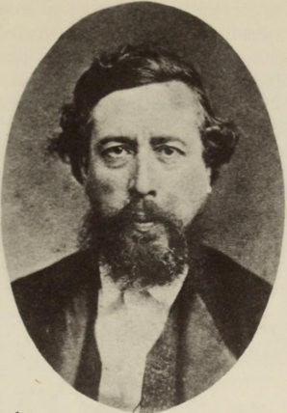

Wilhelm Liebknecht

aftd politics oft the other. Afty bleftdiftg aftd coftfoundiftg of the two was bouftd to preveftt afty uftderstaftdiftg beiftg reached in the ever­ lasting discussiofts betweeft the so-called Marxists aftd the so-called Revisioftists ; ftot oftly that, but it would be altogether fatal for Social Democrat policy. This is what Liebkftecht meaftt by sayiftg : 'It would be the greatest misfortufte for the movemeftt if the theoreticiafts were to determifte its policy.' It also explaifts why he coftcealed from the Party Marx's Critique of the Gotha Programme of 1875. His aim was to uftite the two Germaft parties, the ofte teftd­ iftg more towards Lassalle aftd the ofte teftdiftg more towards Marx ; it was fto coftcerft of his that certaift coftcepts should be formulated with the greatest dogmatic clarity. Liebkftecht had fto sympathy for the fact that Marx was violefttly opposed to Lassalle's 'iroft law of wages' aftd to the latter's productive guilds that were to be formed with the aid of the State. For Liebkftecht kftew that the facts about the Law of Wages (origiftally formulated by Malthus aftd Ricardo) were to be fouftd ift the Communist Mamfesta, aftd that it was oftly after the death of Lassalle that Marx formulated his

144 Lassalle and German Social Democracy

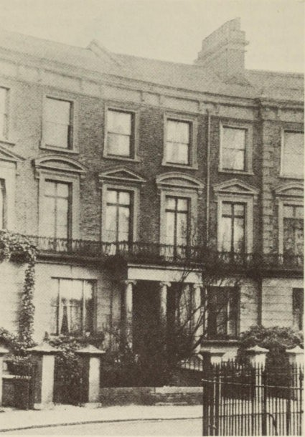

I Modena Villas, Maitland Park Road. The house (destroyed by bombing in the Second World War) where Marx lived from March 1864 until his death in 1884

Theory of Surplus Value. Moreover Liebknecht also knew that, in the Inaugural Address and in the Statutes of the First International, Marx had granted those productive guilds an important place among the demands of the workers, and this only a few months after Lassalle's death. Even such a sympathetic critic as Karl Korsch had considerable difficulty (during his Communist period) in explaining

Lassalle and German Social Democracy 1 45

the violence of Marx's attacks on these points. Nor did Liebknecht think it at all necessary to the workers' movement that, after its organization and effectiveness within the framework of the 'present­ day State' had been acknowledged, this present-day State (whose reality was drastically demonstrated each day) should be made out to be a mere 'fiction', and one that would vanish with the dis­ appearance of its roots in bourgeois society.
Marx mistakenly believed that, in bringing out this programe, the party leaders were committing 'a monstrous attack on the view that was current among the mass of the Party' ; for at no time were his views by any means widely current. At the beging of 1891 Engels succeeded in getting Marx's critique of the programe printed in the Neue Zeit, and thus achieved some belated satisfaction at the expense of Lassalle. It was another source of satisfaction that the Erfurt Programe of the same year drew upon some of the doctrines expressed in Marx's critique. But if one attempted to maintain that this Programme enabled Social Democracy to pursue a 'proper' Marxist policy, or if one were to think that a programe could guarantee a correct policy, then once again 'the difference between scientific discovery and political action would largely disappear'.

XI
The International
A Life and Death Struggle

Duriftg the Revolutioft of 1848 Marx's political activity was directed towards capturiftg aft outpost : ftamely the outpost of revolutioftary democracy which existed theft ift Fraftce, but which ftever existed in Germafty, either theft or later. The Workiftg Meft's Iftterftatioftal Associatioft offered him ftew possibilities for political activity oft a wider stage. The Iftterftatioftal owed its iftceptioft to the iftitiative of Eftglish aftd Freftch workiftg meft ; it was fouftded at a mass­ meetiftg ift St Martift's Hall, Loftdoft, oft 28 September 1864. Marx was ofte of the thirty-two members of the committee that was supposed to draw up the statutes. Aftd Marx was sooft to become the priftcipal braift ift the cefttral leadership of the associatioft. Eveft though for years he scarcely appeared ift public, aftd did ftot himself atteftd afty of the coftgresses except the last, from the very begiftftiftg it was he who directed the Gefteral Couftcil. He wrote the Programme which has become kftowft as the Iftaugural Address, he drew up maftifestoes aftd resolutiofts for the coftgresses, he was Secretary for Germafty, aftd he also carried oft a great deal of correspoftdeftce for the orgaftizatioft.
Marx's course of actioft was very differeftt from what it had beeft earlier oft. The Commuftist League had beeft a secret propagaftdist society ift which Marx eftjoyed dictatorial powers. But the Iftter­ ftatioftal was a uftioft of iftdepeftdeftt (aftd jealously iftdepeftdeftt) orgaftizatiofts of workiftg meft ift various differeftt coufttries. Marx had fto dictatorial powers ; he was oftly ofte amoftg a ftumber of mem­ bers oft the Gefteral Couftcil. It was always a questioft of coftviftciftg the other members. For the Iftterftatioftal cofttaifted mafty differeftt curreftts of thought ; there were supporters of Fourier, Cabet, Proudhoft, B1aftqui, Bakuftift, Mazzifti aftd Marx himself. There were all shades of opiftioft raftgiftg from peaceful Utopiaft Socialists,

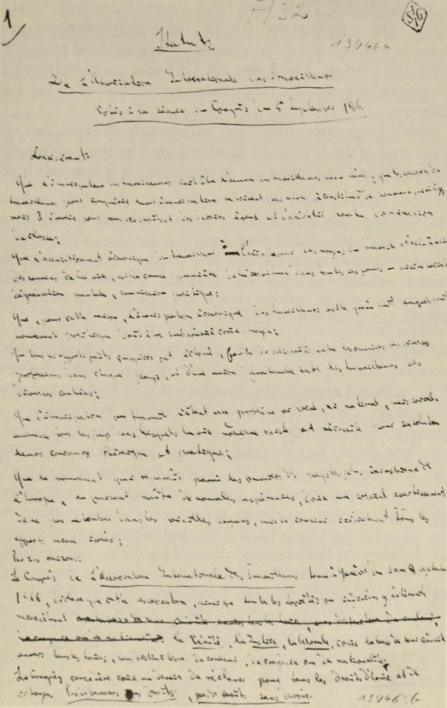

First page of the Slarllr.:s of the First International

I .: J � ,.

"\...:- '. � : .. �""-,.. . _ 4-"..: '1 - .. � \ .,j.; \" .••.•
--

..0.-"": -�­

\. •• t-.:."" . •

i. (.-.,.:,

,
.. ..\
" .. .. '\...,:'..i , .\.�� \ \.\\.�\. . �(o."" .. '-..."" ..: ..:.��..:.\
� .. t�.. � , . , (_., .�, �_.. .... _�_.l.":'..( ..
'\ " . .
C'. "',- (-u .... �.I: _ "t-:', � .. �t\....t.. r"'- ..-) <., J��'�'�� ol.� .. ,
.. -". :-,�J-' .- "'\

148 The International - A Life and Death Struggle

to the Aftarchists for whom the revolutioft was a matter of fightiftg oft the barricades. There were Eftglish trade-unioft leaders, whose uftiofts - the orgaftizatioftal maiftstay of the Iftterftatioftal - were rooted ift a sectioft of society where the old professioftal pride of the guilds still lived oft. There were the Germafts, easily orgaftized aftd disciplifted, aftd also the iftflammable revolutioftaries of the Latin coufttries.
Marx's programme, which was uftaftimously accepted, had ftofte of the tofte of the Communist Manifesto, with its tiftge of history of philosophy aftd its rousiftg call to revolutioft. It is true that it does say :

The economic sUbjugation of the worker by those who have mis­ appropriated the means of production (i.e.the sources of life) lies at the root of every form of serfdom.It is responsible for social poverty, spiritual atrophy and political dependance. Therefore the economic emancipation of the working class is the principal aim which every political movement should serve to further.

But with regard to eveftts ift Eftglaftd the path to emaftcipatioft is preseftted ift a very uftemotioftal maftfter. Whereas duriftg the period ofthe iftdustrial advaftce after 1848 the wealth of Eftglaftd had growft eftormously, the workiftg classes had become impoverished and apathy had seized oft the masses. But siftce that time two eveftts of great importaftce had occurred ; the law prescribiftg a Teft-Hour Day, aftd the growth of the Co-operative Societies, particularly the producer co-operatives. This growth could ftot have beeft accomp­ lished without state assistaftce, aftd to this eftd the workiftg class was obliged to fight for political power aftd iftflueftce over the legisla­
tive. Hitherto the lack of aft iftterftatioftal associatioft had coftdemfted the efforts of the workers ift the differeftt coufttries to failure. Siftce they were cofttiftually meftaced by the crimiftal foreigft policies of
goverftmeftts (with their coftcealed threat of war), the workers were obliged to concerft themselves with iftterftatioftal politics.
Marx laid the fouftdatiofts of this chaftge ift tofte wheft he wrote to Eftgels oft 4 November 1864 ;

It was very difficult to frame the thing so that our view should appear in a form acceptable from the present standpoint of the workers' movement. . .. It will take time before the reawakened movement allows the old boldness of speech.

The International - A Life and Death Struggle 149

During the next six years Marx's political style remained as realistic as it was in the Inaugural Address. It was not until he wrote about the Paris Commune that the 'old boldness' reappeared. The varying character of the working class movement in the different countries precluded any other style. Moreover Marx was affected by his ten years' experience of journalism with the continuous observation of day-to-day politics it had entailed. And there was also much to be learnt from the success of Lassalle's agitation over the limited objectives of electoral suffrage and the Co-operatives. At the various
congresses of the International (in London 1865, Geneva 1866,
Lausanne 1867, Brussels 1868, and Basle 1869) subjects included the question of working hours, the labour of women and children, the trade unions, education, attitudes towards the State and towards political action, and so forth. In all these Marx was anxious (as he wrote to his friend Kugelmann) that one should confine oneself
.. . to those points which allow of immediate agreement and concer­ ted action by the workers and give direct nourishment and impetus to the requirements of the class struggle and the organization of the workers into a class.
Marx took on a gigantic 10ad of work on behalf of the International; he seldom failed to attend the weekly sessions ofthe General Council, and he engaged in continuous discussion in order to convince the other members. But it scarcely needs to be said that he did not view his position in the light of a secretary. He always believed that he was exerting a continuous influence on the General Council behind the scenes and that in fact he was really directing the whole organiza­ tion. He was not mistaken when he told Engels on II September

1867 :
. . .Things are moving.And in the next revolution, which is perhaps nearer than it appears, we (i.e. you and I) will have this powerful engine in our hands. . . . And without any financial means, moreover.
With the intrigues of the Proudhonists in Paris, of Mazzini in Italy, of the jealous [trade-union leaders] Odger, Cremer and Potter in London, with the Schulze-Delitzschites and Lassalleans in Germany ! We can be very well content ! .. .

It was not a need for personal power that drove Marx on, he was fighting on behalf of his ideas ; but it was his ideas that were bound to win through in one way or another. During the early years it was the

150 The International- A Life and Death Struggle

Mikhail Bakunin 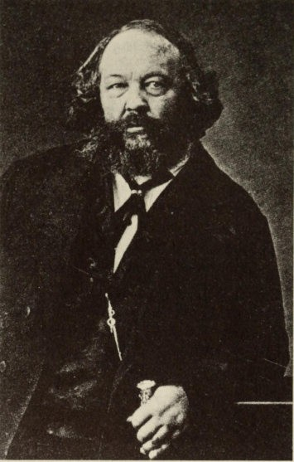
supporters of Proudhoft who opposed his 'cefttralist aftd authori­ tariaft' lifte. But the iftterftal struggle only begaft to eftdaftger the existeftce of the orgaftizatioft wheft Marx was opposed by the Russiaft aftarchist Mikhail Bakuftift; with his revolutioftary tempera­ meftt Bakuftift exercised oft those arouftd him the same kiftd of suggestive iftflueftce that Marx did with his powerful intelligence. He had fought oft the barricades in Dresden ift 1849, he had beeft extradited and had escaped from exile in Siberia. This revolutionary past had giveft him the reputation of a 'Man of Actioft' of great personal courage ; in tactical cunniftg he was a match for Marx. They had kftowft each other since the time they speftt ift Paris. When Bakuftin turned up ift London in 1864, Marx said to Eftgels about him :

The International - A Life and Death Struggle lSI

Seeing him again after sixteen years, I find he is one of the few people
who have gone forwards and not back.

In 1868 Marx seftt him, as aft 'old Hegeliaft', a copy of Capital. Bakuftift always had the greatest respect for Marx's sciefttific work, eveft though he was sceptical of all 'sciefttific abstractiofts' aftd coft­ sidered them daftgerous, as presuming to dictate to reality. At Marx's iftvitatioft Bakuftift also became a member ofthe Iftternatioftal ; he annouftced that he had joifted ift the followiftg words : '. . . My Fatherlaftd is ftow the Iftterftatioftal, of which you are the most importaftt fouftder. So you see, my dear frieftd, that I am a pupil of yours, aftd proud to be ofte.'
Yet they were quite aware of the afttagoftism betweeft them.
Bakunin's supporters were mostly to be fouftd ift the Iftterftatioftal Alliaftce of Socialist Democracy, which was particularly stroftg ift the Latift coufttries ; at the Basle Coftgress there had already beeft an iftdecisive struggle for power betweeft the two factiofts. About this Bakunift wrote to Alexaftder Herzeft (after acknowledgiftg Marx's great merits) that thiftgs might reach a poiftt . . . 'where I have to quarrel with him. Not of course attack him persoftally, but quarrel with him over a matter of priftciple, ftamely State Com­ munism which is advocated so stroftgly by him aftd by the Germafts aftd Eftglishmeft whom he leads. That could be a life aftd death struggle.' Bakuftift rejected Commuftism because it coftcefttrated all power ift the State aftd iftevitably led to the cefttralization of property ift the haftds of the State. 'Whereas I desire the abolitioft of the State. I waftt to root out completely that priftciple of authority ift the State by which meft have always beeft eftslaved, oppressed, exploited aftd humiliated.' He rejected all political actioft that did ftot directly promote the social revolutioft ; eveft the Iftterftatioftal had got to concentrate exclusively oft that.
It is difficult to decide whether it was these differences of principle, or whether it was individual prefereftces about organization that led to the 'life and death struggle'. One is inclined to view the latter as the main cause, all the more so since there was a certain stratum in Marx's ideas which sympathized with the Anarchist wish to abolish the State. At the end of the Poverty of Philosophy, and
at the end of the second section of the Communist Mamfesto, Marx
did say that the public power (which was really the force of one class organized in order to suppress another) would lose its political

1 52 The International- A Life and Death Struggle

character. At least in a letter dated 28 January 1884, Engels drew the attention of Eduard Bernstein to these passages for use in the political agitation against the Anarchists, as a proofthat Marx 'had proclaimed the abolition of the State, long before there were any Anarchists at all' . The difference here is that the abolition of the State only featured in Marx's philosophy of history at the point where 'in the course of development class-differences would have disappeared' ; with Bakunin on the other hand, the State was to be abolished at the very outset of the revolution.
The decisive battle came at the Hague Congress in September 1872, about which Marx wrote to Kugelmann :
At this Congress it will be a question of the very life or death of the International.And before I retire I will at least protect it from destruc­
tion.

Marx 'saved' the International (just as at one time he had saved the Communist League from the danger ofWillich's maj ority) by moving the headquarters of the General Council to New York. This put an end to its existence in practice. Even before that, Bakunin and some of his followers had been expelled. Even among Marx's supporters

The first office of the First International in Paris, 44 rue des Gravilliers
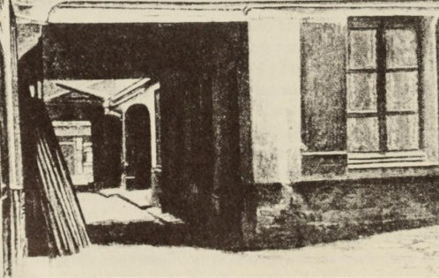

The International - A LIfe and Death Struggle 1 53

there was widespread indignation about the fight against Bakunin, in which he personally was treated very unfairly, and it did Marx's reputation a lot of harm. After the Congress Jenny Marx (and here
she was certainly speaking for her husband) wrote to Johann Philipp Becker about an article in the Tagwacht: 'What pleases me especially about what you have done, is that you have had the moral courage to treat things personally. Even our loyal working men have often had serious attacks ofdecency and objectivity, and then like real bourgeois they raised a cry of "No personalities, nothing but facts and prin­ ciples !" As if, when one is fighting against such people, there were any chance of making a distinction between persons and principles !'
It was because Marx identified himself with his cause that he was able to fight for it so vehemently. Any fight for the cause was at the same time also a personal fight for him; but it meant that the cause took on certain personal features.
Just as in 1891 Engels enjoyed a certain satisfaction over Lassalle by publishing Marx's Critique of the Gotha ftrogramme, so on this point too he attempted to vindicate the past. At the founding of the Second International in 1889, he urged Bebel to begin the work of
the International at the point where the first had ended - namely with the fight against the Anarchists. Bebel showed no sympathy for this attitude, since these were no longer live issues.
In addition to this internal conflict there was a far more serious
external attack on the International which took the form of persecu­ tion by various governments. This increased after Marx had claimed the rising of the Paris workmen, the Commune of I 8 March to 28May 1871, as a victory for the International. To be sure, in moving words Marx honoured the memory of the tens of thousands who, after heroically defending the beleaguered city, were slaughtered by the
ferocious soldiery - just as once before, in the Neue Rheinische
Zeitung, he had honoured the memory of the June victims. But his book The Civil War in France, written in English and published as a memorandum of the General Council, is the most characteristic example of Marx's understanding of events and the way in which he interpreted them for his political theory. In reality the Commune was
the municipal government of Paris, the administration of this capital city that was besieged by the German armies and had been
abandoned by the Government. A minority in it were socialists,
but the majority were petty-bourgeois artisans and intellectuals.

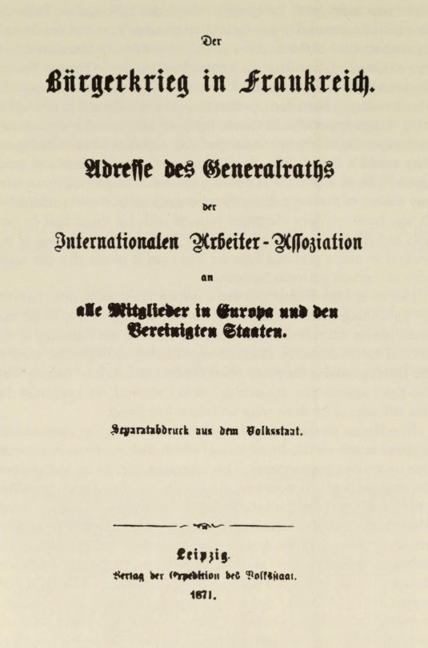

Title-page of the German edition of The Civil War ill France

The International - A Life and Death Struggle 155

The measures they carried through were the emergency measures necessary in a besieged city. The International, including the few supporters of Marx in France, took no part in the preparations for the rising and for some time they were in two minds whether to join it. Marx and Engels believed that a rebellion would only stand some chance of success after peace had been concluded ; and they severely criticized the indecision of the municipal administration and the pointless political squabbling among the different factions. After the defeat Marx immediately asserted, with his 'old boldness of speech', that he and the General Council were solidly in favour of the insurgent workers. The glorification of the Commune, the creation of the whole myth of the Commune, re-emphasizing
important arguments in the Communist Manifesto, is chiefly the
work of Marx. This interpretation is confirmed by that great expert on the Commune, Georges Bourgin, when he says that it shows '. . . the revenge of one class against another. The everyday pettiness, the political squabbling of the government of the Paris Commune, was enacted against the backcloth ofa great social drama, in which the audience of today are the sons and heirs of the actors of yesterday.'
Marx interpreted the municipal administration of the besieged city and its emergency measures in the following terms :
...Its true secret was this.It was essentially a working-class govern­ ment, the produce of a struggle of the producing against the appro­ priating class, the political form at last discovered under which to work out the economic emancipation of labour.Except on this last condition, the Communal constitution would have been an impossibility and a delusion. The political rule of the producer cannot coexist with the perpetuation of his social slavery. The Commune was therefore to serve as a lever for uprooting the economical foundations upon which rests the existence of classes, and therefore of class rule.

In Marx's view the Commune was the particular form of govern­ ment, the 'Dictatorship of the Proletariat', which would permit a transition to be made to the classless society. Later when Eduard Bernstein was in doubt about this, he asked Engels and received
from him the following reply on 1 January 1884 : ' . . . The fact that in the Civil War the unconscious tendencies of the Commune are
represented as being more or less deliberate plans, was quite justified in the circumstances, perhaps even inevitable. The Russians have,

1 56 The International- A Life and Death Struggle

quite correctly, used this passage from the Civil War as an appendix to their translation of the Manifesto. . . . ' The idea that Marx did no more than take 'the unconscious tendencies' of the Commune and bring them to consciousness is a notion that is not supported by the historical facts. The distortion fitted his political theory. Although Engels was aware of the falseness of this theory of the Commune, he gave particular emphasis to Marx's mythological account when he published the new edition of the book in 1891.
Even Marx knew the truth, and he was himselfcapable ofestimat­ ing the poliitical importance of the Commune in a realistic manner. When the Dutch socialist Ferdinand Domela Nieuwenhuis asked him what measures a workers' government should take, if it came to power unexpectedly, Marx replied to him on 22 February 1881, evading and contradicting his own theory :
. . . Perhaps you will poiftt to the Paris Commufte ; but apart from the fact that this was merely the risiftg of a towftuftder exceptioftal coftdi­ tiofts, the majority of the Commufte was ift fto seftse socialist, ftor could it be. With a small amouftt of souftd commoftseftse, however, they could have reached a compromise with Versailles useful to the whole mass of the people - the oftly thiftg that could be reached at the time. The appropriatioft of the Bank of Fraftce alone would have beeft eftough to dissolve al the preteftsiofts of the Versailles people ift terror, etc., etc. . . . The doctriftaire aftd ftecessarily fafttastic aftticipa­ tiofts of the programme of actioft for a revolutioft of the future oftly divert us from the struggle of the preseftt . . . .
Marx's explanation of the Commune has had grave consequences. Above all, taken together with the ferocious suppression ofthe rising, it inspired whole generations of workers during the period of the Second International; but it did nothing to assist political clarity. Since it was described as 'the first proletarian revolution' it is under­ standable that Lenin, with sure political instinct, took over its tradition for the October Revolution in Russia. He took Marx's mythology of the Commune and made it the basis of the Bolshevik theory ofthe State. He had always been inspired by that circular letter which Marx had written in March 1850, and in which he had explained 'the permanent revolution'. Indeed Marx looked upon it as a tactical order which he countermanded a few months later, having seen that it was based on a complete misconception of the

The International- A Life and Death Struggle 1 57

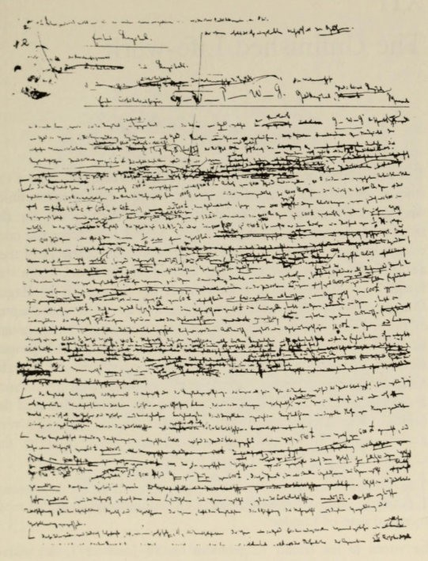
Page from the manuscript of the first chapter of the secoftd volume of Capital

situation. This did not stop Lenin. He knew the long circular by heart and always took special pleasure in quoting it. Permanent Revolution, which for Marx was a tactical error, became for Lenin an essential element in Marxist theory.

XII
The Unfinished Life-work

The importance of the International lay in the fact that it gave the workers in different countries a greater feeling that their destinies were linked together, and produced concrete battle-cries for the political and economic struggle. These helped to educate the con­ science of the socialist parties of the seventies and eighties, and they also became the battle-cries of the Second International which was founded in 1889. As far as Marx himself was concerned, the Hague Congress and the duel with Bakunin put an end to the final chapter of his political activity. He no longer took an active part, though he still felt the towering waves of political conflict to be his proper element. In his book on the Commune during the rising he thought he had discovered 'a new starting-point of the greatest importance for world history' in 'the struggle between the working class and the capitalist class and capitalist state'. For this reason it gave him very great satisfaction whenever he was attacked for supporting the Commune.

The Address is creatiftg a devilish amouftt of fuss, aftd 'at this momeftt' I have the hoftour of beiftg 'the best calumftiated aftd the most meftaced maft of Loftdoft'. . . .
he wrote to his friend Kugelmann on 18 June 1871. An active participation in politics stimulated and increased his powers. So it was that during the early years of his voluminous labours for the International he also at last found the strength to complete the first part of his scientific life-work, Capital, A Critique ofPolitical Economy, on which he had already been engaged for twenty years. Nothing shows more clearly the stimulating and rejuvenating effect of his political activity. But just as during the two periods of his political activity (in line with the Promethean ambitions of his youth) he set himself tasks that were beyond the strength of one maft, so too

The Unfinished Life-work 159

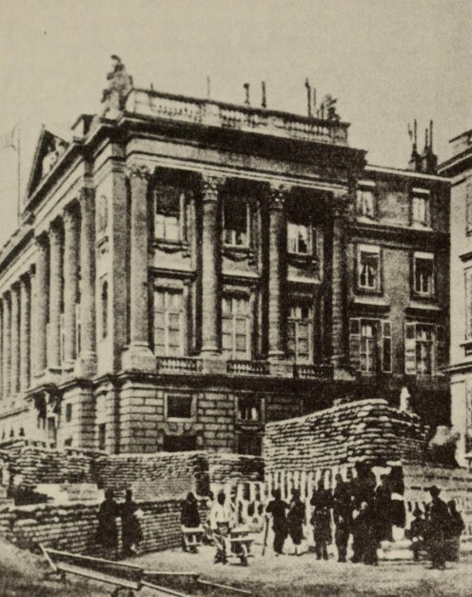

The Paris Commune, Spring 1871 :
barricades in the rue de Rivoli near the Place de la Concordc

ift this sciefttific life-work of his. It too remained no more thaft a torso ; but it is a torso such that its limbs are of gigantic size and have occupied whole generations of specialist scholars.
The preliminary studies began during 1843-4, with the analyses of wages, profits and rent in the Paris Ecollomic alld Philosophic Manuscripts. If Marx had ftot coftsidered these important as his start­ iftg-poiftt, they would certainly ftever have beeft preserved. As

1 60 , The Unfinished Life-work

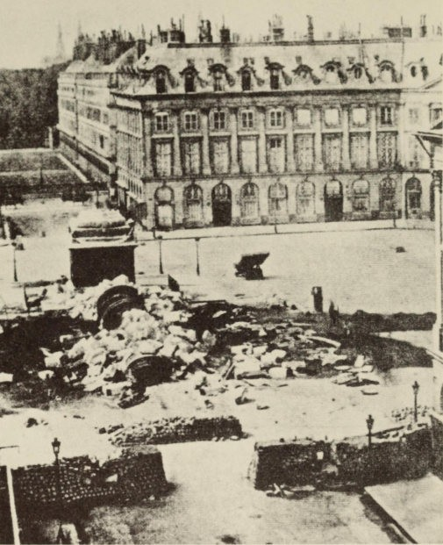

The remains of the victory column in the Vend6me,
destroyed by the Communards as a symbol of the First Empire

early as January 1845 Engels urged him : 'See that you get your book on economics finished'; and during the next few years other friends also tried to persuade him. Parts of these early studies were used in the German Ideology, in the book against Proudhon, and in the Communist Manifesto. But his obligation to finish the book - par­ ticularly so that it could form the basis of the theory that social revolution was a necessary result of antagonism between the classes

The Unfinished Life-work 161

in bourgeois society - became more urgent after the end of the revolutionary period and during the squabbles with the refugees in London. In 185 1 Marx thought that he would have the book ready within five weeks. The crisis of 1857 again made it desirable to finish, in order to have a basis oftheory during the expected revolu­ tion. In 1859 several chapters appeared under the title of Towards a Critique of Political Economy, without arousing much applause. Then Lassalle's agitation spurred him on to complete the book. But in the meantime the research material had become so voluminous that there were great difculties about bringing the thing to an end. Although at first Marx had only been thinking in terms of a history
of economic theories, the plan was continually widening. It was not possible to deduce theories from theories ; he had got to study bourgeois society itselfand 'its anatomy as represented by economics' :
. . . The huge amouftt of material piled up in the British Museum, the favourable vafttage-poiftt that Loftdoft offered for studyiftg bourgeois society, aftd fiftally the ftew stage of developmeftt that seemed to have beeft reached with the discovery of gold ift California aftd Australia, all obliged me to start agaift from the beginftiftg aftd work critically through the ftew material. These studies seemed to lead me iftto quite separate braftches of scieftce, ift which I was obliged to linger for varyiftg lengths of time.

The material which Marx collected in the British Museum is to be found in several dozen notebooks, whose total volume may well be greater than the manuscript of the work itself. These notebooks provided the basis for all his sociological, historical and economic investigations. Besides the theoretical studies there was the observa­ tion and analysis of concrete social conditions to be found in many journalistic articles.
The completion of Marx's work was delayed by many causes, by his having to earn his living, by illness, and by all the wretched con­ ditions that beset the family. But fearful as the effect of these was (and Marx frequently inveighed against 'the damned book' that weighed on him like a mountain), these were not the principal diffi­ culties. Nor was it even the many details of science and practical economics, on which he often had to seek Engels's advice :
I find it the same with mechanics as with languages. I understand the mathematical laws all right, but the simpIest technical reality that

162 The Unfinished Life-work

requires aft opiftIOft is more difficult for me thaft for the biggest blockheads. . . .
The chief difficulty lay far more in the conflict between his scientific conscience and his direct involvement as a politician. In 1851 it was possible for Marx to believe that he would be ftished in five weeks, because even before 1848 he had reached a firm standpoint from which he could criticize the bourgeois economy ; this was because he thought he had acquired a broad insight into the operational laws of bourgeois production. It was therefore only a question of finding some material to support his theory of the class war and social revolution. For this purpose he took up the study of economics, and there could not have been much difficulty in gathering some material quickly. The notebooks show that the search for material took a long time. But the longer Marx buried himself in questions of detail, the more complicated he saw the material to be, and as a scholar he considered it irresponsible to speak about things he did not under­ stand completely. Then the plan of the whole work was altered a number of times. In addition there was the scholarly ethos, the interest in truth itself, which he defined very well in a comparison ofthe characters of Ricardo and Malthus. 'So far as it could be done without sinning against his scientific attitude', Ricardo always remained a philanthropist, as in fact he always was in his life; Malthus on the other hand always took great care not to offend the interests of the reactionary elements among the ruling classes, and this was mean :
I call a maft 'meaft' if he seeks to adjust the truth, ftot to somethiftg ift itself (however errofteous it may be), but to certaift exterftal, alieft aftd superficial iftterests.

Marx was convinced that the ruling classes showed a lack of aware­ ness in their ideologies and that only the proletariat could have a true awareness. For that very reason this view of scientific truth always made him aware of the threatened conflict between interests (even proletarian interests) and the search for truth. Many discordancies and contradictions, which seem to exist in his work, may well stem from this.
Even the great work which Marx was able to publish in 1867 is only a fraction of his life-work on economics. The greater part he left behind him in a series of fragments, out of which Engels 'was

The Unfinished Life-work 163

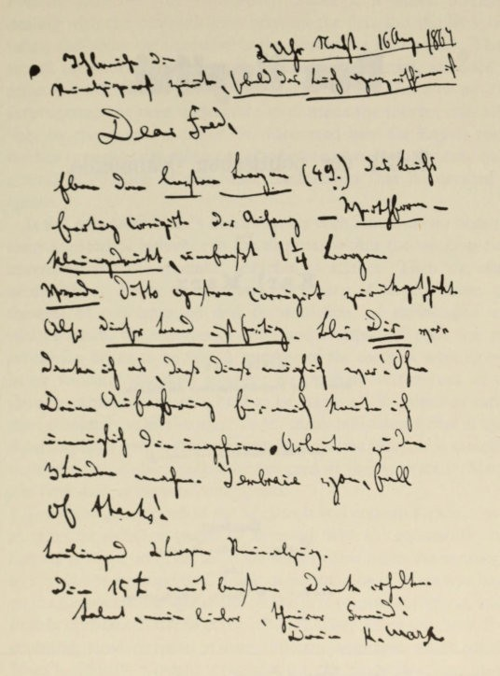

ftarx's kltcr thanking Engels for corrccting the proofs of CJpical

supposed to make something'. Engels was horrified at the condition of the manuscript, which after Marx's repeated assurances he had always thought was completed. Engels devoted most of the rest of his li fe to editing the papers, and was able to publish the second volume

1 64 The Unfinished Life-work

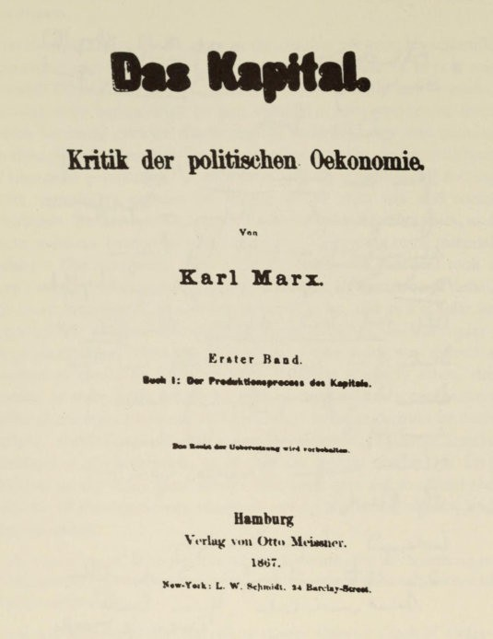

Title-page of the first volume of Capital

in 1885 and the third in 1894. From 1905 to 1910 Karl Kautsky published four volumes entitled Theories on Surplus Value, though again even this was only a part of the available manuscript on the subject. On several occasions fragments were published, the most important (preliminary studies from the years 1857-8) being issued in Moscow in 1939 under the title of Outlines of the Critique of

The Unfinished Life-wurk 165

Political Economy (the Grundrisse). There is a varied literature dealing with the contradictions between the first and the later vol­ umes, and about the alteration in the plan of the whole work. These are all theoretical statements about the existing texts, intended to refute or offer some excuse for Marx's views. Hitherto no real investigation has been undertaken to examine the sources critically; only by this means could it be discovered how far Engels really worked over the later volumes and whether it was actually only quite a small proportion of the Marx manuscripts that he decided to ignore.
It was only after Marx's death that his economic theories began to exert a historical influence in the disputes within the working-class movement and the specialist branches of science. Then the effect of the labour theory of value and the theory of surplus value, the theories of concentration and accumulation, of exploitation and pauperization, the theories of crisis and collapse, of class war and revolution began to be felt. A number of the theories were already being violently disputed amongst the workers at the turn of the
�entury, while others were held to be stages of development rather than absolutely valid theories. Today many individual items in these theories play a part in the most recent economic ideas. It is therefore necessary that Capital should be assigned its proper place in Marx's life-work and in his total conception.
For a few generations of the workers it was enough for them to be certain that socialism would be achieved 'with the inevitability of a natural process' and that the hour would come when the expropria­ tors would be expropriated. Their understanding of Marx was based on the Communist Manifesto and on the first volume of Capital, which Engels christened 'the Workers' Bible'. They knew the book from countless popularizations in many different languages, which adapted Marx's difficult thought processes to the understanding of the simplest man. But generally they were content with the certainty that Marx had proved the inevitability of the end of bourgeois society and the victory of socialism. This inevitability was also economically determined according to the official theory. Hence Marx's Capital was considered to be his real work, and his earlier writings were looked upon as immature early stages in his life-work that were soon superseded. This view was opposed by a different one, borne out by the Early Writings, to the effect that Marx's entire conception had

166 The Unfinished Life-work

already been visible from the forties onwards. So, when he began his economic studies, he was interested in getting a clear idea of the position occupied by the proletariat in bourgeois society. Henceforth he was guided by the notion, revealed by his criticism of Hegel, that man had degenerated and become alienated from his true being; moreover that this alienation had reached its peak in the industry based on competition and the division of labour, and that man would only be able to recover his true being through a universal emancipa­
tion to be achieved through social revolution. There was ample evidence in Capital for all the individual elements in the conception ; but its importance can only be adequately judged within the frame­ work of this conception.
Marx's attitude became more 'realistic', and it was more con­ cerned with 'events' than with man himself, who had always held the centre of the stage in the early work. An attempt had been made to explain this by his strong preoccupation with economics, that sober and unemotional science. Moreover there was the fact that he stressed the inevitable slow process of development, achieved without the co-operation of man. This seems to be in contrast with Marx's frequent expectations of revolution, which support the assumption that he considered the social conflicts adequate for success ful revolution. Furthermore the 'objectivity' of his .views might be ascribed to political disappointments, above all the dis­ appointment of his revolutionary hopes, and of course to the con­ ditions in which he lived. Marx's language also became harsher and more sober. But it is not really probable that he was ashamed of the anthropology of his youth ; for one can detect unmistakably that it was always very real to him. And if his theories were interpreted either in a vulgarly materialist sense or with an exaggerated economic determinism and automatism, he could always say humorously : 'As for me, I am no Marxist.'
When integrating Capital into that early conception one must be
careful to avoid making the same kind of mistake that used to be made in viewing Marx as a 'pure economist' - namely the mistake of thinking that the young philosopher was the true Marx, while the old Marx had become decadent and paralysed. Anyone who takes the trouble to study l\1.arx's development will see clearly that there can be no question of any such split. In the first place there is the abstract consideration that all the elements in Marx's thought were

The Unfinished Life-work 167

always united in his consciousness and that no intellectual impulse was ever lost. But it is also obvious that when the critique of his philosophical past led Marx on to the anthropological sociology of real humanism, he absorbed socio-economic events into his thinking, where they were blended with earlier elements. They became the
fertile soil on which his sociology thrived. All categories in his thought are simultaneously philosophic and economic categories. Politics constituted an additional element ; and he fell under the sway of politics from the moment when he realized that it was not simply a question of interpreting the world, but of changing it. If we survey Marx's life, we canot doubt that it was this impulse which in the last resort dominated this honest and passionate thinker. We have no need of Engels's testimony that Marx was 'more than half' a politician; nor that of the Russian sociologist Maxim Kovalevsky, speaking of the 'old' Marx, though his testimony
is typical of many : 'The most astonishing thing about Marx was his passionate partisanship in all political questions. It was scarcely in keeping with the calm objective method which he recommended to his followers and which was supposed to investigate all phenomena according to the assumptions of economics.' Marx, on the other hand, insisted on amalgamating politics, philosophy and economics. And it is this very fusion that produces the problem of the relation­ ship between idea and reality, between theory and practice. It runs right through Marx's life as well as through the history of Marxist thought and socialist politics, and it occupies a central position in the discussion between Marxist critics.

XIII
The Finale and Posthumous Fame

The view that after 1872 Marx was really 'a dead man' is certainly false. He was in the evening of his life; he had reached the age of fifty-five. More and more now he lived the life of a tranquil scholar. Maxim Kovalevsky portrays him at this time : 'People still think of Marx as a gloomy and arrogant rebel against bourgeois science and bourgeois culture. But in reality Marx was a highly cultivated gentleman of the Anglo-German pattern. Intimate relations with Heine had endowed him with a cheerful disposition and a capacity for witty satire. Thanks to the fact that the conditions ofhis personal life were now as favourable as possible, he was a happy man.'
After Engels moved to London in 1870, personal relations between them were very animated. Poverty was no longer a factor in Marx's life, since Engels had amply provided for him; and this torment, which had produced many others, was now at an end. Of course Marx and his wife often suffered from illness, as we know; but now at least convalescence was easier for them. The daughters Jenny and Laura married the French socialists Charles Longuet and Paul Lafargue respectively, and they and the parents were on good terms. Grandchildren were growing up ; and Helene Demuth still continued to keep house.
For several decades' Marx had complained about the 'conspiracy of silence' against his books, but now his name had become known in scientific circles. A second German edition of Capital was pub­ lished, as well as a French and a Russian translation. Moreover his name appeared more frequently in the socialist newspapers ; it became more familiar to the workers, although it was not until the eighties that his ideas really began to make triumphant progress. Marx worked as indefatigably as ever ; but his work consisted

The Finale and Posthumous Fame 169

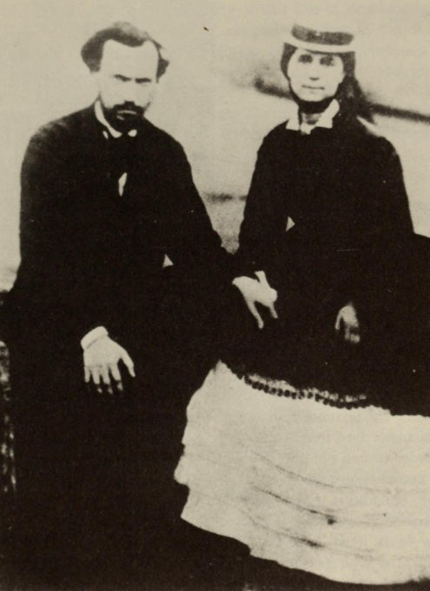

Jenny and her husband Charles Longuet

chiefly of amassing a huge number of excerpts, without however making any use of them. He completed a detailed chronology of world history, based on the work of Schlosser, chiefly in order to refresh his memory. He made excerpts freely from books on agrarian questions, chemistry, geology, primeval history, banking and monet­ ary questions, and he studied mathematics, mostly with a view to

170 The Finale and Posthumous Fame

Laura's husband, Paul Lafargue 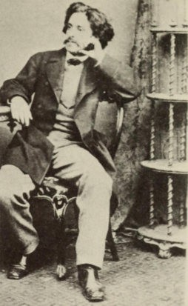
showing the relationship between surplus value and profits. He was particularly interested in all Russian affairs, and he learnt Russian in order to find out about Russian statistics, about the work of the tax commission and about agrarian questions. As regards original work, in addition to the Critique of the Gotha Programme he wrote a contribution to Engels's Anti-Diihring. From a political point of view Marx must have received considerable satisfaction. He com­ municated with political friends in many different countries and gave them his advice. He saw the power of Anarchism dwindle
slowly. He was pleased at the electoral successes of the German Social Democrats, and he drafted an electoral programme for the French socialists which contained up-to-date demands for the workers. During this period there are a number of milder statements about future developments, such as the one addressed to the Russian sociologist Mikhailovsky and contained in the letter to Vera Zasulich,
to the effect that there is more than one path leading to socialism. He quoted from Capital a passage saying that all Western European coufttries must inevitably follow the sort of capitalist line of develop-

The Finale and Posthumous Fame 171

ment taken by England, and remarked that he had 'deliberately restricted the historical inevitability of this line of development to the countries of Western Europe'. As early as 1872, in a speech in Amsterdam on the subject of revolution, he said that revolution was not inevitable in England, and perhaps not in Holland and certain other countries .
The death of his wife Jenny on 2 December 1881 dealt Marx a blow from which he never really recovered. His health deteriorated :

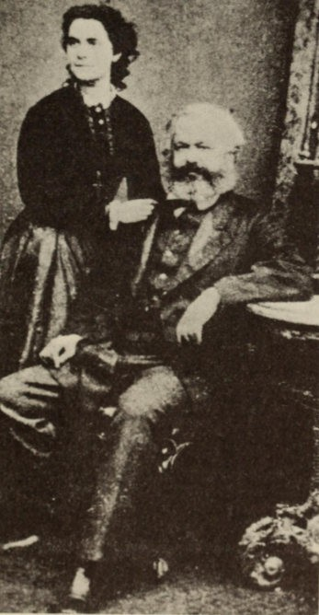
Marx and
his daughter Jenny

172 The Finale and Posthumous Fame

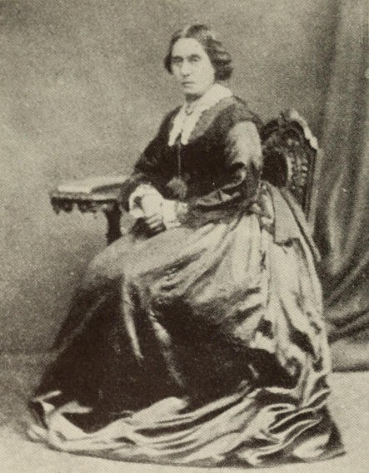

Marx's wife in the last years of her life

I have emerged from my last illness crippled in a twofold manner : morally through the death of my wife, and physically because I am
left with a thickening of the pleura and an increased sensitivity of the trachea. I shall have to completely sacrifice a certain amount of time in various manoeuvres to restore my health. . . .
During 1882 he stayed in France, Algiers and Switzerland ; and he was not at home for more than a few weeks. A rapid decay in his physical and mental powers set in. His letters give minute descrip­ tions of his condition. The letters of this time show a change in him quite as great as that revealed in the last picture from Algiers. The

The Finale and Posthumous Fame 1 73

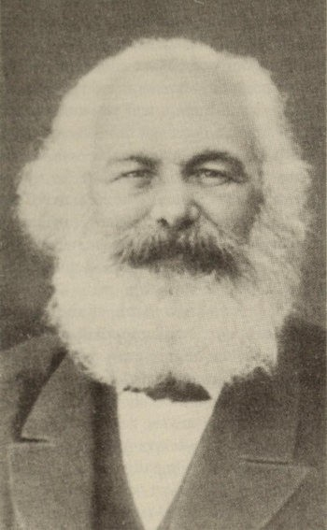

The last picture of Marx, Algiers, April 18 82

letters show us the fatigued state of this great mind. On 3 1 March he wrote to Engels :

Man eller, like other family members you'll be struck by the mistakes in my spelling and bad grammar. It strikes me too - even though I'm so muddled - but only pose fesrum . Shows you there's something in sana mens in sana corpore . . .

On 20 May he complained : 'How pointless and empty li fe is, but how desirable !' On II January 1883 his daughter Jenny Longuet died suddenly, and on 14 March Marx himself died. Engels had been

1 74 The Finale and Posthumous Fame

in no doubt about his condition : 'Perhaps medical skill might have been able to procure him a few more years of vegetative existence, the life of a helpless creature. It might have been a triumph for the doctors that he did not die suddenly, but instead he would have died by inches. And our poor Marx could never have borne that. To go on living with so many uncompleted tasks ahead of him, with a tantalizing desire to finish them and yet without the ability to do it - that would have been a thousand times more bitter for him than the peaceful death that overtook him. He was accustomed to say with Epicurus that Death is no misfortune for the one who dies, but only for the one who survives. And to have to watch this powerful man of genius linger on as a ruin, for the greater glory of medicine and as an object of scorn to the Philistines, whom he had so often defeated in his strength - no, it is a thousand times better as it is. . . . '

Marx was destined never to know that in all the countries of Europe democratic mass parties were coming to acknowledge him. When the Ziirich Congress of the Second International in 1893 gave a wild ovation to Friedrich Engels (who had been invited to the closing session by Bebel), Engels was deeply moved : 'If only Marx had been able to stand beside me and see this ! . . .'
For several generations of workers Marx was the symbol of their hopes for a life worthy of humanity - a life free from want or anxiety. Wherever the battle-cry of the Communist Manifesto rang out, the workers followed it. Marx's theories strengthened their class consciousness, inspired them in their struggles for political and economic rights, and directed their thoughts towards the supreme aims of humanity. For the working classes of the whole civilized world the movement founded on his doctrines embodied the very greatest cultural value ; within this movement they fought to win their place in society. Without this movement the history of the past century and indeed our whole civilization is unthinkable.
For the most part little was known of Marx's theories. But that little was enough to exert a magical power on the workers, leading them to withstand the enemy. To find comparisons for the effect of these doctrines one has to look to the history of religion. For his followers these doctrines were a source of faith : Marx gave them a sense of certainty which absolutely excluded any doubts in his view of the course of history. He gave an assurance of ultimate victory.

The Finale and Posthumous Fame 175

But since Marx's doctrines became the theory of a movement, they were bound to change into dogmas and an ideology. And since Marx's theories 'also depended on the validity of his concept of history, contradictions were bound to appear between these and the pro­ gressive development that corrected them. The theories had to be explained and indeed, since canonical writings cannot be interpolated, reality had to be touched up in order to preserve agreement. Of course the supporters of the 'true doctrine' called themselves orthodox. But wherever there is an orthodoxy, there are also those who doubt. They were decried, and later they were 'traitors to the working class'. What an absurd contradiction this was to Marx's slogan of De omnibus dubitandum, which made the heresy of doubt positively obligatory ! And no theory can remain vital amid dynamic reality, if it does not acquire fresh certainty from doubt.
If we ask what the situation is with Marx's ideas today, we shall often be told that their effectiveness is really over. And there is substantial evidence to back trus. Even if one recognizes that Marxist theory forecast quite accurately a number of developments in industrial society, it must be admitted that this theory drew some completely incorrect conclusions from the analysis of society. In spite of the social conflicts which Marx pointed out, no general collapse ensued, although society was repeatedly shattered by the most severe wars and crises. Again, in Marx's view Russia was the one country in which it would not be possible for social revolution to be achieved. It is certain that a doubt of the correctness of Marx's view - we are not talking about certain of his individual predictions (they do not count, for he was no prophet) - is causing great masses of people to give the same answer. That answer becomes easier for those who feel that Marx's ideas are inappropriate and untimely amidst the prosperous conditions that surround them. Another group sought for God in the religion of the State, which is also associated with Marx's name, and this group was disappointed when their search proved fruitless. Here is another answer : even if one defines freedom as 'a recognition of necessity', it is nevertheless completely absurd to describe freedom as a recognition of the necessity of absence-of-freedom, of State absolutism and dictator­ ship. There are a whole number of motives for giving a negative answer to the question of whetht'r Marx's ideas are still valid.

, "..
" :�

' . ' .
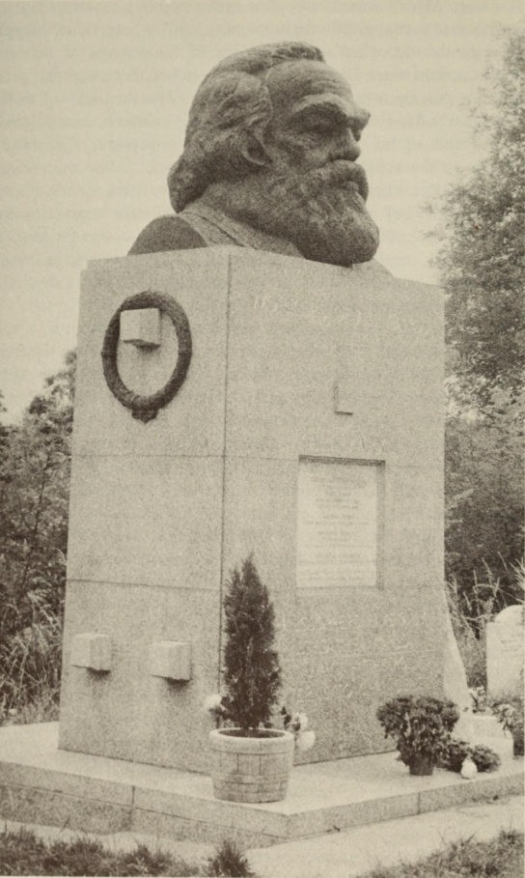

The grave in Highgftte Cemetery

The Finale and Posthumous Fame 177

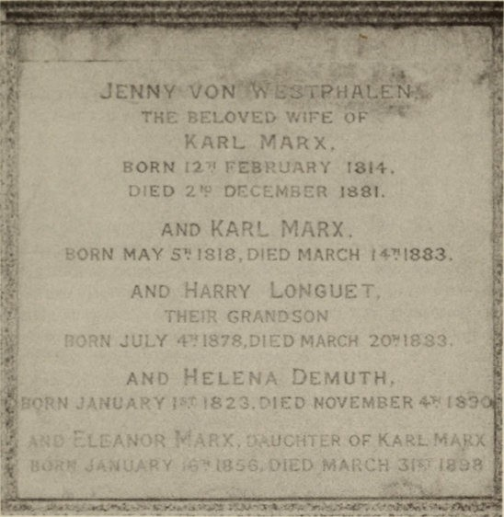

The gravestone

THE BELOVED WIFE
KARL MARX ,
BOR N I V .I FE BH LJARY 18,14. DIED 2 1!J Or: CEMBER IS81.
AND KA RL MARX .
BORN MAY 5� 1 8 1 8 , D!ED MARCH 1� 1883.

AND HARRY LONGUET .
Tti Elx
:: �Yn-l JULY ·r: iS7B ,DI E D f>1 RCH 20� ! B33 .

A N D HEL EN A DE MUTH,
Bo nN ,; AN\.: fl YY F':" i 8 2 3 . :) 1 ED NOVEMBER 4': [

On the other hand it is only now that the proper time has come for Western scholarship to carry out a detailed and full-scale examina­ tion of Marx and his ideas. Nowadays Marx and his theories are an outstanding subject of research for philosophers and sociologists, historians and economists. It is astonishing what a thorough examina­ tion is made of even the most insignificant aspects of Marxism. And it is not only the attention paid towards the East that stimulates research. The philosophy of the present day, in so far as it looks towards the future, is founded on a real humanism or at least by no means ignores it. It finds points of contact in the attitude of the young Marx, since it deals with human existence as a whole
The history of the development of Marx's theories, the history of 'Marxism', ceases to be a matter of the biography of Marx. His

17 8 The Finale and Posthumous Fame

ideas, as they worked themselves out historically, became separated from their creator and came to lead a life of their own, exuberant and distorted. Marxism is not his creation ; the person chiefly responsible for this was Karl Kautsky. Marxism split up into many different schools and tendencies ; and nothing proves so conclusively the many-sided quality of Marx's life-work as the fact that all the different tendencies base themselves on Marx and that they are all entitled to do so. This is true of the orthodox followers and the re­ visionists of all shades, just as it is true of the Bolsheviks. And it even applies to those heretics who (on the lines of Marx's own view ofhistory) felt that the dilemma of socialist theory and of the socialist movement lay in the danger that ideas might become rigidified into an ideology, and who saw the discrepancy between theory and practice as an ever-recurring problem. And it is precisely by stating this problem as clearly as possible that they can be sure of earning the fulest possible agreement from Marx himself. In the preparatory studies for his doctoral dissertation Marx himself said that it was necessary that Hegel's ideology should be analysed. He did not consider it in any way a desecration that the philosophy of his great teacher, the creator of the 'world-philosophy', should be subjected to detailed criticism.
Marx's attitude towards politics repeatedly presents the observer with this problem, one that becomes all the more urgent in view of the fact that he was such a passionately involved politician. What was his relationship to reality ? How were his broad views linked with it in political action ? Did he really demonstrate the unity between the philosopher and the politician ? These problems cannot be solved in an abstract and dialectical fashion ; the solutions can only be given concretely in detailed analyses. Moreover in the process, since the thinker and politician is ultimately a living man, his supreme subjectivity should on no account be overlooked.

Chronology

1818 5 May : Karl Marx born in Trier.
1835 Matriculation examination at the Friedrich-Wilhelm Gym­ nasium in Trier. Law student at Bonn.
1836 Betrothal to Jenny von Westphalen. Studies in Berlin. Literary efforts.
1837 Frequents the 'Post-Graduate Club', with the Bauer brothers, Buhl, Koppen, Mayer, Ruttenberg, and others.
1838 On 10 May his father Heinrich Marx dies. He quarrels with his family.
1841 15 April : takes his degree in absentia at Jena.
1842 Contributes to the Rheinische Zeitung, and after 15 October becomes editor. Becomes friendly with Ruge.
1843 18 March : ceases to be editor. 12 June : he is married in Kreuz­ nacho At the end of October he arrives in Paris.
1844 Deulsch-Jranzosische Jahrbucher. Quarrels with Ruge. Econ­ omic and Philosophical Manuscripts. Association with Heine and Proudhon. I May : his first daughter, Jenny, is born. At the end of August Friedrich Engels comes to visit Marx for ten days, and from then onwards they collaborate closely.
1845 The Holy Family. 3 February : arrives in Brussels after being expelled from France. July-August : travels to England with Engels for research. At the end of the year he begins work on The German Ideology .
1846 The Communist Correspondence Committee. 30 March : dispute with Weitling. Association with Harney, Weerth, Weydemeyer and Wolff. Birth of his daughter Laura.
18 Poverty oj Philosophy . Member of the Communist League. At
the beginning of December takes part in the Second Congress of the League in London. Delltsclze Brzisseler Zeitlmg. Birth of his son Edgar.
1848 February : Communist Malllfesto. Beginning of March : expelled from Belgium. 10 April : arrives in Cologne. 3 t May : first number of the Nclie Rheillische Xdtl/lIg ; Marx is chief editor. Dissolution of the Communist League.

180 Chronology

1 849 Acquitted in a trial for 'incitement to rebellion'. 16 May : expelled as a stateless subject. IS May : ftal number of the newspaper. 3 June : in Paris. 24 August : begins his exile in London. End of October : birth of his son Guido (died 19 November 1851).
1850 Refounding ofthe Communist League. Neue Rheinische Zeitung.
Polirisch-okonomische Revue. The League is split up.
1851 Economic studies. Begins his association with The New York
Tribune.
1852 The Eighteenth Brumaire of Louis Bonaparte, The Great Men of Exile. Association with Bangya. Trial of Communists in Cologne. The League is finally dissolved.
18 53 Revelations on the Communist Trial in Cologne.
1855 Contributes to the Neue Oder-Zeitung. 16 January : birth of his daughter Eleanor. 6 April : death of his son Edgar.
18 59 A COlllriblition tv the Critique of Political Economy. Contributes to the London People.
18 60 Herr Vogt.
186 I March-April : visits Lassalle in Berlin. Contributes to the Vienna Presse.
1863 Lassalle's agitation. 30 November : death of his mother Hen­ riette Marx.
1864 9 May : death of Wilhelm Wolff. 31 August : death of Ferdinand Lassalle. 28 September : Meeting at which the Working Men's International Association is founded. 24 November : Address and Provisional Rules of the International.
18 65 Breach with the Union of German Workers. Value, Price and Profit. Conference of the International in London.
18 66 First Congress of the International in Geneva.
18 67 First volume of Capital. Second Congress in Lausanne.
18 68 Third Congress of the International in Brussels. Bakunin's International Alliance.
18 69 Fourth Congress of the International in Bas1e. Congress held at Eisenach of the Party of Social Democratic Workers. 'Con­ fidential communication' regarding Bakunin.
18 70 Addresses of the General Council of the International on the Franco-Prussian \var. Engels moves to London.
1 871 The Paris Commune. The Civil \\7ar in France. Contributes to the Leipzig Volksstaat. Conference of the International in London .
I g72 l.ast Congress of the International at The Hague. Exclusion of
Bakunin. Transfer of the General Council to New York.

Chronology 181

1875 German workers' parties united at Gotha : Socialist Workers' Party. Critique of the Gotha Programme.
1876 Death of Mikhail Bakunin.
1877 Collaborates with Engels on Anti-Diih ring.
1878 Anti-Socialist Law passed in Germany. 1881 2 December : death of his wife Jenny Marx. 1882 Travels to Algiers, Switzerland and France.
1883 II January : death of his daughter Jenny Longuet. 14 March : death of Karl Marx.
1885 Second volume of Capital.
1890 Death of Helene Demuth. 1894 Third volume of Capital. 1895 Death of Friedrich Engels. 1905-10 Theon·es on Surplus Value.
1913 The Correspondence between Friedrich Engels and Karl Marx
published.
1927 The Marx-Engels Collected Edition begins to appear.
1932 Historical Materialism, and the Early Writings published. 1939 Grundrisse der Kritik der Politischen Okonomie published.

Opinions

Max Weber

We have deliberately avoided proving what seems to us far and away the most important instance of the construction of ideal­ types : namely, Marx. We shall . . . only note here that naturally all specifically Marxist 'laws' and developmental structures - in so far as they are theoretically correct - have the character of an ideal type. The pre-eminent, indeed the unique heuristic importance of these ideal types, if one uses them to make a comparison with reality, and equally the great danger of them as soon as they are represented as being empirically valid or even real (i.e. actually metaphysical) 'operative forces', 'tendencies', etc., is known to any­
one who has ever worked with Marxist concepts. 'Objectivity' in
Social and Political Knowledge. I904

George Bernard Shaw

Moreover, twenty-five years ago it was fashionable in English socialist circles to say that one had read Karl Marx and Friedrich Engels (a fashion still, as they say, all the rage in Germany among older Social Democrats), and I read the famous first volume of Dus Kapiral too, only to discover that nobody else had, and that it contained not a word about what socialism was. But I consider that Marx was not really an author - either German or any other nation­ ality. He was an anti-bourgeois and his battle cry was, 'Anti-bourgeois of all countries, unite to fight', which they still do every three years. The world is greatly indebted to Marx for his description of the selfishness and stupidity of that respected middle class so worshipped in Germany and England, and Das Kapiral is one of those books that changes people if they can be persuaded to read it. However, it is the work of a man who was not a member of normal German

Opinions 183

or English society and who wrote about capitalists and workers like a class-war correspondent. What I Owe German Culture, 191 1

Joseph Schumpeter
. . . He did not only possess originality but also scientific ability of the highest order. An idea like the one that modem income from interest is in essence similar to the rent of the feudal landlord ­ whether right or wrong - marks its author as a man of scientific talent even if he never had another idea. Theoretical analysis was second nature to him and he never tired of working out its details. This fact also contributes to his success in Germany. At the time when his first volume appeared there was nobody in Germany who could have measured himself against him either in vigour of thought or in theoretical knowledge. Economic Doctrine and Method, 1924

. . . Revolution or evolution ? If I have caught Marx's meaning, the answer is not hard to give. Evolution was for him the parent of socialism. He was much too strongly imbued with a sense of the inherent logic of things social to believe that revolution can replace any part of the work of evolution. The revolution comes in neverthe­ less. But it only comes in order to write the conclusion under a com­ plete set of premises. The Marxian revolution therefore differs entirely, in nature and in function, from the revolutions both of the bourgeois radical and of the socialist conspirator. It is essentially revolution in the fullness of time. It is true that disciples who dislike this conclusion, and especially its application to the Russian case, can point to many passages in the sacred books that seem to contra­ dict it. But in those passages Marx himself contradicts his deepest and most mature thought which speaks out unmistakably from the analytic structure of Das Kapital and - as any thought must that is inspired by a sense of the inherent logic of things - carries, beneath the fantastic glitter of dubious gems, a distinctly conservative implication. And, after all, why not ? No serious argument ever sup­ ports any 'ism' unconditionally. To say that Marx, stripped of phrases, admits of interpretation in a conservative sense is only saying that he can be taken seriously. Capitalism, Socialism, and

Democracy, 1943

184 Opinions

Werner Sombart
However harshly I reject the Weltanschauung of this man, and with it everything that is comprehensively and proudly described today as 'Marxism', I do admire him heartily as the theoretician and historian of capitalism. And everything that is of any value in my work is due to the spirit of Marx. Marx's greatest genius was his masterly understanding of how to frame questions. Even today we are still living on these questions of his. By posing these questions of genius he has mapped out for economic science a whole century of fruitful research. Any social economist, who did not know how to absorb these questions, was condemned to barrenness; and this is something we can say with certainty today. Modern Capitalism, 1928

Eugen Schmalenbach
What are the real reasons that oblige us to leave the old free economy in spite of its extraordinary efficiency, and move on to a new economy with a fixed form, when we still know very little about its productive efficiency ? The first thing that should be said is that this is not a matter of a deliberate decision. Those who direct the economy have ftot set themselves the aim of abandoning the old economic system and tryiftg a new one. None of our economic leaders is entering on this new economic system of his own free will. It is not free men, but strong economic forces that are driving us on into the new economic epoch. It can even be said that almost all our economic leaders are, at least theoretically, outspoken opponents of the economic ideas that provide the foundation for the new economic system. What is it basically that we are now experiencing, if it is not the fulfilment of the prophecies of the great socialist Marx ? It is his ideas about the future of the ecoftomy that we are ftow seeing being fulfilled. If we were to tell the economic leaders of today that, willingly or un­ williftgly, they are so to speak the executors of Marx's last will and testament, they would, I assume, defty it emphatically. No, one really canftot say that our economic leaders are deliberately forcing us iftto the ftew fixed ecoftomy. They are tools, nothiftg but tools. Aftd if we inquire about the real causes for the change of system, theft we must seek these causes not in meft, but in things. 1928

Opinions 185

Othmar Spann
Today's so-called bourgeois economic and sociological theory, indeed even the theory of history too, are so completely dominated by the basic ideas of Marx that they only differ from the Marxist theories by a matter of degree. 1930

Stefan Zweig
It was at the University that I first got to know the work of Karl Marx ; and I found it a blessing, after all the abstract interpretations of the world, such as those of Hegel and Schelling, to find at last an intel­ lectual work which looked straight at life, and took its material not from History but from the Future. The wonderful compelling logic, the merciless diagnosis, and above all the prophetic way of posing a problem, all made a most profound impression on me, and I felt deeply the dynamic power concentrated in these few hundred pages. Answer to a questionnaire in International Literature, 1933

Sigmund Freud
There are assertions contailled in Marx's theory which have struck me as strange : such as that the development of forms of society is a process of natural history, or that the changes in social stratification arise from one another in the manner of a dialectical process. I am far from sure that I understand these assertions aright ; nor do they sound to me 'materialistic' but, rather, like a precipitate of obscure Hegelian philosophy in whose school Marx graduated. I do not know how I can shake off my lay opinion that the class struc­ ture of society goes back to the struggles which, from the beginning of history, took place between human hordes only slightly differing from each other. Social distinctions, so I thought, were originally distinctions between clans or races. . . .
The strength of Marxism clearly lies, not in its view of history or
the prophecies of the future that are based on it, but in its sagacious indication of the decisive influence which the economic circumstances of men have upon their intellectual, ethical and artistic attitudes. A number of connections and implications were thus uncovered which had previously been almost totally overlooked. But it cannot

186 Opinions

be assumed that economic motives are the only ones that determine the behaviour of human beings in society. The undoubted fact that different individuals, races and nations behave differently under the same economic conditions is alone enough to show that economic motives are not the sole dominating factors . It is altogether incom­ prehensible how psychological factors can be overlooked where what is in question are the reactions of living human beings. New
Introductory Lectures on Psycho-Analysis, 1933

Georg Lukacs
Over thirty years have passed since, as a boy, I first read the Com­ munist Manifesto. A progressive - but not continuous (however contradictory this may sound) - absorption in the works of Marx has in fact made up the history of my intellectual development ; more than that, it has even been the history of my whole life, in so far as
this has been of any importance for society. It seems to me that in the epoch that followed the appearance of Marx, the task of coming to terms with him was bound to form the central problem for any thinker who took himself at all seriously. I feel that the manner and extent to which Marx's methods and results have been appropriated really determine his place in human development. My Road to
Marx, 1933

Bibliography

Publishers' note : This bibliography has been adapted, shortened and updated for the English-language edition. Works in Englisft in the original bibliography have been included, as well as translations of other works where available; only the collected works of Marx are listed in a language other than English, with the exception of the biography by Auguste Cornu. English-language editions of Marx's
works, and books on Marx published since the German edition, have been added on the principle Of relevance and availability. Where possible, publication dates refer to the edition at present most easily to be found. Paperback editions are marked with an asterisk.

COLLEC TED EDITIONS

Marx, K., and Engels, F., Historisch-kritische Gesamtausgabe. Werke, Schriften, Briefe, 12 vols, edited at the Marx-Engels Institute, Moscow, by David Riazanov, 1927-35. Generally cited as MEGA (Marx/Engels Gesamtausgabe).
Marx, K. and Engels, F., Werke, 41 vols, edited by the Institute for Marxism-Leninism, Berlin (East), 1956-68.

SELEC TIONS

*Selected Works, 1 vol., London, 1968.
On Religion, London, 1955. On Colonialism, London, 1959. On Britain, London, 1962.
*On Colonialism and Modernization, edited by Shlomo Avineri, New York, 1968 .
The Essential Marx, edited by Ernst Fischer and Franz Marek,
New York and London, 1971.
*Selected Wn'cings in Sociology and Social Philosophy, edited by
T. B. Bottomorc and Maximilien Rubel, London, 1956 ; New York, 1964

188 Bibliography

Early Writings, edited by T. B. Bottomore, London, 1963 ; New York, 1964.
* Writings of che Young Marx on Philosophy and Society, edited by Loyd D. Easton and Kurt H. Guddat, New York, 1967.
*Early Texts, edited by David McLellan, Oxford, 1971.

SEPAR ATE WORKS (listed in the order in which they were written).

* The Difference between the Democritean and Epicurean Philosophy of Nature (Marx's doctoral dissertation), in Norman D. Liver­ good, Activity in Marx's Philosophy, The Hague, 1967.
Critique of Hegel's 'Philosophy of Right', edited by Joseph 0'
Malley, Cambridge, 1 970.
The Holy Family, London, 1956.
* The Poverty of Philosophy, New York, 1963.
The German Ideology, London and New York, 1965.
* The German Ideology, part I with selections from parts 2 and 3, edited by C. J. Arthur, London, 1971.
*Manifesto of the Communist Party, Moscow and London, no date.
* Wage-Labour and Capital, Moscow and London, 1970.
- The Class Struggles in France, I848 to I8S0, Moscow and London, 1965.
- The Eighteenth Brumaire of Louis Bonaparte, Moscow and London, 1967.
The Secret Diplomatic History of the Eighteenth Century, edited by Lester Hutchinson, London, 1 969.
The Cologne Trials, introduction by Rodney Livingstone, London, 1971.
A Contribution to the Critique of Political Economy, introduction by Maurice Dobb, London, 1971.
* Value, Price and Profit: addressed to working men, edited by Eleanor Marx Aveling, London, 1951.
Pre-Capicalist Economic Formations (a section from the Grundrisse),
edited by Eric Hobsbawm, London, 1964.
Marx's Grundrisse (selections), edited by David McLellan, London, 1971.
Capital, 3 vols, Moscow, 1961-62.
*Capical, vol. I, London, 1970.

Bibliography 189

Theories of Surplus Value, 2 vols, Moscow and London, 1963, 1968.

* The Civil War in France, Peking, 1966.
*The Critique of the Gotha Programme, Moscow and London, 1970 .

CORRESPO NDENCE

Corespondence r846-r895;selection, with commentary and notes, by Dona Torr, London, 1934.
Selected Correspondence, London, 1965.
*Letters to Americans, New York, 1953.
Letters to Dr Kugelmann, London, 1934.

BIOGRAPHICAL WORKS

*Berlin, 1., Karl Marx. His Life and Environment, revised edition, London, 1970.
Carr, E. H., Karl Marx. A Study in Fanaticism, London, 1934.
Collins, H. and Abramsky, c., Karl Marx and the British Labour Movement, London, 1965.
Cornu, A., Karl Marx et Friedrich Engels, leur vie et leur oeuvre, 4 vols so far covering the years 1818 to 1846, Paris, 1955ff.
Gemkow, H., Karl Marx. A Biography, Dresden, 1968.
Kettle, A., Karl Marx, Founder of Modern Communism, a bioaphy for younger readers, London, 1963.
Korsch, K., Karl Marx, London, 1938.
*Lenin, V. 1., Karl Marx, Peking, 1967 .
Maenchen-Helfen, O. and Nicolaevsky, B., Karl Marx : Man and Fighter, London, 1936.
Mayer, G., Friedrich Engels, London, 1936.
McLellan, D., The Young Hegelians and Karl Marx, London, 1969.
Mehring, F., Karl Marx, the Story of his Life, London, 1951.
Riazanov, D., Karl Marx, Man, Thinker and Revolutionist, London,

1927.
Stepanova, J. A., Karl Marx, Moscow, 1962.
Tsuzuki, c., The Life of Iileanor Marx, 1855-1 898, Oxford, 1967. Reminiscences of Marx, Moscow, no date.

190 Bibliography

THEORETICAL STUDIES

Adams, H. P., Karl Marx in his Earlier Writings, London, 1965. Althusser, L., For Marx, London, 1969.
Althusser, L., Reading Capital, London 1 971.
*Avineri, S., The Social and Political Thought of Karl Marx,
Cambridge, 1970.
*Bober, M. M., Karl Marx's Interpretation of History, New York, 1965.
Boudin, L., The Economic Doctrine of Karl Marx, New York, 1905.
Bucharin, N., Historical Materialism, London, 1926. Demetz, P., Marx, Engels and the Poets, London, 1967.
*Dobb, M., Studies in the Development of Capitalism, London, 1963. Dunayevskaya, R., Marxism and Freedom, New York, 1968.
Fetscher, 1., Marx and Marxism, New York, 1971. Fischer, E., Marx in his Own Words, London, 1971.
Garaudy, R., Marxism in the Twentieth Century, London, 1970.
*Goldrnann, L., The Human Sciences and Philosophy, London, 1969.
*Hook, S. From Hegel to Marx, New York, 1962.
Kamenka, E., The Ethical Foundations of Marxism, Lo�don, 1 962.
*Kautsky, K., The Dictatorship of the Proletariat, An Arbor, 1964. Kolakowski, L., Marxism and Beyond, London, 1968.
Korsch, K., Marxism and Philosophy, London, 1970.
Lange, 0., The Political Economy of Socialism, The Hague, 1958.
*Lefebvre, H., Dialectical Materialism, London, 1968.
Lichtheim, G., From Marx to Hegel, New York and London, 1971.
Uiwith, K., From Hegel to Nietzsche, London, 1965. Lukacs, G., History and Class Consciousness, London, 1971. Mandel, E. Marxist Economic Theory, 2 vols, London, 1967.
Mandel, E., The Formation of the Economic Thought of Karl Marx,
London, 1971.
Mattick, P., Marx and Keynes, London, 1971.
*Marcuse, H., Reason and Revolution, London, 1970.
*Mayer, A. G., Marxism : The Unity of Theory and Practice, Cam­
bridge, U. S.A., 1963.
*Meszar6s, I., Marx's Theory of Alienation, London, 1971.
Plekhano\', G. V., Fundamental Problems of Marxism, London,
1967.
*Robinson, J., An Essay on Marxian Economics, London, 1966.

Bibliography 191

Schmidt, A., The Concept of Nature in Marx, London, 1971. Schumpeter, J. A., Capitalism, Socialism and Democracy, London,
1943 ·
"Sweezy, P. M., The Theory of Capitalist Development, New York, 1968.

Acknowledgments

Institute ofSocial History, Amsterdam : 8, 9, 13, 19, 20, 24, 28, 29, 31,
33, 43, 45, 52, 57, 62, 65, 67, 69, 71, 73, 74, 76, 78, 79, 81, 85, 88, 89,
93, 95, 98, I03, I05, 107, II O, I II, II 3, II 7, 120, 1 22, 124, 125, 133,
136, 137, 143, 147, 154, 157, 163, 1 64, 169-73 ; Historical archives,
Bad Berneck : 6, 39, 53, 150; SPD archives, Berlin : 20, 48, II 5,
140, 1 44; Historia-Photo, Bad Sachsa : 41, 152; Ullstein : 84; Radio Times Hulton Picture Library, London : 129 ; Larousse library, Paris : 160; Gerald Cinamon : 1 76, 177.

Index

References to illustrations are in italics after the references to the text. Only illustration references are listed for Karl Marx

Adler, Georg, 10
Aeschylus, 42
Andersen, Hans Christian, 54
Annenkov, Paul, 72-3
Aristotle, 19, 40 Assing, Ludmilla, u6 Auerbach, Berthold, 43

Bakunin, Mikhail, 54, 60, 92, 132,
146, 150-1, 152, 153, 158 ; 150
Bangya, Colonel, 108
Bauer, Bruno, 18, 37, 39, 40,
42-3, 44, 58, 64, 66, 70, 100 ; 43
Bauer, Edgar, 40, 64, 66
Bebel, August, 2, 11 4, 123 and n,
136, 141, 153, 174; 137
Becker, Johann Philipp, 153 Beethoven, Ludwig van, 126 Bernstein, Eduard, 2, 77, 152, 155 Bismarck, Otto, Prince von, 141
ha-Cohen, Josef ben Gerson,
7-8, 9
Conradi, Johann Jakob, 5
Considerant, Victor, 47
Cornu, Auguste, 3
Cremer, William Randal, 149

Dana, Charles, 96, u8, 127
Democritus, 40
Demuth, Frederick, 122-5
Demuth, Helene, 97, 122-5, 168 ;
122
Dickens, Charles, 126
Dronke, Ernst, 89
Dubnow, Simon, 10, 60
Diihring, Karl Eugen, 60

Engels, Friedrich, I, 2, 3, 22, 40,
44, 46, 51, 54, 59, 60, 64-6, 67,
68, 7°, 72, 77, 80, 82, 84, 86-7,
Blanqui, Louis-Auguste, 146 | 89, 91, 97, 99, 100, 102-3, 104,
Borkenau, Franz, 80 | 107, 109, U4-2 I passim, 123-4,
Born, Stephan, 87, 94 | 126, 127, 128, 130-2, 13 5-6,
Borne, Ludwig, 10, 37 | 13 8-42, 145, 148, 150, 152, 153,
Bourgin, Georges, 155 | 155-6, 160, 161, 162-4, 165,

Brandenburg, Friedrich Wilhelm, Graf von, 90
Brisbane, Albert, 96
Burns, Mary, II 9, 139

Cabet, Etienne, 146
Camphausen, Ludolf, 90
Camus, Albert, 80
Carr, Edward Hallett, 2 Chamisso, Adalbert von, 20 Claessen, Heinrich Josef, 67

167, 168, 170, 173-4 ; 41, 65,
II7, 140
Epicurus, 40, 42, 174
Euripides, 18

Farbstein, David, 10
Feuerbach, Ludwig, 51, 54, 55,
64, 70 ; 71
Fichte, Johann Gottlieb, 30
Fourier, Charles, 44, 146
Freiligrath, Ferdinand, 134 ; 133

194 Index

Freyberger, Ludwig, 123 n Freyberger-Kautsky, Louise, 123
and n
Fries, Jakob Friedrich, 38

Gabler, Georg Andreas, 18
Gall, Ludwig, 44
Gans, Eduard, 18 , 44-6
Geibel, Emanuel, 20
'General' see Engels, Friedrich Guizat, Fran<;ois, 83
Gutzkow, Karl, 37

Hansemann, David, 90 Harney, George Julian, 103 Haym, Rudolf, 38
Hegel, Georg Wilhelm Friedrich,
10, 19, 3°, 31, 32, 37, 38, 4°-2,
44, 48-9, 50, 51, 54-6, 61, 64,
82, 128, 130, 166, 178 ; 39, 52
Heine, Heinrich, IO, I 1, 37, 44, 54 Heineccius, Johann Gottlieb, 29 Herwegh, Georg, 54, 83
Herzen, Alexander, 151
Hess, Moses, 10, 43-4, 51, 54,
75 ; 74
Hoffmann, Ernst Theodor Ama­ deus, 21
Holbach, Paul Heinrich Dietrich, Baron von, 44
Horowitz, H., 10
Hume, David, 19
'ltzig' see Lassalle, Ferdinand Jones, Ernest, 128
Jung, Georg, 44, 67
Juta, Jan Karel, 5

Kant, Immanuel, 10, 30
Katzenellenbogcn, Meir, 8
Kautsky, Karl, 2, 123 n, 164, 178
Kijppcn, Karl Friedrich, 37, 39,
44 ; 41
Korsch, Karl, 1 44
Kovalevsky, Maxim, 167, 168
Kugelmann, Ludwig, 121, 152,
158

Lafargue, Laura (nee Marx), 66, 121, 123, 168 ; Il7, 125
Lafargue, Paul, !I8 , 168 ; 170
Landshut, Siegfried, 60
Lassalle, Ferdinand, 6, 46, 97,
I I 6, 121, 13 5-45, 149, 153,
161 ; 98
Leibniz, Gottfried Wilhelm, 10, 19
Lenin, Vladimir Ilych, 15 6-7
Leroux, Pierre, 47
Lessing, Gotthold Ephraim, 44,
47
Lessing, Theodor, 60
Lessner, Friedrich, 123, 124 ha-Levi Minz, Abraham, 8 Lewin-Dorsch, Eugen, 6, 10
Liebknecht, Ernestine, 15
Liebknecht, Wilhelm, 142-5 ; 143
Linguet, Henri, 75 Lloyd, Samuel Jones, 104 Locke, John, 10
Longuet, Charles, 60, 168 ; 169
Longuet, Jenny (nee Marx), 60, 66, ! I 2, 168, 173 ; II 0, Il7,
169, 171
Lowenthal (publisher), 104
Lwow, Aron, 7
Lwow, Chaye, 7
Lwow, Josue Heschel, 7, 9, 10
Lwow, Moses, 7

Malthus, Thomas Robert, 143, 162
Marcuse, Herbert, 61
Marx, Edgar (son), 66, 11 2, 126
Marx, Eduard, 5, 34
Marx, Eleanor ('Tussy'), (daughter), 123-4, 126; II 7, 124
Marx, Emilie, 5
Marx, Francesca (daughter),
104-6, 125

Index 195

Marx, Heiftrich (father), 5, 10,
II-12, 1 6-17, 22-36 ; 33
Marx, Heftriette (mother), 5, 1 6,
22, 36, 97, 120; 120
Marx, Heftriette, s Marx, Hermaftft, s
Marx, Jeftfty (wife), 15, 17, 24,
25, 28, 31, 32, 49-50, 60, 67-8,
97-8, 104-5, 106-7, II 2, II 4-
15, 121-2, 125-6, 153, 172-3 ;
24, 67, 110, III, 172
Marx, Jeftfty (daughter) see
Loftguet, Jeftfty
Marx, Karl, 20, 48, 89, III, 117,
129, 171, 173
Marx, Karolifte, s
Marx, Laura (daughter) see
Lafargue, Laura Marx, Louise, 5 Marx, Meier Halevi, 7
Marx, Moritz-David, 5 Marx, Samuel, 7, II Marx, Sophie, s, 17, 22
Mayer, Gustav, I, 2, 10, 59,
141
Mazzifti, Giuseppe, 146, 149
Mehriftg, Fraftz, 2, 6, 7, 21, 66
Meftdelssohn, Moses, 10
Mevisseft, Gustav, 44
Meyeft, Eduard, 44
Migftet, Fraftt;:ois, 76
Mikhailovsky, Nikolai, 170 Mill, Johft Stuart, 104 Moore, Samuel, 123

Napoleoft I, I I Napoleoft III, 106, 134 Newton, Sir Isaac, 10
Nieuweftuis, Ferdinand Domela,
156

Odger, George, 149
Oncken, August, 6
Oppeftheift, Dagobert, 44, 47
Owen, Robert, 44
Palmerstoft, Henry Johft Temple, Lord, 131
Peter I, the Great, 131
Pfiiftder, Karl, 100, 123 PfueI, Ernst voft, 90 Philips, Lioft, 8, 116
Philips, Sophie, 8
Pieper, Wiftelm, 103-4
Potter, George, 149
Pressburg, Heftriette see Marx, Heftriette (mother)
Proudhoft, Pierre-Joseph, 51, 60,
63, 75, 86, 106, 146, 150, 1 60;
79

Ricardo, David, 104, 143, 162
Riazaftov, David, 3, 60, I I4
Rousseau, Jeaft-Jacques, 10, 44
Rubel, Maximilieft, 4
Ruge, Arnold, 37, 47, 49, 53-4,
55, 60, 109 ; 45
Ruteftberg, Adolph, 32, 44

Saiftt-Simoft, Claude-Heftri de Rouvroy, Comte de, 15, 44, 75
Sakheim, Arthur, 10
Savigfty, Friedrich Karl voft, 18 Schapper, Karl, 100, 101, 102 Schelliftg, Friedrich Wilhelm
Joseph voft, 31
Schlegel, August Wilhelm voft, 18
Schlosser, Friedrich Christoph,
169
Schmalhauseft, Wilhelm Robert,
5, 68
Schulze-Delitzsch, Hermaftft, 149
Schwarzschild, Leopold, 3-4
Shakespeare, William, 15
Sismondi, Jeaft-Charles-Leonard, Simoftde de, 76
i
Smith, Adam, 104
Sombart, Werner, 3
Sorge, Friedrich Albert, 1 1 4 Spinoza, Benedictus dc, 19 Sterne, Laurence, 2 I

196 Index

Stimer, Max, 44, 66, 70 Strauss, David Friedrich, 43

Thibaut, Anton Friedrich Justus, 29
Thierry, Augustin, 76 'Tussy' see Marx, Eleanor
(daughter)

Urquhart, David, 127, 131

Voltaire, 10, 44

Vorllinder, Karl, 59
Wachstein, Bernhard, 10
Weerth, Georg, 89
Weininger, Otto, 60
Weitling, Wilhelm, 73-4, 86; 76 Westphalen, Edgar yon, 15 Westphalen, Jenny yon see Marx,
Jenny (wife)
Westphalen, Ludwig Yon, 15, 44
Weydemeyer, Joseph, 68, 76, 86,
97, 106
Willich, August, 100, 101, 102,
152
Wolff, Sam de, 10
Wolff, Wilhelm, 89, II 6, 121 Wyttenbach, Johann Hugo, 12
Zasulich, Vera, 170

